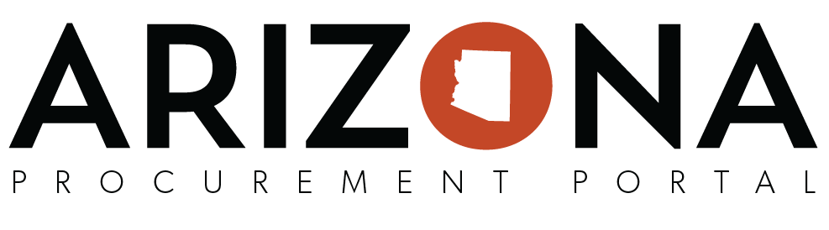

**Source to Contract Training Card**

|  |  |
| --- | --- |
| **Login Information** | |
| **Assigned Number:** | _______ |
| **Sourcing User ID:** | ADAPROC___ |
| **Supplier User ID:** | S2Ctrain___@noemail.gov |
| **Password:** | APP2020! |
| **Solicitation Information** | |
| **Setup Project** | * **Label**: Sweet Treats <Initials / Today’s Date> * **Commodity:**  50160000 – Chocolate and sugars and sweeteners and confectionary products * **Agency:** Arizona Department of Administration |
| **Schedule Information** | * **Code:** IS1 * **Step:** Identify Commodities for Suppliers * **Type:** Action * **Manager:** You * **Assigned to:** You * **Begin Date:** Today’s Date * **End Date:** 1 week from Today’s Date |
| **Setup Document** | * **Select Document Type:** Solicitation * **Title:** IFB<BPM#> * Confirm Document is set - 'en' * **Set Document Status:** Approved |
| **Identify Suppliers** | * **Commodity Codes:** 5016000 and 5000000 |
| **Prepare Rfx** | * **RFx Type:** IFB * **Label:** Sweet Treats < Initials / Today’s Date> * **Bid Due Date:** Today’s Date / 2:00PM * **Publication Begin Date:** Today’s Date / 12:00AM * **Process:** ‘Pre-Bid Meeting @ 11:00AM’ * **Summary:** ‘Ordering chocolates and candies for the State of AZ.’ |

|  |  |
| --- | --- |
|  | |
| **Requisition #** |  |
| REQ_____________________ | PO_____________________ |
| REQ_____________________ | PO_____________________ |