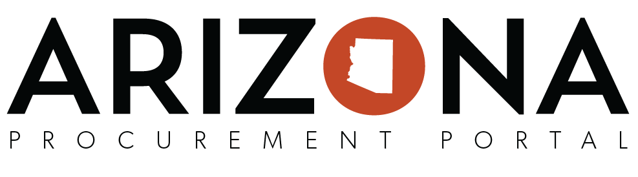

**Creating Requisitions Training Card**

|  |  |
| --- | --- |
| **Login Information** | |
| **Assigned Number:** | _______ |
| **User ID:** | ADAREQ___ |
| **Password:** | APP2020! |
| **Requisition Information** | |
| **Supplier:** | Brennan and Dale LLC |
| **Items:** | Accountant |
| **Short Description:** | Temporary Accountants  <*THREE LETTER INITIALS*> <*TODAYS DATE*> |
| **Site:** | Community Corrections |
| **Accounting Information** | |
| **Budget Fiscal Year:** | 2020 |
| **Function:** | A3051601FT |
| **Object Code:** | 7599 |

|  |  |
| --- | --- |
| **Notes** | |
| **Requisition #** | **Purchase Order #** |
| REQ_____________________ | PO_____________________ |
| REQ_____________________ | PO_____________________ |