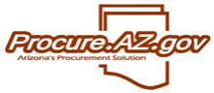
1 Navigation

This page was intentionally left blank.
Contents
1. Navigation in ProcureAZ 1
Learning Objectives 1
Lesson Overview 1
1.1. Login to ProcureAZ 2
1.2. Home Page 3
Role Selection 4
Header and Navigation Bars 4
Home – Welcome Back – Overview 4
1.3. Header and Navigation Bars 5
Header Bar Links 5
Header Bar Tools 5
Navigation Bar 6
Quick Buy 6
Items 6
Documents 7
Vendors 7
1.4. My Account – User Profile 9
Activity 1.4 11
ProcureAZ Navigation Review 11
Lesson Summary 13
Check Your Progress 14

- Navigation in ProcureAZ

Learning Objectives
In this lesson, you will:
- Review the Login process
- Review the Home Page
- Identify the Header and Navigation Bar options
- Examine the User Profile information

Lesson Overview
ProcureAZ is a statewide online procurement system that is used to manage all agency and statewide solicitations and contracts. The integration of ProcureAZ with AFIS, the statewide financial management system, allows for the automatic verification of accounting and budget information. Procurement consists of processing Requisitions (purchase requests), Purchase Orders, and Receipts. In this lesson, users will review the navigation of ProcureAZ along with some of the features that are available.

  - Login to ProcureAZ
ProcureAZ is accessed by using a web browser, such as Internet Explorer, to navigate to the application website and logging in with user credentials. The web address for ProcureAZ is:
http://procure.az.gov
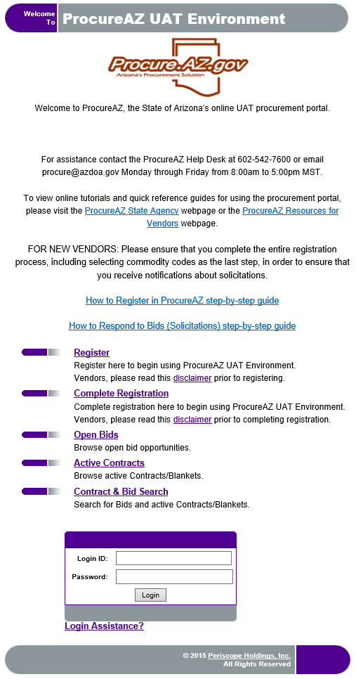
The page that displays is the Login Screen. Registered users are able to log in by typing their Login ID and Password into the Login fields and clicking the Login button. If a user has forgotten their User ID or password, the Login Assistance? link will walk the user through the process of recovering their login credentials.
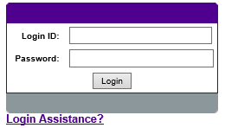
There are several other links on the Login Screen that can be used by vendors and/or unregistered users. The Register and Complete Registration links allow vendors to register in ProcureAZ so that they can receive notice of and respond to Bid opportunities as well as have Purchase Orders sent to them.
The Open Bids link allows unregistered users to view a list of open solicitation opportunities and to filter them by commodity categories.
The Active Contracts link allows unregistered users to view a complete list of all active contracts for agencies with the ability to filter by commodity category.
The Contract and Bid Search link allows unregistered users to search for current or past solicitation opportunities, active contracts and their associated solicitations.
To log in, enter a Login ID and Password and click the Login button. Users will be required to change their password the first time they log in.
  - Home Page
When a user has successfully logged into ProcureAZ, the first page that is displayed is called the Home Page. The Home Page that is displayed depends on the user role assigned to the user. Users can only see the tabs, options, and pages that have been assigned to that user role. Depending on the user roles assigned, the Home Page will allow access to other user roles, search and help functions, navigation options, and updated news and document information.
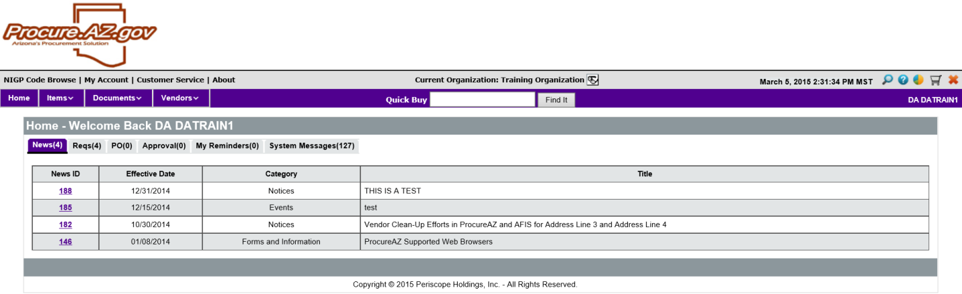

Role Selection
Along the top of the page, role tabs allow users with more than one role assigned to switch between those roles by selecting the corresponding role tab. These tabs are visible at all times. If you do not have more than one role you will not see any tabs.

Header and Navigation Bars
The Header and Navigation Bars are displayed at the top of the screen at all times. They contain links and icons that are used to navigate around and perform actions in the system.

Home – Welcome Back – Overview
For most users, the Home Page will display a Home – Welcome Back section that contains all of the information required by the user role separated into tabs.
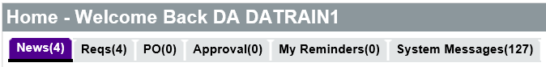
The following types of tabs are available:
- News – Used to view general news bulletin and information items created by administrators
- Document Types – The tabs for the various document types are available depending on the user role and are used to view documents in the various stages of approval and processing
- Approval – Used to view documents created by the user that are currently pending approval by another user and documents created by other users that are currently pending the user’s approval
- My Reminders – Used to view reminder items that have been created on documents to remind users of task that need to be completed
- Events – Only available for Basic Purchasing users. Displays Master Blanket Purchase Order events for contract expiration and renewal
- System Messages – Displays all system warning and error messages that have occurred on documents processed in ProcureAZ
  - Header and Navigation Bars
The Header and Navigation Bars are located at the top of the page and contain links, icons, and drop down menus that are used to access information and documents in ProcureAZ. The official system clock is also displayed in the Header Bar. Clicking any of the links or icons in the Header Bar will navigate to a different page within the system, meaning that users should be careful and always save changes to any documents that are currently open before clicking any of the links or icons.

Header Bar Links
The navigation links on the right side of the Header Bar are used for the following:
- NIGP Code Browse – Used to open the NIGP Code Browse page to search for Class and Class Item commodity codes
- My Account – Used to view and edit the current user’s profile information. Editing the information requires entering the user’s current password to confirm the profile changes
- Customer Service – Used to navigate to the State Procurement Office’s ProcureAZ website for help and documentation
- About – Used to display the version of the ProcureAZ (BuySpeed) application that is currently running

Header Bar Tools
The icons in the top right corner of the Header Bar are used to navigate to Search, Help, and Reporting functions. The icons displayed are as follows:
Topic | Icon | Functionality
Advanced Search |  | Opens the Advanced Search page used to search for documents based on specific criteria
Help |  | Opens the online User Manual for the BuySpeed application
Reporting Dashboard |  | Available only to Basic Purchasing users
Ad Hoc Reporting |  | Available only to specific users
Administrative Reports |  | Opens the list of available administrative reports categorized by document type
Dashboard |  | Opens the Document Management Dashboard, a shortcut to documents processed in the last 180 days
Shopping Cart (G2B Punchout)– |  | Starts the Punchout Shopping process
Log out |  | Logs the user out of ProcureAZ

Navigation Bar
The Navigation Bar consists of drop down menus for Items (by Classification category), Documents (by document type), and Vendors (vendor browse and search), depending on the user role, as well as a shortcut button to go ‘Home’. The name of the current user is displayed on the right side of the Navigation Bar.

Quick Buy
The Quick Buy feature in the Navigation Bar can be used as a quick search tool to locate items by keyword. Enter a Keyword and click the Find It button to display the Quick Buy Search Results page. On the results page, the Advanced Search feature is also available to further refine the search. From the Quick Buy page, Items can be selected and added to a new Requisition or an existing Requisition.
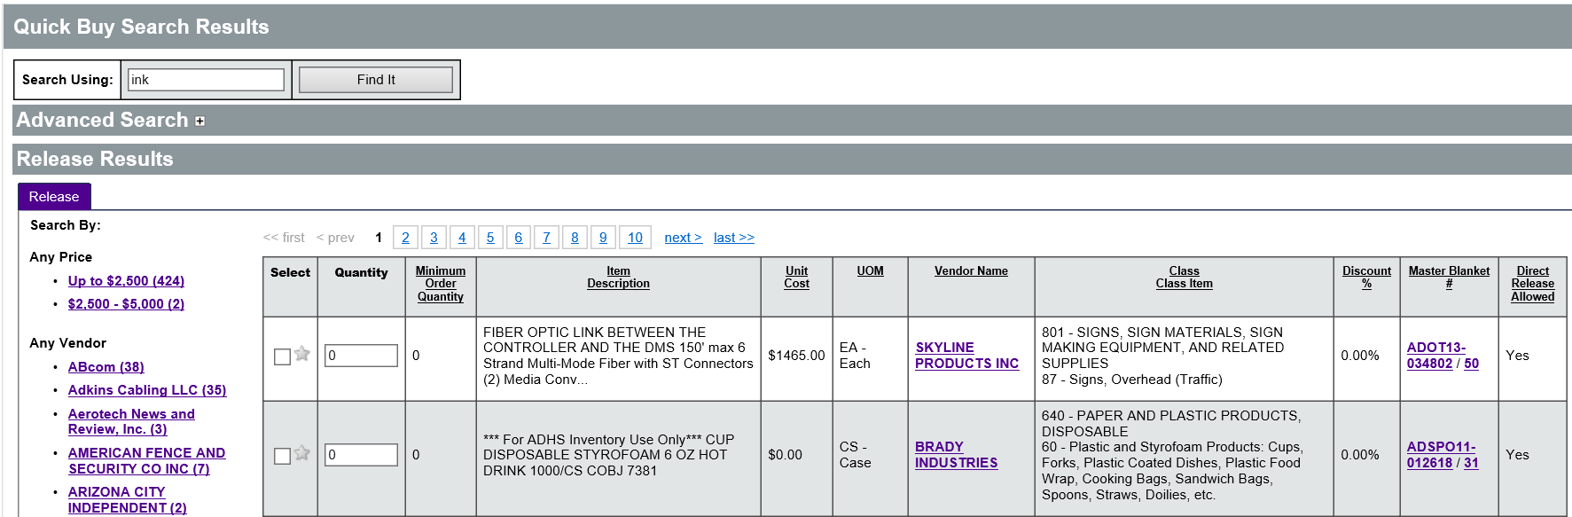

Items
The Items menu displays a list of Item categories and sub-categories. Selecting a category from the menu will display the Quick Buy Search Results page for the selected Items. Users can select Items and add those Items to a new Requisition or an existing Requisition.
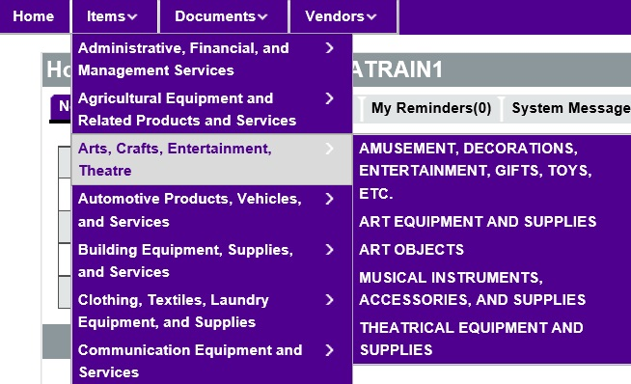

Documents
The Documents menu displays a list of document types by document status. For example, to view all Requisitions that are currently in progress, click Documents > Requisitions > In Progress. This will display a list of documents along with their descriptions and type.
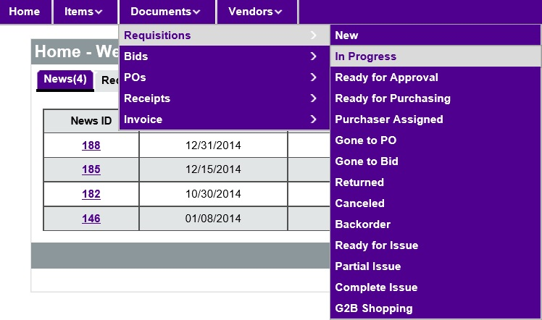

Vendors
Vendors can be browsed by Commodity Code or by using the Vendor Search feature. Browsing vendors by Commodity Code will display a list of all vendors who have associated themselves with the selected code.
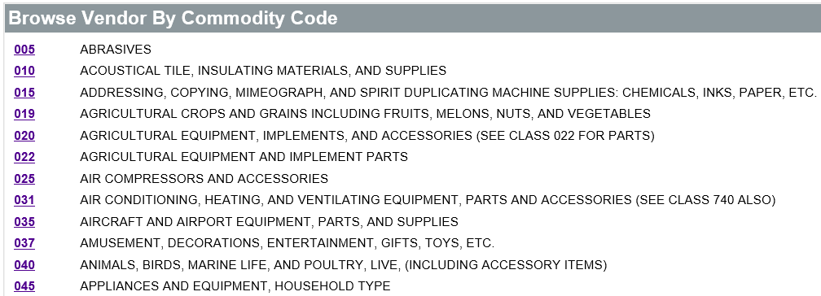

  - My Account – User Profile
In the Header Bar, the My Account link is used to view the current user’s profile and contact information. The contact information displayed includes the user’s name, job title, department, email address, phone number, and proxy user (if applicable). The information in the user profile can be changed by clicking the Edit button. Any fields marked with an asterisk (*) are required.
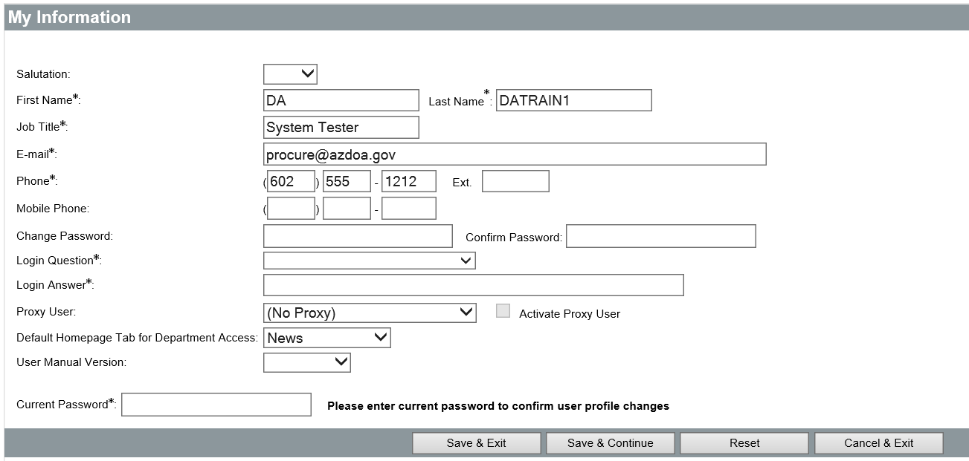
A user’s profile can be updated using the following fields:
- First Name/Last Name – Enter the displayed name for the user
- Job Title – Enter a job title for the user
- Email – Enter the user’s valid email address
- Phone/Mobile Phone – Enter the user’s phone number
- Change Password/Confirm Password – Used to change the user’s password
- Login Question – Used if the password is forgotten and the needs to be reset
- Login Answer – The answer required for the Login Question to be successful when the password has been forgotten
- Proxy User – Used to delegate approval on the user’s behalf to another user. The proxy user will receive email notifications for any documents awaiting approval by the current user. A proxy user does not have the ability to send another user’s document
- Default Homepage Tab – Used to set the tab that is initially displayed when logging as a user with a specific user role. Only users with multiple roles will be able to choose from their available tabs.
- User Manual Version – Used to select the version of the manual that is displayed when clicking the Help icon
If changes have been made to the user information, the user must enter the current password to confirm the profiles changes. The Save buttons are used to confirm the changes. The Reset button will revert any changes made since the information was last saved. The Cancel and Exit button will close the page without saving any changes.

Activity 1.4

ProcureAZ Navigation Review
Scenario
This is the first time you are logging into ProcureAZ and you would like to familiarize yourself with the login steps and navigation features in the system. You will explore the links and icons on the Header Bar and edit your User Profile information.
Steps
- Navigate to the ProcureAZ Login Screen and log into the system.
  - Open Internet Explorer.
  - If ProcureAZ is not the default Home Page, enter the website URL from the Training Data Card in the address field and press Enter.
  - Enter the User ID and Password you were provided into the corresponding fields.
  - Click the Login button.
- At the ProcureAZ Home Page, observe the navigation features available.
  - In the Header Bar, observe the links and icons available.
  - In the Navigation Bar, click the drop down menu for Items.
  - Observe the list of categories.
  - Click the drop down menu for Documents.
  - Observe the list of document types.
  - Click the drop down menu for Vendors.
  - Observe the vendor search options.
- View the available reports.
  - In the Header Bar, click the Administrative Reports icon.
  - Observe the list of reports available by document type.
  - At the bottom of the page, click the Exit button.
- View the User Profile information.
  - In the Header Bar, click the My Account link.
  - Observe the user contact information.
  - Click the Edit button.
  - In the Login Question field, select What is your favorite food?
  - In the Login Answer field, enter Pizza.
  - In the Current Password field, enter the password you were provided.
  - Click the Save and Exit button.
  - Click the Exit button.
- View the tabs in the Home – Welcome Back section.
  - In the Home – Welcome Back section, click the Reqs tab.
  - Observe the documents listed on the In Progress tab.
  - Observe the tabs for each document status.
  - Click the My Reminders tab.
  - Observe the My Reminders tabs for each document type available.
  - Click the Exit button.

Lesson Summary
In this lesson you:
- Reviewed the Login process
- Reviewed the Home Page
- Identified the Header and Navigation Bar options
- Reviewed the User Profile information

Check Your Progress
- Users can recover their password and user ID if they are forgotten.
  - True
  - False
- The Help icon contains a(n) ______.
  - Exclamation point
  - Dollar sign
  - Question mark
  - Asterisk
- In the Navigation Bar, the Documents drop down menu lists documents by __________.
  - Document status then document type
  - Document department then document date
  - Document type then document status
  - Document type then document department
- The My Account link displays a user’s profile information such as __________.
  - User creation date
  - User password
  - User proxy
  - User address

