10 Receiving

This page was intentionally left blank.
Contents
10. Receiving Items and Services 1
Learning Objectives 1
Lesson Overview 1
10.1. Receipt Overview 2
Receipt Status 2
10.2. Receipt Creation 3
Purchase Order Status 3
Locate a Purchase Order 3
10.3. Receiving Items 5
General Tab 5
Items Tab 6
Receive All 7
Add Receiving 7
Process Receipt 7
Add Return 8
Process Return 9
Cancel Item 10
Updated Items Tab 11
Adjustments 11
10.4. Attachments and Notes 13
Attachments Tab 13
Attachment Modification 14
Adding, Editing, and Deleting Notes 14
Item Notes 14
10.5. Summary and Approval 16
Submit for Approval 16
Approval Paths 16
Document Approved 17
Activity 10.1 18
Create a Receipt Document 18
Lesson Summary 20
Check Your Progress 21

- Receiving Items and Services

Learning Objectives
In this lesson, you will:
- Examine the Receiving process
- Create a Receipt document
- Complete the Receipt of Items
- Review the process of attaching documentation and adding notes to a Receipt
- Review the submission and approval process for a Receipt

Lesson Overview
In ProcureAZ, Receipts are used by Basic Purchasing and Department Access users to document the receipt, return, and cancellation of ordered items or services. In this lesson, users will examine the receiving process and create documents to record the receipt of goods and services.

  - Receipt Overview
When goods or services have been received or need to be returned or canceled, the corresponding Purchase Order document can be used to create a Receipt. The Receipt document records the quantity of items or dollar amount of services that has been received, returned, or canceled.
Receipts should be created for each shipment of goods or service deliverable provided. This allows accounting to perform a 3-way match using the Purchase Order, Receipt, and Invoice documents to ensure that only goods and services that have been received are paid for.

Receipt Status
When a Receipt document is created in ProcureAZ, the status of the document is updated as it moves through the approval process. The status of the document determines what changes can be made to the document. The possible Receipt document statuses are:
- In Progress – The document is still being completed by the originator. It is editable by the originator or other authorized user
- Ready for Approval – The document has been submitted for approval. The document cannot be edited. The document can only be approved, disapproved, or canceled
- Approved for Invoice – The items or services on the Receipt have been approved and Accounts Payable users are now authorized to pay Invoices for them
- Returned – The document has been disapproved by an approver. The document can be reopened by the originator which will return the document to an In Progress status
- Canceled – The document has been canceled by the originator, an approver, or other authorized user. The document cannot be edited or reopened
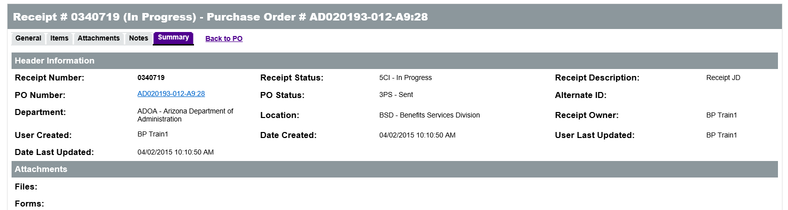

  - Receipt Creation
Receipts are created against Purchase Orders in ProcureAZ. Receipts can be created by Basic Purchasing and Department Access users. Basic Purchasing users can create receipts for all locations with their organization. Department Access users can only create Receipts against Purchase Orders that are assigned to a Location for which they have access rights.

Purchase Order Status
Receipts can be entered for Purchase Orders with a status of Sent, Partial Receipt or Complete Receipt. A Purchase Order with a status of Sent means that the PO has been sent to the vendor. A Purchase Order with a status of Partial Receipt means that some of the ordered goods or services have been received. If a Purchase Order has a status of Complete Receipt, all goods and services have been received and a Receipt can only be used to process an adjustment to previous Receipts. However, if there is a Change Order in progress on the Purchase Order, no Receipts can be entered.

Locate a Purchase Order
Receipts can be created by locating the Purchase Order for the items or services. The Advanced Search feature can be used to locate an existing PO by selecting Purchase Order from the Document Type drop down list. In the search fields, enter any known information about the Purchase Order, such as the PO Description or PO Number, and click the Find It button. The results of the search will display below the search fields.
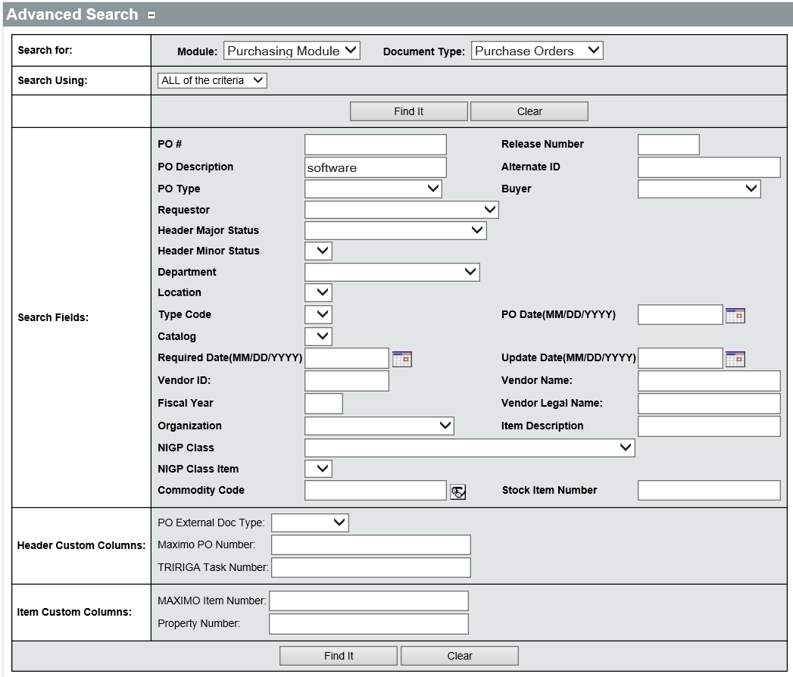
TIP: For more information on Advanced Search, refer to Lesson 12 Advanced Search.

Click the document number to open the Purchase Order to the Summary tab.
On the Summary tab of the Purchase Order, click the Create Receipt button in the middle of the page to display a new Receipt.
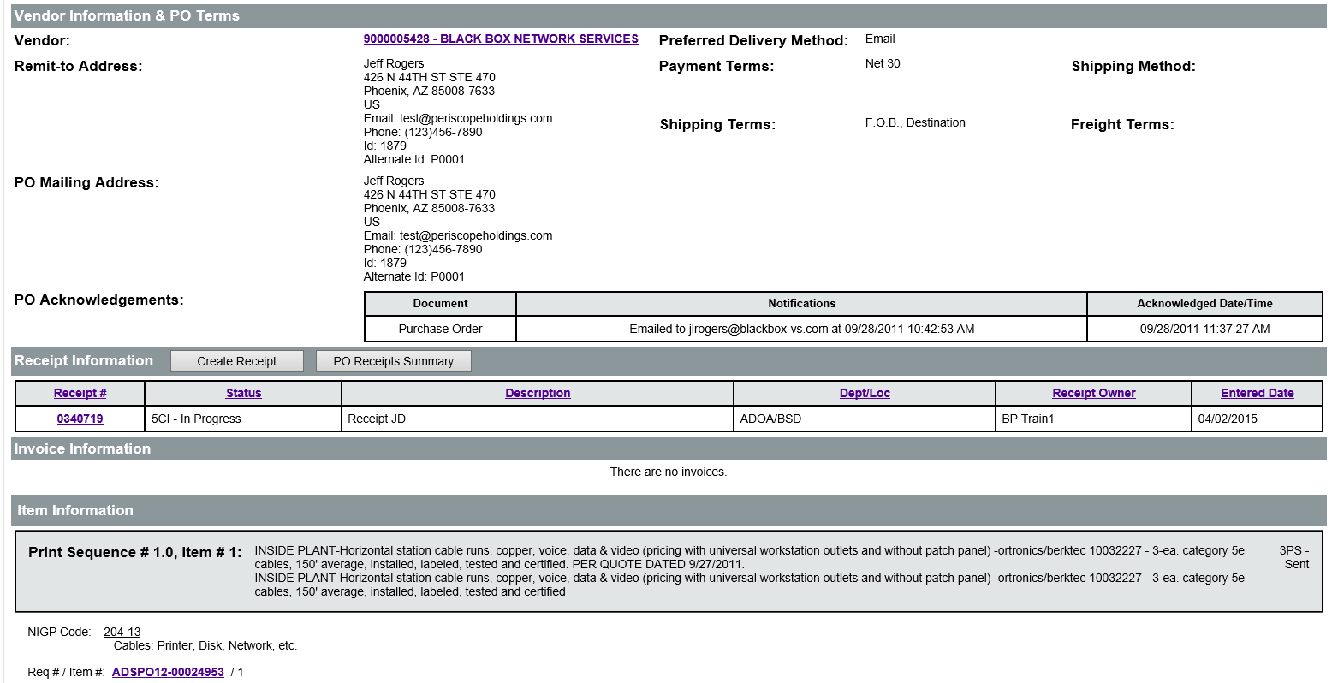
  - Receiving Items
Clicking the Create Receipt button on the PO will open the new Receipt document to the General tab. Like all other documents created in ProcureAZ, it is best to proceed through each tab of the document from left to right. Users must enter at least the required data on each tab and click the Save & Continue button as each tab is completed. Users can review all of the information in the document on the Summary tab before submission.

General Tab
The General tab displays the information for the entire document, including the PO Number that is being referenced, the Receipt document status, and the PO document status. The four required fields on the General tab are: Receipt Description, Department, Location, and Receipt Owner. The Receipt Description will need to be entered and should briefly state the purpose of the document. The Department and Location will be auto-populated with the values from the Purchase Order but can be changed to any Department and Location that the user is authorized for, if necessary. The Receipt Owner will default to the user that is entering the receipt.
TIP: The Receipt Owner can be changed to any user with receiving rights for the location within the user’s organization. This can be helpful if a user is entering the receipt on behalf of another agency team member.

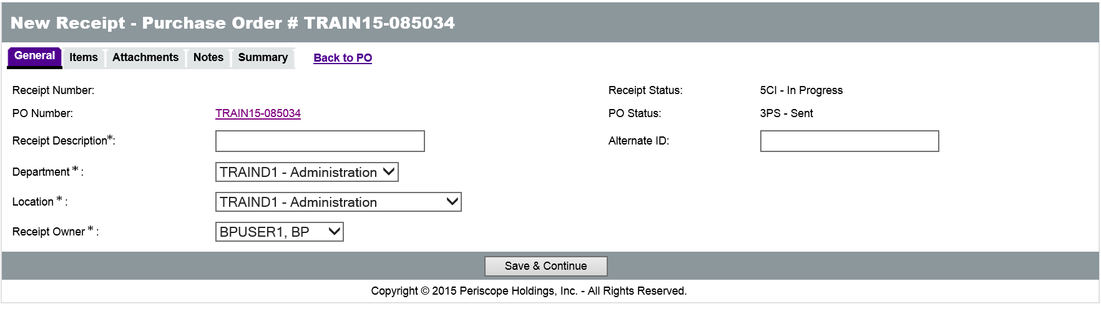
After completing the required fields on the General tab, click the Save & Continue button to save your progress and then click the Items tab.

Items Tab
The Items tab lists all of the Items on the Purchase Order along with pricing, quantity, and receiving information. Users will want to observe the Receipt Method and Remaining Quantity/Dollar columns for each Item that has been received before processing the receipt of any items. The Receipt Method displays either Quantity, recommended for goods (commodities), or Dollars, used for services.
TIP: The Receipt Method of Quantity or Dollars was established when the Purchase order was created and is carried forward to the receipt.
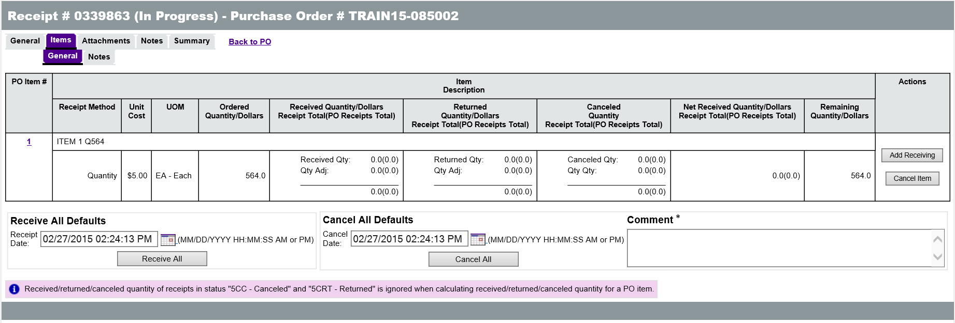
The value in the Remaining Quantity/Dollars column indicates the amount of the goods or services that have not yet been received on the Purchase Order. Users will not be able to receive more than the value in this column.
The Items tab allows users to indicate if they are receiving or canceling the Items and specify the amount (dollars or quantity dependent upon receipt method). Users have the option to receive or cancel individual Items or all at once. The Receipt Date field will initially populate with the current date, but can be changed by clicking the Calendar icon and selecting a different date in the date picker.

Receive All
The Receive All button, in the Receive All Defaults section at the bottom of the screen, can be used when all Items have been received at the same time. Clicking Receive All will refresh the Items tab to reflect the updated receiving information for each Item. This action will also remove the other receiving alternatives. Any changes to the Receipt now require the creation of an adjustment or the cancellation of the Receipt.
TIP: Do not use Receive All if you need to identify the Service From/To dates for your items. It is not possible to enter that information when using Receive All.
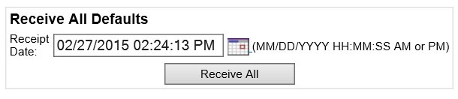

Add Receiving
When a portion of the ordered goods and/or services have been received, click the Add Receiving button in the right column for each Item that has been delivered and complete the details of the Receipt.
On the Receiving Items> General tab, all of the information about the Item, including how much of the Item has been received, returned, or canceled to date, is displayed. At the top of the screen, users can indicate the Date Received or use the default of the current date and time. In the Receipt Item Receiving/Return Details section, enter the Quantity/Dollar amount received for the selected Item.

Process Receipt
Enter the amount (quantity/dollars) received, in the Quantity/Dollars column, in the Receiving row. This value cannot exceed the Remaining Quantity/Dollars amount displayed in the PO Item Receiving Summary for the Item. If desired, users can enter a comment regarding the receipt in the Comment field.
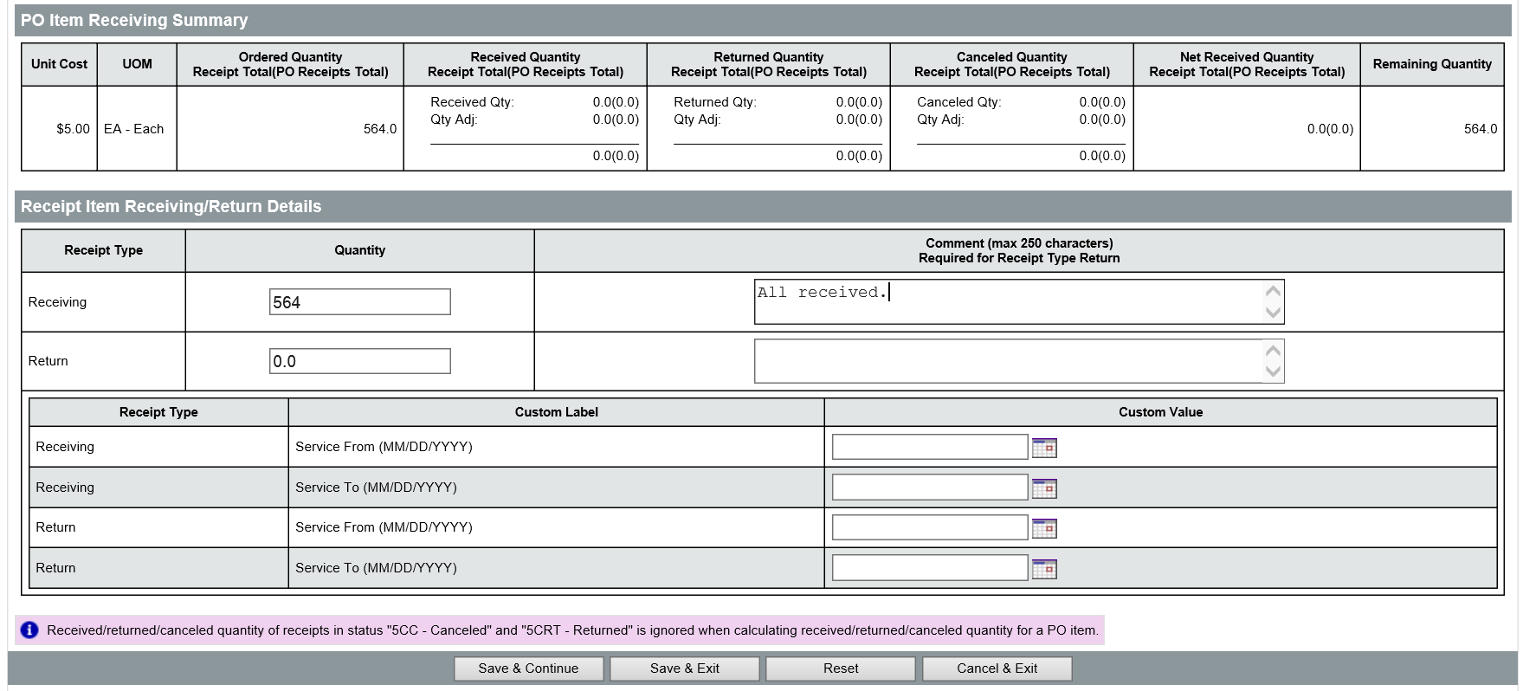
New
Feature
The Service From and Service To date fields are used to indicate the service period for the line Item being received. Enter or select the applicable dates using the Date picker.

TIP: Service From / To Dates are often useful reference information for agencies that are using grant funds to pay for the items ordered. Follow your agency guidelines on usage of these fields.
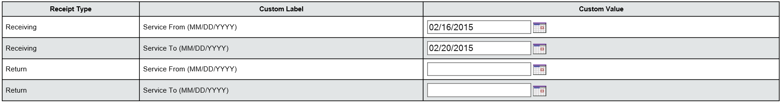
When the receiving entry is complete, click the Save & Exit button to return to the Items tab.
TIP: Be sure to double-check the receiving entry before saving. Once the document has been saved, any changes to the amounts entered for the receipt require either the creation of an adjustment or the cancellation of the receipt.

Add Return
Receipts are also used when ordered goods and services have been received and need to be returned for any reason. Click the Add Receiving button in the right column for each Item that has been delivered and complete the details of the return.
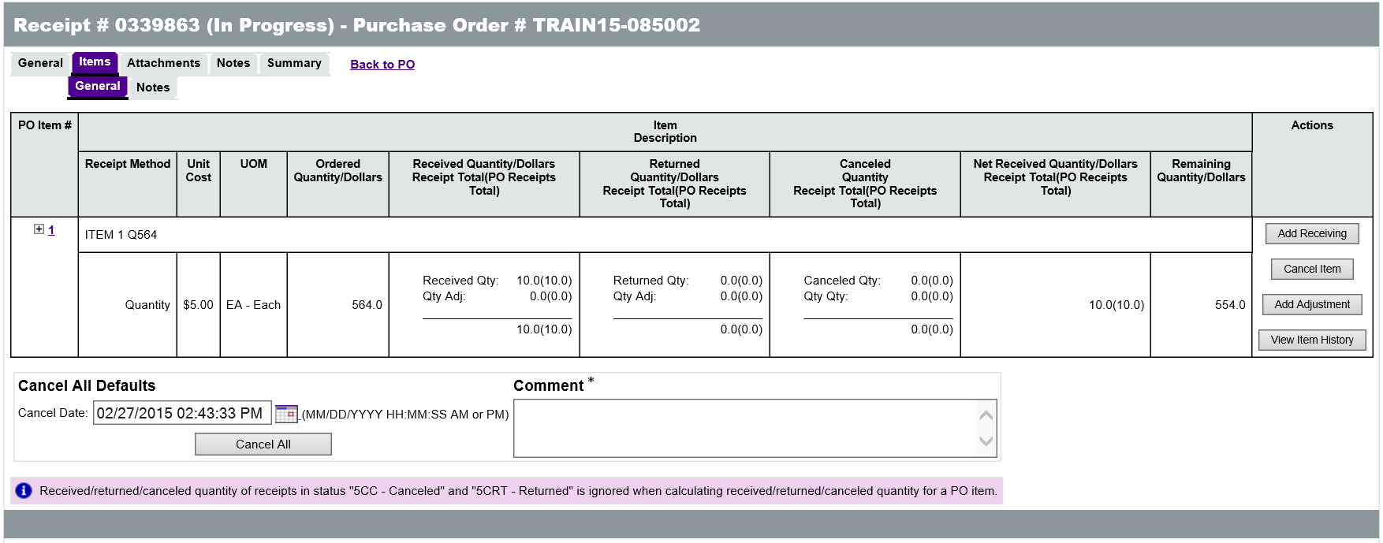
On the Receiving Items> General tab screen, all of the information about the Item, including how much of the Item has been received, returned, or canceled to date is displayed. At the top of the screen, users can indicate the Date Returned or use the default of the current date and time. In the Receipt Item Receiving/Return Details section, enter the Quantity/Dollar amount returned for the selected Item.

Process Return
To process the return of an Item enter the amount (quantity/dollars) returned in the Return row. When processing a return, a comment must be entered in the Comment field that explains the reason for the return.
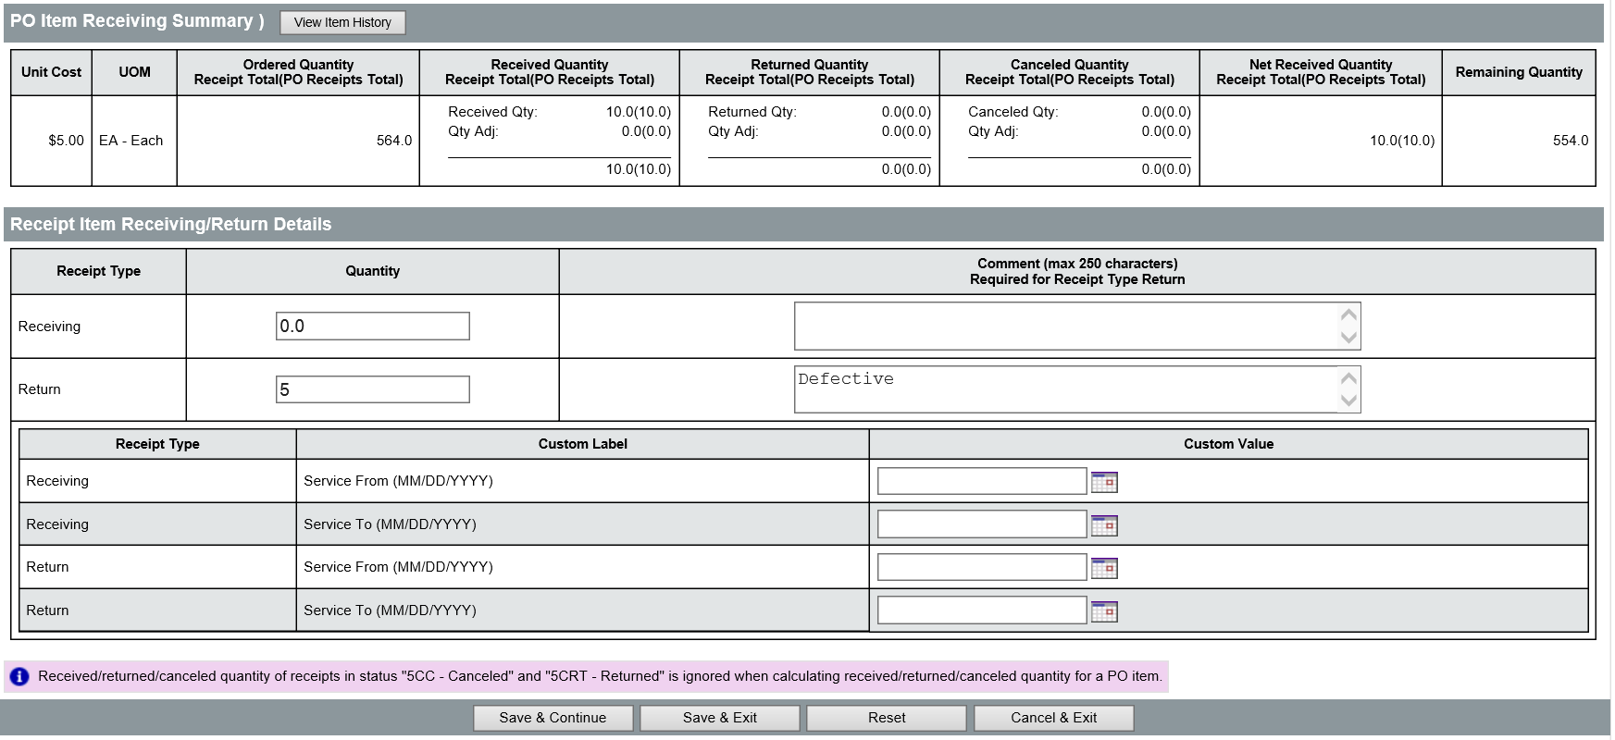

The Service From and Service To date fields are used to indicate the service period for the Item being returned. This should reflect the dates that were entered when the item was originally received. Enter or select the appropriate dates using the Date picker.
New
Feature
When the return entry is complete, click the Save & Exit button to return to the Items tab.
TIP: Be sure to double-check the return entry before saving. Once the document has been saved, any changes to the amounts entered for the return require either the creation of an adjustment or the cancellation of the Receipt.

Cancel Item
A Cancel Item action is performed when an amount of the Item is no longer needed. If an approved Receipt document includes the cancellation of any Items, a Change Order will automatically be created for the associated Purchase Order. The Change Order will cancel the same amount of the Item that was canceled on the Receipt. The Cancel Item screen looks very similar to the Add Receiving screen. The details about the Item are displayed, including the current received, returned, and canceled amounts of the Item and the Remaining Quantity/Dollar Amount.
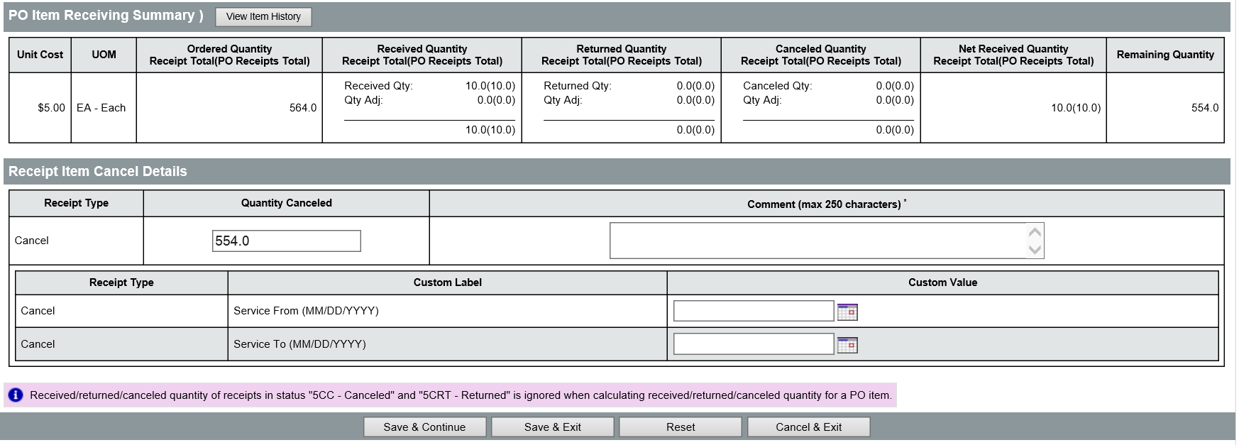
The Receipt Item Cancel Details section contains fields for the Quantity Canceled and Comments. In the Quantity/Dollar Amount Canceled field, enter the amount to be canceled and provide the required Comment which explains the reason for the cancellation.
TIP: If the full balance of the item is canceled it is no longer adjustable within a Receipt. A red error message will be displayed if a Receipt is entered for Items that have been cancelled.
Once entry is complete, click the Save & Exit button at the bottom of the screen to return to the Items tab.

Updated Items Tab
After entering receiving information for an Item, the options displayed in the Actions column will change for that Item. The Add Receiving button appears if there is still a Remaining Quantity/Dollars for the Item and allows users to process additional receipts/returns up to the remaining balance. The Cancel Item button allows users to cancel Items that have not yet been received. The Add Adjustment button appears, enabling users to enter an adjustment to the currently received, returned, or canceled amount of the Item. Finally, clicking the View Item History button will display a pop-up window that lists the full receipt history of the Item (as pictured below).
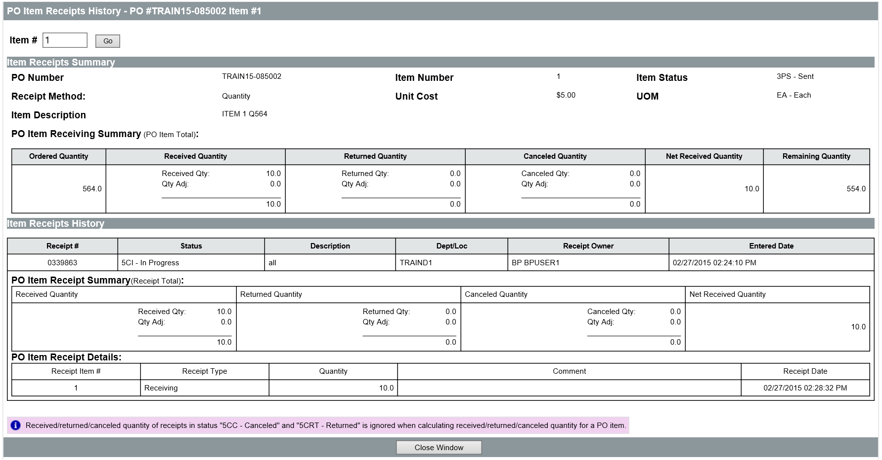

Adjustments
Adjustments are used to correct any errors that may have been made during the receiving process by allowing users to increase or decrease the amount of the Item that has been indicated as received, returned, or canceled. The Adjustment Details screen looks very similar to the Add Receiving and Cancel Item screens. The details about the Item appear, including the current received, returned, and canceled amounts of the Item and the Remaining Quantity/Dollar Amount. The Adjustment Details section allows the entry of receiving, return, and cancellation adjustments. The Comment field is required for any adjustment entry and should explain the reason for the adjustment.
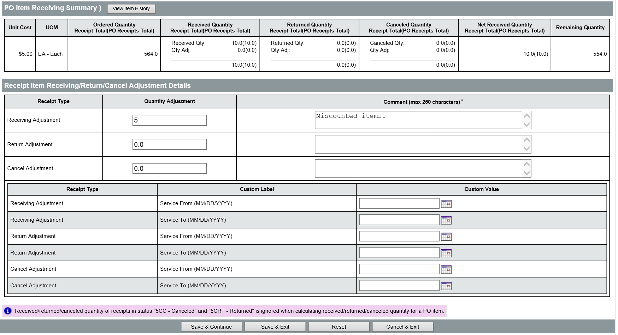
Enter the amount of the adjustment in the Quantity/Dollars Adjustment fields. To increase the amount of an Item that has been received/returned/canceled, enter a positive number. To decrease the amount of an Item that has been received/returned/canceled, enter a negative number. For example, if four of an Item were originally indicated as returned and only two were actually returned, enter “-2” into the Quantity Adjustment field for the Return Adjustment line. Then enter a comment that explains the reason for the adjustment. Once the adjustment is complete, click the Save & Exit button at the bottom of the screen to return to the Items tab.

  - Attachments and Notes
On the Receipt document, additional documentation related to the Receipt can be attached on the Attachments tab. Documentation can include packing slips, invoices, or other information. It is recommended that the packing slip be signed by the individual that received the goods, scanned, and attached to the Receipt in ProcureAZ.
Any file accessible from the local computer can be attached to the Receipt. The number of attachments on the document is displayed in parenthesis on the Attachments tab.

Attachments Tab
On the Attachments tab, click the Add File button. On the Add File page, the Name field is the display name for the file that will appear wherever attachment repository files are displayed.
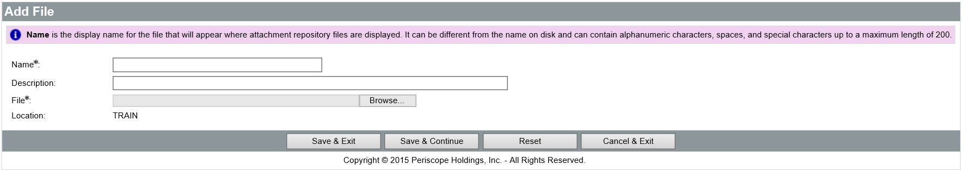
The Name can be different than the name of the file and can contain alphanumeric characters, spaces, and special characters up to a maximum length of 200 characters. If no Name is entered, it will default to the file name. The Description field is optional but can be used to enter a longer description of the file, its purpose, or any notes/comments about the file.
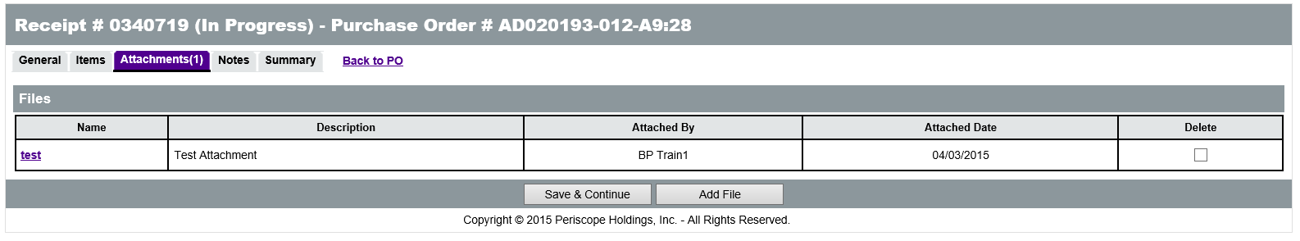
Clicking the Browse or Choose File (browser dependent) button will display a File Explorer window that allows the user to navigate to the folder location on the local machine or shared drive and select the file to upload. When the appropriate file has been selected, click Open in the File Explorer window to add the file path to the Attachment screen.
When all fields have been completed and the file has been selected, click the Save & Exit button to upload the file to ProcureAZ and attach it to the Receipt. To attach more files, click Save & Continue.

Attachment Modification
On the Attachments tab, the Delete check box will delete the attachment from the Receipt. To remove the attachment, check the corresponding box in the Delete column. Then click the Save & Continue button to apply the changes.
The Name of the file is a link to the file detail screen. On the Attachment Detail screen, only the Description can be modified. The file can also be downloaded by clicking the Download icon. If the Description has been changed, save the changes by clicking the Save & Exit button.

Adding, Editing, and Deleting Notes
The Header > Notes tab is used to add notes about the Receipt document that are only visible to Organization users who access the document. Notes are entered in the Note field, which allows multiple lines of text to be entered. When one note is entered, clicking the Save & Continue button will save the note and add a new blank Note field for another note. Any notes that are saved to the document are stamped with the date they were added. Checking the Delete check box and clicking the Save & Continue button will remove the note from the document. The reset button will revert any changes made to the notes since the document was last saved. Like Attachments, the number of Notes added to the Receipt will display in parenthesis on the Notes tab.
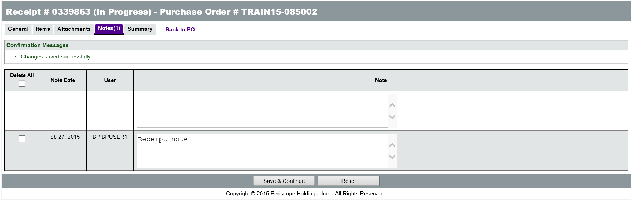

Item Notes
Notes can also be added to an individual Item on the Receipt on the Items > Notes tab. In order to enter an Item-level note to an Item, some quantity of the Item must have been received. On the Items > Notes tab, expand the PO Item # line, then click the Receipt Item # link. The Item-level note field will be displayed which is identical to the Header-level note field. When finished, click the Save & Exit button to return to the list of Items on the Items > Notes tab.
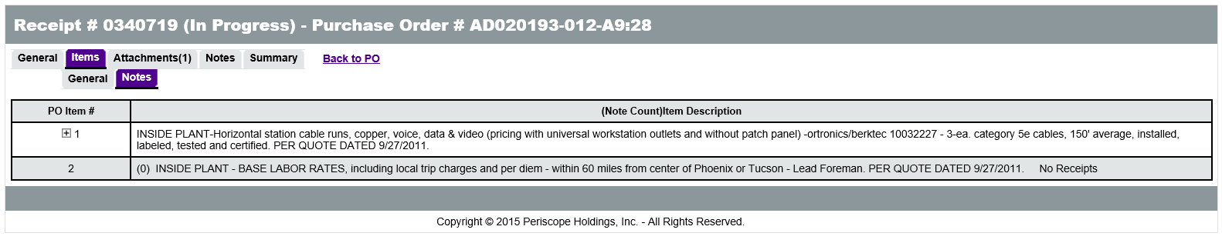

  - Summary and Approval
Once all necessary information on the Receipt has been completed, users should review all of the information on the Summary tab. The Summary tab will display all of the information from the document along with any warnings or errors that may prevent processing the Receipt. Any warnings that are present do not require action, but errors must be corrected prior to submitting the Receipt.

Submit for Approval
If the information on the Summary tab is complete and correct, click the Submit for Approval button to submit the document.
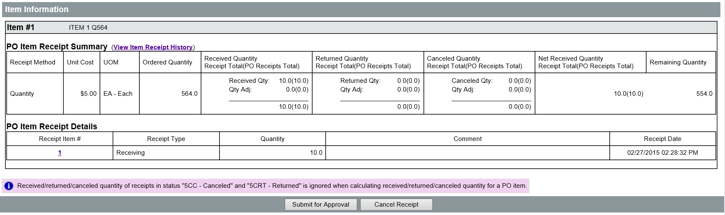
The Receipt document will be in a Ready for Approval status throughout the approval process unless the receipt has no approval paths and is able to be automatically approved by the user. While in Ready for Approval status, no changes can be made to the Receipt. If necessary, approvers can add additional approvers that will need to review the document.

Approval Paths
If there are approval paths configured for the Receipt document type, they will be displayed on the Summary tab. When submitted, the document will route to the first approver on the approval path.
When no approval path has been configured, users can select automatic approval or add an approver manually during the submission process.
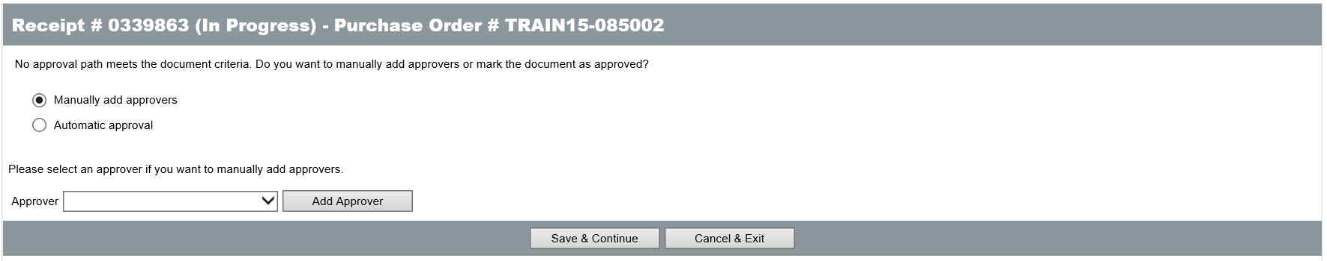

Document Approved
When the Receipt has received all required approvals or been automatically approved, the status will change to Approved for Invoice. Once in Approved for Invoice status, accounts payable can create an Invoice to pay up to the received amount on each item. If the document is disapproved, the status will change to Returned and the creator of the document will be notified of the disapproval. Returned Receipt documents can be edited by clicking the Reopen Receipt button on the Summary tab.
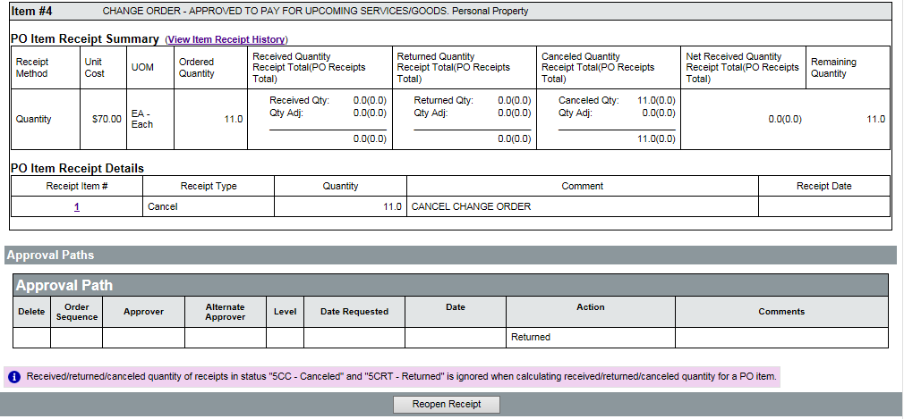

Activity 10.1

Create a Receipt Document
Scenario
You have received a shipment of oars and need to process the Receipt in ProcureAZ. You will locate the Purchase Order document that was used to order the oars and create the Receipt. One of the oars was damaged, so you will need to return the oar to the vendor and indicate the return on the Receipt.
Setup
- Log in to ProcureAZ using the Requisitioner (DA) role from your Training Data Card. This activity requires you to have completed Activities 5-1 through 5-4.
Steps
- Locate the Purchase Order in a Sent status.
  - At the top of the screen, click the magnifying glass icon for the Advanced Search feature.
  - On the Advanced Search page, in the Document Type drop down list, select Purchase Orders.
  - In the PO Description field, enter oars datrain# (where # is your student number).
  - In the PO Date(MM/DD/YYYY) field enter today’s date or click on the calendar icon and click on today (highlighted in yellow).
  - Click the Find It button at the bottom of the screen.
  - In the list of results, click the Purchase Order # link to open the Purchase Order.
  - On the Summary tab, observe the information on the boat and oars order.
  - Click the Create Receipt button in the middle of the Summary page.
- Complete the General tab of the Receipt.
  - On the General tab, in the Receipt Description field, enter Received the oars DATrain# (where ‘#’ is your student number).
  - Observe the information in the other fields on the General tab.
  - Click the Save & Continue button.
  - Click the Items tab.
- Process the receipt of the oars.
  - Observe the information on the Items > General tab for the Ordered Quantity, Receipt Method, and Remaining Quantity.
  - Click the Add Receiving button in the Actions column for Item 2.
  - In the Quantity field for Receiving, enter 2.
  - Click the Save & Exit button to save the changes.
- Review and submit the Receipt.
  - Click the Summary tab.
  - Review the information on the Summary tab.
  - At the bottom of the Summary tab, click the Submit for Approval button.
  - Click Yes to the “Are you sure you want to submit this receipt for approval?” dialogue box.
  - On the Approval Path screen, select the radio button for Automatic approval.
  - Click the Save & Continue button to finalize the submission and create the approved Receipt.
  - When you are finished, click Home to return to the Home Page.
- Locate the Purchase Order in a Partial Receipt status.
  - At the top of the screen, click the magnifying glass icon for the Advanced Search feature.
  - On the Advanced Search page, in the Document Type drop down list, select Purchase Orders.
  - In the PO Description field, enter oars.
  - Click the Find It button at the bottom of the screen.
  - In the list of results, click the Purchase Order # that is related to your Student# link to open the Purchase Order.
  - On the Summary tab, observe the information on the order.
  - Click the Create Receipt button in the middle of the Summary page.
- Complete the General tab of the Receipt.
  - On the General tab, in the Receipt Description field, enter Received the Boat DATrain# (where ‘#’ is your student number).
  - Observe the information in the other fields on the General tab.
  - Click the Save & Continue button.
  - Click the Items tab.
- Process the receipt of the boat and return a damaged oar.
  - Observe the information on the Items > General tab for the Ordered Quantity, Receipt Method, and Remaining Quantity.
  - Click the Add Receiving button in the Actions column for Item 1.
  - In the Quantity field for Receiving, enter 1.
  - Click the Save & Exit button to save the changes.
  - Click the Add Adjustment button in the Actions column for Item 2.
  - In the Quantity field for Return, enter 1.
  - In the Comment field enter Oar arrived damaged.
  - Click the Save & Exit button to save the changes.
- Review and submit the Receipt.
  - Click the Summary tab.
  - Review the information on the Summary tab.
  - At the bottom of the Summary tab, click the Submit for Approval button.
  - When asked if you want to submit the receipt for approval click OK.
  - On the Approval Path screen, select the radio button for Automatic approval.
  - Click the Save & Continue button to finalize the submission and create the approved Receipt.
  - Click OK after the document has finished processing to refresh the screen if asked.

Lesson Summary
In this lesson you:
- Examined the Receiving process
- Created a Receipt document
- Completed the Receipt of Items
- Reviewed the process of attaching documentation and adding notes to a Receipt
- Reviewed the submission and approval process for a Receipt

Check Your Progress
- Receipts should only be created when all of the items on a Purchase Order have been received.
  - True
  - False
- The amount of an Item that is received can be __________ the Remaining Quantity/Dollars.
  - Less than
  - Greater than
  - Equal to
  - Both a and c
- The Service From and Service To date fields are only available when receiving or returning Items individually, not when Receiving All.
  - True
  - False
- Adjustment values are always positive.
  - True
  - False
- Notes can be added at the Header level and at the Item level for received items.
  - True
  - False
- Approved Receipt documents have a status of ____________.
  - Ready for Approval
  - Returned
  - Payment Approved
  - Approved for Invoice

