12 Advanced Search

This page was intentionally left blank.
Contents
12. Advanced Search 1
Learning Objectives 1
Lesson Overview 1
12.1. Using Advanced Search 1
Launch Advanced Search 1
Enter Search Criteria 2
Document Search 3
Commodity Code Search 3
Item Search 4
Vendor Search 4
Perform a Search 5
Search Tips 5
Activity 12.1 7
Use Advanced Search to Locate a Document 7
Lesson Summary 8
Check Your Progress 9

- Advanced Search

Learning Objectives
In this lesson, you will:
- Explore the use of the Advanced Search feature
- Use Advanced Search to locate a document

Lesson Overview
The Advanced Search feature in ProcureAZ allows users to locate any document, item, commodity code, or vendor that they have access to. Advanced Search provides context dependent search fields based on the type of object selected. This lesson will explore the Advanced Search options and best practices.
  - Using Advanced Search
When searching for objects using the Advanced Search feature, most users will only be able to view the documents and items created by their Organization. For Department Access users, results may be further restricted to those documents and items created by their Department.

Launch Advanced Search
The Advanced Search feature is available from any page or document screen by clicking the magnifying glass icon on the right side of the Header Bar.
When working in a document, users should save the document before clicking the Advanced Search icon because it will navigate away from the document when clicked. On the Advanced Search screen, users must first select the Module and Document Type to be searched.
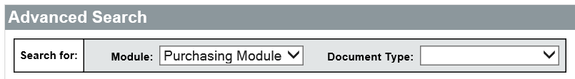
The Purchasing Module will default in the Module field and does not need to be changed. ProcureAZ will not be used to manage Inventory. The Document Type field contains a drop down list of the available document types and objects that can be searched, including:
  - Bids
  - Commodity Codes
  - Contracts/Blankets
  - Items
  - Invoices
  - Purchase Orders
  - Quotes
  - Requisitions
  - Vendors
Select the Document Type from the drop down list to display the available search fields for that type.

Enter Search Criteria
The search fields provided are different for each document type. Search criteria can be entered into any one or a combination of fields. When entering data into multiple fields, the user can search based on ALL of the criteria or ANY of the criteria by selecting the option in the Search Using drop down box. For searches using ALL of the criteria, only results that match all of the entered data will be returned. For searches using ANY of the criteria, all results that match any of the entered data will be returned. To reset the search fields, click the Clear button.
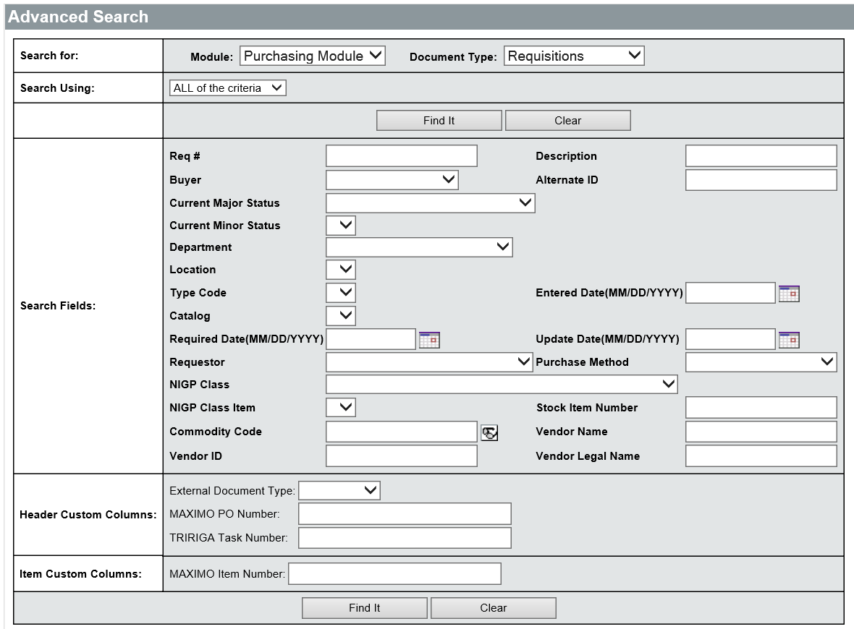
The search fields that allow text entry can be used to search by partial word/number, keyword, or phrase. For partial text, results are returned if the entered string is found anywhere in that field. For example, typing part of a document number will return all documents whose document number contains the entered number.
For text fields, such as Description or Vendor Name, capitalization has to match the text in that field on the document. For example, entering “emer” into the Description field would not return a Requisition with the Description “Emergency purchase of supplies”. The text would need to be entered as “Emer” in order for the Requisition to be included in the results.

Document Search
Users can search based on Document Type by selecting the type from the drop down list. Requisitions, Bids, Purchase Orders, Invoices, Quotes, and Contracts can all be searched. Searching for documents using Advanced Search can be a faster way of locating a document whose current status or full document number is unknown. Depending on the Document Type selected, the following fields may be available to search:
  - Document # – The number auto-assigned to the document
  - Release Number – The number of an order off a particular contract
  - Alternate ID – The alternate identification number provided for the document
  - Header/Current Major Status – The current status of the document
  - Document Description – The description provided for the document
  - Organization/Department/Location – The business units provided for the document
  - Entered Date – The date the document was created
  - Item Description – The description of any item on the document
  - Buyer – The Basic Purchasing user that owns the document
  - Requestor – The user that created the corresponding Requisition document
  - Purchase Method – The purchase method associated with the document
  - NIGP Class/Item – The NIGP Code provided for any item on the document
  - Vendor – The vendor associated with the document

Commodity Code Search
Commodity Codes can be searched by NIGP Class/Item, Group, and Description.
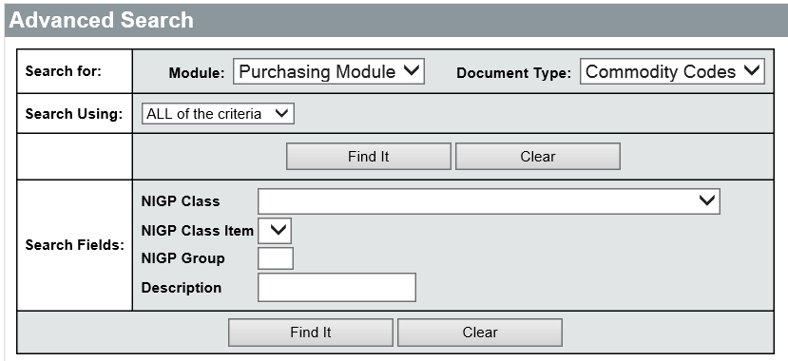

Item Search
Items that have been saved in ProcureAZ can be searched by document (reference), Vendor, Department/Location, Description, NIGP Class/Item code, or Commodity code.
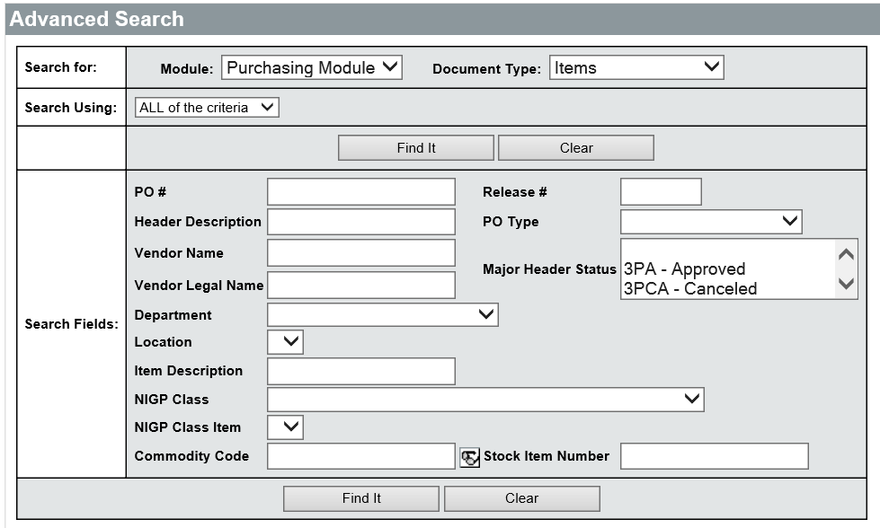

Vendor Search
Vendors can be searched by Vendor ID, Keyword, address information, NIGP Class/Item/Keyword, and other identifying information, such as Counties Served and Entity Type. Vendors can also be located by starting letter or number using the letter and number links in the Browse by section.
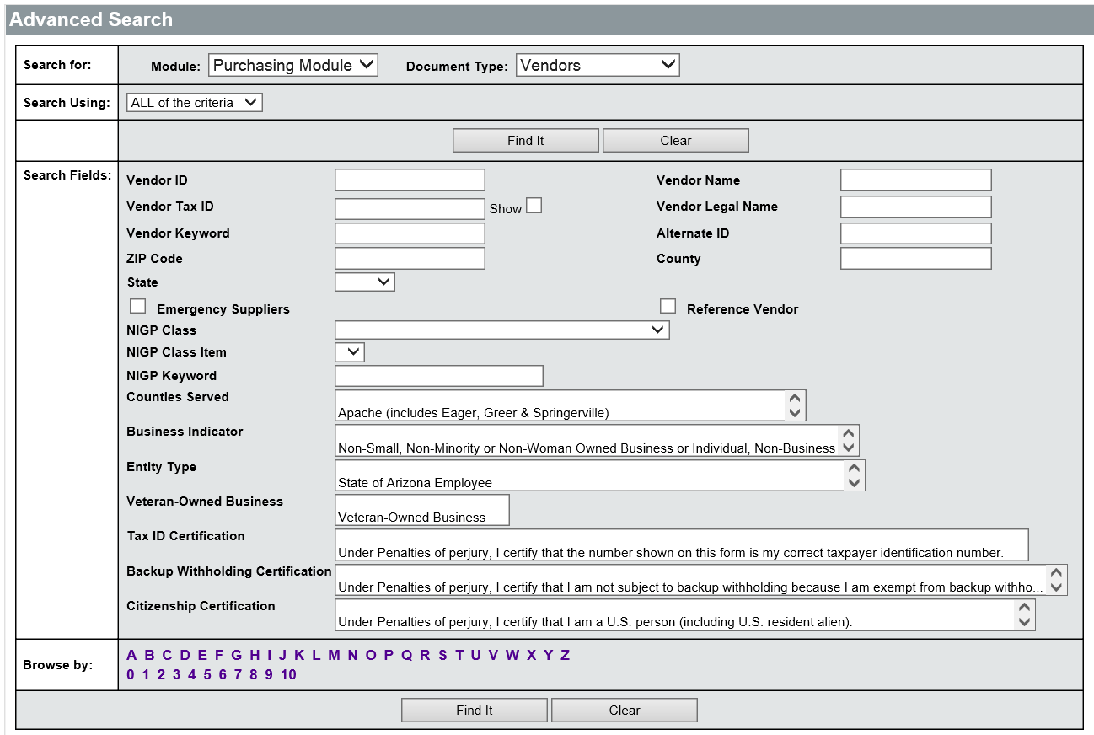

Perform a Search
When all criteria have been entered into the search fields, click the Find It button to display the results of the search. In the list of results, only 25 results are displayed at one time. If there are more than 25 results returned, the page numbers and scroll links can be used to navigate through the remaining results. For document results, clicking the document number will open the document to the Summary tab for viewing.
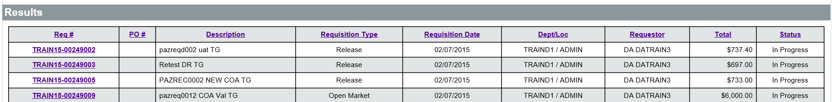

Search Tips
When entering search criteria it is best to enter as much known information as possible, if the Document number isn’t available. This will result in fewer items being returned in the search and make locating the desired object much easier. The fewer search fields completed or the more generic the search terms, the more results that are likely to be returned. Searching based on ANY of the criteria will also typically return more results because results can match any of the entered data.
It is recommended, when searching based on a keyword or text field, that singular words are used. It may be necessary to try several keywords until the desired result is displayed. When a complete word does not return the desired results, try shortening the word or removing prefixes/suffixes.

Activity 12.1

Use Advanced Search to Locate a Document
Scenario
You need to find a Requisition that was processed but you are unsure of the current status. You will use the Advanced Search feature to locate the document in ProcureAZ.
Setup
- User is logged in to the ProcureAZ home page as a user with the Requisitioner role.
Steps
- Open the Advanced Search page.
  - In the Header Bar, click the magnifying glass icon for Advanced Search.
  - Observe the fields for Module and Document Type.
  - In the Document Type drop down list, select Requisitions.
  - Observe the fields that appear on the Advanced Search page.
- Search for a Requisition.
  - In the Purchase Method drop down list, select RPA.
  - In the Description field, enter Emergency.
- Locate and open the desired document.
  - Click the Find It button.
  - Observe that the Advanced Search fields have been collapsed and the results of the search displayed.
  - In the Results, click the Req # for the RPA document.
  - Observe the information on the Summary tab of the document, including the document status.
  - When you are finished, click Home to return to the Home Page.

Lesson Summary
In this lesson you:
- Explored the use of the Advanced Search feature
- Used Advanced Search to locate a document

Check Your Progress
- Advanced Search can be used to search for existing ___________.
  - Items
  - Requisitions
  - Commodity Codes
  - All of the above
- Which type of object can be browsed by starting letter or number?
  - Item
  - Commodity Code
  - Vendor
  - Bid
- What types of keywords should be avoided in text based search fields?
  - Singular words
  - Plural words
  - Words with prefix or suffix
  - Both b and c

