3 On Contract
Punchout

This page was intentionally left blank.
Contents
3. On Contract Ordering – Punchout Requisition 1
Learning Objectives 1
Lesson Overview 1
3.1. Create a Punchout Requisition 2
Shopping Cart Integration 2
Vendors 3
Department and Location 3
Ship-to and Bill-to Addresses 3
Adding Items 4
Check Out 5
General Tab 6
Invoice Method 6
P-Card Enabled 7
Save and Continue 7
Items Tab 8
Vendors Tab 8
Address Tab 8
Accounting Tab 9
Object Code Inference 10
Add Accounting to Header 10
Add Accounting to Line Items 11
Accounting Verification 11
Adding and Removing Attachments 11
Attaching a Document 12
Attachment Modification 13
Adding, Editing, and Deleting Notes 13
Item Notes 14
Managing Reminders 14
Create a Reminder 14
Modify and Delete Reminders 14
My Reminders 14
Reviewing and Submitting the Requisition 15
Submit For Approval 16
Activity 3.1 17
Create a Punchout Requisition 17
3.2. Check the Status of a Punchout Requisition 19
Checking the Status 19
Correcting Returned Requisitions 19
Reopen Requisition 20
Changes to Items 20
Cancel Punchout Requisition 20
Activity 3.2 21
Check Requisition Status and Cancel Returned Requisition 21
3.3. Punchout Purchase Orders 22
Punchout Purchase Order Creation 22
Sending to Vendor 22
Punchout Purchase Order Change Orders 22
Cancel Punchout Purchase Order 22
Lesson Summary 24
Check Your Progress 25

- On Contract Ordering – Punchout Requisition

Learning Objectives
In this lesson, you will:
- Create a Punchout Requisition
- Check the status of a Punchout Requisition and correct/cancel a Returned Requisition
- Review the Punchout Purchase Order process

Lesson Overview
ProcureAZ allows users to purchase goods directly from the website of certain vendors that have contracts established with the State. The punchout integration between ProcureAZ and external vendor websites is used to browse and select Items which are then added to the Punchout Requisition document.
This lesson introduces the on-contract punchout ordering process in ProcureAZ. This process begins with the creation of a Punchout Requisition which is a type of Release. Following the submission of a Punchout Requisition, a Punchout Purchase Order is created. This lesson also reviews the document cancellation process. In the activities, users will gain work-applicable experience in the ProcureAZ training environment by navigating and creating the various documents in the Punchout lifecycle.

  - Create a Punchout Requisition
On-contract ordering through a Punchout Requisition involves: selecting a vendor, selecting the Items from the vendor’s website, completing the Requisition, and then submitting Requisition for approval. The Punchout ordering process in ProcureAZ provides several benefits:
- Ensures that organizations always get the correct and most recent pricing on Items under contract
- Allows the State to track all spending with each contractor and on particular Items which helps the State negotiate contract prices in the future
- Provides the convenience of using online shopping websites while remaining in compliance with ProcureAZ’s automated approval routing process
This topic will introduce the Punchout Requisition creation process.

Shopping Cart Integration
In order to create a Punchout Requisition, a user must have the Requisitioner or Contract Shopper role assigned and selected. The process of creating a Punchout Requisition starts by clicking the Shopping Cart icon in the Header Bar. This will display the G2B Punchout Shopping screen where users need to complete several fields in order to proceed.
TIP: Users must have their pop-up blockers turned off in order to successfully use the Punchout ordering process.
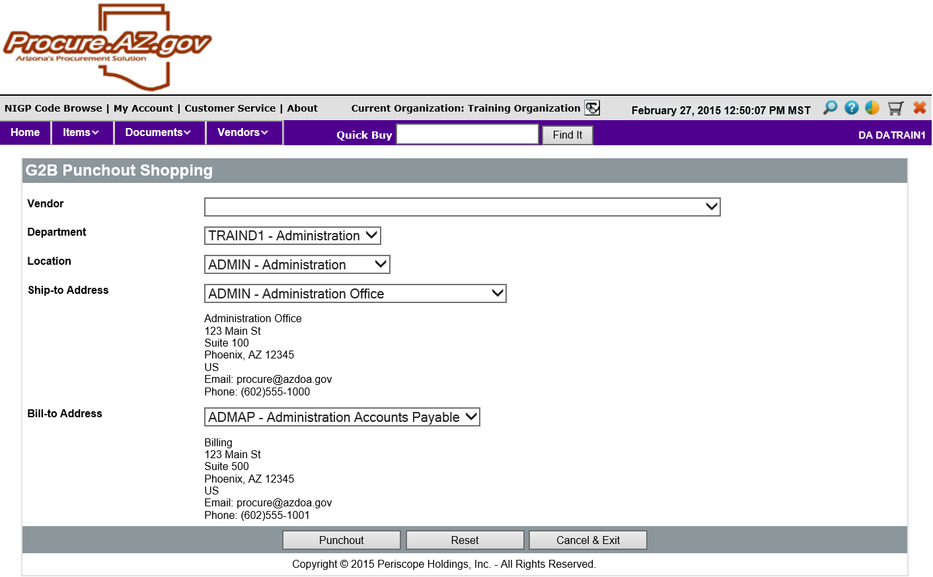

Vendors
The first field on the G2B Punchout Shopping screen is the Vendor drop down list. The list includes selected vendors that have an established purchasing contract with the State. Each vendor in the list has a customized website that will allow users to browse and select Items. If a vendor does not appear in the list, there is no G2B (Punchout) Master Blanket contract established with that vendor.

Department and Location
The Department and Location fields will default to the Department and Location assigned to the user. The drop down list for each field contains all Departments and Locations for which the user has been authorized. Users may need to change the Department and/or Location selected before creating the Punchout Requisition.

Ship-to and Bill-to Addresses
The Ship-to and Bill-to Address fields will default to the addresses configured for the default Department and Location. These can be changed by clicking the eyeglass icon next to each field and selecting the address in the Ship-to or Bill-to Lookup screen. If the Department and Location have been changed, the Ship-to and Bill-to addresses will not update automatically. Users may need to change the Ship-to and Bill-to addresses before creating the Punchout Requisition.
Punchout Requisitions cannot have different ship-to or bill-to addresses assigned for each line Item. All Items on one Punchout Requisition can only be shipped to one address and billed to one address.
TIP: The information on the G2B Punchout Shopping screen cannot be changed once the Punchout process has begun by navigating to the vendor’s website. It is important to verify the information on this screen before continuing the process.

Adding Items
When the fields on the G2B Punchout Shopping screen are complete, click the Punchout button to display the selected vendor’s website. The page displayed will look similar to the company’s public website, with the exception that only the Items and Pricing established under the State contract are available.

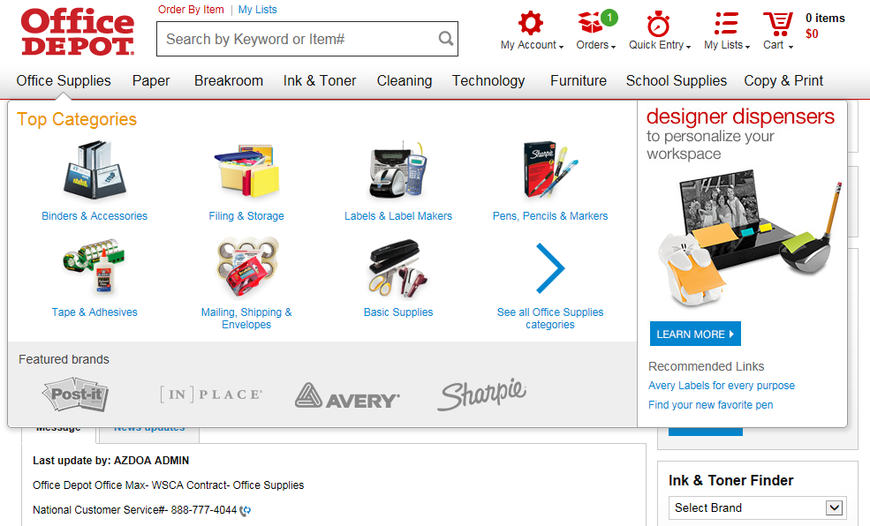

Each vendor website may have different navigation and/or search options available for the user. Typically, Items can be browsed by category or searched using a keyword or part number. Users can add and remove individual Items to/from the shopping cart and change quantities.

Check Out
When all Items have been added to the cart, users can proceed to the cart to check out.
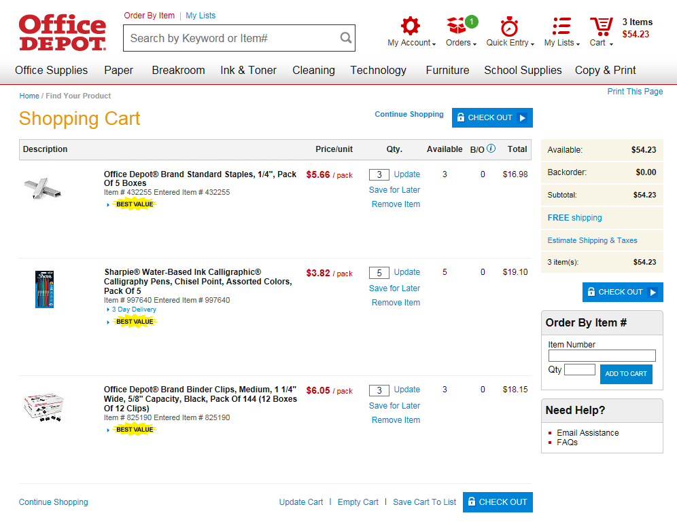

Clicking the respective Check Out button on the vendor’s website will close the vendor’s webpage and return the user to ProcureAZ with a new Requisition in progress that contains the Items selected. A warning message may be displayed that states that the website wants to close the current webpage. Click OK in the message box to return to ProcureAZ. The new Requisition document starts on the General tab.

General Tab
Creating documents in ProcureAZ is best done by completing each tab in the document from left to right, starting with the General tab. Some of the tabs on the Requisition document are populated based on the vendor and Items selected.
The Requisition General tab is used to enter detailed information that defines the document as a whole. There are several required fields on the General tab. Optional fields can be completed if applicable.
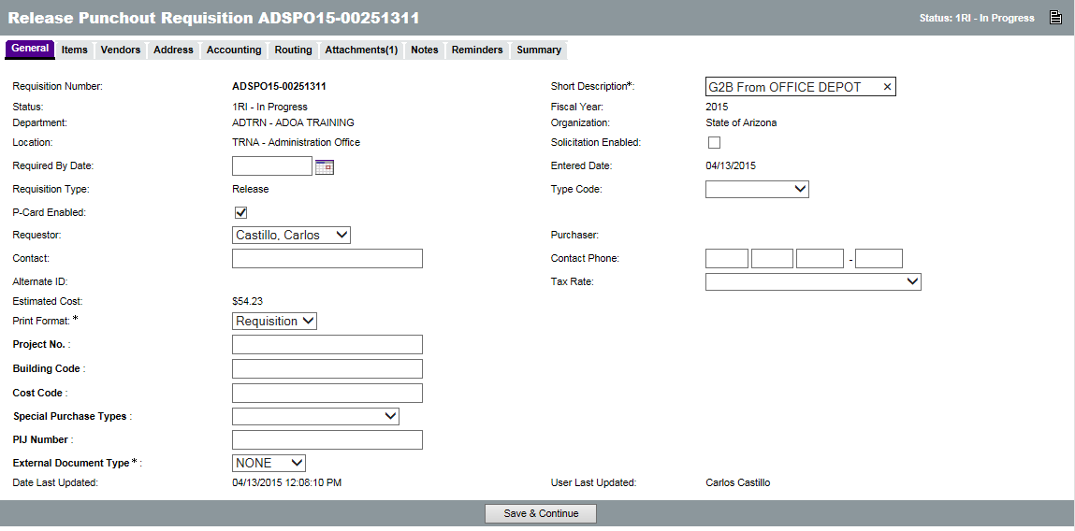
The new Requisition will have a Requisition Number assigned and a status of 1RI, Requisition In Progress, which means that it is currently being entered by the user. The Department and Location are displayed and cannot be changed from the values selected earlier. The Short Description field will default based on the vendor selected but should be modified by the user to contain a brief but sufficient description of the goods being purchased, for example, “Office Supplies for Payroll.” The Requisition Type on a Punchout Requisition is automatically set to Release. The rest of the fields are optional and can be entered or changed, if applicable. Two of the optional fields on the General tab are the Invoice Method field and P-Card Enabled check box.

Invoice Method
The Invoice Method field on the General tab is used to select whether Two Way or Three Way Match will be used for the Requisition/Purchase Order. Two Way Match is a new option available to specific users in ProcureAZ that requires a Purchase Order but does not require a Receipt to be entered before an Invoice can be processed. Selecting Three Way Match means that both a Purchase Order and a Receipt are required before an Invoice can be submitted. Three Way Match is the default Invoice Method and requires that the full documentation trail be created for a purchase.
New
Feature
TIP: Two Way Match is a role granted to specific users by their agency. If users do not have the Two Way Match role, they will not see the Invoice Method field and the Requisition/Purchase Order Invoice Method will default to Three Way Match.
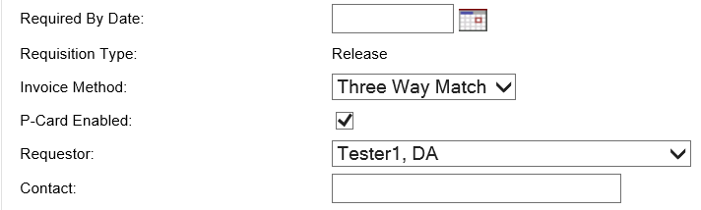

P-Card Enabled
The P-Card Enabled check box will default based on the Master Blanket contract setting. Requisition users will need to determine if a P-Card (Procurement Card) is being used as the payment method for the purchase. In order to use a P-Card to pay for a purchase, the Master Blanket must be configured as P-Card Enabled and the check box on the Requisition should be checked. If the Master Blanket contract is P-Card Enabled but the payment method needs to be by invoice/warrant, the P-Card Enabled check box on the Requisition should be unchecked.
TIP: The P-card enabled check box is not modifiable after approvals, so the Requisitioner needs to uncheck it immediately if the Punchout order is not going to be paid using the P-Card.

Save and Continue
When the General tab is complete, clicking the Save & Continue button at the bottom of the screen will save the current document and allow the user to continue filling out the rest of the document.
TIP: If the Requistioner forgets to click Save and Continue, the Punchout will be saved automatically. Forgetting to click Save and Continue on all other ProcureAZ tabs will not have the same result.

Saving the document will create the Punchout Requisition with an assigned Requisition Number which can be used to locate and reference the document. The document status will still be In Progress and it can be accessed and completed later, if necessary, by navigating to Documents > Requisitions > In Progress, or by searching for the Requisition number.
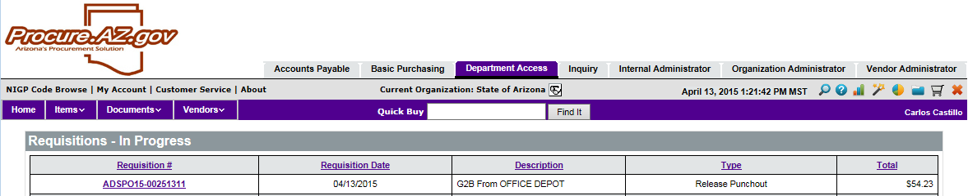

Items Tab
The Items tab displays the Items selected on the vendor’s website. The Items cannot be changed and additional Items cannot be added to the Requisition. Users should review the Items tab to make sure that all Items were applied correctly to the Requisition.
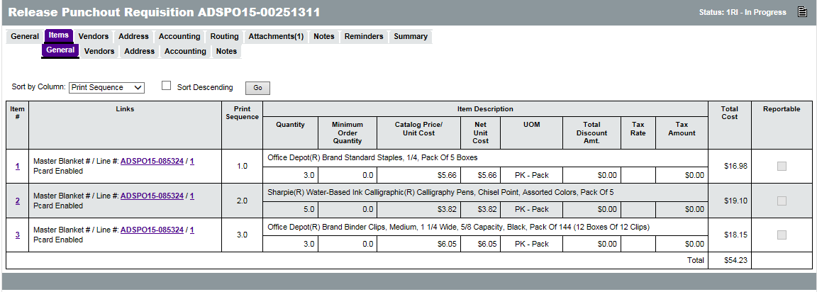

Vendors Tab
The Vendors tab displays the Vendor ID and name of the selected vendor. The vendor cannot be changed. The only change that users can make on the Vendors tab is to select a Vendor Remit-to Address for mailing a payment.
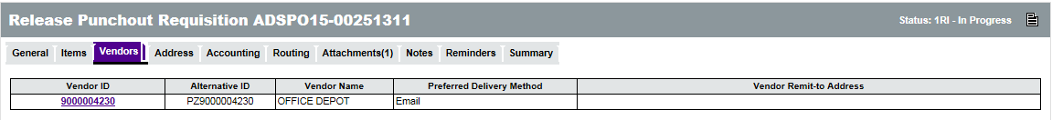

Address Tab
The Address tab displays the Ship-to and Bill-to Address selected earlier and cannot be changed. Users should review the Address tab to make sure that the address information is accurate.
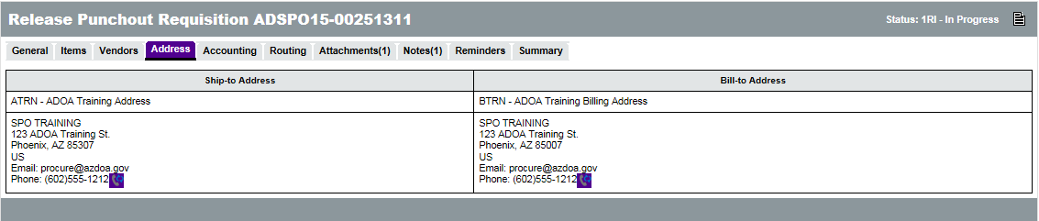

Accounting Tab
Account codes can be added at the document level on the Header > Accounting tab or at the individual Item level on the Items > Accounting tab. Account codes entered at the Header level will apply the same information to all of the Requisition Items. Account codes are required for all Requisition Items. Users will need to know the specific Account Codes for their Department, or enter the Budget Fiscal Year along with an Accounting Template or Function code that will infer the appropriate Account codes during the interface process with AFIS.
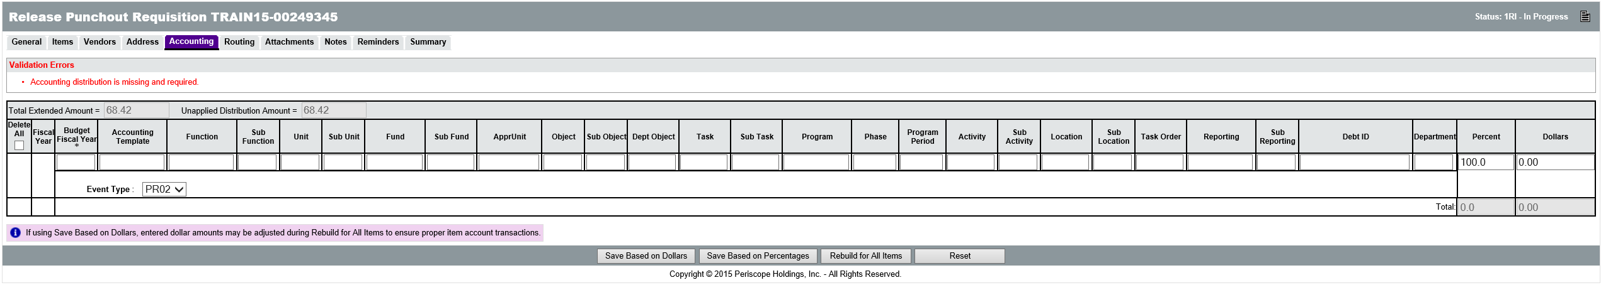
TIP: If no accounting information is available to the user, placeholder accounting codes can be entered temporarily. The correct accounting codes will need to be entered for the Items prior to applying the final approval to the Requisition.
The elements/segments that must be entered depends upon the accounting methodology selected by the agency. If the agency has adopted use of Accounting Template or Function codes, the user must enter:
  - Budget Fiscal Year
  - Either Accounting Template or Function
If neither Accounting Template nor Function code are entered, the user must enter:
  - Budget Fiscal Year
  - Unit
  - Fund
  - Appr Unit
  - Task
TIP These are the minimum requirements enforced by ProcureAZ. However, the fields required by AFIS vary dependent upon the Agency’s accounting methodology.

Object Code Inference
ProcureAZ requires that each Item being purchased can be identified using a five-digit NIGP code. Because of this established relationship, when users complete the Accounting tab on a Requisition, the Object code for each Item can be inferred based on the combination of NIGP code and dollar amount. If the user enters an Object code, ProcureAZ will not overwrite the code with an inferred Object code. The Object code will only be inferred if the field is left blank. During the inference process, if a matching Object code is found, it will be written to the Object field, but if no matching Object code is found, the field will be left blank and require input from the user before submitting the document to AFIS.
New
Feature
TIP: Users should refer to their agency’s policy regarding Object code usage. Users should enter an Object code if their agency has special expectations or usage for it.

Add Accounting to Header
On the Header > Accounting tab, the Accounting codes can be entered into their respective fields. At the far right of the page (scrolling is necessary) there are fields for entering the Percent or Dollar distribution for the Accounting line. If multiple Accounts are responsible for payment of the request, their responsibility amount can be entered as either a percentage of the total or a dollar amount. Only the Percent field or the Dollars field can be used but not both.
Entering a value into one field will automatically calculate the other when the changes are saved. If the Percent field is used, the Save Based on Percentages button will update the Dollars. If the Dollars field is used, the Save Based on Dollars button will update the Percent. The sum of the percentages must equal 100 and the sum of the dollars must equal the total amount of the cost of the Items on the request. The Unapplied Distribution Amount must always be 0.
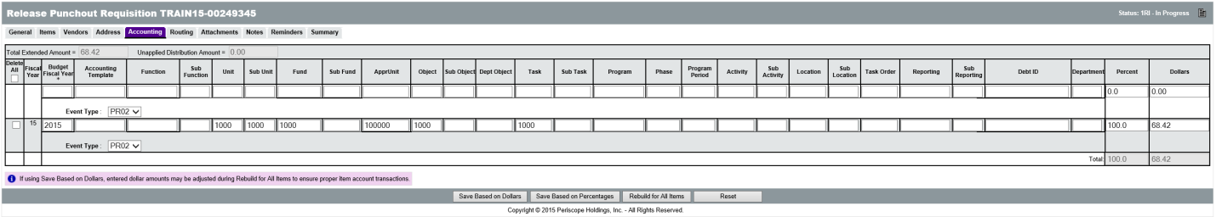
Once all Accounting information has been entered and the Unapplied Distribution Amount is 0, clicking the Rebuild for All Items button will apply the Accounting information to all of the Requisition Items.
At this point the document will be locked by ProcureAZ to perform several tasks and a system warning message will inform the user that the document is locked for editing. After locking the document, the Object code is inferred based on the Item’s NIGP code and a validation check is performed to ensure that all required information has been entered. Once the process is complete, a message box is displayed that informs the user that the page will be refreshed.
TIP: The Object code is only inferred if left blank. If an Object code has been entered, ProcureAZ will not overwrite the Object based on the NIGP code.

Add Accounting to Line Items
When Accounting codes must be different for each line item on the Requisition, the Items > Accounting tab must be completed.
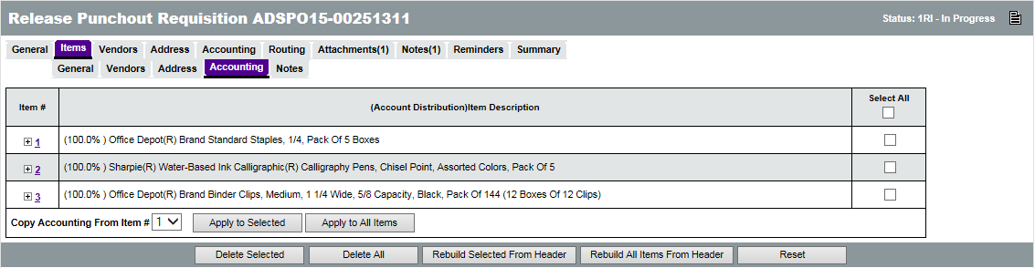
On this screen, each Item on the Requisition is displayed. Clicking the Item Number for an Item will display the same screen used on the Header, except that it applies only to the individual Item. The same Accounting information is required on this page and the Percent or Dollars fields can be used to distribute the cost of an Item across multiple accounts.
After entering the last Accounting line for an Item, but before saving, you can tell the system what to display after clicking one of the save buttons. The available options are: Current Page, Next Item, Previous Item, and Exit. Upon saving any changes, the system will lock the document for editing and perform the Object inference (if left blank) as well as the required field validation. A message box will be displayed when the document is ready to be refreshed.

Accounting Verification
Approvers can change the Accounting codes that have been entered during the approval process, if necessary.

Adding and Removing Attachments
The Header > Attachments tab is used to view any existing attachments and add new attachments to the Requisition. State Procurement Office administrators can add default attachments to all new Requisitions so there may be attachments on the document that you did not add. The Attachments tab will display the number of attachments on the document in parenthesis. For example, Attachments(2) means that there are 2 attachments on the Requisition.
There are two Attachment tabs, one for Agency uploaded documents, and one for Vendor uploaded documents. Agency users can only upload documents to the Agency tab. If the document should not be viewable by vendors, the Show Vendor check box should be unchecked (it is checked by default). Vendors can only upload documents to the Vendor tab.
TIP: Vendors never see a requisition so the vendor attachment tab is simply a placed holder. Vendors cannot add attachments directly to the requisition.

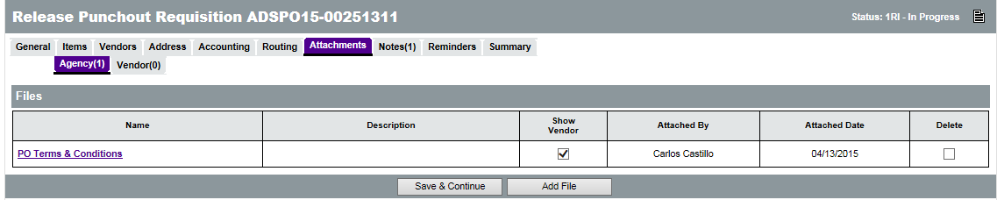
Any supporting documents for the purchase must be scanned and attached to the Requisition as specified by policy. This might include documentation such as specification sheets, scope of work reports, or hard copy quotes. All Requisitions must include specifications for goods or services and, if sufficient detail cannot be contained in the Item Description field, any appropriate supporting documents must be attached. It is important that any attached document name accurately describes the document.

Attaching a Document
On the Attachments > Agency tab, click the Add File button. On the Add File page, the Name field is the display name for the file that will appear wherever attachment repository files are displayed. The Name can be different than the name of the file and can contain alphanumeric characters, spaces, and special characters up to a maximum length of 200 characters. If no Name is entered, it will default to the file name. The Description field is optional but can be used to enter a longer description of the file, its purpose, or any notes/comments about the file.
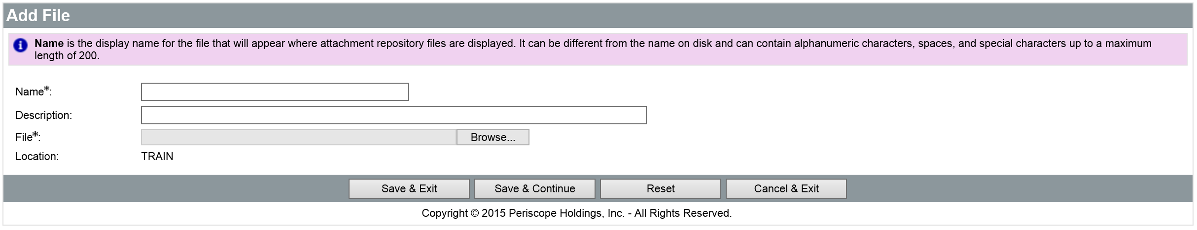
Clicking the Browse button will display a File Explorer window that allows the user to navigate to the folder location on the local machine or shared drive and select the file to upload. When the appropriate file has been selected, click Open in the File Explorer window to add the file path to the Attachment screen.
When all fields have been completed and the file has been selected, click the Save & Exit button to upload the file to ProcureAZ and attach it to the Requisition. To attach more files, click Add File.

Attachment Modification
On the Attachments > Agency tab, the Show Vendor check box determines whether the vendor can view the attachment and the Delete check box will delete the attachment from the Requisition. After changing either of these settings, click the Save & Continue button to apply the changes.
The Name of the file is a link to the file detail screen. On the Attachment File Detail screen, only the Description can be modified. The file can also be downloaded by clicking the Download icon. If the Description has been changed, save the changes by clicking the Save & Exit button.

Adding, Editing, and Deleting Notes
The Header > Notes tab is used to add notes about the Requisition document that are only visible to Organization users who access the document. Notes are entered in the Note field, which allows multiple lines of text to be entered. When one note is entered, clicking the Save & Continue button will save the note and add a new blank Note field for another note. Any notes that are saved to the document are stamped with the date they were added. Checking the Delete check box and clicking the Save & Continue button will remove the note from the document. The reset button will revert any changes made to the notes since the document was last saved. Like Attachments, the number of Notes added to the document will display in the tab name in the Header > Notes tab.
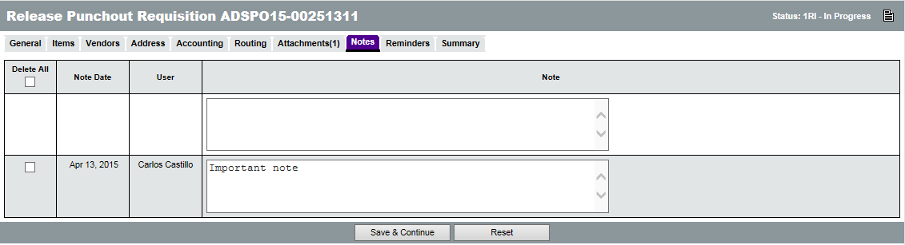

Item Notes
Notes can also be added to an individual Item on the Requisition on the Items > Notes tab. On this page, clicking the Item Number will display the same screen as the Header > Notes tab except that these Notes are added to a specific Item. Both header level and item level notes will follow on to the Purchase Order.

Managing Reminders
The Reminders tab on a Requisition is used to create automatic reminders that will notify a user prior to the due date of the Reminder. When there are no reminders, the first line is used to create a new reminder.

Create a Reminder
The Due Date field can be set to the date that the Requisition is due or any other date for which the user would like a reminder. The calendar icon can be used to select a date. The Comment field can contain text up to 250 characters and is used to type the reminder message that will be sent to the user. The Remind Whom field contains a drop down menu of all of the users in the system. Selecting a user from the list will notify that user based on the date settings on the reminder. The Days Prior to Remind field is used to specify the number of days, prior to the Due Date, that the user will be notified about the Reminder. If the Send Email check box is checked, ProcureAZ will send an email to the user with the reminder and comment.
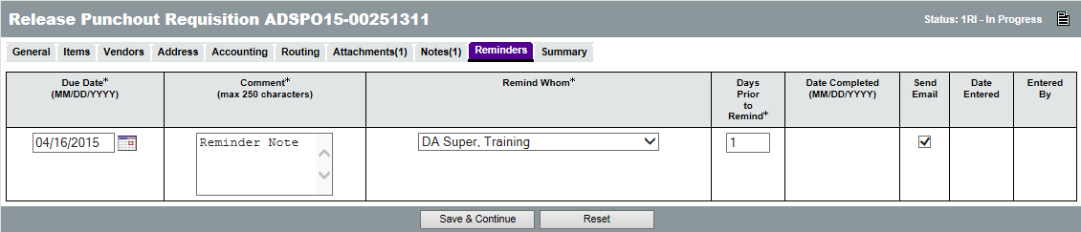

Modify and Delete Reminders
Existing Reminders can be edited and deleted on the Reminders tab of the Requisition. Only the user who added the reminder can remove it. If changes are made or the Delete check box is checked, clicking the Save & Continue button will apply the changes and/or deletions.

My Reminders
Any reminders that have been added for a user will display on that user’s My Reminders tab which is available on the Home Page. The My Reminders tab will display the number of current reminders in parenthesis. On the My Reminders page, reminders are separated into tabs by document type. The Reminder appears on the My Reminders page when the number of days prior to the due date has arrived. Reminders can be marked as complete by entering or selecting a date for the Date Complete field. This will remove the reminder from the My Reminders tab and mark the reminder as complete on the document.

Reviewing and Submitting the Requisition
The Summary tab displays all of the information on the Requisition. Any warnings or errors present in the document will be displayed at the top of the screen. Yellow warning messages will not prevent document submission but should be noted by the user. Red error messages will prevent document submission and must be addressed prior to submitting the document for review. The document creator should scan the Summary page to make sure that all data was entered correctly. Any necessary corrections can be made on the tab where that information was entered.
TIP: Before submitting the document for approval, users must verify the method of payment and make sure that the appropriate option is selected for P-Card Enabled for the Requisition.
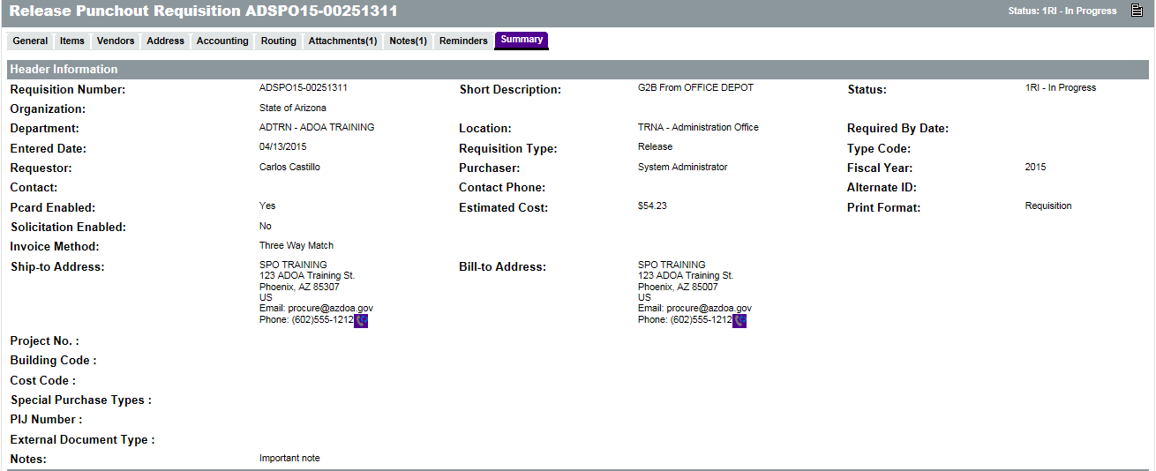
When all errors have been corrected and the Summary page has been reviewed, the document is ready to be submitted for approval. There are three buttons at the bottom of the Summary page:
  - Submit for Approval – Click this button to submit the Requisition for approval. The approval path that has been triggered by the document will appear.
  - Cancel Requisition – Click this button to cancel the Requisition. This will delete the Requisition from ProcureAZ. A warning pop-up window will ask you to confirm cancellation.
  - Print – Click this button to display a printable version of the document.

Submit For Approval
Click the Submit for Approval button. A dialog box pop-up will ask you to confirm submission of the Requisition, click OK. If there are approvals required and auto-cascading approval paths have been set up, the Approval Path screen will display the users that need to approve the document and the order of the approvals. For non-auto cascading approval paths, users will need to select the appropriate path for the document. If no approval paths are found for the document, the document moves to the next status.
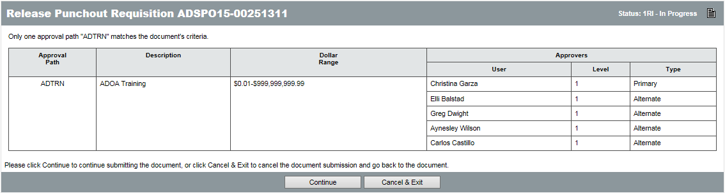
The Continue button will send the Requisition to the first approver in the Approval Path. Until the Continue button is clicked the document will remain in an In Progress status. Clicking the Cancel & Exit button will cancel document submission and return to the Summary tab of the document.
When the Continue button is clicked, if document submission is successful, a message will be displayed at the top of the screen stating that the transaction was successful. Any warning or error messages generated by the submission will also be displayed.

Activity 3.1

Create a Punchout Requisition
Scenario
You need to request the purchase of batteries for your Department. The batteries are covered under a Master Blanket contract with access to a Punchout vendor website so you will create a Punchout Requisition for the Items and submit it for approval.
Setup
- User is logged in to the ProcureAZ home page as a user with the Requisitioner role.
Steps
- Create the new Requisition document.
  - In the Header Bar, click the Shopping Cart icon.
  - On the G2B Punchout Shopping page, in the Vendor field, select the Company on your Training Card.
  - Click the Punchout button.
- Select the Item on the website.
  - On the Company website, click Tools & Equipment.
  - Click Flashlights and Batteries.
  - Click Batteries.
  - For the first item on the page, click the Add to Cart button.
  - At the top of the page, click My Cart.
  - On the Shopping Cart page, change the Quantity to 4.
  - Click Check Out.
  - On the Order Confirmation page, click Complete Checkout.
  - In the dialog box, click Yes to close the vendor’s website.
- Complete the Release Punchout Requisition.
  - On the General tab, in the Short Description field, enter Batteries for Training.
  - Verify that the P-Card Enabled check box is checked.
  - Click the Save & Continue button.
  - On your Training Card, write down the Requisition Number that has been assigned to the Requisition in the space provided for Activity 3.1.
  - Click the Items tab.
  - Review the Item listed.
  - Click the Vendors tab.
  - Review the vendor listed.
- Complete the Accounting tab.
  - Click the Accounting tab.
  - In the Budget Fiscal Year field, enter the current Budget Fiscal Year.
  - In the Unit field, enter the Unit on your Training Card.
  - In the Fund field, enter the Fund on your Training Card.
  - In the Appr Unit field, enter the Appr Unit on your Training Card.
  - In the Object field, enter the Object on your Training Card.
  - In the Task field, enter the Task on your Training Card.
  - Click the Save Based on Percentages button.
  - Click the Rebuild for All Items button. The document will need up to a minute to process the new accounting information.
  - When the process is complete, click the OK button in the dialog box that appears.
- Review and submit the document for approval.
  - Click the Summary tab.
  - Review all of the information on the document.
  - Click the Submit for Approval button.
  - In the dialog box, click OK.
  - Optional: On the Approval Path screen, click the Continue button. This will submit the order to the vendor. Only submit the order if the training system will not send it to the vendor.

Note: If the Requisition is submitted, the Trainer will need to process the disapproval of each submitted document before beginning the next activity.

  - Check the Status of a Punchout Requisition
The status of a Requisition can be monitored at any point in the document lifecycle. The Home Page displays tabs for all document types accessible by the user profile.

Checking the Status
The Reqs tab is used to view Requisitions saved in ProcureAZ and contains sub-tabs for each document status. Each tab name contains the number of documents displayed on that tab in parenthesis. For example, Ready for Approval (4) means that there are 4 Requisitions awaiting approval. If the document has been submitted for approval, it will move to the Ready for Approval tab.
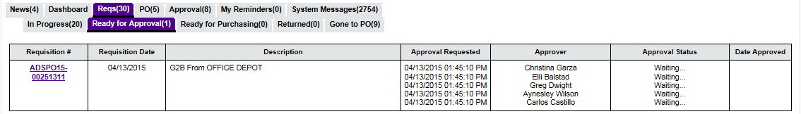
On the Ready for Approval tab, any Requisitions that are awaiting approval are displayed along with the Approval Requested date, the Name(s) of the Approver(s), the Approval Status, and the Date Approved. Clicking the Requisition document number will open the document for review. On a Ready for Approval document, Notes can be added to the document by any user with access to the document and the Accounting information can be modified, but only by the current approver.
If the document is disapproved for any reason, it will change to Returned status and the creator will be notified by email that the document has been disapproved.

Correcting Returned Requisitions
Any disapproved Requisitions that you created will be displayed on the Reqs > Returned tab. Clicking the Requisition document number will open the document to the Summary tab. The Approval Paths section at the bottom of the Summary tab displays the Approval Actions that have been applied to the document. If the approver added any comments to the document when they disapproved it, they will be displayed in the Approval Path section. The options at the bottom of the Summary tab allow the document creator to reopen, cancel, or print the Requisition.
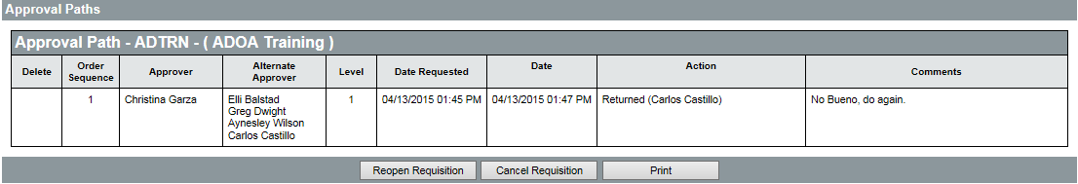

Reopen Requisition
When a document has been returned, it may be necessary to follow up with the Approver in order to make sure that any issues preventing approval are properly addressed before resubmission. Only the Accounting information on the Punchout Requisition can be changed. If changes are required and allowed, on the Summary tab, click the Reopen Requisition button to change the status of the document to In Progress and enable document modification.

Changes to Items
Items on a Punchout Requisition cannot be changed once they have been selected from the vendor’s website. If the Requisition Items are not correct, the Requisition document must be canceled and a new Requisition must be created.

Cancel Punchout Requisition
Only the creator or a user with the Basic Purchaser role can cancel a Punchout Requisition. The Cancel Requisition button is located on the Summary tab of the Requisition and will cancel the Requisition completely. Once the Requisition has been canceled, a new Requisition can be created with the correct information and submitted for approval if necessary.
TIP: Punchout Requisitions cannot be cloned. If a requisition needs to be created the user will have to start from scratch.

Activity 3.2

Check Requisition Status and Cancel Returned Requisition
Scenario
You want to check on the status of the Requisition you submitted. The Requisition you created in the previous activity has been returned because the wrong tools were selected on the vendor’s website. You will cancel the returned Requisition.
Setup
- User is logged in to the ProcureAZ home page as a user with the Requisitioner role.
Steps
- Review the approval status of the recently submitted Requisition documents.
  - In the Home section, click the Reqs tab.
  - Click the Reqs > Ready for Approval tab.
  - Observe the documents listed on the Ready for Approval tab.
- Locate and open the Returned document.
  - Click the Reqs > Returned tab.
  - Locate the Requisition document number that you wrote down on your Training Card in Activity 3.1.
  - Click the Requisition document number to open the document.
  - Review the Approver comments in the Approval Paths section.
- Reopen the Requisition for modification.
  - At the bottom of the Summary tab, click the Reopen Requisition button.
  - Observe the System Warning message that the Requisition is being processed.
  - When processing is complete, in the dialog box, click OK.
- Cancel the Requisition.
  - On the Summary tab of the Requisition, click the Cancel Requisition button.
  - In the dialog box, click OK.

  - Punchout Purchase Orders
The next step in the Punchout lifecycle is the conversion from an approved Requisition to a Purchase Order. Purchase Orders are documents that are used to purchase goods or services. Purchase Orders are used to communicate the details of a purchase to both the vendor and any internal departments that need to know about the purchase.

Punchout Purchase Order Creation
Once the Requisition has received the final approval, a Purchase Order is created automatically with a status of Ready to Send. The creator of the Requisition will receive a notification that the Requisition has been approved and that a Purchase Order has been created and needs to be sent to the vendor. Only the user that created the request can send it to the vendor.
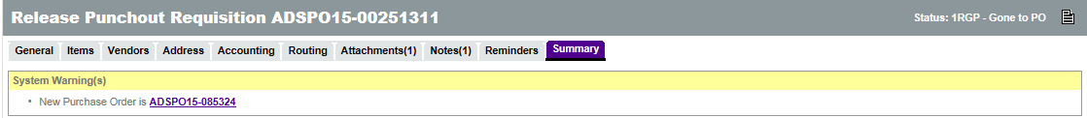

Sending to Vendor
The automatically created Purchase Order is sent to the vendor electronically. As the requestor, open the Purchase Order document to the Summary tab. At the bottom of the page, in the Vendor Notification Actions section, click the Save & Continue button to send the PO to the vendor.
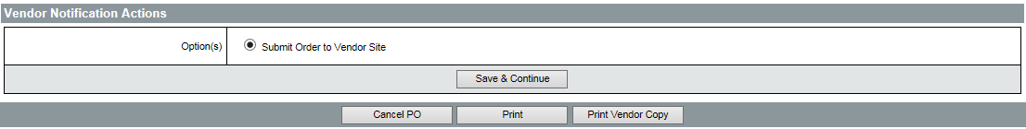

Punchout Purchase Order Change Orders
Change Orders are not permitted for Punchout Purchase Orders. A new Requisition with the correct information must be created and approved if changes are required.

Cancel Punchout Purchase Order
Prior to sending the purchase order to the vendor, the PO can be canceled by clicking the Cancel PO button. Once the Punchout Purchase Orders has been Sent to the Vendor, it cannot be canceled directly. In order to cancel a Punchout Purchase Order, a cancellation Receipt must be created for the PO. Additionally, since the cancellation Receipt information is not transmitted to the vendor, the vendor must be notified via phone call of the cancellation. For more information on Receipts, refer to Lesson 10 Receiving Items and Services.
Note: There will not be a Punchout Purchase Order in the system for each student unless the training system is setup to allow processing and conversion from Requisition to Purchase Order.

NOTE: The State’s integration methodology excludes P-Card transactions. Please consult with your agency regarding their P-Card processing expectations in AFIS.

Lesson Summary
In this lesson you:
- Created a Punchout Requisition
- Checked the status of Requisitions and corrected Returned Requisitions
- Reviewed the Punchout Purchase Order process

Check Your Progress
- Punchout Requisitions are created to purchase Items __________.
  - Off Contract
  - On Contract via vendor website
  - On Contract via telephone
  - On Contract via catalog
- After proceeding through the Check Out process, additional Items can still be added to a Requisition.
  - True
  - False
- Orders can be paid for by _________.
  - Warrant
  - P-Card
  - Neither of the above
  - Both a and b
- Punchout Purchase Orders are created ___________.
  - By the Requestor after approval
  - By the Buyer after approval
  - By clicking the Create PO button on an approved Requisition
  - Automatically by the system

