4 On Contract
Release

This page was intentionally left blank.
Contents
4. On Contract Ordering – Release Requisition 1
Learning Objectives 1
Lesson Overview 1
4.1. Create a Release Requisition 2
General Tab 2
Invoice Method 3
P-Card Enabled 3
Save and Continue 3
Adding Items 4
Search Items 4
Add Items 5
Adding Freight Items 6
P-Card Enabled 7
Modify Items 7
Vendors Tab 7
Address Tab 8
Apply Addresses on Header 8
Apply Addresses on Line Items 8
Accounting Tab 9
Object Code Inference 10
Add Accounting to Header 10
Add Accounting to Line Items 11
Accounting Verification 11
Adding and Removing Attachments 12
Attaching a Document 12
Attachment Modification 13
Adding, Editing, and Deleting Notes 13
Item Notes 14
Managing Reminders 14
Create a Reminder 14
Modify and Delete Reminders 15
My Reminders 15
Reviewing and Submitting the Requisition 15
Submit For Approval 16
Routing 16
Activity 4.1 17
Create a Release Requisition 17
4.2. Check the Status of a Release Requisition 20
Checking the Status 20
Correcting Returned Requisitions 20
Reopen Requisition 21
Activity 4.2 21
Check Requisition Status and Correct Returned Requisition 21
4.3. Release Purchase Orders 23
Direct Release Purchase Orders 23
Standard Release Purchase Orders 23
Release Purchase Order Integration to AFIS 24
Activity 4.3 26
Review a Release Purchase Order 26
4.4. Cancel or Clone a Release Purchase Order and Requisition 27
Cancel a Release Purchase Order 27
Cancel a Release Purchase Order Using a Receipt 28
Cancel a Release Requisition 28
Clone a Release Purchase Order 28
Clone a Release Requisition 29
Activity 4.4 30
Clone and then Cancel a Release Requisition 30
Lesson Summary 32
Check Your Progress 33

- On Contract Ordering – Release Requisition

Learning Objectives
In this lesson, you will:
- Create a Release Requisition
- Check the status of a Release Requisition and correct a returned Requisition
- Review a Release Purchase Order
- Cancel a Release Purchase Order and Requisition
- Clone a Release Requisition

Lesson Overview
This lesson introduces the on-contract release ordering process in ProcureAZ. This process begins with the creation of a Release Requisition document on which Item and accounting information is entered. Following the submission and approval of a Release Requisition, a Release Purchase Order is created.
This lesson also reviews the document cancellation and cloning processes. In the activities, users will gain work-applicable experience in the ProcureAZ training environment by navigating and creating the various documents in the Release lifecycle.

  - Create a Release Requisition
Release Requisitions are used to request the purchase of goods or services that are available on an existing contract. The creator of the document must have the Department Access Requisitioner role designation. The Items are added to the Requisition by searching for a contract or contract items and selecting the desired Items. Submission of a Standard Release will route the Release to a Basic Purchaser for approval. Approval of a Release Requisition typically results in the creation of a Purchase Order ready for the creator to send to the vendor.
The process of creating a new Release Requisition begins by using the menu in the Header Bar to select Documents > Requisitions > New. This will display the New Requisition document General tab. It is recommended that documents are completed by following the tabs from left to right.

General Tab
The Requisition General tab is used to enter detailed information that defines the document as a whole. There are several required fields on the General tab. Optional fields can be completed if applicable.
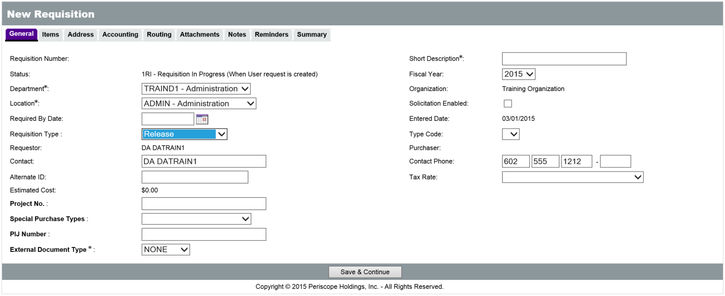
The new Requisition will have a status of 1RI, Requisition In Progress, which means that it is currently being entered by the user. The Department and Location fields contain drop down menus for selection, but these fields will default to the values stored in the user’s profile. The Short Description field is required and should contain a brief but sufficient description of the goods or services being purchased, for example, “Office Supplies for Payroll.” The Requisition Type field contains a drop down menu for the type of Requisition, and should be set to Release. The rest of the fields are optional and can be entered or changed, if applicable. One of the optional fields on the General tab is the Invoice Method field.

Invoice Method
The Invoice Method field on the General tab is used to select whether Two Way or Three Way Match will be used for the Requisition/Purchase Order. Two Way Match is a new option available to specific users in ProcureAZ that requires only a Purchase Order and an Invoice to be created when invoicing. Selecting Three Way Match means that invoicing will require a Purchase Order, a Receipt, and an Invoice. Three Way Match is the default Invoice Method and requires that the full documentation trail be created for a purchase.
New
Feature
TIP: Two Way Match is a role granted to specific users by their agency. If users do not have the Two Way Match role, they will not see the Invoice Method field and the Requisition/Purchase Order Invoice Method will default to Three Way Match.
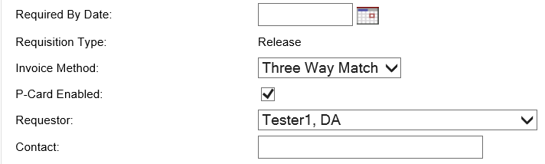

P-Card Enabled
The P-Card Enabled check box will only appear on the General tab of a Release Requisition if the selected Items are purchased from a vendor that accepts P-Cards. Requisition users will need to determine if a P-Card (Procurement Card) is being used as the payment method for the purchase and return to the General Tab after selecting the Items on the Items tab to update this setting. In order to use a P-Card to pay for a purchase, the Release must be configured as P-Card Enabled and the check box on the General tab of the Requisition should be checked. If the contract is P-Card Enabled but the payment method needs to be by invoice/warrant, the P-Card Enabled check box on the Requisition should be left unchecked.

Save and Continue
When the General tab is complete, clicking the Save & Continue button at the bottom of the screen will save the current document and allow the user to continue filling out the rest of the document.
Saving the document will create the Release Requisition and assign a Requisition Number which can be used to locate and reference the document. The document status will still be In Progress and it can be accessed and completed later, if necessary, by navigating to Documents > Requisitions > In Progress, or by searching for the Requisition number.
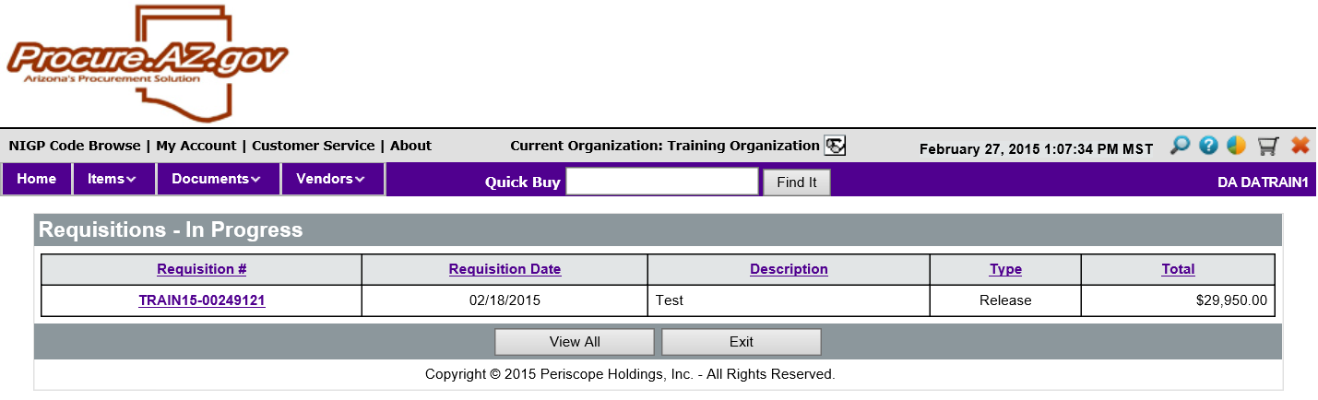

Adding Items
On the Items tab, the Search Items button is used to locate Items that can be added to the Requisition. Only Items that are listed on a Master Blanket contract/PO can be added to a Release Requisition. Item information, such as price and unit of measure, for contract Items that have been added to the Requisition cannot be modified. Once added to the Requisition, depending on the type of contract Item, only certain fields may be modifiable. For contract Items with a specified price, only the Quantity and the line Item description can be changed. For contract Items purchased based on a quote from a vendor, the quantity should be set at 1, and the total price of the line must be entered along with any quoted discount, if applicable. When pricing is based on a quote, the quote has to be attached to the Requisition on the Attachments tab.

Search Items
Click the Search Items button to display the Search Items page. There are two ways to search for Items: the keyword search field and the Advanced Search criteria section.
For a keyword search, enter the keyword into the Search Using field and click the Find It button. All search results that contain the keyword will be displayed below.
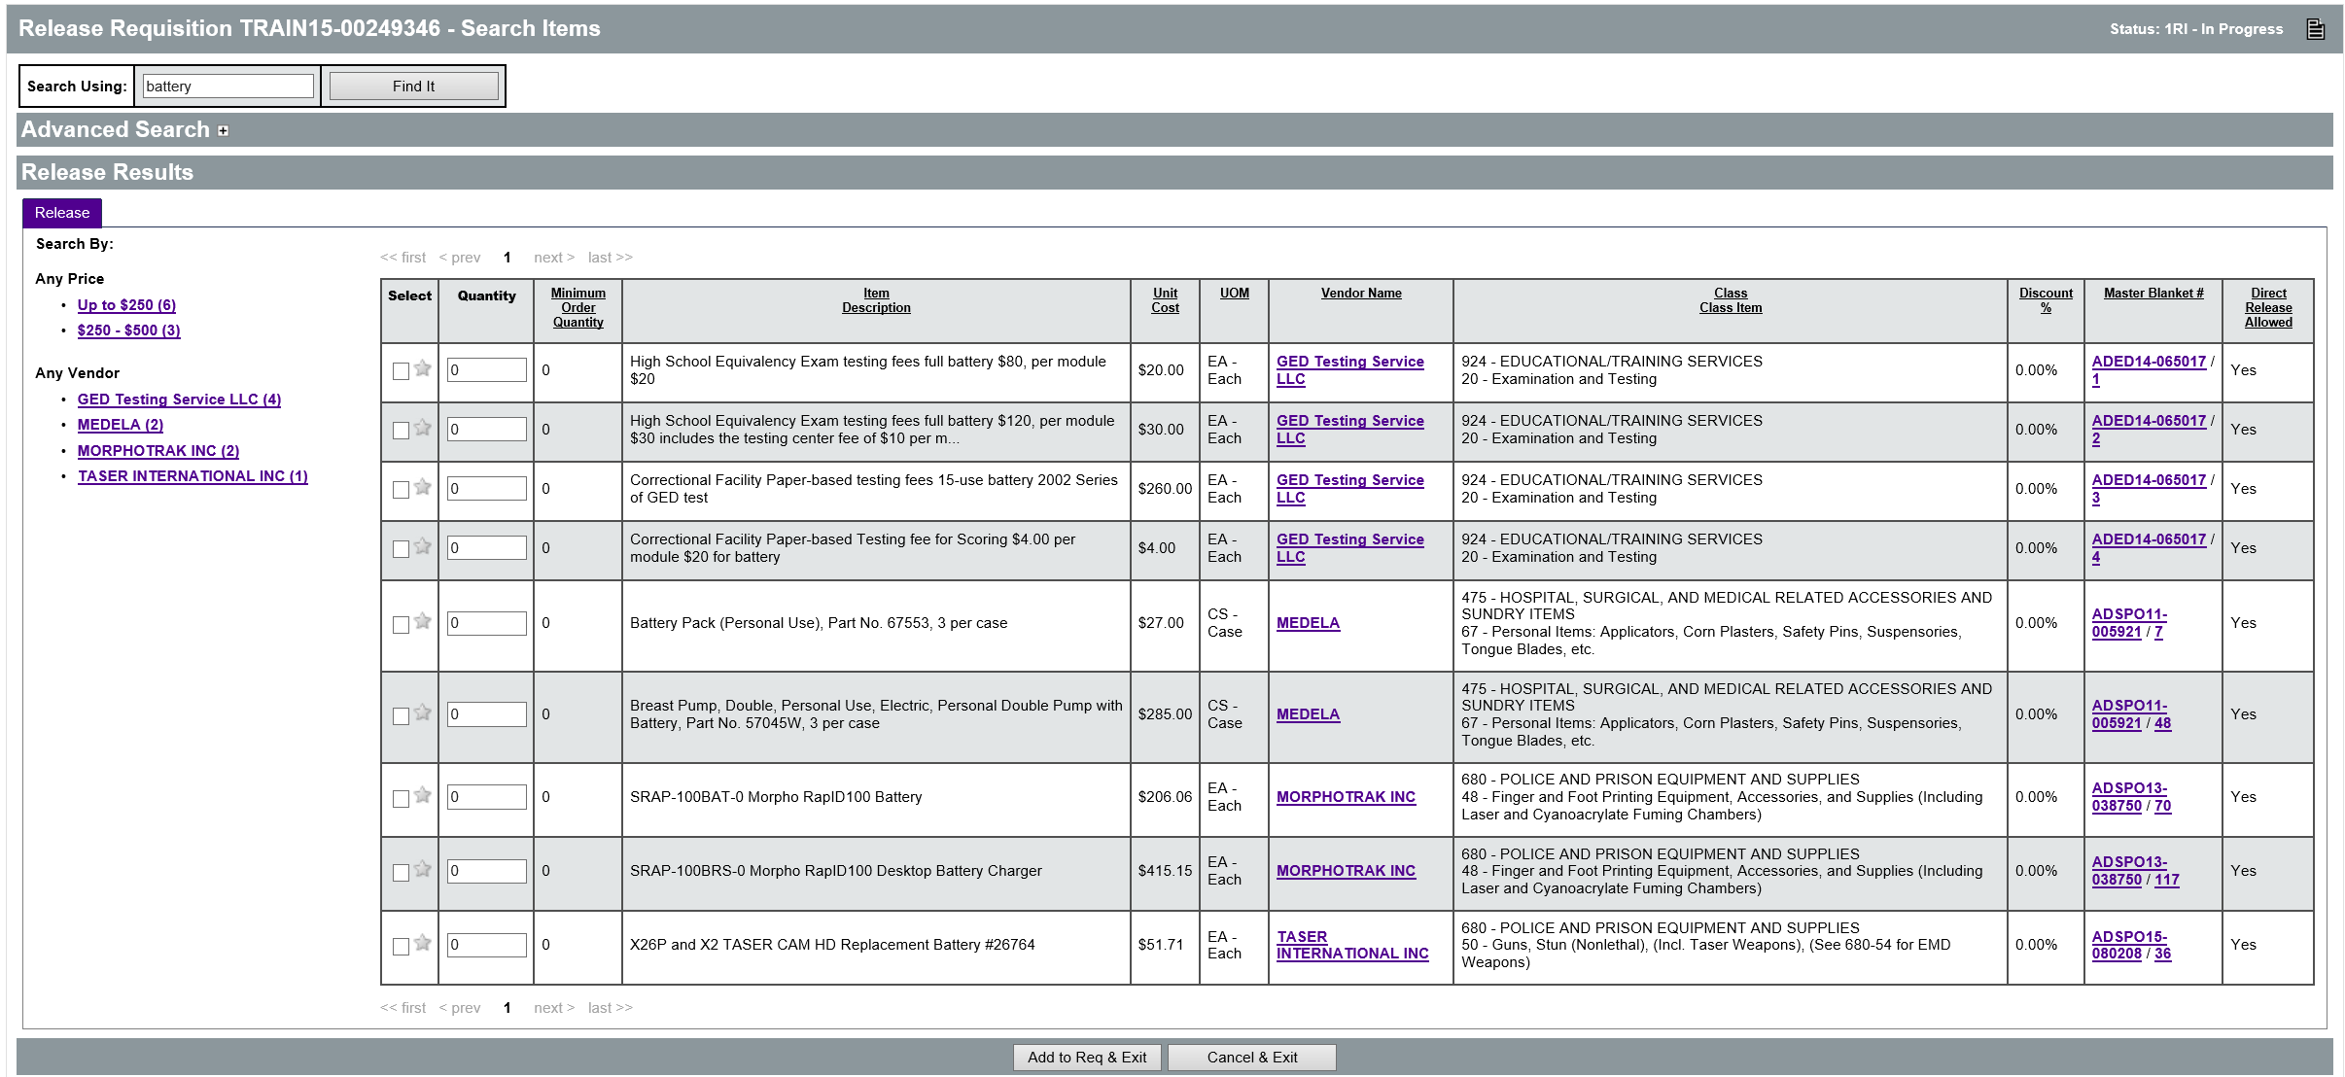
To use the Advanced Search criteria section, expand the section to view the fields. The recommended way to add Items is to use Advanced Search to search by Contract/PO #. Enter the number provided on the contract and click the Find It button to display all of the Items on that contract.
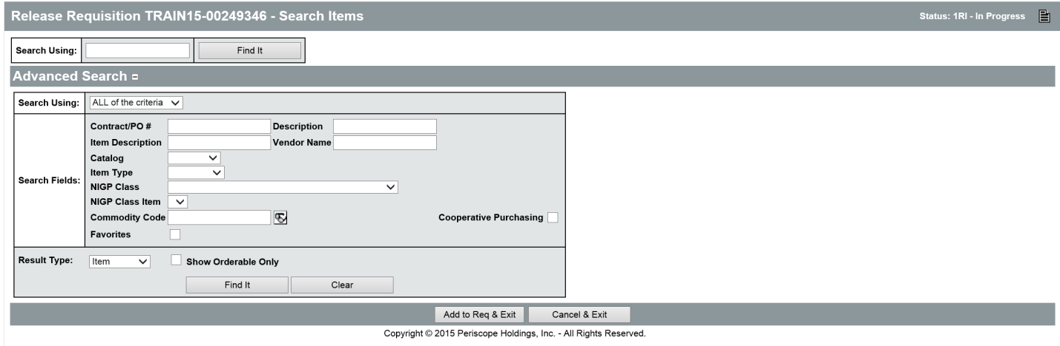

TIP: The Search Using (keyword, Item Description (advanced search) and Quick Buy (top of screen) all search for matches within the Item Description field

Add Items
In the search results, locate the desired Item and enter the Quantity to be ordered. For service Items and Items purchased based on a quote from a vendor, the quantity selected should be 1. Users can also add the selected Item to their Favorites by clicking the Star in the left column. Once a Quantity has been specified for all desired Items, click the Add to Req & Exit button.
TIP: Clicking the Star will add the item to your list of favorites. This can be useful when you repeatedly purchase items. When searching for items you use favorites as a search criteria.

The Requisition Items tab will display the selected Items along with their price and other information.
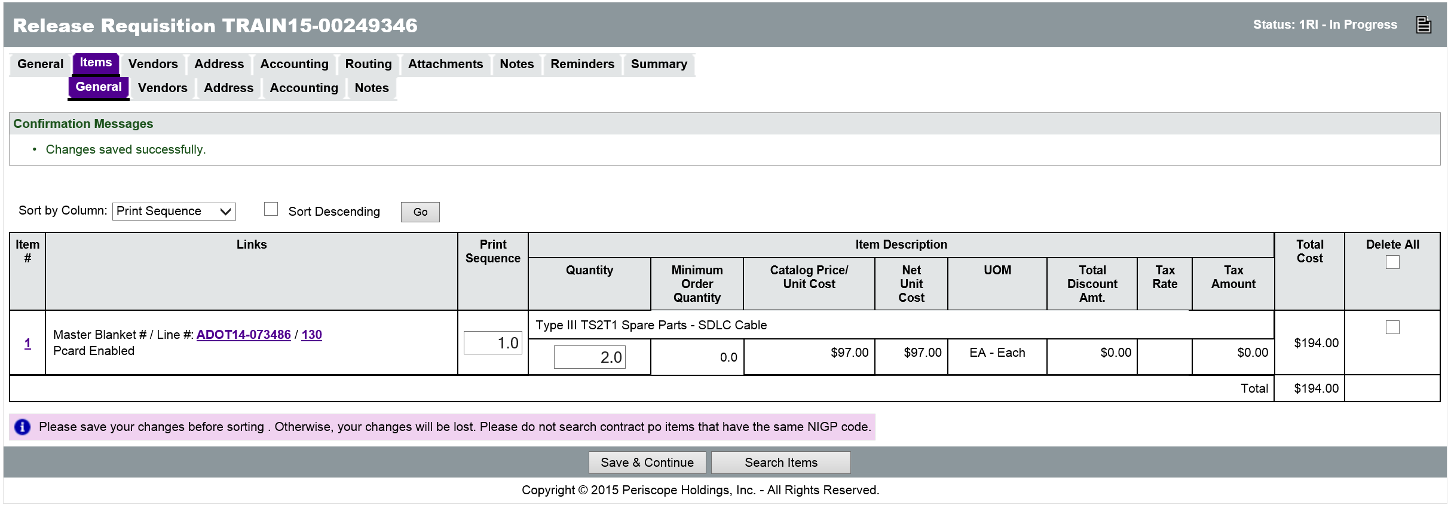
For service Items or Items chosen from an attached pricesheet/catalog or quote from a vendor, an Enter Info link will appear in the Catalog Price/Unit Cost field. Click the link to open the Item details page. On the Item details page, add the necessary information, including the Total Cost in the Unit Cost field, and enter the discount percentage if applicable. When finished, click the Save & Exit button.

Adding Freight Items
If Freight needs to be encumbered on the Release, the Freight Item for the selected vendor must be added to the Requisition and the amount added.
New
Feature
After adding goods to the Requisition, click the Search Items button, and perform a search based on the vendor providing the Items selected. Locate the Freight Item for that vendor, and change the Quantity to 1. Add the Freight Item to the Requisition by clicking the Add to Req & Exit button. The cost of the Freight must be added manually. On the line Item for Freight, click the Enter Info link to display the Item details page. In the Catalog Price/Unit Cost field, enter the cost of the Freight. When finished, click Save & Exit.

P-Card Enabled
Once Items have been added to the Release Requisition, the user must return to the General tab and update the setting for P-Card Enabled. If the purchase will be paid for with a Procurement Card, the box needs to be checked.

Modify Items
Items that have been added to the Requisition can have their Quantity and Description and tax rate changed and can be removed from the Requisition completely by checking the Delete check box for the Item or for all Items in the right column. Freight charges can be modified, if necessary, by clicking the Item # in the left column to open the Item details page and updating the cost in the Catalog Price/Unit Cost field. Items that required the user to enter the pricing info allow the user to modify the quantity, cost, and unit of measure on the Item details page. If any changes are made to the Items on the Items tab, click the Save & Continue button to save the changes before changing tabs or navigating to a different page.
TIP: Items that need the pricing entered show an ‘Enter Info’ link in the Catalog Price/Unit Cost field. The quantity and unit of measure is also modifiable for this type of item.

Vendors Tab
On the Vendors tab, the vendors will already be selected based on the Items that have been added to the Release Requisition. Changes are not required on the Vendors tab, unless the Remit-to address for a vendor needs to be selected. The Vendor Remit-to Address field provides a drop down list for selecting the correct address on file for sending documents to the vendor. If any changes are made on the Vendors tab, click the Save & Continue button before changing tabs or navigating to a different page.
TIP: The remit address is included on the PO sent to the vendor. If you choose the wrong remit address, it cannot be changed/corrected on the PO after it is sent. The AP staff is able to change the remit address when they create the Invoice.

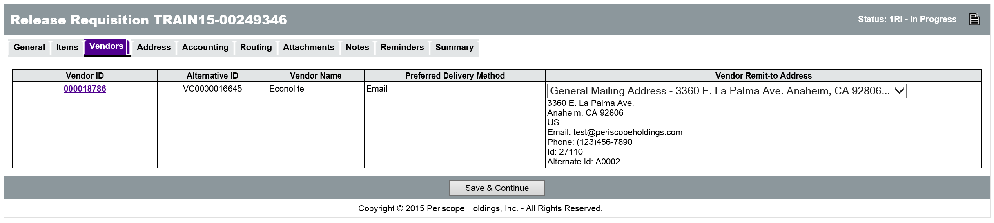

Address Tab
Address information can be modified at the document level on the Header > Address tab or at the individual Item level on the Items > Address tab. Address information entered at the Header level will apply the same information to all of the Requisition Items. A Ship-to and Bill-to address is required for all Requisition Items.
If the Department selected on the Header > General tab has a default Ship-to and Bill-to Address assigned, then those addresses will automatically populate the Header > Address tab on the Requisition. If the Department selected has multiple Ship-to or Bill-to Addresses configured, and they need to be changed at the document level, the Header > Address tab is used to apply the change. If the addresses need to be changed at the individual Item level, the Item Address tab is used to apply the change.

Apply Addresses on Header
All available addresses for the selected Department will appear in the drop down list for the Ship-to and Bill-to Address fields. If the address for the either the Ship-to or Bill-to Address has been changed, click the Save & Continue button to apply the change at the Header level, then click the Apply Ship-to to All Items button and/or the Apply Bill-to to All Items button to apply the change to all of the Requisition Items Ship-to and/or Bill-to Addresses respectively.
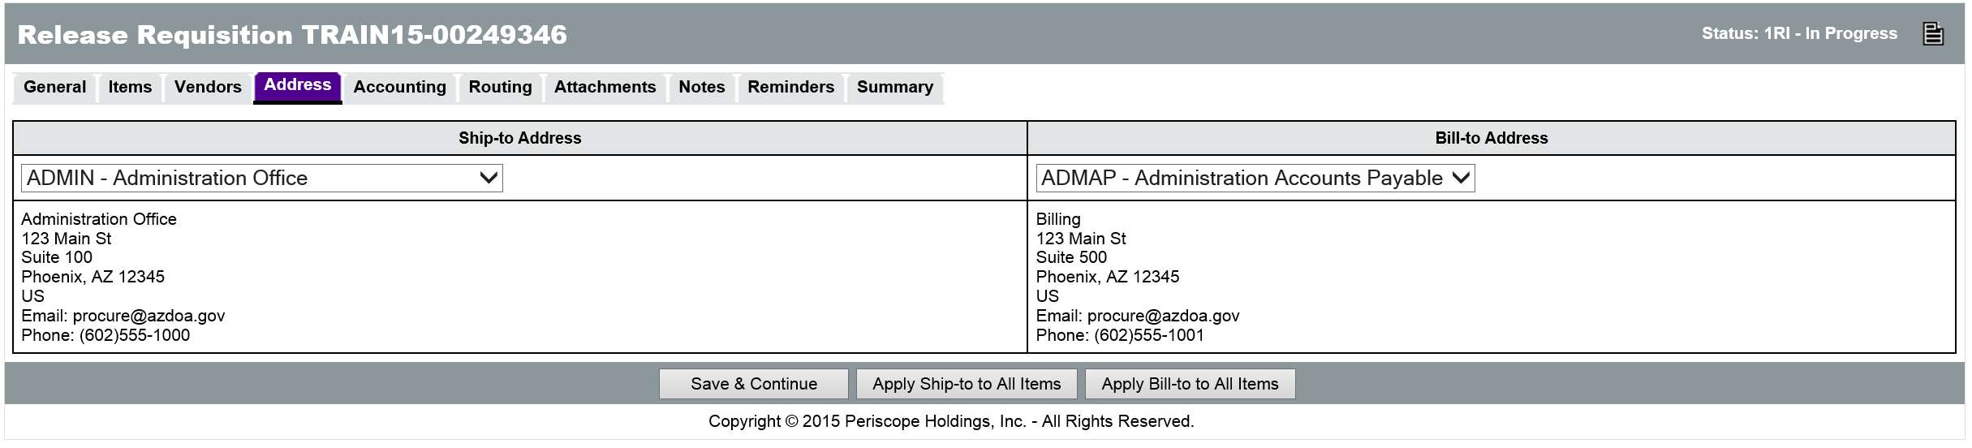

Apply Addresses on Line Items
If Items need to be shipped to different addresses, or if vendors need to send invoices to different addresses for different Items, then use the Items > Address tab to select the addresses for each Item. To apply a different address to multiple Items simultaneously, select the Items and use the Ship-to or Bill-to Address fields at the bottom of the page to select a different address. The Apply to Selected button will apply the selected address to the selected Items. The Apply to All Items button will apply the selected address to all of the Requisition Items. The Reset Selected to Header button will change any Ship-to or Bill-to Address to match the address on the Header > Address tab. When changes are complete, click the Save & Continue button to save the changes.
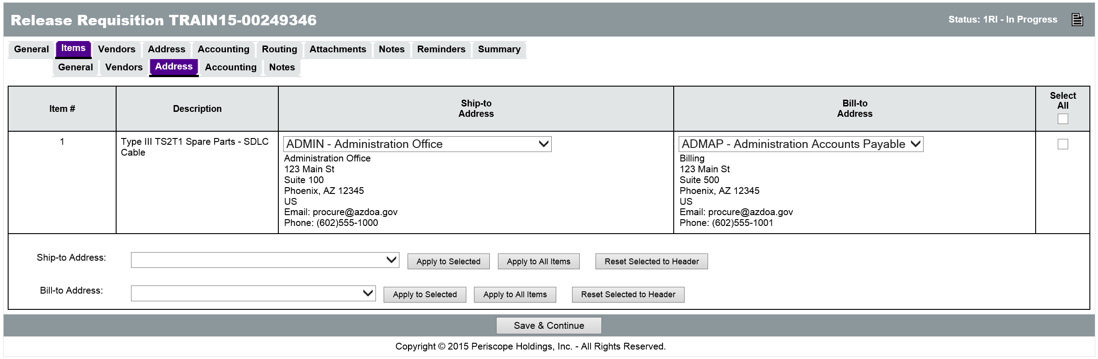

Accounting Tab
Account codes can be added at the document level on the Header > Accounting tab or at the individual Item level on the Items > Accounting tab. Account codes entered at the Header level will apply the same information to all of the Requisition Items. Account codes are required for all Requisition Items. Users will need to know the specific Account Codes for their Department, or enter the Budget Fiscal Year along with an Accounting Template or Function code that will infer the appropriate Account codes during the interface process with AFIS.
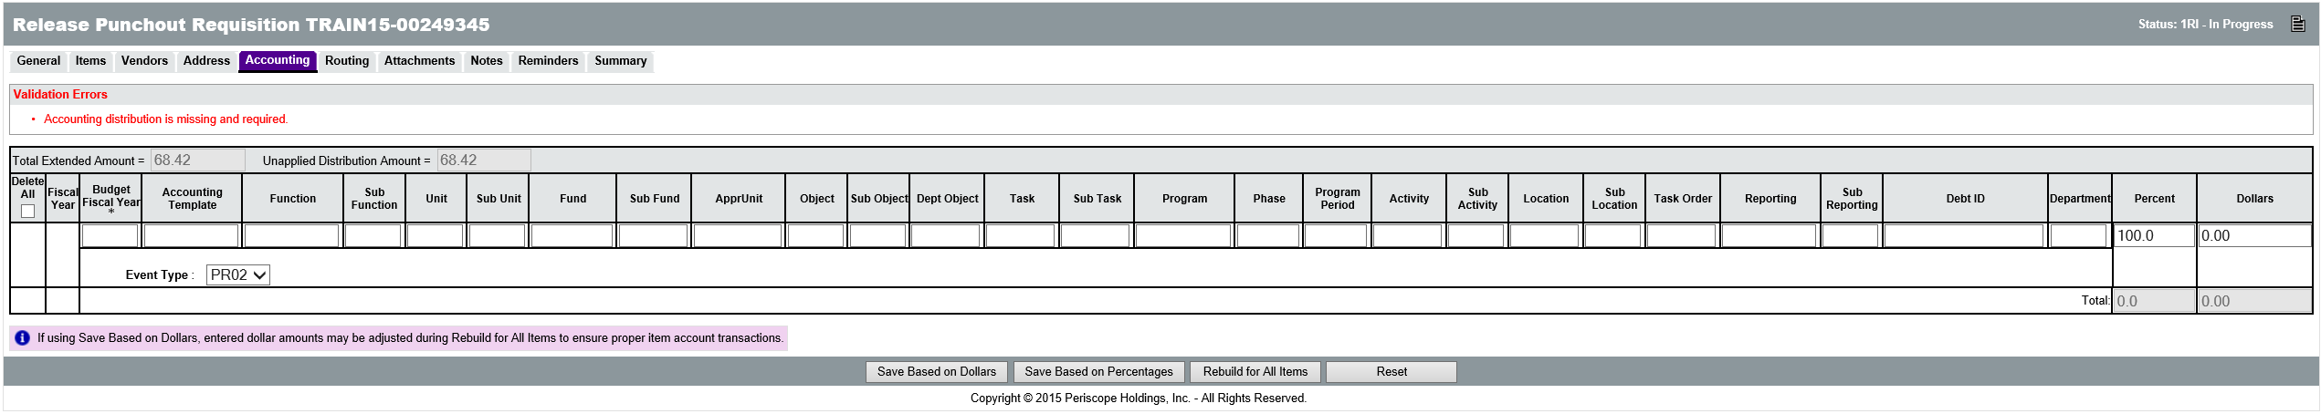
TIP: If no accounting information is available to the user, placeholder accounting codes can be entered temporarily. The correct accounting codes will need to be entered for the Items prior to applying the final approval to the Requisition.
If the Account codes are not inferred from the Accounting Template or Function code, the Accounting fields that require or conditionally require data entry are:
  - Budget Fiscal Year – Required for all Items, regardless of whether Account codes are entered or inferred.
  - Unit – Conditionally required if not using an Accounting Template or Function code.
  - Fund – Conditionally required if not using an Accounting Template or Function code.
  - Appr Unit – Conditionally required if not using an Accounting Template or Function code.
  - Object – Conditionally required for transmission to AFIS if not using an Accounting Template or Function code. Optional for documents that will not be interfaced to AFIS. See the next section for more information on Object code inference.
  - Task – Conditionally required if not using an Accounting Template or Function code.

Object Code Inference
ProcureAZ requires that each Item being purchased can be identified using a five-digit NIGP code. Because of this established relationship, when users complete the Accounting tab on a Requisition, the Object code for each Item can be inferred based on the combination of NIGP code and dollar amount. If the user enters an Object code, ProcureAZ will not overwrite the code with an inferred Object code. The Object code will only be inferred if the field is left blank. During the inference process, if a matching Object code is found, it will be written to the Object field, but if no matching Object code is found, the field will be left blank and require input from the user before submitting the document to AFIS.
New
Feature
TIP: Users should refer to their agency’s policy regarding Object code usage. Users should enter an Object code if their agency has special expectations or usage for it.

Add Accounting to Header
On the Header > Accounting tab, the Accounting codes can be entered into their respective fields. At the far right of the page (scrolling is necessary) there are fields for entering the Percent or Dollar distribution for the Accounting line. If multiple Accounts are responsible for payment of the request, their responsibility amount can be entered as either a percentage of the total or a dollar amount. Only the Percent field or the Dollars field can be used but not both.
TIP: Don’t forget to add either the amount or the percentage to the rightmost column BEFORE you click Save and continue. If those fields are left blank the accounting information you entered will disappear.

Entering a value into one field will automatically calculate the other when the changes are saved. If the Percent field is used, the Save Based on Percentages button will update the Dollars. If the Dollars field is used, the Save Based on Dollars button will update the Percent. The sum of the percentages must equal 100 and the sum of the dollars must equal the total amount of the cost of the Items on the request. The Unapplied Distribution Amount must always be 0.
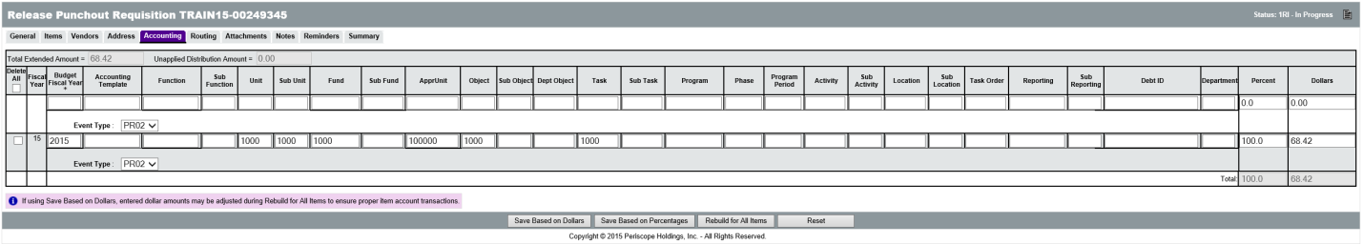
Once all Accounting information has been entered and the Unapplied Distribution Amount is 0, clicking the Rebuild for All Items button will apply the Accounting information to all of the Requisition Items.
At this point the document will be locked by ProcureAZ to perform several tasks and a system warning message will inform the user that the document is locked for editing. After locking the document, the Object code is inferred based on the Item’s NIGP code and a validation check is performed to ensure that all required information has been entered. Once the process is complete, a message box is displayed that informs the user that the page will be refreshed.
TIP: The Object code is only inferred if left blank. If an Object code has been entered, ProcureAZ will not overwrite the Object based on the NIGP code.

Add Accounting to Line Items
When Accounting codes must be different for each line item on the Requisition, the Items > Accounting tab must be completed. On this screen, each Item on the Requisition is displayed. Clicking the Item Number for an Item will display the same screen used on the Header, except that it applies only to the individual Item. The same Accounting information is required on this page and the Percent or Dollars fields can be used to distribute the cost of an Item across multiple accounts.
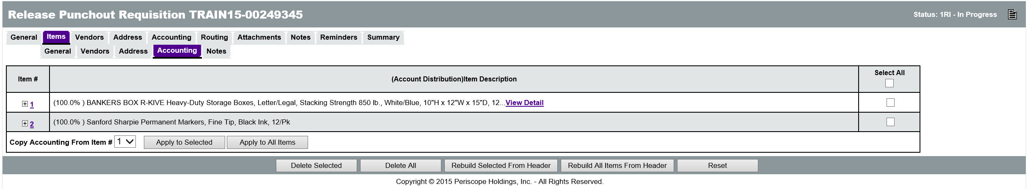
After entering the last Accounting line for an Item, but before saving, you can tell the system what to display after clicking one of the save buttons. The available options are: Current Page, Next Item, Previous Item, and Exit. Upon saving any changes, the system will lock the document for editing and perform the Object inference (if left blank) as well as the required field validation. A message box will be displayed when the document is ready to be refreshed.

Accounting Verification
When the Requisition is submitted for approval, approvers can change the Accounting codes that have been entered if necessary.

Adding and Removing Attachments
The Header > Attachments tab is used to view any existing attachments and add new attachments to the Requisition. State Procurement Office administrators can add default attachments to all new Requisitions so there may be attachments on the document that you did not add. The Attachments tab will display the number of attachments on the document in parenthesis. For example, Attachments(2) means that there are 2 attachments on the Requisition.
There are two Attachment tabs, one for Agency uploaded documents, and one for Vendor uploaded documents. Agency users can only upload documents to the Agency tab. If the document should not be viewable by vendors, the Show Vendor check box should be unchecked (it is checked by default). Generally, only vendors can upload documents to the Vendor tab. The exception to this is when it is a Bid that has been converted to a Master Blanket (or an Informal Quote has been awarded to the vendor). In that case, the purchaser can choose which vendor’s documents will be automatically attached to the resulting PO by the system.
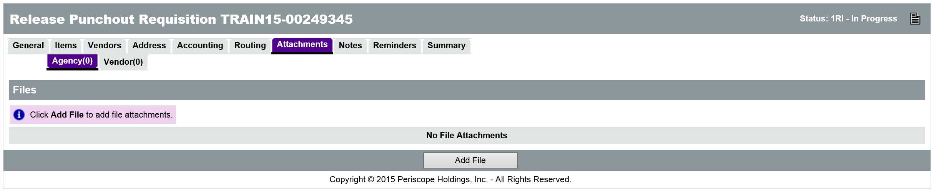
Any supporting documents for the purchase must be scanned and attached to the Requisition as specified by policy. This might include documentation such as specification sheets, scope of work reports, or hard copy quotes. All Requisitions must include specifications for goods or services and, if sufficient detail cannot be contained in the Item Description field, any appropriate supporting documents must be attached. It is important that any attached document name accurately describes the document.

Attaching a Document
On the Attachments > Agency tab, click the Add File button. On the Add File page, the Name field is the display name for the file that will appear wherever attachment repository files are displayed. The Name can be different than the name of the file and can contain alphanumeric characters, spaces, and special characters up to a maximum length of 200 characters. If no Name is entered, it will default to the file name. The Description field is optional but can be used to enter a longer description of the file, its purpose, or any notes/comments about the file.
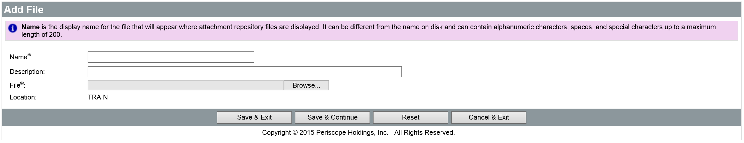
Clicking the Browse button will display a File Explorer window that allows the user to navigate to the folder location on the local machine or shared drive and select the file to upload. When the appropriate file has been selected, click Open in the File Explorer window to add the file path to the Attachment screen.
When all fields have been completed and the file has been selected, click the Save & Exit button to upload the file to ProcureAZ and attach it to the Requisition. To attach more files, click Add File.

Attachment Modification
On the Attachments > Agency tab, the Show Vendor check box determines whether the vendor can view the attachment and the Delete check box will delete the attachment from the Requisition. After changing either of these settings, click the Save & Continue button to apply the changes.
The Name of the file is a link to the file detail screen. On the Attachment File Detail screen, only the Description can be modified. The file can also be downloaded by clicking the Download icon. If the Description has been changed, save the changes by clicking the Save & Exit button.

Adding, Editing, and Deleting Notes
The Header > Notes tab is used to add notes about the Requisition document that are only visible to Organization users who access the document. Notes are entered in the Note field, which allows multiple lines of text to be entered. When one note is entered, clicking the Save & Continue button will save the note and add a new blank Note field for another note. Any notes that are saved to the document are stamped with the date they were added. Checking the Delete check box and clicking the Save & Continue button will remove the note from the document. The reset button will revert any changes made to the notes since the document was last saved. Like Attachments, the number of Notes added to the document will display in the tab name in the Header > Notes tab.
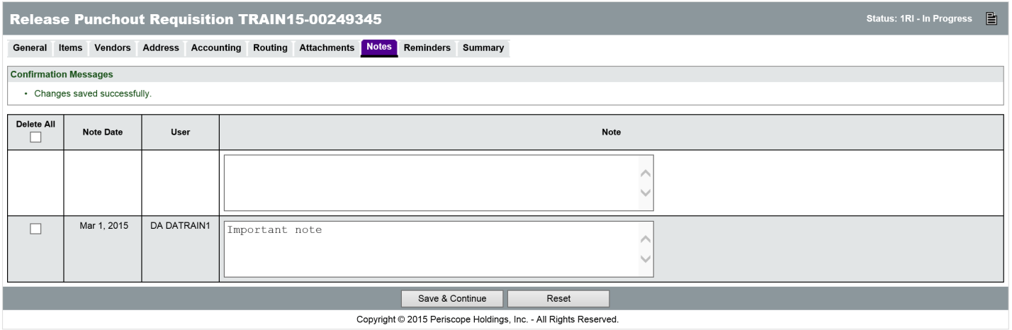

Item Notes
Notes can also be added to an individual Item on the Requisition on the Items > Notes tab. On this page, clicking the Item Number will display the same screen as the Header > Notes tab except that these Notes are added to a specific Item. Both header level and item level notes will follow on to the Purchase Order.

Managing Reminders
The Reminders tab on a Requisition is used to create automatic reminders that will notify a user prior to the due date of the reminder. When there are no reminders, the first line is used to create a new reminder.

Create a Reminder
The Due Date field can be set to the date that the Requisition is due or any other date for which the user would like a reminder. The date picker icon can be used to select a date. The Comment field can contain text up to 250 characters and is used to type the reminder message that will be sent to the user. The Remind Whom field contains a drop down menu of all of the users in the system. Selecting a user from the list will notify that user based on the date settings on the reminder. The Days Prior to Remind field is used to specify the number of days, prior to the Due Date, that the user will be notified about the Requisition. If the Send Email check box is checked, ProcureAZ will send an email to the user with the reminder and comment.
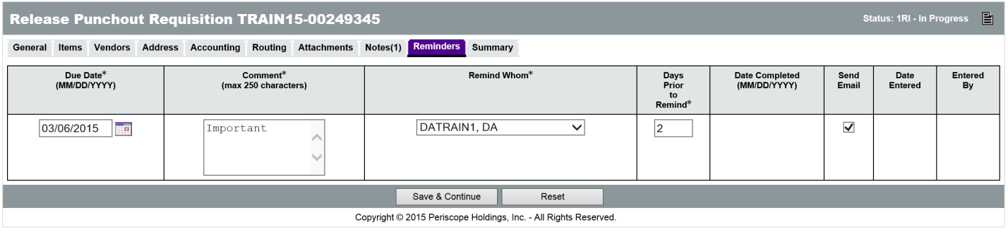

Modify and Delete Reminders
Existing Reminders can be edited and deleted on the Reminders tab of the Requisition. Only the user who added the reminder can remove it. If changes are made or the Delete check box is checked, clicking the Save & Continue button will apply the changes and/or deletions.

My Reminders
Any reminders that have been added for a user will display on that user’s My Reminders tab which is available on the Home Page. The My Reminders tab will display the number of current reminders in parenthesis. On the My Reminders page, reminders are separated into tabs by document type. The Reminder appears on the My Reminders page when the number of days prior to the due date has arrived. Reminders can be marked as complete by entering or selecting a date for the Date Complete field. This will remove the reminder from the My Reminders tab and mark the reminder as complete on the document.

Reviewing and Submitting the Requisition
The Summary tab displays all of the information on the Requisition. Any warnings or errors present in the document will be displayed at the top of the screen. Yellow warning messages will not prevent document submission but should be noted by the user. Red error messages will prevent document submission and must be addressed prior to submitting the document for review. The document creator should scan the Summary page to make sure that all data was entered correctly. Any necessary corrections can be made on the tab where that information was entered.
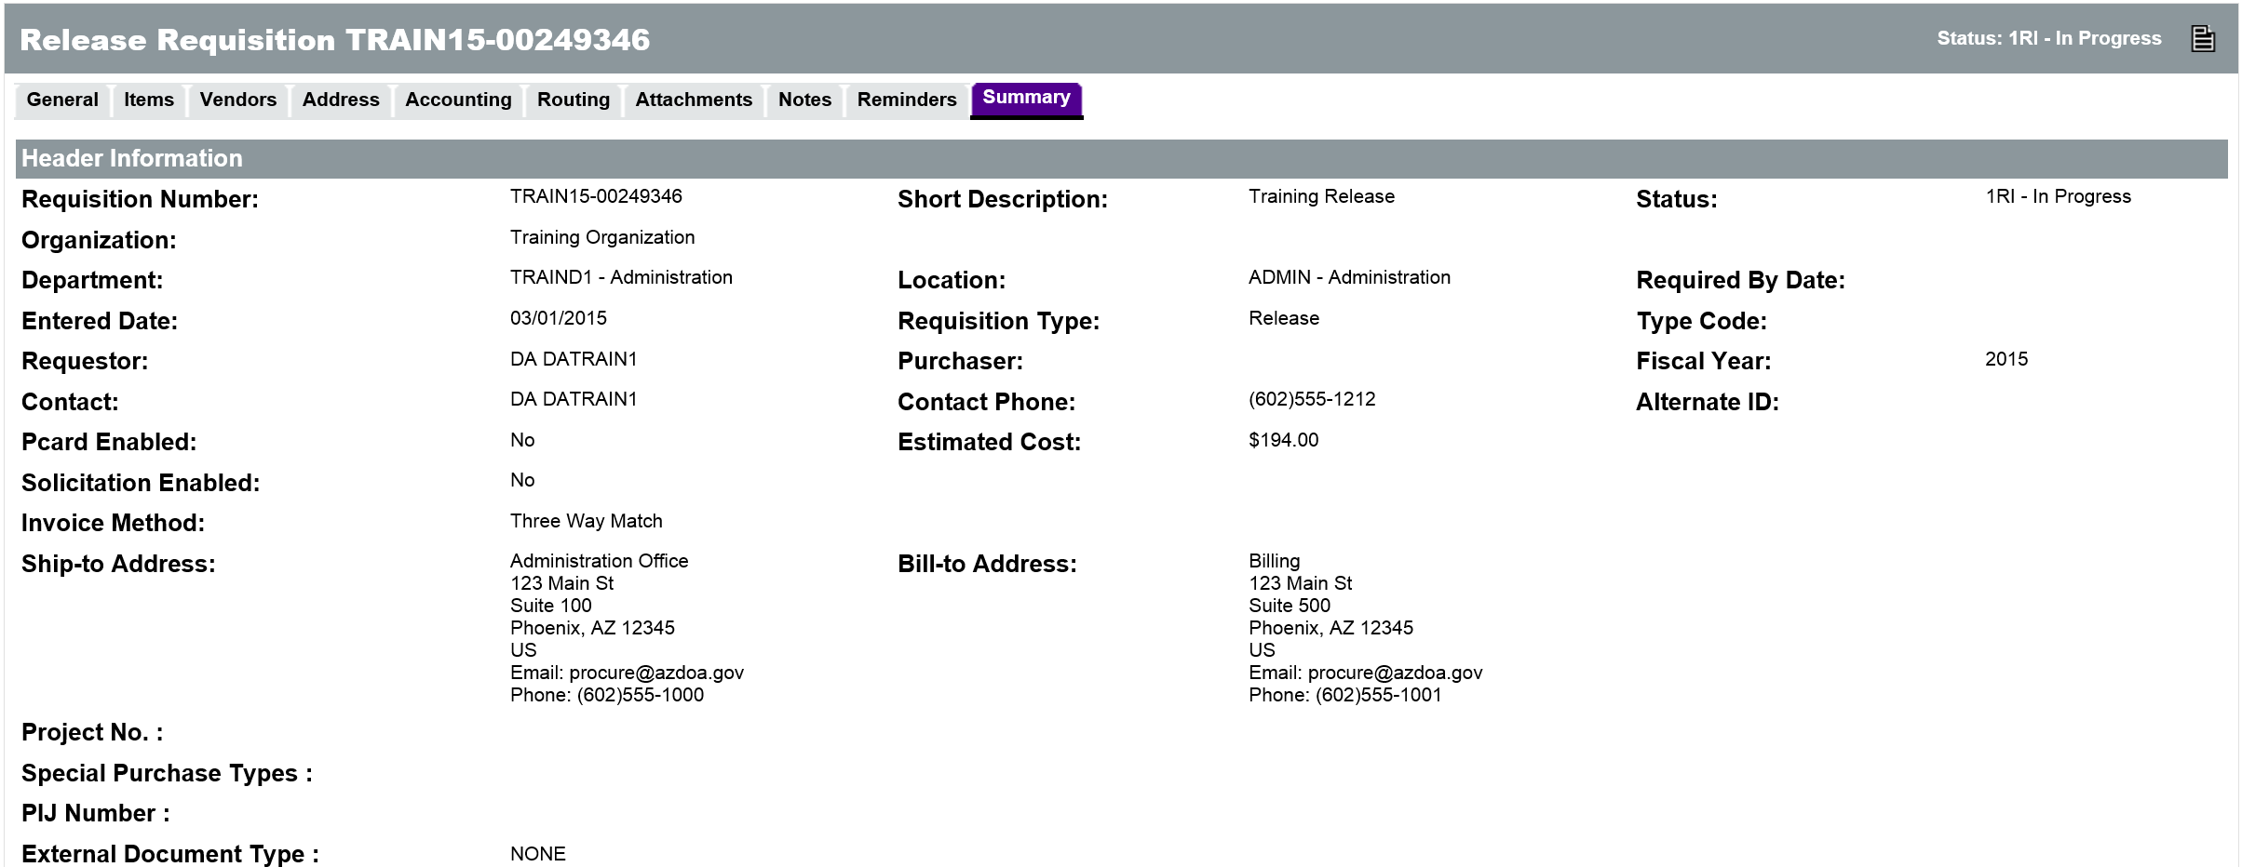
When all errors have been corrected and the Summary page has been reviewed, the document is ready to be submitted for approval. There are four buttons at the bottom of the Summary page:
  - Submit for Approval – Click this button to submit the Requisition for approval. The approval path that has been triggered by the document will appear.
  - Cancel Requisition – Click this button to cancel the Requisition. This will delete the Requisition from ProcureAZ. A warning pop-up window will ask you to confirm cancellation.
  - Clone Requisition – Click this button to create an exact copy of the Requisition. The next screen will ask you to enter the Fiscal Year for the new document.
  - Print – Click this button to display a printable version of the document.

Submit For Approval
Click the Submit for Approval button. A dialog box pop-up will ask you to confirm submission of the Requisition, click OK. If there are approvals required and auto-cascading approval paths have been set up, the Approval Path screen will display the users that need to approve the document and the order of the approvals. For non-auto cascading approval paths, users will need to select the appropriate path for the document. If no approval paths are found for the document, the document moves to the next status.
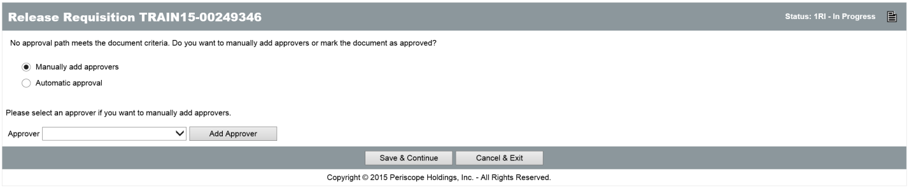
The Continue button will send the Requisition to the first approver in the Approval Path. Until the Continue button is clicked the document will remain in an In Progress status. Clicking the Cancel & Exit button will cancel document submission and return to the Summary tab of the document.
When the Continue button is clicked, if document submission is successful, a message will be displayed at the top of the screen stating that the transaction was successful. Any warning or error messages generated by the submission will also be displayed.

Routing
After submitting for approval the routing tab will display the details for any approval paths on the document.

Activity 4.1

Create a Release Requisition
Scenario
You need to request the purchase of temporary services for your Department. The services are covered under a contract so you will create a Release Requisition for the Items and submit it for approval.
Setup
- Log in to ProcureAZ using the Requisitioner (DA) role on your Training Data Card.
Steps
- Create the new Requisition document.
  - In the Header Bar, click Documents.
  - Hover the mouse over Requisitions. The Requisitions menu expands.
  - Click New. The New Requisition document opens.
- Complete the data entry on the General tab.
  - Make sure the Department matches the Department on your Training Card. If it does not select the matching Department from the drop down menu.
  - In the Location drop down menu, select the Location on your Training Card. If it does not select the matching Location from the drop down menu.
  - In the Requisition Type drop down menu, select Release.
  - In the Short Description field, enter today’s date, your user name and Front Desk Temp (example: 12 Mar DATrain1 Front Desk Temp).
  - Click the Save & Continue button. Observe the Confirmation Message that is displayed.
  - On your Training Card, write down the Requisition Number that has been assigned to the Requisition in the space provided for Activity 4.1. Step B.6.
- Add an Item to the Requisition.
  - Click the Items tab.
  - On the Items > General tab, click the Search Items button.
  - In the Search Using field, enter Clerical.
  - Click the Find It button.
  - The list of vendors is listed to the left of results list. If necessary, click the Show More link to see all of the vendors that have items in the search results.
  - Scroll down the list of vendors and click on the company listed on your Training Card.
  - In the Release Results section, find the Item Clerical Services Hourly Rate (Unit Cost $10.00), and in the Quantity field, enter 20.
  - Click the Add to Req & Exit button.
- Add another Item to the Requisition.
  - On the Items > General tab, click the Search Items button.
  - In the Search Using field, enter Accounting.
  - Click the Find It button.
  - The list of vendors is listed to the left of results list
    - Scroll down the list of vendors and click Kelly Services Inc. If necessary, click the Show More link.
  - In the Release Results section, find the Item Category A. - ACCOUNTING - To view hourly rates, see attached price list. Each agency will enter specific job title a...(Unit Cost $15.00), and in the Quantity field, enter 20.
  - Click the Add to Req & Exit button.
  - Click Save and Continue
- Review the Vendors tab.
  - Click the Header > Vendors tab.
  - Observe the vendors listed along with their Remit-to Address information.
- Review the Address information on the Requisition.
  - Click the Header > Address tab.
  - Observe the Ship-to and Bill-to Address for the selected Department.
- Complete the Accounting information on the Requisition.
  - Click the Header > Accounting tab.
NOTE: Refer to the Accounting Information section of the Training Data Card
  - Use the accounting information from Function Code 1.
  - Click the Save Based on Percentages button.
  - Click the Rebuild for All Items button. The document will need up to a minute to process the new accounting information.
  - When the process is complete, click the OK button in the dialog box that appears.
- Add an Attachment to the Requisition.
  - Click the Attachments tab.
  - Click the Add File button. The Add File page opens.
  - Click the Browse button.
  - Navigate to the Documents folder (look on the left side of the file window for the shortcut).
  - Double-Click Documents for Training.
  - Select the file noted on your training card for Activity 4.1 Step H.6.
  - Click Open.
  - In the Name field, enter today’s date and Vendor Quote.
  - Click the Save & Exit button.
- Optional: Add another Attachment to the Requisition.
  - Click the Add File button. The Add File page opens.
  - Click the Browse button.
  - Navigate to the Documents folder (look on the left side of the file window for the shortcut).
  - Double-Click Documents for Training.
  - Select the file noted on your training card for Activity 4.1 Step I.5.
  - Click Open.
  - In the Name field, enter Item FAQ.
  - Click the Save & Exit button.
- Optional: Add a Note to the Requisition.
  - Click the Notes tab.
  - In the Note field, enter This is a training Requisition.
  - Click the Save & Continue button.
- Review and submit the document for approval.
  - Click the Summary tab.
  - Review all of the information on the document.
  - Click the Submit for Approval button.
  - In the dialog box, click OK.
  - On the Approval Path screen, click the Continue button.
  - Go to the Routing tab to review the approval path details.
- Click the Home button to indicate you have completed the activity.
Note: Trainer will need to process the disapproval of each submitted document before beginning the next activity.

  - Check the Status of a Release Requisition
The status of a Requisition can be monitored at any point in the document lifecycle. The Home Page displays tabs for all document types accessible by the user profile.

Checking the Status
The Reqs tab is used to view Requisitions saved in ProcureAZ and contains sub-tabs for each document status. Each tab name contains the number of documents displayed on that tab in parenthesis. For example, Ready for Approval(4) means that there are 4 Requisitions awaiting approval. If the document has been submitted for approval, it will move to the Ready for Approval tab.
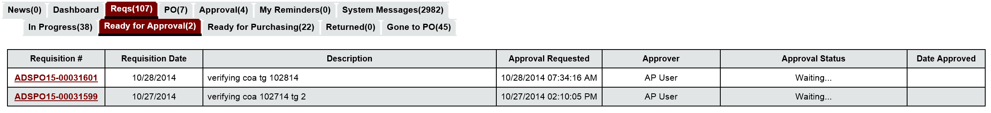
On the Ready for Approval tab, any Requisitions that are awaiting approval are displayed along with the Approval Requested date, the Name(s) of the Approver(s), the Approval Status, and the Date Approved. Clicking the Requisition document number will open the document for review. On a Ready for Approval document, Notes can be added to the document by any user with access to the document and the Accounting information can be modified, but only by the current approver.
If the document is disapproved for any reason, it will change to Returned status and the creator will be notified by email that the document has been disapproved.

Correcting Returned Requisitions
Any disapproved Requisitions that you created will be displayed on the Reqs > Returned tab. Clicking the Requisition document number will open the document to the Summary tab. The Approval Paths section at the bottom of the Summary tab displays the Approval Actions that have been applied to the document. If the approver added any comments to the document when they disapproved it, they will be displayed in the Approval Path section. The options at the bottom of the Summary tab allow the document creator to reopen, cancel, clone, or print the Requisition.
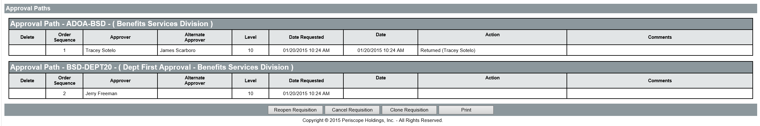

Reopen Requisition
When a document has been returned, it may be necessary to follow up with the approver who disapproved it in order to make sure that any issues preventing approval are properly addressed before resubmission. If changes are required, on the Summary tab, click the Reopen Requisition button to change the status of the document to In Progress and enable document modification.

Activity 4.2

Check Requisition Status and Correct Returned Requisition
Scenario
You want to check on the status of the Requisition you submitted. The requisition you created in the previous activity has been returned for correction. You will reopen the Requisition in order to make the necessary changes and resubmit it for approval.
Setup
- Log in to ProcureAZ using the Requisitioner (DA) role on the Training Data Card.
Steps
- Review the approval status of the recently submitted Requisition documents.
  - In the Home section, click the Reqs tab.
  - Click the Reqs > Ready for Approval tab.
  - Observe the documents listed on the Ready for Approval tab.
- Locate and open the Returned document.
  - Click the Reqs > Returned tab.
  - Locate the Requisition document number that you wrote down on your Training Card in Activity 4.1.
  - Click the Requisition document number to open the document.
  - Review the Approver comments in the Approval Paths section.
- Reopen the Requisition for modification.
  - At the bottom of the Summary tab, click the Reopen Requisition button.
  - Observe the System Warning message that the Requisition is being processed.
  - When processing is complete, in the dialog box, click OK.
- Enter the correct accounting information for the Requisition.
  - Click the Header > Accounting tab.
NOTE: Refer to the Accounting Information section of the Training Data Card
  - Use the accounting information from Function Code 2.
  - Click the Save Based on Percentages button.
  - Click the Rebuild for All Items button. The document will need up to a minute to process the new accounting information.
  - When the process is complete, click the OK button in the dialog box that appears.
- Resubmit the Requisition.
  - Click the Summary tab.
  - Click the Submit for Approval button
  - In the dialog box, click OK.
  - On the Approval Path screen, click the Continue button.

Note: Trainer will need to process the approval of each submitted document before beginning the next activity.

  - Release Purchase Orders
The next step in the Release lifecycle is the conversion from an approved Requisition to a Purchase Order. Purchase Orders are documents that are used to purchase goods or services. Purchase Orders are used to communicate the details of a purchase to both the vendor and any internal departments that need to know about the purchase.
Release Requisitions do not integrate to AFIS. The first integration point for Releases is when the document is converted to a Purchase Order. The AFIS integration methodology will be described after the individual Release Purchase Order types are discussed below.
i
There are two types of Release Purchase Orders: Direct and Standard. The Purchase Order type is based on the type of Master Blanket contract established.

Direct Release Purchase Orders
Direct Release Master Blankets are the most common type of Master Blanket for the State. When a Direct Release Master Blanket is used, the Release Purchase Order will automatically be created after final approval has been applied to the Release Requisition. A link to the new requisition will be displayed at the top of the Release Requisition. Click that link to access the new Purchase Order. The new Purchase Order will have a status of Ready to Send. The PO still needs to be sent to the vendor. This can only be done by the creator of the Requisition. Scroll down to the Vendor Notification Action section at the bottom of the Purchase Order, select one of the options and click Save and Continue to notify the vendor about the Purchase Order. The document status will change to 3PS – Sent.

Standard Release Purchase Orders
When a Standard Release Master Blanket is used and final approval has been applied to the Requisition, the Requisition changes to Ready for Purchasing status. The contract administrator (now listed as the Purchaser on the Requisition) must either disapprove the order or click the Convert to PO button (bottom of the document). If the conversion is successful, a link to the new PO will be displayed at the top of the requisition. Click that link to move to the PO document. The current PO status will be In Progress.
The Purchaser must click Submit for Approval at the bottom of the Summary tab when the PO reflects the proper content. If there are applicable approval paths, the document is sent through the approval process before the status changes to Ready to Send. The PO must then be sent to the vendor by the Basic Purchasing user. The Basic Purchaser needs to scroll to the bottom of the Summary tab of the purchase order and click one of the options in the Vendor Notification Action section.
The requestor will receive a notification email when the Requisition has been converted to a PO. The PO will not appear in the original requestor’s PO queues at all, but can be located by searching for and opening the Requisition. The Summary tab of the Requisition will contain a link to the referencing Purchase Order.

Release Purchase Order Integration to AFIS
After the Release Purchase Order document has been created, the status of the document is set to In Progress and the Purchase Order document is automatically interfaced to AFIS. If the accounting codes are legitimate and sufficient funds are available in the account to pay for the requested Items, the document should successfully interface to AFIS. Successful integration will create a pre-encumbrance in AFIS. The ProcureAZ Release Purchase Order’s alternate ID field will display a string/value that begins with RQ.
i
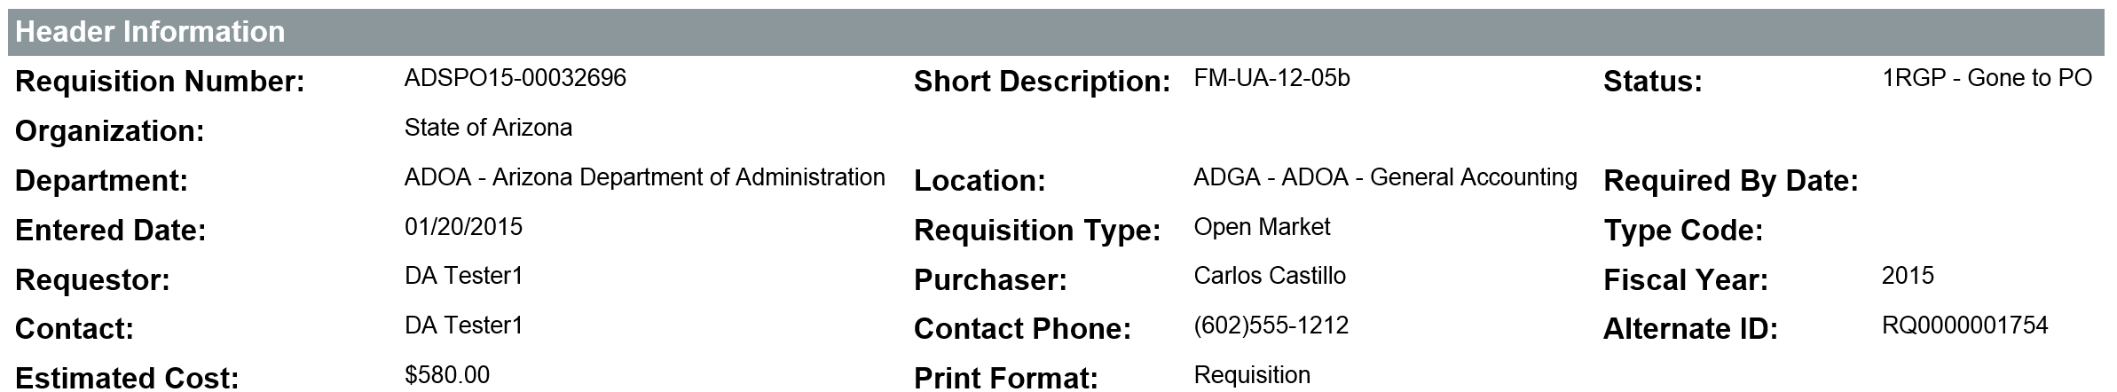
That RQ number is the Document ID for the document that was interfaced to AFIS. Individuals with access to view documents in AFIS can review the content of that document in AFIS by searching for the Document ID.
i
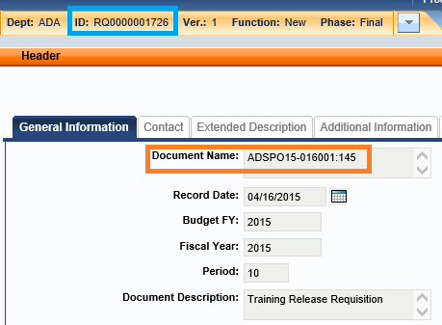
After the conversion to a Purchase Order, the Basic Purchaser may edit the Purchase Order content. Any accounting-related changes will result in additional integration to AFIS each time the document is saved. The possible changes include, but may not be limited to:
  - Number of items
  - Cost
  - Account Coding
Most changes will result in the creation of a new version of the same document in AFIS
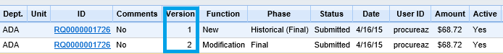
TIP: If a new item is added to the PO, the integration will not be triggered until the accounting is added to that item.

Once the Release Purchase Order document has received final approval, the status of the document changes to Ready to Send. The Basic Purchaser must then take action to notify the vendor. The two options available are Send Email and Notify Vendor or Set to Printed Status. Select one of those options and click Save and Continue.
After clicking Save and Continue, the ProcureAZ Purchase Order document is automatically interfaced to AFIS. If the ProcureAZ Purchase Order document interfaces successfully, the pre-encumbrance is liquidated in AFIS and an encumbrance is created in AFIS. The ProcureAZ Purchase Order’s Alternate ID field will now display a string/value that begins with PO.
i
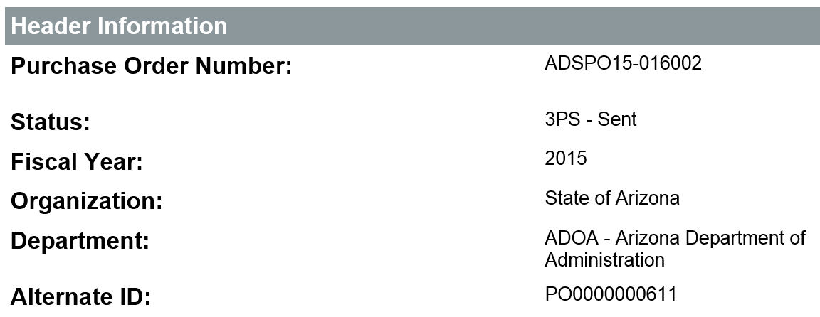
That PO number is the Document ID for the document that was interfaced to AFIS. Individuals with access to view documents in AFIS can review the content of that document in AFIS by searching for the Document ID.
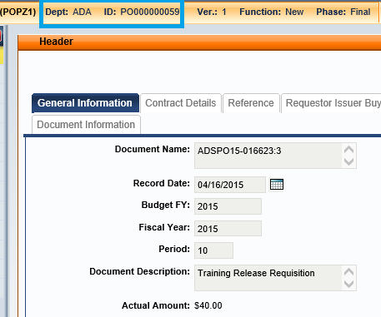

Activity 4.3

Review a Release Purchase Order
Scenario
The Requisition you submitted in the previous activity has received the final approval which resulted in the automatic creation of a Release Purchase Order. You want to locate and review the Purchase Order that was created.
Setup
- User is logged in with the Requisitioner (DA) role from your Training Data Card.
Steps
- Navigate to the Requisitions by document status.
  - In the Header Bar, click Documents.
  - Hover over Requisitions.
  - Click Gone to PO.
- Locate a Requisition document.
  - On the Requisitions – Gone to PO page, locate the Requisition document that you wrote down on your Training Card in Activity 4.1.
  - Observe that the Requisition appears in the list.
  - Click the Requisition document number to open the document.
  - Observe that the Item Information section on the Summary tab contains a link to the New Purchase Order document.
- Review the Purchase Order document.
  - Click the ADSPO Purchase Order number link to open the Purchase Order document.
    - If you pick the other PO, it will error out because that vendor is not setup in the AFIS test system we are using.
  - Review the information on the Summary tab of the Purchase Order.
    - Notice that the Alternate ID contains RQ###########
      - This is the AFIS Document ID for the Requisition (creates PreEncumbrance) that was integrated to AFIS
    - Notice that the accounting displayed with each item contains many more fields than the three Function Code fields that you entered from your Training Data Card.
      - This is a result of the AFIS Function Code Inference being passed back to ProcureAZ after the document integration
  - Observe the document status (should be Ready to Send)
- Send PO to Vendor
  - Scroll to the bottom of the Summary tab.
  - Click radio button for Set to Printed status
  - Click Save and Continue.
  - Click the OK button if status window pops up.
  - Observe the document status (should be Sent)

  - Cancel or Clone a Release Purchase Order and Requisition
In ProcureAZ, not all documents can be canceled directly or when they have certain statuses. Documents cannot be canceled when their information is currently being used by another document. For example, if a Requisition has been converted into a PO, the information on the Requisition is being used by the PO and the status of the Requisition is determined by the PO. In this situation, the Requisition could not be canceled unless the PO was first canceled.
If an individual item on a Purchase Order is canceled, the Requisition will return to Ready for Purchasing status because of that item. The Requisition can then be canceled, or the item can be canceled, but the Purchase Order will remain active.
When an existing document contains all of the information needed to create a new document, the existing document can be cloned, or used as the basis for a new document. For example, if an agency orders the same office supplies from the same vendor using the same accounting codes, the Requisition information used to create one order can be copied to a new Requisition using the Clone document feature.
TIP: You cannot create a clone of a Punchout.

Cancel a Release Purchase Order
Users cannot directly cancel a Release Purchase Order document regardless of role. There is no Cancel PO button on the Summary tab of a Release Purchase Order. A Department Access user with modification rights to a Purchase Order can cancel the document or individual line Items using a Receipt. This is recommended for Purchase Orders that are in a Sent status.
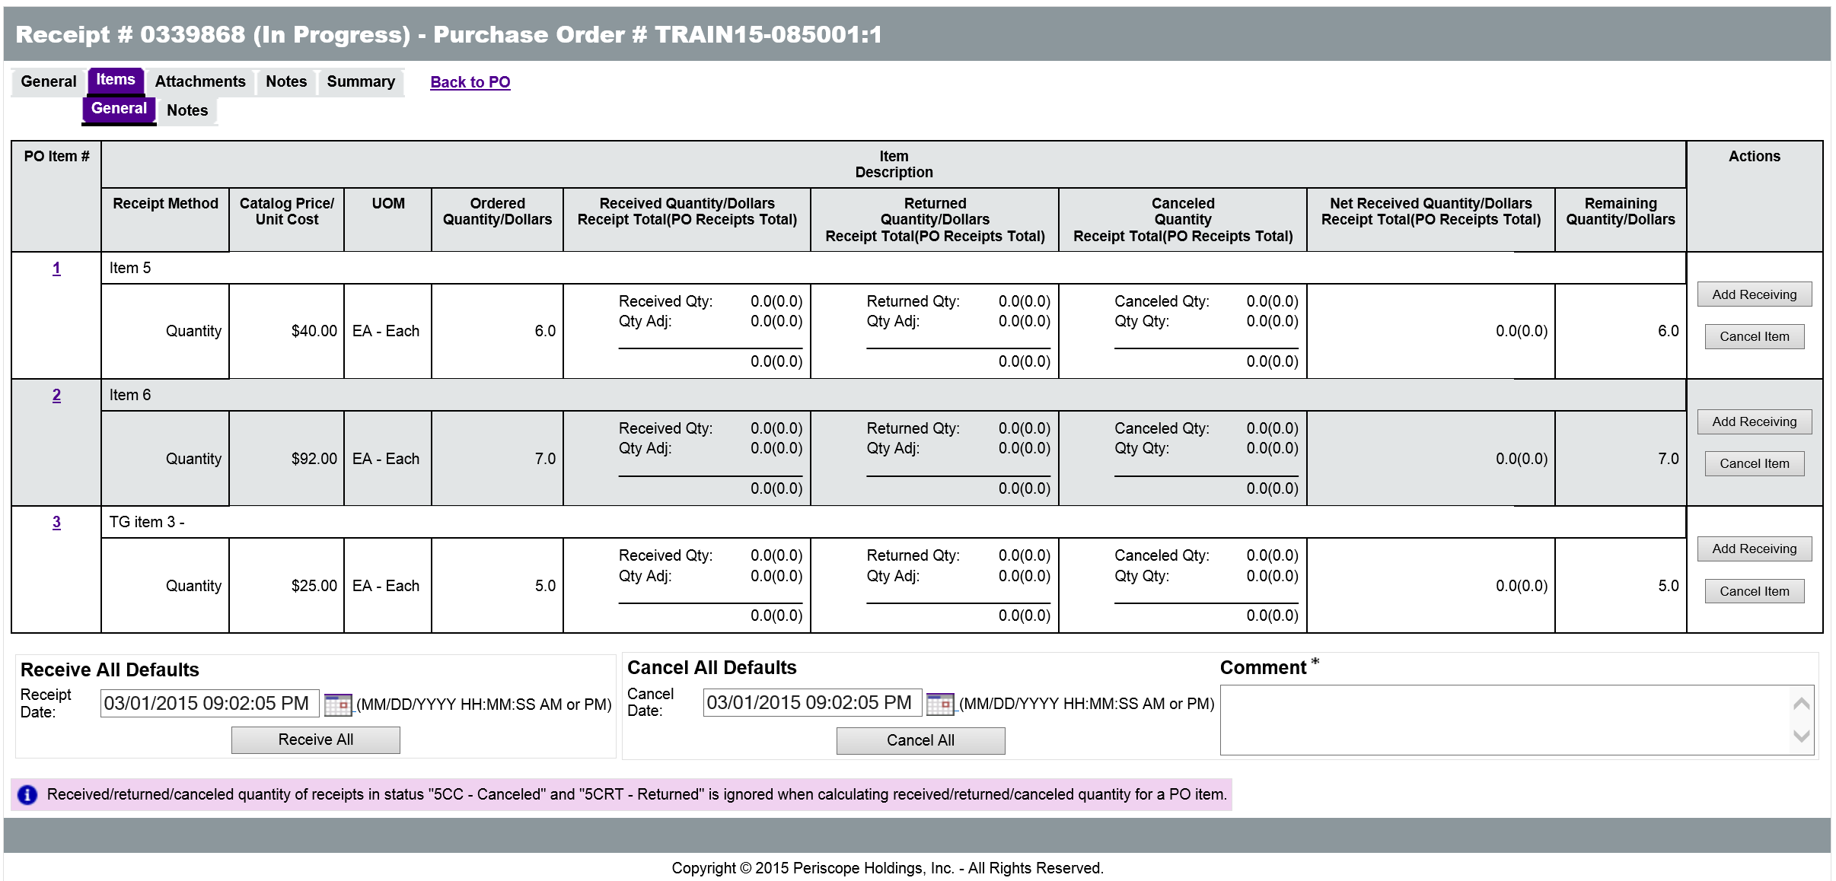

Cancel a Release Purchase Order Using a Receipt
When an Item is canceled on a Receipt, a Change Order is automatically created for the Purchase Order that will cancel the Item on the Purchase Order. For more information on the receiving process, refer to Lesson 10, Receiving Items and Services.

Cancel a Release Requisition
A Requisition can be canceled in ProcureAZ if it has not yet been converted into a Purchase Order or if the referencing Purchase Order document or item on the document is first canceled. If a buyer has determined that an on-contract purchase needs to be made off-contract, they can cancel the Purchase Order and inform the Requisition creator of the need to cancel the Requisition and submit an Open Market (off-contract) Requisition.
To cancel a Release Requisition, open the document to be canceled and click the Summary tab. At the bottom of the Summary tab, click the Cancel Requisition button. A dialog pop-up will appear to confirm the cancellation. Clicking OK in the dialog box will proceed with the cancellation of the Requisition document.

Clone a Release Purchase Order
ProcureAZ does not allow Release Purchase Orders to be cloned by Department Access users as this would bypass important steps in the procurement lifecycle. Basic Purchasing users have the option to Clone a Release Purchase Order on the Summary tab of the document by clicking the Clone PO button.

Clone a Release Requisition
An existing Release Requisition document can be used to create a new Release Requisition with all of the same information including Items, Addresses, Accounting, Attachments, and Notes. All of the copied information on the Clone document is editable. This process is useful for submitting the same Requisition for quarterly purchases and can be performed by any user with access to the original Release Requisition document.
Locate the Release Requisition to be cloned and open the document. Navigate to the Summary tab and click the Clone Requisition button at the bottom of the page.
On the General tab, the new document must be assigned to the appropriate Fiscal Year as the original document may have been created and saved in a prior or closed Fiscal Year. Once a Fiscal Year has been selected, click the Save & Continue button to create the new document. Clicking the Cancel & Exit button will cancel the clone process.

Activity 4.4

Clone and then Cancel a Release Requisition
Scenario
You need to place an order for more office supplies. Since this order will be very similar to an order that you placed in a previous activity, you will create a clone of the original Requisition. Before the Requisition can be submitted, you receive notice that the purchase will not be made through your department. You will need to cancel the new Requisition.
Setup
- Log in to ProcureAZ using the Requisitioner (DA) role on your Training Data Card.
Steps
- Locate the original Requisition used to request the purchase of clerical services.
  - In the Header Bar, click Documents.
  - Hover over Requisitions.
  - Click Gone to PO.
- Create a clone of the original Requisition to request the purchase of office supplies.
  - On the Requisitions – Gone to PO page, locate the Requisition document number that you wrote down on your Training Card in Activity 4.1.
  - Click the Requisition document number for the Requisition that will be cloned. The document opens to the Summary tab.
  - At the bottom of the Summary tab, click the Clone Requisition button.
  - In the Fiscal Year drop down list, select the current Fiscal Year.
  - Click the Save & Continue button.
  - The Summary tab displays a System Warning message that includes a link to the cloned Requisition.
  - On your Training Card, write down the Requisition Number that has been assigned to the Requisition in the space provided for Activity 4.4.
  - Click the document number link in the System Warning message to open the cloned Requisition to the Summary tab.
  - Observe that all of the information from the original Requisition has been copied to the new Requisition.
  - Click Home to return to the Home Page.
- Locate the new Requisition that needs to be canceled.
  - In the Header Bar, click Documents.
  - Hover over Requisitions.
  - Click In Progress.
- Process the cancellation of the Requisition.
  - On the Requisitions – In Progress page, locate the Requisition document number that you wrote down on your Training Card for Activity 4.4.
  - Click the Requisition document number for the Requisition that needs to be canceled. The document opens to the Summary tab.
  - At the bottom of the Summary tab, click the Cancel Requisition button.
  - In the dialog box, click OK.
  - After the cancellation has finished processing, click OK In the popup window that is displayed. The page will refresh.
  - Observe that the status of the document has changed to Canceled.
  - Click Home to return to the Home Page.

Lesson Summary
In this lesson you:
- Created a Release Requisition
- Checked the status of a Release Requisition and corrected a returned Requisition
- Reviewed a Release Purchase Order
- Canceled a Release Purchase Order and Requisition
- Cloned a Release Requisition

Check Your Progress
- A Release Requisition is used to request goods or services on-contract.
  - True
  - False
- The cost of Items on the Release Requisition can only be modified if the cost was entered manually by the user.
  - True
  - False
- What information is provided for a vendor on the Vendors tab of a Release Requisition?
  - Headquarters
  - Contract expiration date
  - Remit-to Address
  - ACH/EFT information
- What status do new Direct Release Purchase Orders have?
  - Ready for Purchasing
  - Ready for Approval
  - Ready to Send
  - In Progress

