6 Informal Quotes

This page was intentionally left blank.
Contents
6. Informal Quotes 1
Learning Objectives 1
Lesson Overview 1
6.1. Informal Quote Creation Methods 2
6.2. Informal Quote Setup 3
Receiving Bids 3
Restricting Vendors 3
Bid Date Section 4
Setup Fields 4
6.3. Bidders 5
Vendor Search 5
Notify Vendors 6
6.4. Response 9
Manage Attachments 10
Apply Pricing to Req Items 10
6.5. Review and Recommendation 11
Single Price Quote 11
Compare Price Quotes 11
Recommendation 12
6.6. Create a Purchase Order 12
Direct Open Market Purchase Order 12
Open Market Purchase Order 13
Activity 6.6 14
Process an Informal Quote and Recommendation 14
Lesson Summary 17
Check Your Progress 18

- Informal Quotes

Learning Objectives
In this lesson, you will:
- Identify the creation process for an Informal Quote
- Review the configuration options for an Informal Quote
- Examine the process of adding vendors that can submit price quotes
- Review the vendor response options
- Identify the process of reviewing and recommending vendors for Requisition Items
- Review the methods for converting the Requisition into a Purchase Order

Lesson Overview
Informal Quote documents are created during the off-contract Requisition process. They are used to solicit Informal Quotes for goods and services through ProcureAZ and to document quotes received from outside ProcureAZ. The Informal Quote process involves the creation of the Item(s) that price quotes are to be solicited for and the indication of the relevant dates and vendors for notification. This lesson covers the Informal Quote process of creating and publishing the request and documenting price quotes received electronically or otherwise as well as the creation of the final PO from the original Requisition.

  - Informal Quote Creation Methods
Informal Quotes can only be used for Requisitions for off-contract goods and services. This means that the Requisition must be either an Open Market or Direct Open Market Requisition in order to conduct the Informal Quote process. Users in the Department Access Requisitioner role have the ability to create Requisitions for off-contract goods and services.
There are two ways to create a new Requisition. One way is to create the document as a clone of an existing Requisition. This will create a new document with all of the information from the existing document already completed. The other way is to create the new Requisition from the beginning, starting with a blank document.
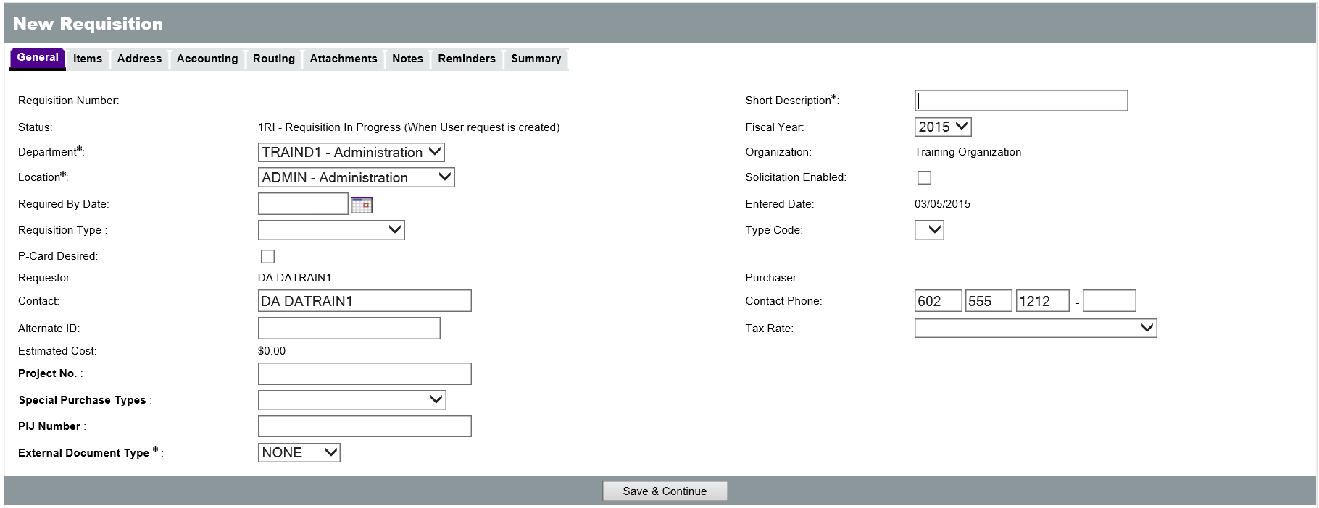
Requisitions that have been created through the cloning process will have a Requisition number assigned, allowing users to access and complete the documents at a later time. New Requisitions that have not been created through the cloning process will need to have the required information entered on the General tab before the document can be saved.

  - Informal Quote Setup
Once a Requisition document is In Progress and Items have been added to the Requisition, the Informal Quote options become available on the Vendors tab. Since the Informal Quote options can only be used for Open Market and Direct Open Market Requisitions, the correct option for Requisition Type should be selected on the General tab which will restrict the Items that can be added to only off-contract Items. Users may also wish to add attachments to the Requisition on the Attachments tab with any necessary documentation or specifications.
On the Vendors tab of the Requisition, there are several options available that will direct the Informal Quote process depending on how it has been authorized to proceed.
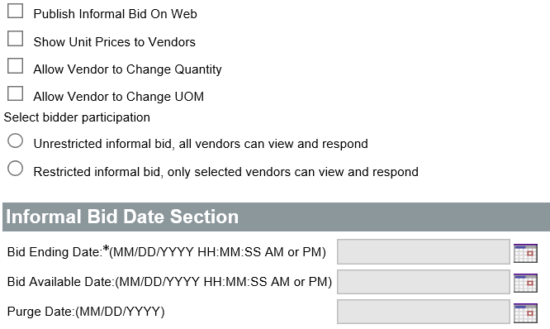

Receiving Bids
If bids are to be received from vendors through ProcureAZ, then the Informal Bid must be published on the web and an ending date specified. If bids are to be received outside of ProcureAZ, then the Informal Bid is not published on the web and no dates are entered. Any quotes received from vendors outside of ProcureAZ can be added as attachments to the Requisition and the pricing on the selected quote can be added to the Items.

Restricting Vendors
If all registered vendors are allowed to view and respond to the request within ProcureAZ, the Informal Bid is set to Unrestricted. If only the selected vendors can view and respond to the request within ProcureAZ, the Informal Bid is set to Restricted.

Bid Date Section
If the Informal Bid should be made available immediately, only the Bid Ending Date needs to be specified. If the Informal Bid should not be made available immediately, the Bid Available Date needs to be specified which will prohibit viewing and responding until that date.

Setup Fields
The following fields are available on the Vendor tab for Informal Quotes:
- Publish Informal Bid on Web – When this box is checked, vendors can view and submit prices quotes for the Items on the Requisition through ProcureAZ; also requires a Bid Ending Date. If this box is not checked, price quotes must be solicited outside of ProcureAZ
- Show Unit Prices to Vendors – When this box is checked, vendors can see the unit price estimates entered for each Item on the Requisition
- Allow Vendor to Change Quantity – When this box is checked, vendors can change the desired quantity for each Item on the Requisition
- Allow Vendor to Change UOM – When this box is checked, vendors can change the desired unit of measure for each Item on the Requisition
- Unrestricted Informal Bid – When this option is selected, all registered vendors can view and respond to the quote request within ProcureAZ. If neither the Unrestricted nor Restricted option is selected, all registered vendors can view and respond to the quote request.
- Restricted Informal Bid – When this option is selected, only the vendors that have been added to the Requisition can view and respond to the quote request within ProcureAZ
- Bid Ending Date – Enter or select the date and time that all vendor quotes are expected to be received
- Bid Available Date – Enter or select the date and time that the notification about the quote request will be sent to vendors or the quote request made available in ProcureAZ

TIP: Bid Available Date will default to the current date/time making it immediately available.

TIP: Don’t set the Bid Ending Date equal to the Bid Available Date – that would result in nothing being published.

  - Bidders
Clicking the Lookup & Add Vendors button will cause a Lookup & Add Reference Vendors pop-up window to appear that allows the user to search for a vendor in the database. In the Lookup fields, users can search for a specific vendor by Vendor Name or Vendor ID. The easiest way to locate a vendor is to click the Find Vendors for All Commodity Code on the Req button located at the bottom of the pop-up window. This will return a list of all vendors that are registered with the Class Item and Commodity codes associated with the Requisition Items.
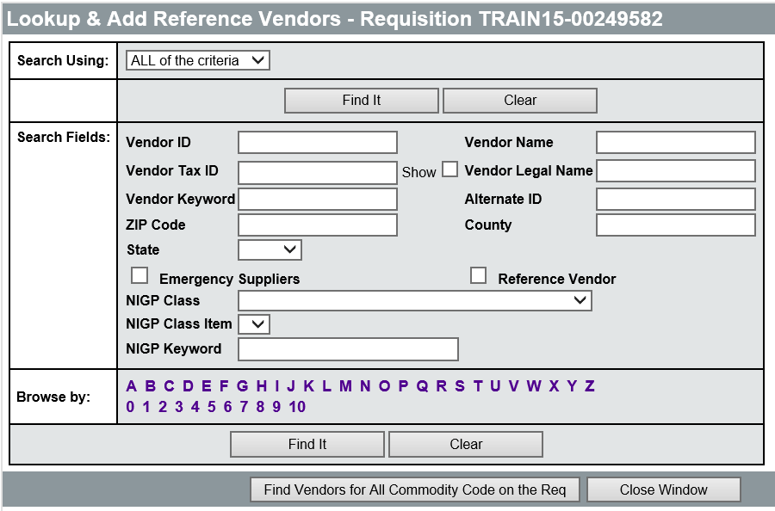

Vendor Search
The Lookup & Add Reference Vendors page allows users to search based on any vendor related criteria. The Vendor ID, Vendor Name, Vendor Tax ID, Vendor Legal Name, Vendor Keyword, and Vendor address information fields can be searched based on the information entered for ALL or ANY of the criteria by selecting the desired search option at the top of the page.
Any information entered in the fields is used as a search string. The search string can be anywhere in the returned field. For example, searching based on a Vendor Name of Acme will return all vendors with the letters “acme” anywhere in their Vendor Name (i.e. Tracmeet, Pacmen Ghost Co.).
Vendors that have designated themselves as suppliers for a NIGP Class and Class Item can also be searched along with other identifying vendor information.
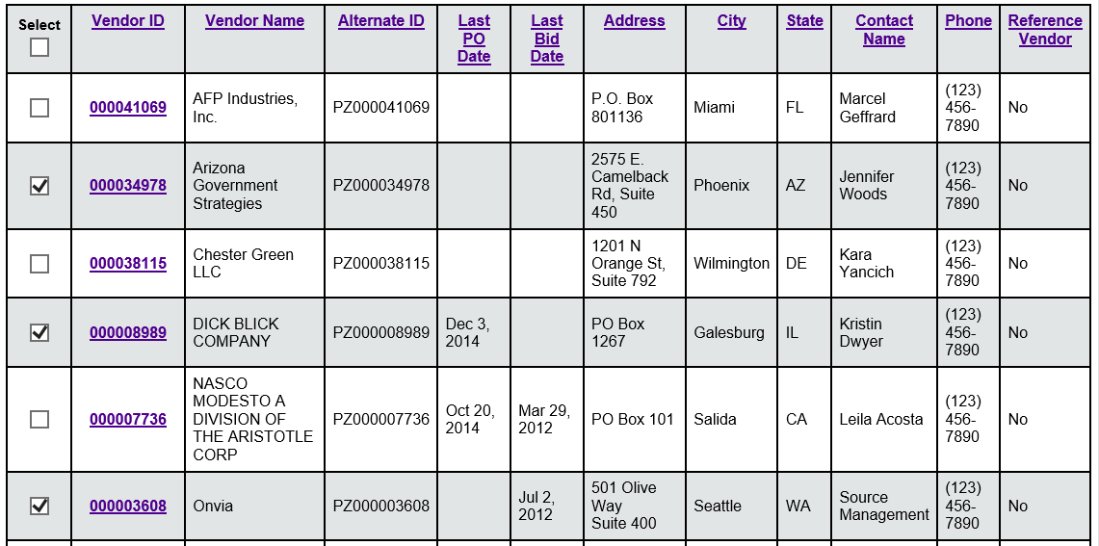
Once the desired vendor has been located in the search results, click the Select check box for the desired vendor. With a vendor or vendors selected, the Save & Exit button adds the selected vendor(s) to the Requisition and closes the Lookup Vendors pop-up window. The Save & Continue button adds the vendor(s) to the Requisition and allows additional searches on the Lookup Vendor screen or additional selections to be made. If there are more than 25 results for the search, clicking the Save & Next Page button will add the selected vendor(s) to the Requisition (if any were selected) and scroll to the next page of results. One of the Save buttons must be clicked before navigating to another webpage in order to save any selections. To exit without saving any changes, click the Close Window button.

Notify Vendors
Once the desired vendors have been added to the Requisition and the Publish Informal Bid on Web option and Bid Ending Date selected, click the Save and Continue button to save the changes. The Notify Vendor button will appear at the bottom of the screen. Clicking the Notify Vendors button will display the Send Notification screen.
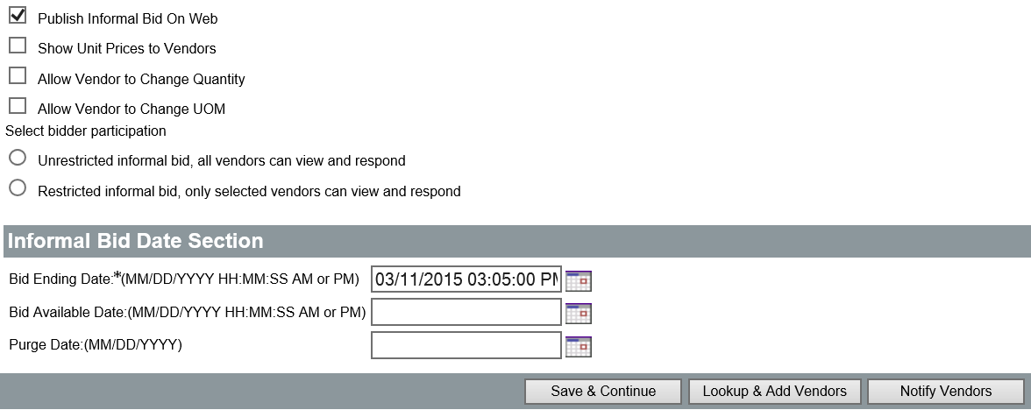
On the Send Notification screen, select the vendor(s) to which to send a notification and click the Send Notification to Selected Vendors button.
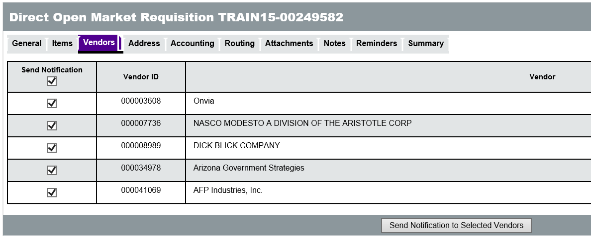
On the Compose Email screen, the user can customize the email notification Subject and Text that will be sent to the vendor(s). Any necessary attachments can also be included with the email by uploading them to the document. Click the Send Notification button to send the Informal Quote email to the selected vendor(s).
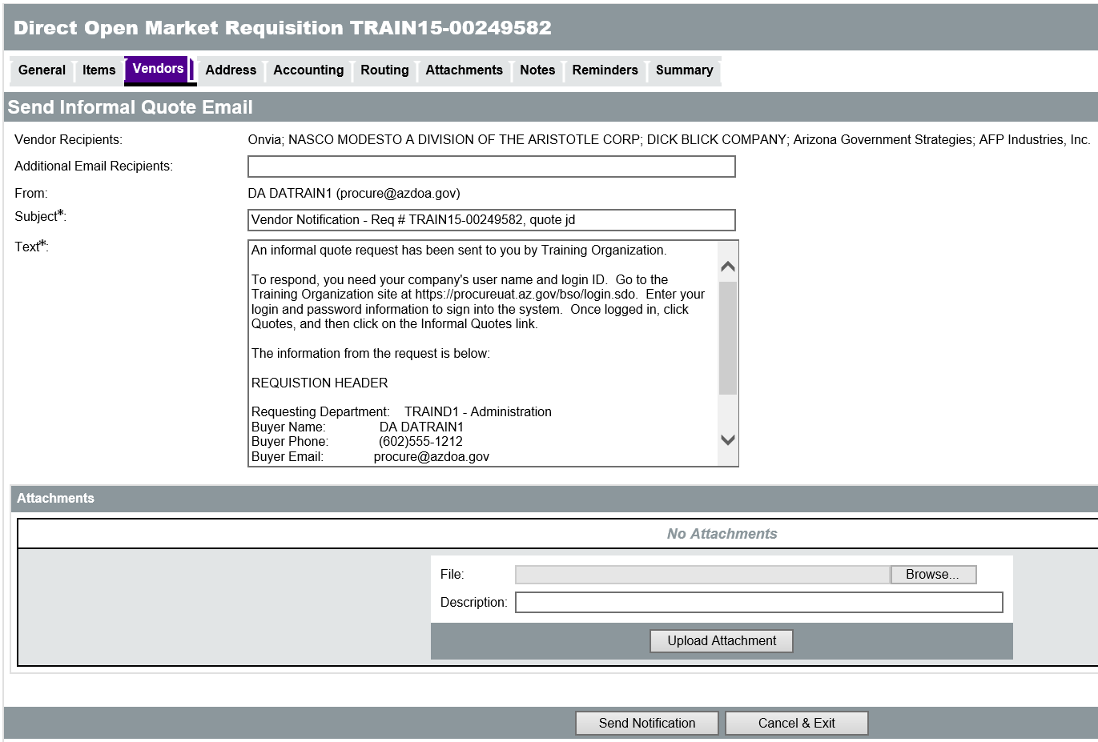
A pop up message box will ask the user to confirm the notification and state that no changes can be made to the request or the due date. Click OK to confirm the notification and display the Vendor Notification Result page.
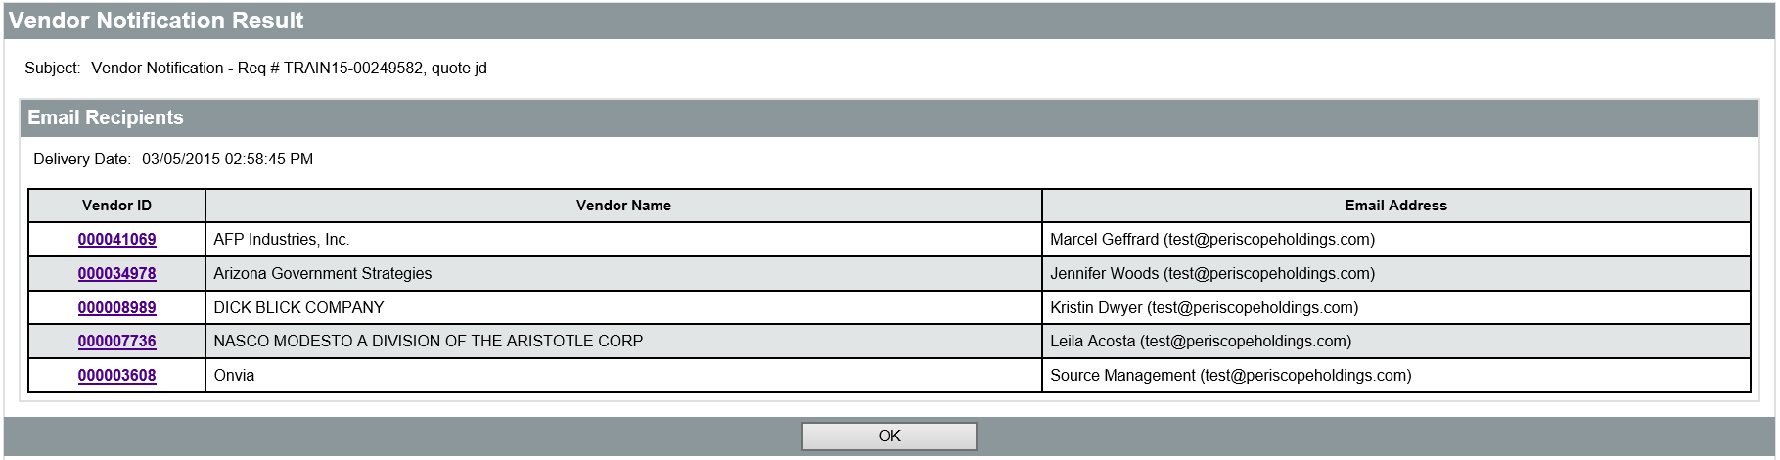
Click the OK button to return to the Vendors tab of the document. New vendors can be added and notified by following the steps outlined above until the Bid Ending Date and only newly added vendors will receive an email when the Notify Vendors button is clicked.

  - Response
When a vendor receives a notification, they can view the Informal Quote by logging into ProcureAZ and navigating to the Quotes > Informal tab. Once they have created the Informal Quote with the pricing information and clicked either of the Save buttons, the price quote will be submitted for review.
If price quotes have been received from vendors outside of ProcureAZ, they can be documented on the Vendors tab of the Requisition. For the selected vendor, click the Create link in the Informal Quote column and enter the pricing information that they provided into the Informal Quote. The screen displayed is the same as the screen the vendor sees when creating a price quote.
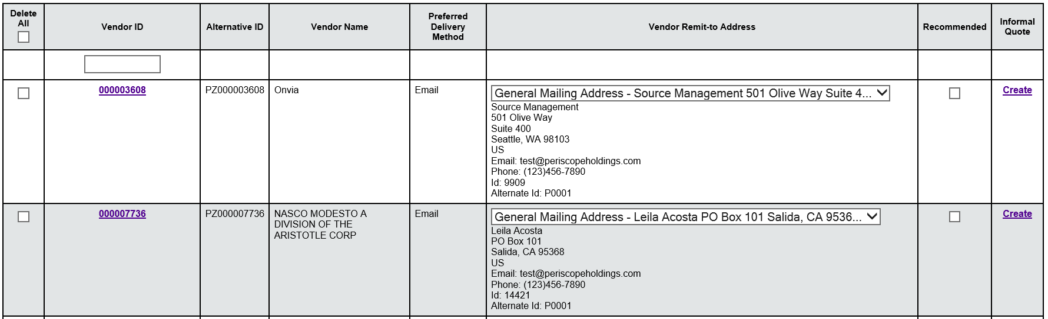
Enter the Unit Cost, Tax Rate, and any Freight cost associated with the Items on the Informal Quote. Once the pricing information has been entered, click the Save & Continue button to display the Manage Attachments and Apply Pricing to Req Items buttons. When finished entering the Informal Quote, click Save and Exit to return to the Vendors tab.
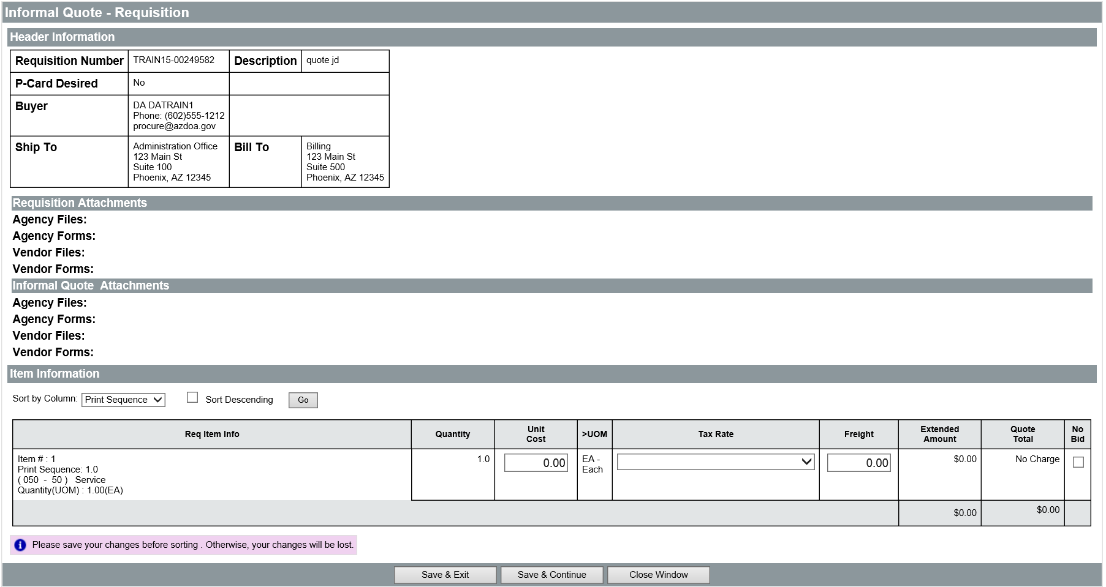

Manage Attachments
Click the Manage Attachments button to display the Attachment screen.
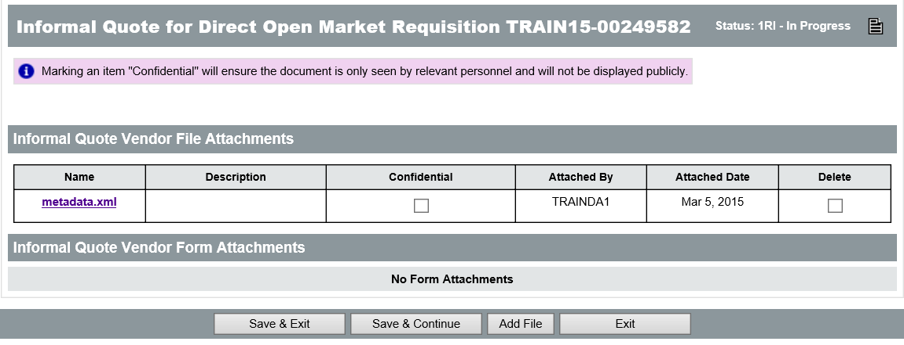
Click the Add File button to display the Add File screen. To attach a file to the quote, click the Browse button, locate the file to include, and click Open. Enter a Name for the file to display on the quote and click either Save & Exit to exit or Save & Continue to add additional attachments. On the Attachment screen, click Save & Exit to return to the Informal Quote.
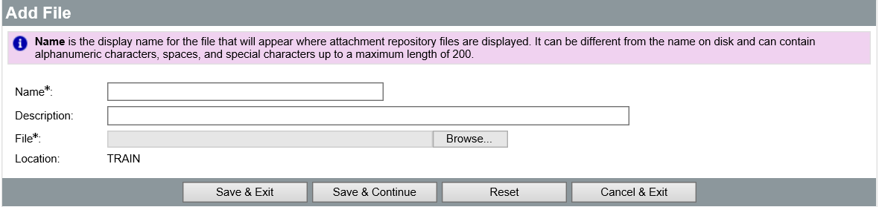

Apply Pricing to Req Items
The Apply Pricing to Req Items button is used to apply the quoted quantity, cost, tax rate, unit of measure, and freight cost to the corresponding Items on the Requisition. This process is discussed further in the next section, Review and Recommendation.

  - Review and Recommendation
Once all price quotes have been received from vendors and entered into ProcureAZ, the Informal Quote column displays a View/Edit link that allows users with the Requisitioner role to view and modify a price quote. A new Informal Quote Tabulation button also appears at the bottom of the screen that is used to compare all of the available price quotes.

Pricing can be applied to the Requisition Items from either the individual price quote or the tabulation screen.
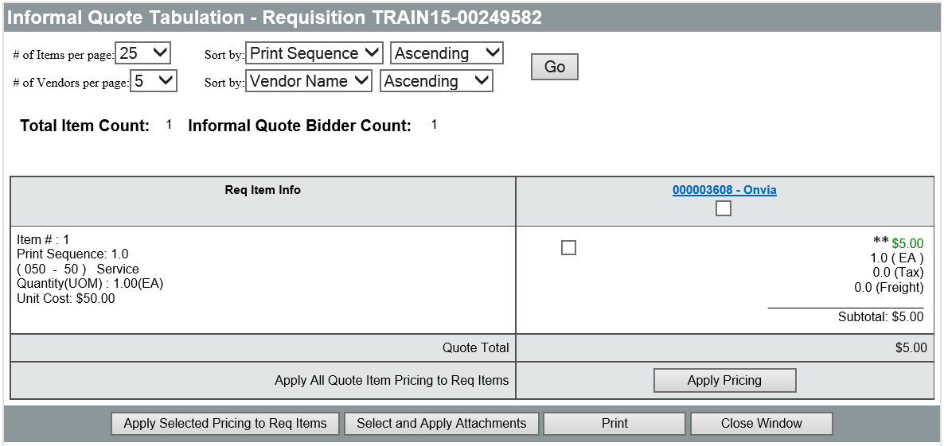

Single Price Quote
On the individual Informal Quote screen for a vendor, users can review the submitted price quote and edit the information if necessary. To apply the pricing and set the vendor as recommended, click the Apply Pricing to Req Items button at the bottom of the screen. A pop-up window appears to warn you of the change to the Requisition.

Compare Price Quotes
On the Vendor tab, the Informal Quote Tabulation button is used to compare all submitted quotes side-by-side. On the Tabulation page, the number of Items and Vendors displayed and the sorting method can be changed.
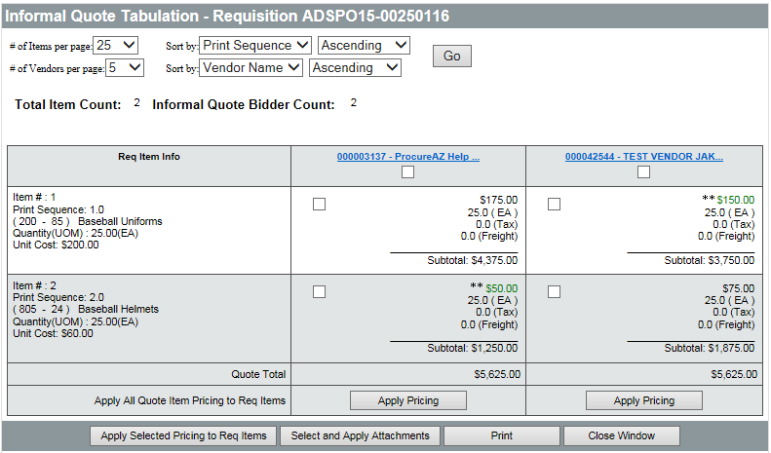

Recommendation
For the Requisition Items, a single vendor can be recommended for all Items or a different vendor can be recommended for each Item. To recommend a single vendor, click the Apply Pricing button within that vendor’s column. This will select the check box next to each Item’s price quote for that vendor and mark the vendor as the Recommended Vendor for the Requisition Items. To recommend different vendors for each Item, click the check box next to a price quote for each Item, then select the Apply Selected Pricing to Req Items button. If a different vendor is recommended for each Item or a combination of Items, multiple Purchase Orders will be created since a PO may only have one vendor.
The quoted cost from the recommended vendor will be applied to the corresponding Items on the Requisition.
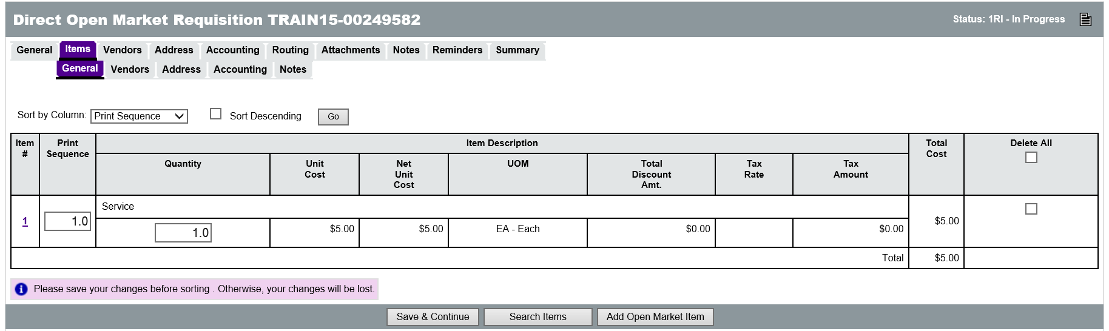
  - Create a Purchase Order
The Informal Quote process is used to complete the Item information on an Open Market or Direct Open Market Requisition. Completed Requisitions are converted into Purchase Orders.

Direct Open Market Purchase Order
When creating a Direct Open Market Requisition, pricing must be applied from the quotes to every Requisition Item before completing the Requisition and converting it to a Purchase Order. Department Buyers or Department Access users with the Department Buyer role can convert a Direct Open Market Requisition to a Purchase Order.

Open Market Purchase Order
When creating an Open Market Requisition, it is recommended that all pricing and quantity information be entered before submitting the Requisition to Procurement for conversion to a Purchase Order. Department Access users without the Department Buyer role cannot convert an Open Market Requisition to a Purchase Order.

Activity 6.6

Process an Informal Quote and Recommendation
Scenario
You would like to submit a Requisition for Informal Bid by three (3) vendors in order to get the best possible price. You will open an existing Requisition that is already in progress and complete the Informal Bid options. You will then enter the pricing information for the quotes and complete the Requisition.
Setup
- User is logged in to the ProcureAZ home page as a Basic Purchasing (BP) user.
Steps
- Create the new Requisition document.
  - In the Header Bar, click Documents.
  - Hover the mouse over Requisitions. The Requisitions menu expands.
  - Click New. The New Requisition document opens.
- Complete the data entry on the General tab.
  - In the Requisition Type drop down menu, select Direct Open Market.
  - In the Short Description field, enter Special Signage.
  - Click the Save & Continue button. Observe the Confirmation Message that is displayed.
  - On your Training Card, write down the Requisition Number that has been assigned to the Requisition in the space provided for Activity 6.1.
- Add an Item to the Requisition.
  - Click the Items tab.
  - On the Items > General tab, click the Add Open Market Item button.
  - In the Description field, enter Warning sign, at least 3 x 4 with post.
  - In the Quantity field, enter 6.
  - In the Unit Cost field, enter 150.
  - In the UOM drop down menu select EA for Each.
  - In the NIGP Class field, click the eyeglass icon. The NIGP Code Browse page opens in a pop-up window.
  - In the NIGP Keyword field, enter signage.
  - Click the Search button.
  - In the results, click the radio button for 559-70 Signage (Includes Destination, Routing and Advertising).
  - Click the Save & Exit button.
- Add another Item to the Requisition.
  - On the Items > General tab, click the Save & Add New button.
  - In the Description field, enter Trail Sign.
  - In the Quantity field, enter 12.
  - In the Unit Cost field, enter $75.
  - In the UOM drop down menu select EA for Each.
  - In the NIGP Class field, click the eyeglass icon. The NIGP Code Browse page opens in a pop-up window.
  - In the NIGP Keyword field, enter signage.
  - Click the Search button.
  - In the results, click the radio button for 559-70 Signage (Includes Destination, Routing and Advertising).
  - Click the Save & Exit button.
- Complete the Informal Bid options.
  - In the Requisition, click the Vendors tab.
  - Click the Lookup & Add Vendors button.
  - Click the Find Vendors for All Commodity Code on the Req button.
  - Select the first 3 vendors in the list by checking the box in the left column.
  - Click Save & Exit.
  - Check the Publish Informal Bid On Web check box.
  - Check the Restricted informal bid option.
  - In the Bid Ending Date field, select the next business day.
  - Click Save & Continue.
- Enter the informal quote information for the first vendor.
  - On the Vendors tab, for A & A Cottages, click the Create link in the Informal Quote column.
  - On the Informal Quote page, in the Unit Cost field, enter 5.
  - Click Save & Continue.
  - Click Manage Attachments.
  - Click Add File.
  - On the Add File page, click the Browse button.
  - Select the Vendor Quote 1 file.
  - Click Open.
  - In the Name field, enter Quote 1.
  - Click Save & Exit.
  - Click Save & Exit again.
- Enter the informal quote information for the second vendor.
  - On the Vendors tab, for the second vendor, click the Create link in the Informal Quote column.
  - On the Informal Quote page, in the Unit Cost field, enter 6.
  - Click Save & Continue.
  - Click Manage Attachments.
  - Click Add File.
  - On the Add File page, click the Browse button.
  - Select the Vendor Quote 2 file.
  - Click Open.
  - In the Name field, enter Quote 2.
  - Click Save & Exit.
  - Click Save & Exit again.
- Enter the informal quote information for the third vendor.
  - On the Vendors tab, for the third vendor, click the Create link in the Informal Quote column.
  - On the Informal Quote page, in the Unit Cost field, enter 4.
  - Click Save & Continue.
  - Click Manage Attachments.
  - Click Add File.
  - On the Add File page, click the Browse button.
  - Select the Vendor Quote 3 file.
  - Click Open.
  - In the Name field, enter Quote 3.
  - Click Save & Exit.
  - Click Save & Exit again.
- Complete the vendor recommendation process for the Requisition.
  - On the Vendors tab, click the Informal Quote Tabulation button.
  - For the vendor with the lowest Quote Total, click the Apply Pricing button.
  - In the pop up window, click OK.
  - Click the Apply Selected Pricing to Req Items button.
  - Click the Close Window button.
- Optional: Submit the Requisition for approval.
  - Click the Summary tab.
  - Review the information on the Summary tab.
  - Click the Submit for Approval button.
  - In the pop up window, click OK.
  - Select Automatic approval.
  - Click Save & Continue.
  - In the Navigation Bar, click Home to return to the Home Page.

Lesson Summary
In this lesson you:
- Identified the creation process for an Informal Bid solicitation
- Reviewed the configuration options for an Informal Bid solicitation
- Examined the process of adding vendors that can submit price quotes
- Reviewed the vendor response options
- Identified the process of reviewing and recommending vendors for Requisition Items
- Reviewed the methods for converting the Requisition into a Purchase Order

Check Your Progress
- The Informal Quote process can only be processed for off-contract goods and services.
  - True
  - False
- All Informal Quote requests must be received by vendors through ProcureAZ.
  - True
  - False
- What are the 3 decisions that need to be made when configuring the Informal Quote process?
  - Available Items, Restricted/Unrestricted Vendors, and Publishing on the Web
  - Restricted/Unrestricted Vendors, Publishing on the Web, and Available Dates
  - Delivery Method, Available Dates, and Available Items
  - Recommended Vendors, Unit Pricing, and Tax Cost
- Recommended vendors can be applied ____________.
  - As a single vendor for all Items
  - As a different vendor for each Item
  - As a backup vendor for each Item
  - Both a and b

