7 Off Contract
RPA

This page was intentionally left blank.
Contents
7. Off Contract Ordering – RPA Requisition 1
Learning Objectives 1
Lesson Overview 1
7.1. Create an RPA Requisition 2
General Tab 2
Invoice Method 3
Adding and Editing Items 3
Search Items 4
Add RPA Item 5
Quantity and Cost 7
Discount and Markup Percentage 7
NIGP Code Search 7
Invoice Number 8
Payment Due Date 8
Item List 8
Sorting 8
Vendors Tab 9
Vendor Add Request 10
Remit-To Address 10
Address Tab 10
Apply Addresses on Header 10
Apply Addresses on Line Items 11
Accounting Tab 11
Add Accounting to Header 12
Add Accounting to Line Items 12
Accounting Verification 12
Adding and Removing Attachments 13
Attaching a Document 13
Attachment Modification 14
Adding, Editing, and Deleting Notes 14
Item Notes 14
Managing Reminders 15
Create a Reminder 15
Modify and Delete Reminders 15
My Reminders 15
Reviewing and Submitting the Requisition 16
Submit For Approval 16
Activity 7.1 18
Create an RPA Requisition 18
7.2. RPA Purchase Orders, Receipts, and Invoices 21
Lesson Summary 22
Check Your Progress 23

- Off Contract Ordering – RPA Requisition

Learning Objectives
In this lesson, you will:
- Create an RPA Requisition
- Review the RPA Purchase Order, Receipt, and Invoice process

Lesson Overview
This lesson introduces the Request for Purchase Authorization (RPA) process in ProcureAZ. The process begins with the creation of an RPA Requisition document on which Item, Vendor, and Accounting information is entered. Following the submission and approval of a Requisition, an RPA Purchase Order, Receipt, and Invoice are created.
In the activities in this lesson, users will gain work applicable experience in the ProcureAZ training environment by navigating and creating the various documents in the RPA lifecycle.

  - Create an RPA Requisition
An RPA is required when a purchase has been made for goods or services outside of ProcureAZ. The RPA process records the purchase details and, upon final approval, automatically completes the transactions that normally follow a Requisition: the Purchase Order, Receipt, and Invoice document creation. The RPA process is typically only used for emergency purchases and the RPA Requisition requires that users enter the explanation for the purchase. This explanation must include the estimated business impact that would have occurred by following the standard procurement procedure.
The process of creating a new RPA Requisition begins by using the menu in the Header Bar to select Documents > Requisitions > New. This will display the New Requisition document General tab. It is recommended that documents are completed by following the tabs from left to right.

General Tab
The Requisition General tab is used to enter detailed information that defines the document as a whole. There are several required fields on the General tab. Optional fields can be completed if applicable.
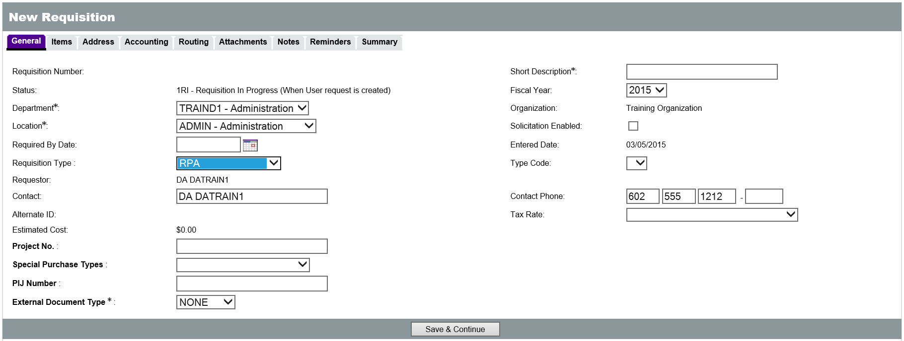
The new Requisition will have a status of 1RI, Requisition In Progress, which means that it is currently being entered by the user. The Department and Location fields contain drop down menus for selection, but these fields will default to the values stored in the user’s profile. The Short Description field is required and should contain a brief but sufficient description of the goods or services being purchased, for example, “Office Supplies for Payroll.” The Requisition Type field contains a drop down menu for the type of Requisition, and should be set to RPA. The rest of the fields are optional and can be entered or changed, if applicable. One of the optional fields on the General tab is the Invoice Method field.

Invoice Method
The Invoice Method field on the General tab is used to select whether Two Way or Three Way Match will be used for the Requisition/Purchase Order. Two Way Match is a new option in ProcureAZ that requires only a Purchase Order and an Invoice to be created when invoicing. Selecting Three Way Match means that invoicing will require a Purchase Order, a Receipt, and an Invoice. Three Way Match is the default Invoice Method and requires that the full documentation trail be created for a purchase.
New
Feature
Tip: Two Way Match is a role granted to specific users by their agency. If users do not have the Two Way Match role, they will not see the Invoice Method field and the Requisition/Purchase Order Invoice Method will default to Three Way Match.
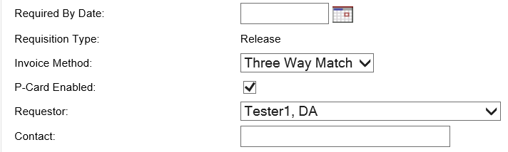
When the General tab is complete, clicking the Save & Continue button at the bottom of the screen will save the current document and allow the user to continue filling out the rest of the document.
Saving the document will create the Release Requisition and assign a Requisition Number which can be used to locate and reference the document. The document status will still be In Progress and it can be accessed and completed later, if necessary, by navigating to Documents > Requisitions > In Progress, or by searching for the Requisition number.
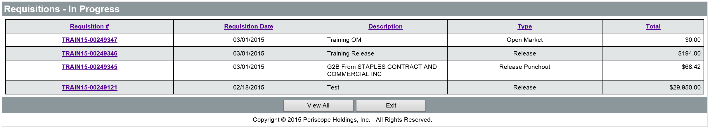

Adding and Editing Items
On the Items tab of the RPA Requisition, there are two ways to add line Items: search by keyword, contract, or PO information (similar to a Release Requisition) or manually create the Item (similar to an Open Market Requisition).
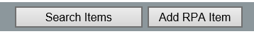
Regardless of how the Items are added to the RPA, any Item details can be modified as if they were created manually. When all Items have been added to the Requisition, click the Save & Continue button and proceed to complete the rest of the document.

Search Items
Click the Search Items button to display the Search Items page. There are two ways to search for Items: the keyword search field and the Advanced Search criteria section.
For a keyword search, enter the keyword into the Search Using field and click the Find It button. All search results that contain the keyword will be displayed below.
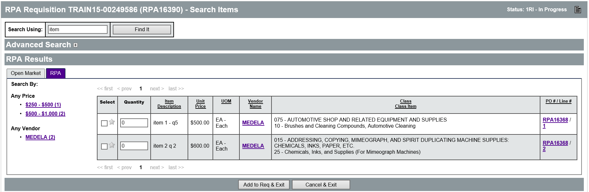
To use the Advanced Search criteria section, expand the section to view the fields. The recommended way to add Items is to use Advanced Search to search by Contract/PO #. Enter the number provided on the contract and click the Find It button to display all of the Items on that contract.
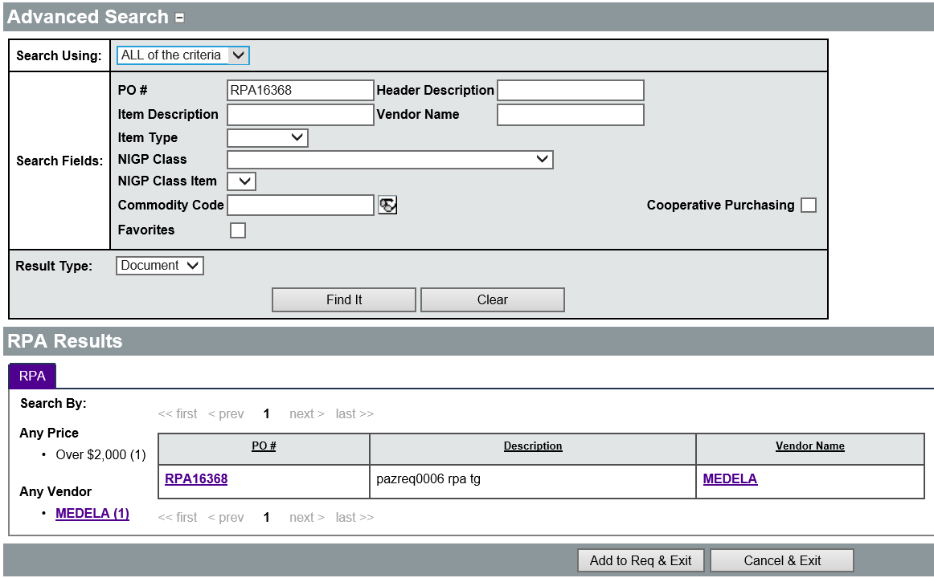
In the search results, locate the desired Item and enter the Quantity to be ordered. Users can also add the selected Item to their Favorites by clicking the Star in the left column. Once a Quantity has been specified for all desired Items, click the Add to Req & Exit button.
The Requisition Items tab will display the selected Items along with their price and other information.
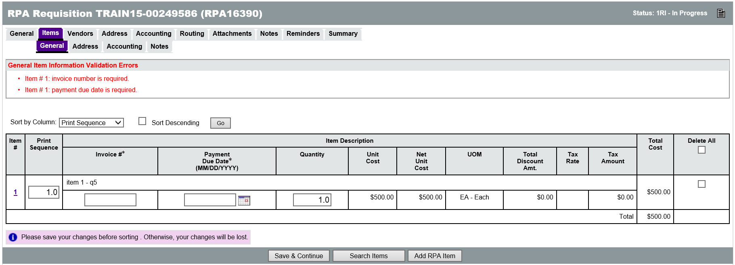

Add RPA Item
Click the Add RPA Item button to manually create a new Item. In order to create a new Normal Item in ProcureAZ, the following fields are required:
  - Print Sequence – The line sequence number determines the order in which the items will appear to vendors. This will default to the order in which Items are added to the Requisition and does not need to be changed.
  - Item Type – This value can either be Normal or Narrative. Normal items can be ordered. Narrative items only allow a Description, Project, Building Code, Cost Code, and Property Number to be entered.
  - Description – Enter the definition of the good or service being requested. For Narrative items, this can be instructions or other information.
  - Quantity – Enter the total number of the item being requested. See the information on entering quantities and costs below.
  - Unit Cost – Enter the estimated cost of one unit of the item. See the information on entering quantities and costs below.
  - Unit of Measure – Select the unit of measure for the item from the drop down menu.
  - NIGP Class – If known, the 3-digit NIGP Class code for the item can be entered directly in the field. The code can also be selected from the drop down menu or searched for using the eyeglass icon. For more information, refer to the NIGP Code Browse section in Lesson 2.2.
  - NIGP Class Item – If known, the 2-digit NIGP Class Item code for the item can be entered directly in the field. The code can also be selected from the drop down menu or searched for using the eyeglass icon next to the NIGP Class drop down. For more information, refer to the NIGP Code Browse section in Lesson 2.2.
Other optional fields available when creating an Item include: Discount %, Total Discount Amt., Tax Rate, Manufacturer, Brand, Model, Make, and Packaging.
The Tax Rate is based on where the order is coming from. For example, if the vendor is in Flagstaff, then that is the Tax Rate that should be used. The Tax Rate should always be entered when the vendor is known. If the vendor is out of State, then the AZ State Tax rate should be chosen (use tax) if the agency wants to encumber the use tax.
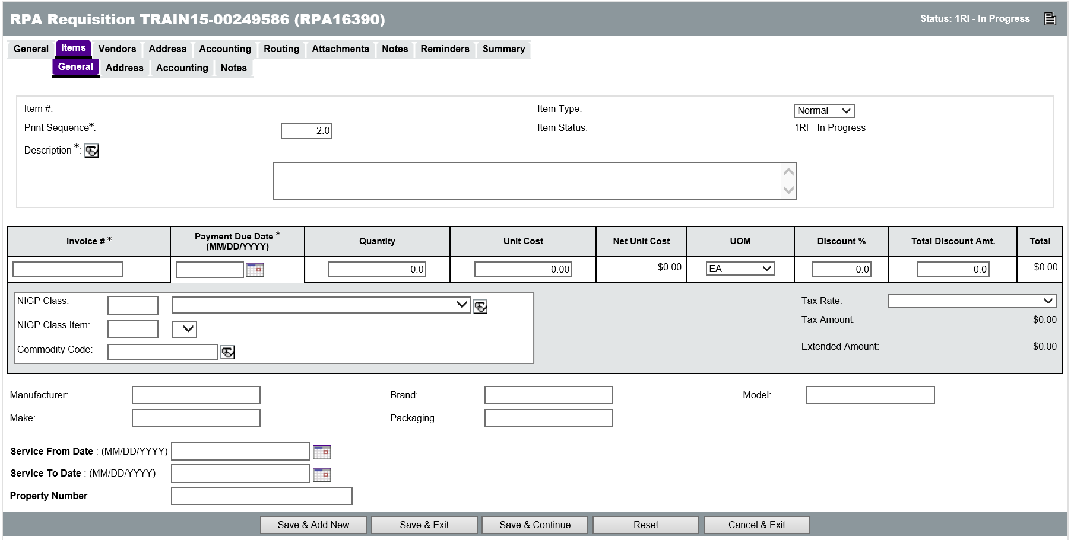

Quantity and Cost
If the Item being entered will be received by quantity, such as chairs or desks, enter the exact number and unit of measure for the items being purchased, for example 50 and Each. If a service is entered that will be paid for based on an invoice amount, for example 4 hours of consulting services, enter a quantity of 4, a unit of measure of Hourly, and the estimated cost per hour for the service. The estimated cost is required even if the Requisition must go through a formal solicitation process.

Discount and Markup Percentage
Only one of the Discount % and the Total Discount Amt. fields can be entered. Entering a Discount % will automatically calculate the Total Discount Amt. and vice versa. In order to process a discount, the Discount % field must be a positive number or the Total Discount Amt. field must be a negative number. A negative number in the Discount % field or a positive number in the Total Discount Amt. field signifies a markup.

NIGP Code Search
The NIGP Class and Class Item fields allow searching for the appropriate class and item records to assign to the Item. This will open the NIGP Code Browse page in a pop-up window (Pop-up blocker should be disabled when working with ProcureAZ). The NIGP Keyword search field allows users to search by keyword. Enter a keyword in the box and click the Search button. It may be necessary to try different keywords in order to find one that returns the desired results. When the appropriate Class and Class Item have been found, select the radio button for the Class Item and click the Save & Exit button to populate the fields on the Requisition. For more information on using the NIGP Code Browse feature, refer to Lesson 2.2.
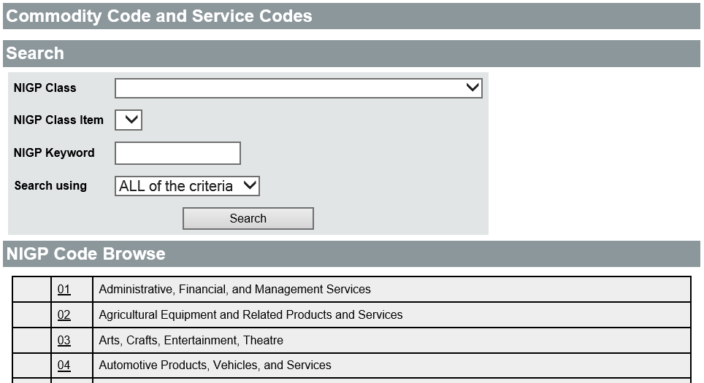

Invoice Number
For each Item added to the RPA Requisition, the Invoice number is required. Users must enter the Invoice number on the Invoice received from the vendor.

Payment Due Date
For each Item added to the RPA Requisition, the Payment Due Date stated on the Invoice must also be entered. The date can be selected by clicking the calendar icon next to the field.

Item List
From the list of Items on the Requisition, it is possible to edit the current items, continue adding items, delete existing items, modify the print sequence, or modify the quantity of existing items. To edit an existing line item description, click the Item Number link in the first column. To add additional Items, click either the Search Items or Add RPA Item button. To delete an item, check the Delete check box in the last column on the right and click the Save & Continue button. Checking the Delete All check box will mark all lines for deletion. To modify the print sequence or quantity, enter the new value in the corresponding field, and click the Save & Continue button.

Sorting
The Item list can also be sorted by different columns by selecting the desired column from the Sort by Column drop down menu. The Descending check box will change the sorting order to descending.
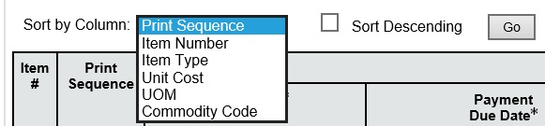
The sorting method selected is enabled by clicking the Go button. It is important to remember to save any changes made on the Item list screen before changing the sorting method because changes will be lost otherwise.

Vendors Tab
On the Vendors tab, users must manually add the vendor from which the goods were purchased. If the vendor is already registered in ProcureAZ, the Lookup & Add Vendor tool can be used to locate them by Vendor ID, Name, Keyword, or other information. If the vendor is not registered in ProcureAZ, the user will need to manually enter the new vendor using the Vendor Add Request button on the Lookup & Add Vendor page.
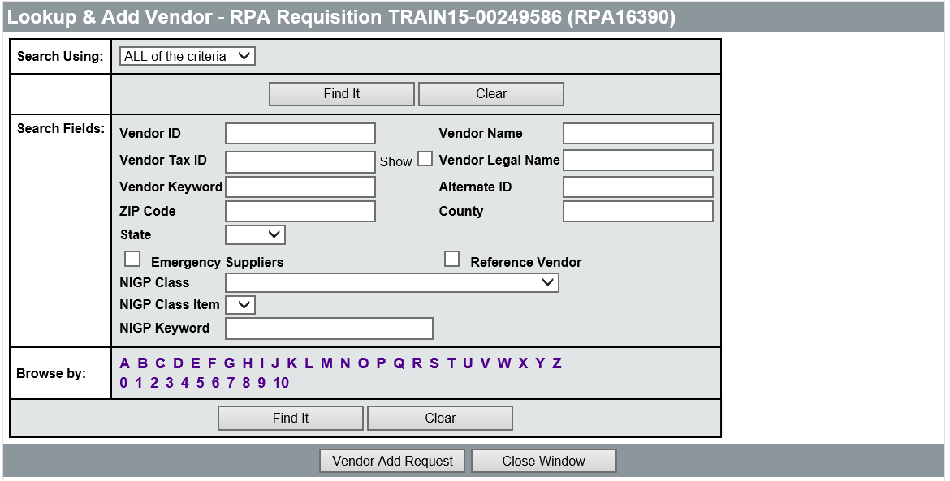
When the vendor has been added, click the Save & Continue button to continue completing the Requisition.
Users should perform a thorough search for the vendor on the vendor lookup page before using the Vendor Add Request option. If the vendor is located in the system, select the vendor and click the Add Vendor button to add the vendor to the Requisition.

Vendor Add Request
ProcureAZ Help Desk does not offer this service; this functionality should not be used in ProcureAZ.

Remit-To Address
On the Vendors tab, once a vendor has been added to the Requisition, the Remit-to Address field provides a drop down list that can be used to select a different address for the vendor.

Address Tab
Address information can be added at the document level on the Header > Address tab or at the individual Item level on the Items > Address tab. Address information entered at the Header level will apply the same information to all of the Requisition Items. A Ship-to and Bill-to address is required for all Requisition Items.
If the Department selected on the Header > General tab has a default Ship-to and Bill-to Address assigned, then those addresses will automatically populate the Header > Address tab on the Requisition. If the Department selected has multiple Ship-to or Bill-to Addresses configured, and they need to be changed at the document level, the Header > Address tab is used to apply the change. If the addresses need to be changed at the individual Item level, the Item Address tab is used to apply the change.

Apply Addresses on Header
All available addresses for the selected Department will appear in the drop down list for the Ship-to and Bill-to Address fields. If the address for the either the Ship-to or Bill-to Address has been changed, click the Save & Continue button to apply the change at the Header level, then click the Apply Ship-to to All Items button and/or the Apply Bill-to to All Items button to apply the change to all of the Requisition Items Ship-to and/or Bill-to Addresses respectively.
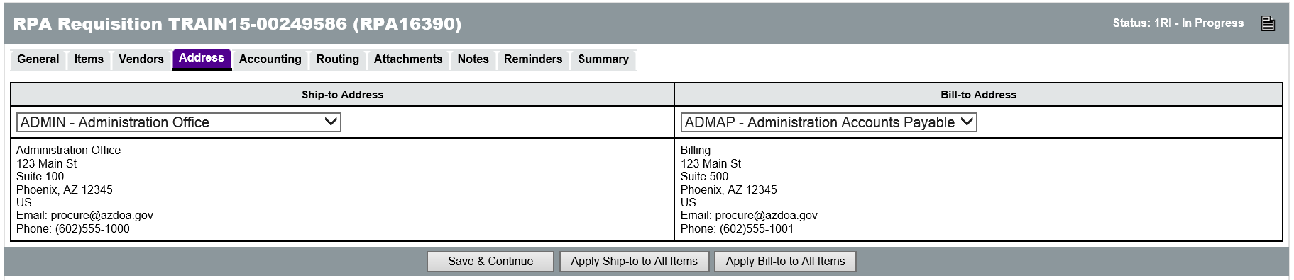

Apply Addresses on Line Items
If Items need to be shipped to different addresses, or if vendors need to send invoices to different addresses for different Items, then use the Items > Address tab to select the addresses for each Item. To apply a different address to multiple Items simultaneously, select the Items and use the Ship-to or Bill-to Address fields at the bottom of the page to select a different address. The Apply to Selected button will apply the selected address to the selected Items. The Apply to All Items button will apply the selected address to all of the Requisition Items. The Reset Selected to Header button will change any Ship-to or Bill-to Address to match the address on the Header > Address tab. When changes are complete, click the Save & Continue button to save the changes.

Accounting Tab
Accounting codes can be added at the document level on the Header > Accounting tab or at the individual Item level on the Items > Accounting tab. Accounting codes entered at the Header level will apply the same information to all of the Requisition Items. Accounting codes are required for all Requisition Items. Users will need to know the Accounting information for their Department, or have an Accounting Template or Function code that, when entered, will infer the appropriate Accounting information during the interface process with AFIS.
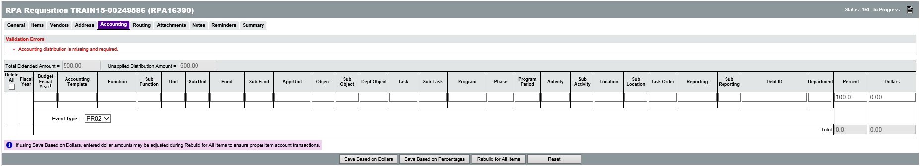
TIP: If no accounting information is available to the user, placeholder accounting codes can be entered temporarily. The correct accounting codes will need to be entered for the Items prior to applying the final approval to the Requisition.
If the Accounting information is not inferred from the Accounting Template or Function code, the Accounting fields that require data entry are:
  - Budget Fiscal Year
  - Unit
  - Fund
  - Appr Unit
  - Object
  - Task
The Object code will be inferred from the NIGP code, but can be entered if your agency has special expectations or usage for the Object code.

Add Accounting to Header
On the Header > Accounting tab, the Accounting codes can be entered into their respective fields. At the far right of the page (scrolling is necessary) there are fields for entering the Percent or Dollar distribution for the Accounting line. If multiple Accounts are responsible for payment of the request, their responsibility amount can be entered as either a percentage of the total or a dollar amount. Only the Percent field or the Dollars field can be used but not both.
Entering a value into one field will automatically calculate the other when the changes are saved. If the Percent field is used, the Save Based on Percentages button will update the Dollars. If the Dollars field is used, the Save Based on Dollars button will update the Percent. The sum of the percentages must equal 100 and the sum of the dollars must equal the total amount of the cost of the Items on the request. The Unapplied Distribution Amount must always be 0.
Once all Accounting information has been entered and the Unapplied Distribution Amount is 0, clicking the Rebuild for All Items button will apply the Accounting information to all of the Requisition Items.

Add Accounting to Line Items
When Accounting codes must be different for each line item on the Requisition, the Items > Accounting tab must be completed. On this screen, each Item on the Requisition is displayed. Clicking the Item Number for an Item will display the same screen used on the Header, except that it applies only to the individual Item. The same Accounting information is required on this page and the Percent or Dollars fields can be used to distribute the cost of an Item across multiple accounts.
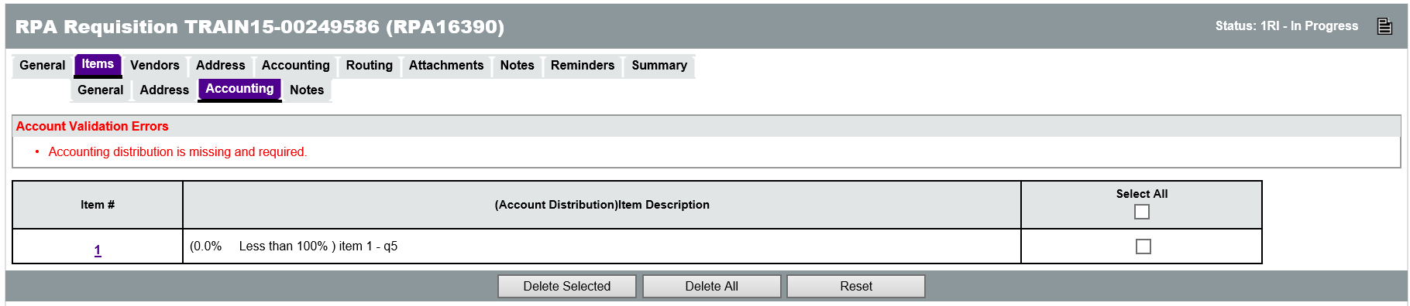
After entering the last Accounting line for an Item, but before saving, you can tell the system what to display after clicking one of the save buttons. The available options are: Current Page, Next Item, Previous Item, and Exit.
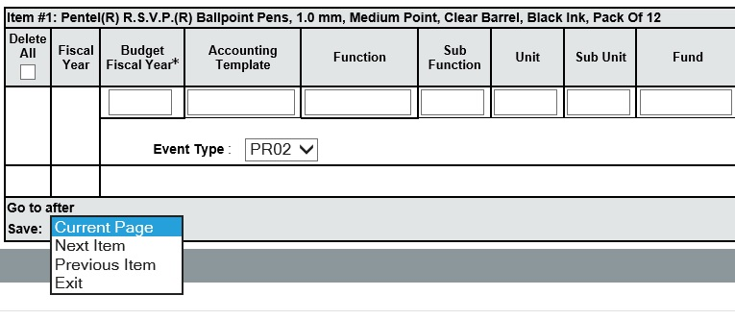

Accounting Verification
When the Requisition is submitted for approval, approvers can change the Accounting codes that have been entered if necessary.

Adding and Removing Attachments
The Header > Attachments tab is used to view any existing attachments and add new attachments to the Requisition. State Procurement Office administrators can add default attachments to all new Requisitions so there may be attachments on the document that you did not add. The Attachments tab will display the number of attachments on the document in parenthesis. For example, Attachments(2) means that there are 2 attachments on the Requisition.
There are two Attachment tabs, one for Agency uploaded documents, and one for Vendor uploaded documents. Agency users can only upload documents to the Agency tab. If the document should not be viewable by vendors, the Show Vendor check box should be unchecked (it is checked by default). Vendors can only upload documents to the Vendor tab.
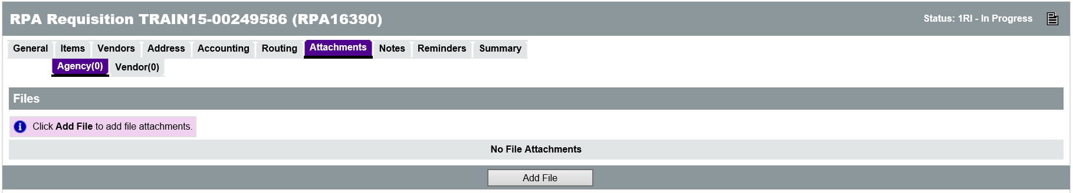
Any supporting documents for the purchase must be scanned and attached to the Requisition as specified by policy. This might include documentation such as specification sheets, scope of work reports, or hard copy quotes. All Requisitions must include specifications for goods or services and, if sufficient detail cannot be contained in the Item Description field, any appropriate supporting documents must be attached. It is important that any attached document name accurately describes the document.

Attaching a Document
On the Attachments > Agency tab, click the Add File button. On the Add File page, the Name field is the display name for the file that will appear wherever attachment repository files are displayed. The Name can be different than the name of the file and can contain alphanumeric characters, spaces, and special characters up to a maximum length of 200 characters. If no Name is entered, it will default to the file name. The Description field is optional but can be used to enter a longer description of the file, its purpose, or any notes/comments about the file.
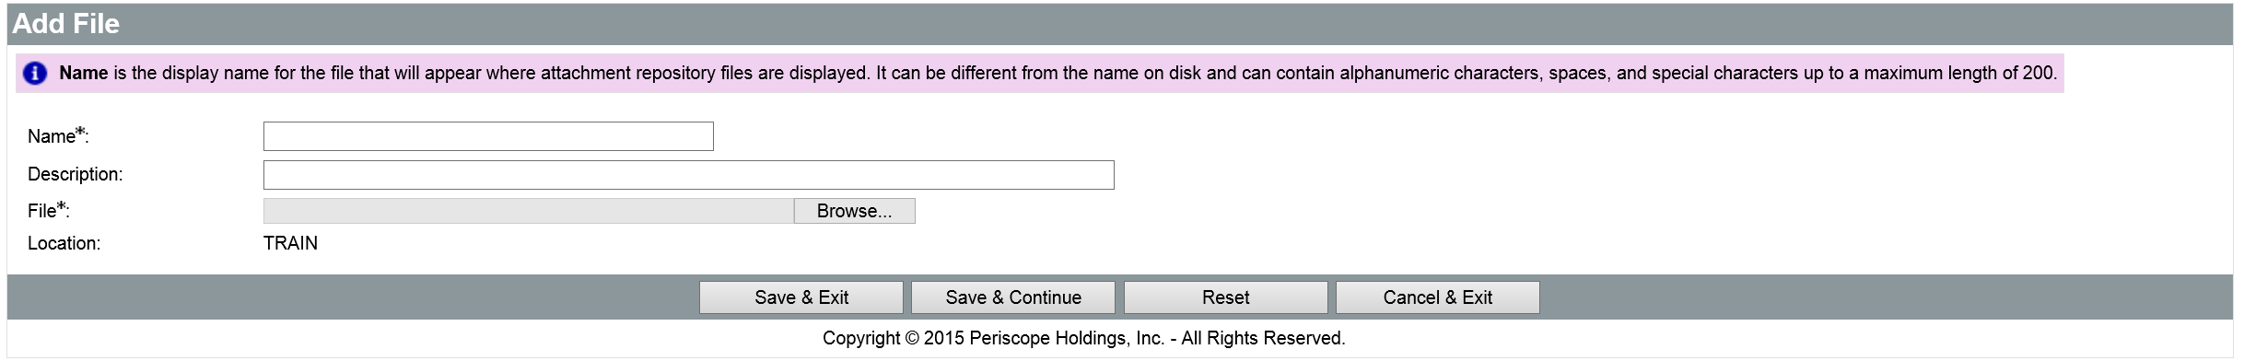
Clicking the Browse button will display a File Explorer window that allows the user to navigate to the folder location on the local machine or shared drive and select the file to upload. When the appropriate file has been selected, click Open in the File Explorer window to add the file path to the Attachment screen.
When all fields have been completed and the file has been selected, click the Save & Exit button to upload the file to ProcureAZ and attach it to the Requisition. To attach more files, click Add File.

Attachment Modification
On the Attachments > Agency tab, the Show Vendor check box determines whether the vendor can view the attachment and the Delete check box will delete the attachment from the Requisition. After changing either of these settings, click the Save & Continue button to apply the changes.
The Name of the file is a link to the file detail screen. On the Attachment File Detail screen, only the Description can be modified. The file can also be downloaded by clicking the Download icon. If the Description has been changed, save the changes by clicking the Save & Exit button.

Adding, Editing, and Deleting Notes
The Header > Notes tab is used to add notes about the Requisition document that are only visible to Organization users who access the document. Notes are entered in the Note field, which allows multiple lines of text to be entered. When one note is entered, clicking the Save & Continue button will save the note and add a new blank Note field for another note. Any notes that are saved to the document are stamped with the date they were added. Checking the Delete check box and clicking the Save & Continue button will remove the note from the document. The reset button will revert any changes made to the notes since the document was last saved. Like Attachments, the number of Notes added to the document will display in the tab name in the Header > Notes tab.
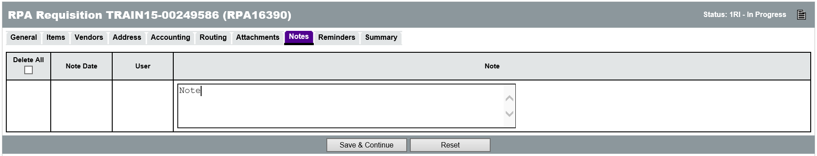

Item Notes
Notes can also be added to an individual Item on the Requisition on the Items > Notes tab. On this page, clicking the Item Number will display the same screen as the Header > Notes tab except that these Notes are added to a specific Item. Both header level and item level notes will follow on to the Purchase Order.

Managing Reminders
The Reminders tab on a Requisition is used to create automatic reminders that will notify a user prior to the due date of the Requisition. When there are no reminders, the first line is used to create a new reminder.

Create a Reminder
The Due Date field can be set to the date that the Requisition is due or any other date for which the user would like a reminder. The date picker icon can be used to select a date. The Comment field can contain text up to 250 characters and is used to type the reminder message that will be sent to the user. The Remind Whom field contains a drop down menu of all of the users in the system. Selecting a user from the list will notify that user based on the date settings on the reminder. The Days Prior to Remind field is used to specify the number of days, prior to the Due Date, that the user will be notified about the Requisition. If the Send Email check box is checked, ProcureAZ will send an email to the user with the reminder and comment.
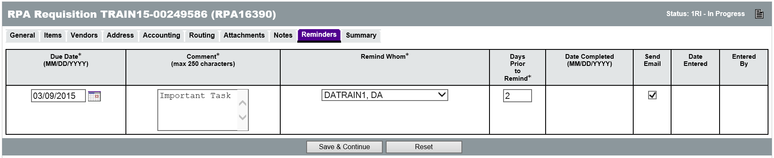

Modify and Delete Reminders
Existing Reminders can be edited and deleted on the Reminders tab of the Requisition. Only the user who added the reminder can remove it. If changes are made or the Delete check box is checked, clicking the Save & Continue button will apply the changes and/or deletions.

My Reminders
Any reminders that have been added for a user will display on that user’s My Reminders tab which is available on the Home Page. The My Reminders tab will display the number of current reminders in parenthesis. On the My Reminders page, reminders are separated into tabs by document type. The Reminder appears on the My Reminders page when the number of days prior to the due date has arrived. Reminders can be marked as complete by entering or selecting a date for the Date Complete field. This will remove the reminder from the My Reminders tab and mark the reminder as complete on the document.

Reviewing and Submitting the Requisition
The Summary tab displays all of the information on the Requisition. Any warnings or errors present in the document will be displayed at the top of the screen. Yellow warning messages will not prevent document submission but should be noted by the user. Red error messages will prevent document submission and must be addressed prior to submitting the document for review. The document creator should scan the Summary page to make sure that all data was entered correctly. Any necessary corrections can be made on the tab where that information was entered.
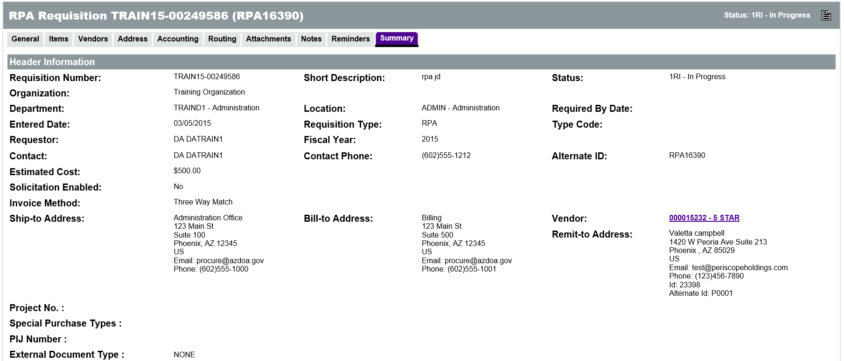
When all errors have been corrected and the Summary page has been reviewed, the document is ready to be submitted for approval. There are four buttons at the bottom of the Summary page:
  - Submit for Approval – Click this button to submit the Requisition for approval. The approval path that has been triggered by the document will appear.
  - Cancel Requisition – Click this button to cancel the Requisition. This will delete the Requisition from ProcureAZ. A warning pop-up window will ask you to confirm cancellation.
  - Clone Requisition – Click this button to create an exact copy of the Requisition. The next screen will ask you to enter the Fiscal Year for the new document.
  - Print – Click this button to display a printable version of the document.

Submit For Approval
Click the Submit for Approval button. A dialog box pop-up will ask you to confirm submission of the Requisition, click OK. If there are approvals required and auto-cascading approval paths have been set up, the Approval Path screen will display the users that need to approve the document and the order of the approvals. For non-auto cascading approval paths, users will need to select the appropriate path for the document. If no approval paths are found for the document, the document moves to the next status.
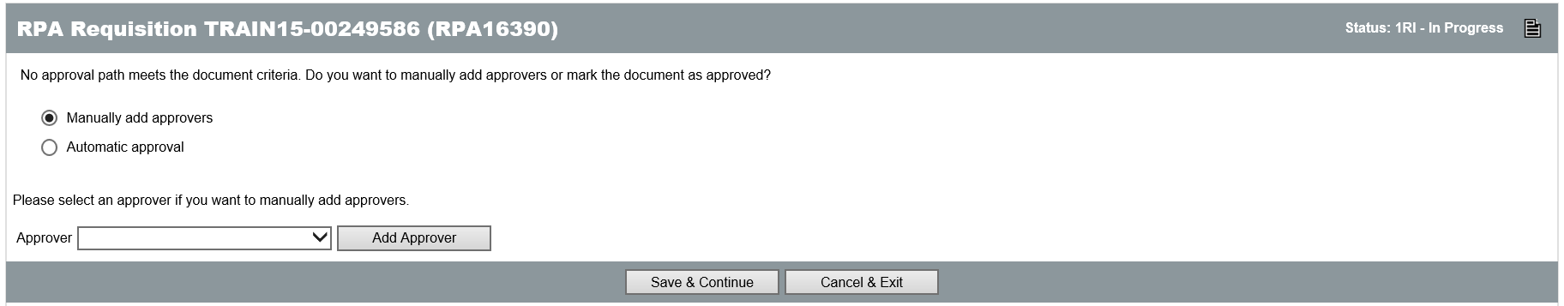
The Continue button will send the Requisition to the first approver in the Approval Path. Until the Continue button is clicked the document will remain in an In Progress status. Clicking the Cancel & Exit button will cancel document submission and return to the Summary tab of the document.
When the Continue button is clicked, if document submission is successful, a message will be displayed at the top of the screen stating that the transaction was successful. Any warning or error messages generated by the submission will also be displayed.

Activity 7.1

Create an RPA Requisition
Scenario
You purchased some supplies that were needed immediately in order to complete a project on time. You need to create and submit an RPA Requisition for the supplies that were purchased.
Setup
- User is logged in to the ProcureAZ home page as a user with the Requisitioner role.
Steps
- Create the new Requisition document.
  - In the Header Bar, click Documents.
  - Hover the mouse over Requisitions. The Requisitions menu expands.
  - Click New. The New Requisition document opens.
- Complete the data entry on the General tab.
  - In the Department drop down menu, select the Department on your Training Card.
  - In the Location drop down menu, select the Location on your Training Card.
  - In the Requisition Type drop down menu, select RPA.
  - In the Short Description field, enter Emergency Supplies.
  - Click the Save & Continue button. Observe the Confirmation Message that is displayed.
  - On your Training Card, write down the Requisition Number that has been assigned to the Requisition in the space provided for Activity 6.1.
- Add an Item to the Requisition.
  - Click the Items tab.
  - On the Items > General tab, click the Search Items button.
  - In the Search Using field, enter Inkjet.
  - Click the Find It button.
  - In the Release Results section, for the HP #27 Black Inject Cartridges, in the Quantity field, enter 1.
  - Click the Add to Req & Exit button.
  - On the General tab, in the Invoice # field, enter 12345.
  - In the Payment Due Date field, click the Calendar icon and select the date 30 days from today’s date.
  - Click the Save & Continue button.
- Add a vendor to the Requisition.
  - Click the Header > Vendors tab.
  - Click the Lookup & Add Vendor button.
  - On the Lookup & Add Vendor page, in the Vendor ID field, enter the Vendor ID from your Training Card.
  - In the results, select the radio button for the vendor that is displayed.
  - Click the Add Vendor button.
  - On the Vendors tab, click the Save & Continue button.
- Review the Address information on the Requisition.
  - Click the Header > Address tab.
  - Observe the Ship-to and Bill-to Address for the selected Department.
- Complete the Accounting information on the Requisition.
  - Click the Header > Accounting tab.
  - In the Budget Fiscal Year field, enter the current Budget Fiscal Year.
  - In the Unit field, enter the Unit on your Training Card.
  - In the Fund field, enter the Fund on your Training Card.
  - In the Appr Unit field, enter the Appr Unit on your Training Card.
  - In the Object field, enter the Object on your Training Card.
  - In the Task field, enter the Task on your Training Card.
  - Click the Save Based on Percentages button.
  - Click the Rebuild for All Items button. The document will need up to a minute to process the new accounting information.
  - When the process is complete, click the OK button in the dialog box that appears.
- Optional: Add an Attachment to the Requisition.
  - Click the Attachments tab.
  - Click the Add File button. The Add File page opens.
  - Click the Choose File button.
  - Navigate to the C: Drive.
  - Select the Vendor Documentation file.
  - Click Open.
  - In the Name field, enter Business Impact Justification Report.
  - Click the Save & Exit button.
- Optional: Add another Attachment to the Requisition.
  - Click the Add File button. The Add File page opens.
  - Click the Choose File button.
  - Navigate to the C: Drive.
  - Select the Item Documentation file.
  - Click Open.
  - In the Name field, enter Item FAQ.
  - Click the Save & Exit button.
- Add a Note to the Requisition.
  - Click the Notes tab.
  - In the Note field, enter These supplies were needed to complete a project on time.
  - Click the Save & Continue button.
- Review and submit the document for approval.
  - Click the Summary tab.
  - Review all of the information on the document.
  - Click the Submit for Approval button.
  - In the dialog box, click OK.
  - On the Approval Path screen, click the Continue button.

Note: Trainer will need to process the disapproval of each submitted document before beginning the next activity.

  - RPA Purchase Orders, Receipts, and Invoices
Following the final approval of an RPA Requisition, several documents are created automatically in order to complete the normal ordering process that has already taken place. Because the goods or services have already been purchased, received, and invoiced, the Requisition document required the Invoice number during creation.
- RPA Purchase Order - The RPA Purchase Order is created automatically with a status of Complete Receipt meaning that the Items have already been marked as received.
- RPA Receipt – The RPA Receipt is created automatically that completes the receipt of all Items on the RPA Purchase Order.
- RPA Invoice – The RPA Invoice document is created automatically with a status of In Progress for the vendor and items that were added to the Requisition.
The RPA Invoice must be submitted by an Accounts Payable user for approval. The approved document will be interfaced to AFIS in order to process the payment to the vendor. For more information on the Invoice process, refer to Lesson 11 Invoices.

Lesson Summary
In this lesson you:
- Created an RPA Requisition
- Reviewed the RPA Purchase Order, Receipt, and Invoice process

Check Your Progress
- RPA Requisitions should be created for purchases that are made _________.
  - In accordance with procurement procedure
  - Outside of ProcureAZ in an emergency
  - By request of a supervisor
  - By credit card
- Contract Items added to an RPA cannot be modified.
  - True
  - False
- RPA Items added to a Requisition are added manually in a process that is similar to a _________.
  - Punchout
  - Release
  - Open Market
  - None of the above
- The vendor is selected automatically based on the Items added to the Requisition.
  - True
  - False

