9 Document
Approval

This page was intentionally left blank
Contents
9. Document Approval 1
Learning Objectives 1
Lesson Overview 1
9.1. Overview 2
Approval Actions 2
Approve 2
Disapprove 2
Cancel 3
Approval Terms 3
Level 3
Primary 3
Alternate 3
Proxy 3
Questions for Document Review 3
Requisition 4
Bid 4
Purchase Order 4
Change Order 4
Receipt 4
Invoice 4
9.2. Navigation 5
Approval Dashboard 5
9.3. Review 6
Review Requisitions 6
Review RPAs 7
Review Bids 7
Ready for Approval Bids 7
Evaluated and Opened Bids 7
Review Purchase Orders 8
Open Market and Release Purchase Orders 8
Master Blanket Purchase Orders 9
Review Change Orders 9
Review Receipts 10
9.4. Approval 11
Add/Remove Approvers 11
Approval Actions 11
Lesson Summary 13
Check Your Progress 14

- Document Approval

Learning Objectives
In this lesson, you will:
- Identify the actions, terms, and document types involved in the approval process
- Review the navigation of the Approval Dashboard
- Identify the key parts of the document review process
- Learn how to approve, disapprove, and cancel a document

Lesson Overview
Document Approval refers to the process by which documents are approved or disapproved by a user with the approval role. In ProcureAZ, Organization Administrators determine who can approve documents, the circumstances for approval, and the approval order. Based on the criteria established by Organization Administrators, submitted documents are routed to the appropriate user for review and approval. It is up to each Agency to establish the approval paths that documents will follow when submitted. This lesson covers the Document Approval process and the actions that can be taken on a document.

  - Overview
As an overview of the approval process, this topic includes some of the terms that are used, the actions that can be performed on a document, and the questions that should be asked when reviewing a document.

Approval Actions
It is important to understand the approval actions and the effect that each action has on a document. There are three actions that can be taken when reviewing a document: Approve, Disapprove, and Cancel.

Approve
Applying the approval action to a document after review means that the document meets all business rules. The approval path determines how many approvals are required before the document proceeds to the next status. If additional approvals are necessary, approving a document will cause the document to be sent to the next approver on the path. If no additional approvals are necessary, the document status will change to allow for further processing.

Disapprove
Applying the disapproval action to a document after review means that the document has not met all business rules or that the document contains other errors in data entry. When a document is disapproved, the status changes to Returned for most documents. The only document that does not change to a Returned status is an Evaluated Bid. When an Evaluated Bid is disapproved, the creator is able to modify the award recommendation on the Bid and re-submit it for approval.
When disapproving a document it is recommended that users enter the reasons for disapproval in the Comment section which is located below the approval options. A helpful comment will provide the creator with the steps that they can take to correct the document.
If the creator receives a notification that the document has been disapproved or finds the document in Returned status, they have the ability to re-open the document, which changes the document status to In Progress and allows them to edit it. When a document is re-submitted after corrections are made, it must be approved again by all approvers on the approval path.

Cancel
When a document is canceled, it can no longer be re-opened or edited. If the document needs to be recreated, it can be cloned, which will create a new In Progress copy of the canceled document.

Approval Terms
When referencing document approvals there are several terms that are used to describe parts of the approval process.

Level
The level refers to the order (from smallest to largest) that users will be notified to review and approve in an approval path. If multiple approval paths are assigned with the same priority, ProcureAZ determines the order of approval based on the level of each approver.

Primary
The primary approver is the user that is responsible for providing an approval at any one level on an approval path. When building the approval path, there must be at least one primary approver assigned at every level in the path. Primary approvers receive an email notification, if enabled, that includes a link to ProcureAZ and explains that a document is currently awaiting approval.

Alternate
The alternate approver is the user that can provide approval in place of the primary approver at any one level on a specific approval path (i.e. the primary approver is unable to approve a document). An alternate approver receives the same initial email notification, if enabled, as the primary approver.

Proxy
A proxy approver is a user that can provide approval in place of another specific approver across all approval paths. When an approver will be unable to perform the approval role for an extended period of time, a proxy user can be activated that will be able to approve a document on any approval path in place of the designated approver. A proxy approver receives the same email notification, if enabled, as the approver.

Questions for Document Review
As approvers, users will want to be familiar with the proper use of each type of document they are required to review. Besides reviewing documents for obvious data entry errors, there are certain questions that should be asked when reviewing specific types of documents.

Requisition
For Open Market and Release Requisition documents, approvers need to review the document and decide if the purchase request should be authorized. For RPA Requisition documents, approvers need to decide if payment should be authorized for an order that has already been placed. On Requisitions, approvers can modify the Item Commodity Codes and the Accounting information only, if necessary.

Bid
Approvers for Bids that are Ready for Approval need to decide if the solicitation should be published. Approvers for Bids that are Evaluated or Opened need to decide if the recommended solicitation award(s) should be made. On Bids, approvers can modify the bidders list and the attachments only.

Purchase Order
For Open Market and Release Purchase Order documents, approvers need to review the document and decide if the Purchase Order should be sent to the vendor and the associated funds encumbered. For Master Blanket Purchase Order documents, approvers need to review the document and decide if the finalized contract should be sent to the contractor and made visible to the public. On Purchase Orders, approvers can modify the Item Commodity Codes and the Accounting information only, if necessary.

Change Order
For Open Market and Release Purchase Orders, approvers need to review the document and decide if the Change Order should be applied to the Purchase Order. For Master Blanket Purchase Orders, approvers need to review the document and decide if the amendment should be applied to the contract.

Receipt
Approvers for Receipts need to determine if the Receipt information is accurate. Approvers cannot make any changes to a Receipt during the approval process.

Invoice
Approvers for Invoices need to determine if the Invoice information is accurate. Approvers cannot make any changes to an Invoice during the approval process.

  - Navigation
In ProcureAZ, documents are approved by users assigned to an approval role. Role tabs appear at the top of the screen. After logging into the system, the Approval tab can be located on the approval user’s Home Page, in the Home – Welcome Back section. The Approval tab displays the Approval Dashboard.

Approval Dashboard
The Approval Dashboard on the Approval tab will list documents in two sections. The first section, My Documents Pending Approval, contains documents that the user has submitted that are currently awaiting approval by another user. The second section, Documents Pending My Approval, contains a list of documents grouped by document type that are currently awaiting the user’s approval.
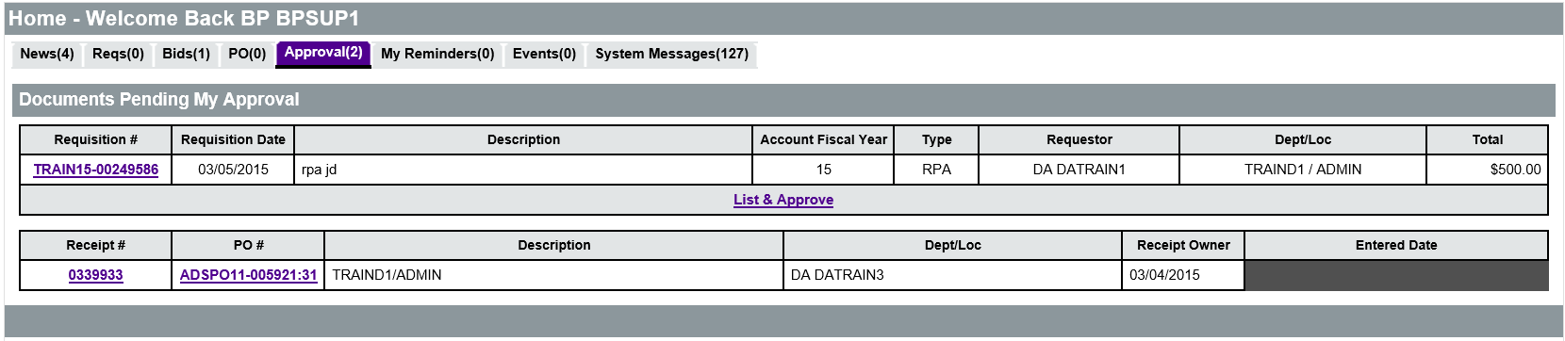
In the Documents Pending My Approval section, the document number is a link to the document that requires approval. For Requisitions, Bids, Purchase Orders, and Receipts, click the document number in the first column to open the document. For Change Order documents, click the Change Order number in the second column to open the Change Order.
Also displayed in columns on the Approval Dashboard is key document information such as the Description, Fiscal Year, Type, Requestor, Department, and Total amount.

  - Review
Selecting a document on the Approval Dashboard will display the Summary tab of the document for review. The Summary tab contains all of the information entered on the document. The approval options are located at the bottom of the Summary tab. After review, documents can be approved, disapproved, or canceled.

Review Requisitions
In order to determine if a purchase request should be approved, the reviewer must verify that all information on the Requisition is complete and accurate.
The Header and Item information is displayed on the Summary tab of the document and should be reviewed thoroughly. The Header section contains general information for the document, including the Description, Fiscal Year, Department, Document Type, Purchaser, Cost (Estimated or Actual), Address information, and Attachment links.
The Item section contains a list of all items on the Requisition and their details. Each line item displays the Description, Quantity, Unit Cost, Unit of Measure, Account Code, etc. The Account Code for each item should be verified for accuracy.
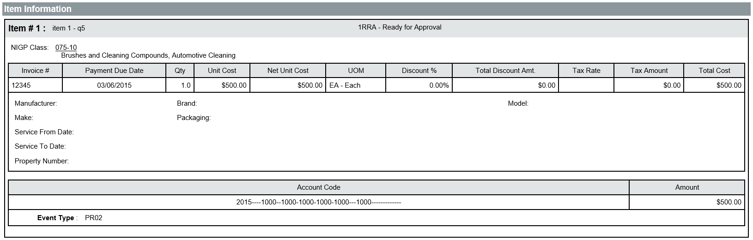
The Requisition should clearly state what is being purchased and why it is being purchased. All purchases must be supported by a valid business need. Any supporting documentation for the purchase should be reviewed to ensure that the items and dollar amounts match the items and dollar amounts on the requisition. In addition to the standard Header and Item information, the following fields should also be reviewed on the Requisition:
  - Requestor – The user that created and submitted the Requisition
  - P-Card Enabled – If Yes is indicated, a P-Card will be used to pay for the goods or services on the Requisition. Ensure that the requestor has P-Card rights
  - Estimated Cost – The estimated cost of the goods/services on the Requisition
  - Vendors – The vendor(s), if applicable, that the requestor recommends ordering from
During the review process, approvers can only modify the Account Codes and add notes to the document if necessary. Any other changes must be made by the requestor.

Review RPAs
When reviewing an RPA Requisition, the approver must determine whether payment should be authorized for a purchase already made. In addition to the Header and Item information that should be reviewed for completion and accuracy, the documentation and justification for the purchase as an RPA must be reviewed to ensure that the purchase was necessary.
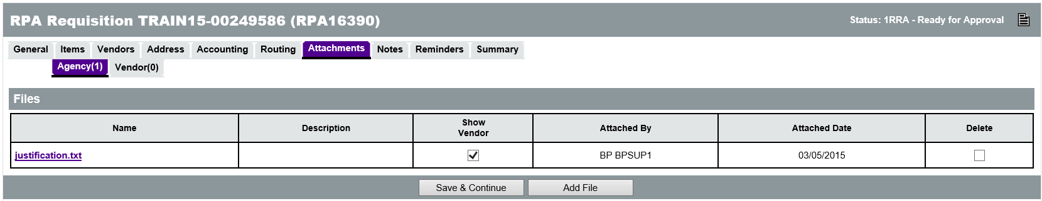

Review Bids
When reviewing a Bid, the approver will either be deciding whether or not to publish a Bid that is Ready for Approval or approve an award recommendation for a Bid that is Evaluated or Opened.

Ready for Approval Bids
When a Bid is in Ready for Approval status, reviewers need to review all of the information in the Header and Item information fields. In particular, the following fields in the Header section should be reviewed:
  - Bid Available Date – The date/time that vendors will be able to view and respond to the solicitation within ProcureAZ
  - Bid Opening Date – The date/time that vendors will no longer be able to respond to the solicitation within ProcureAZ
  - Pre-Bid Conference – Indicates whether a Pre-Bid Conference will be held and, if so, provides the relevant details
  - Bidders – Displays a list of the vendors that will receive notification of the solicitation opportunity

Evaluated and Opened Bids
When a Bid is in Evaluated or Opened status, approval is performed on the Bid Tabulation (Bid Tab) document that is associated with the Bid. On the Summary tab of the Bid document, the Bid Tab option appears at the bottom of the screen. Clicking the Bid Tab button will display the Bid Tabulation which lists all of the responses submitted by vendors on the Quotes tab. Vendor price quotes can be compared by Item side-by-side on the Items tab.
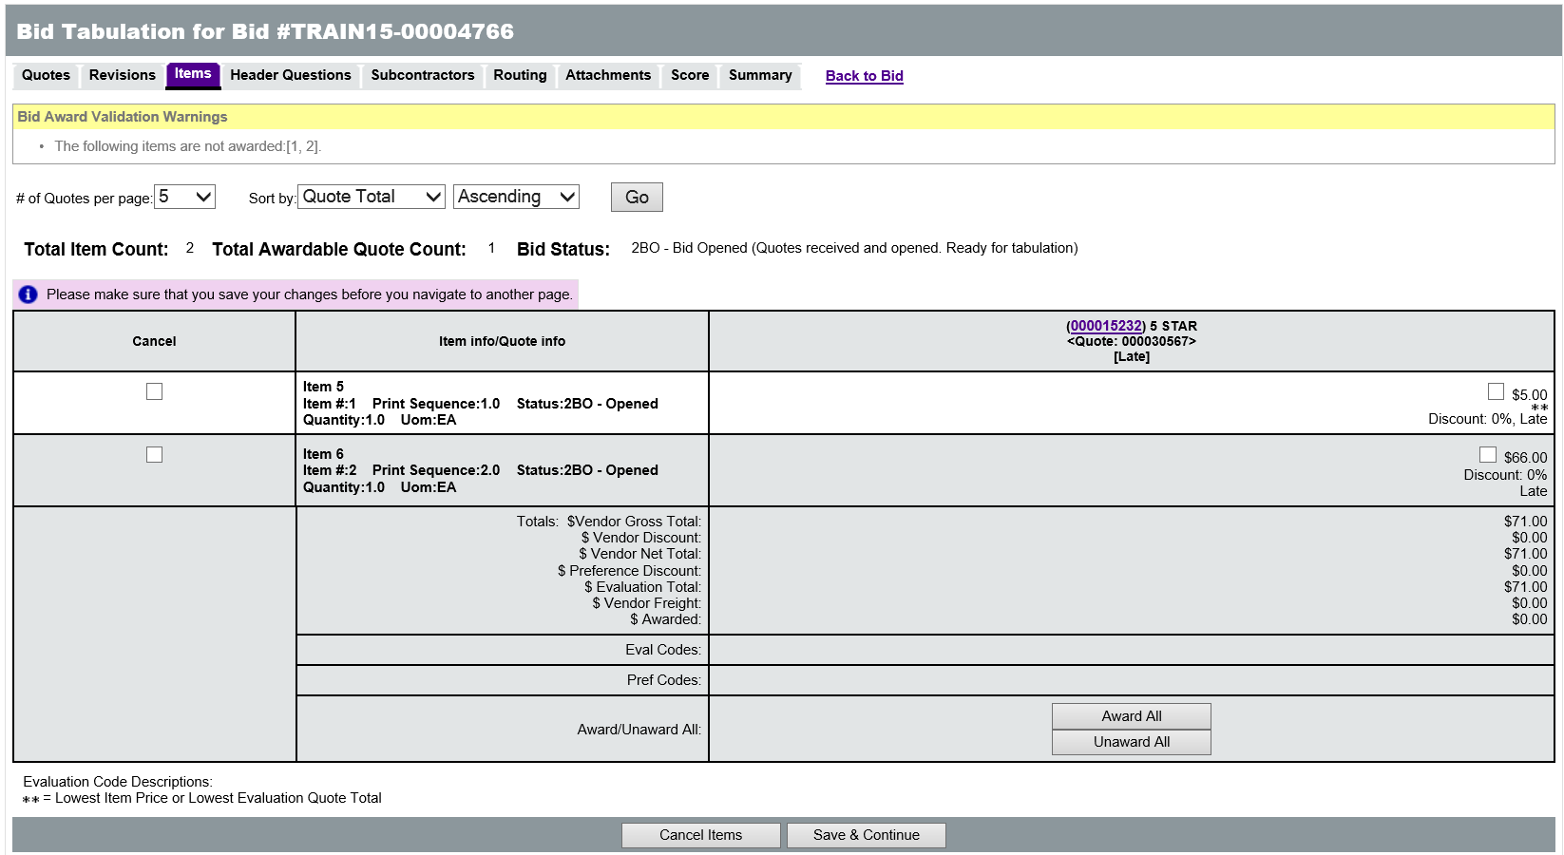
On the Summary tab of the Bid Tabulation, approvers can view price quotes by Item for each recommended vendor, as well as any supporting documentation, such as evaluation materials.
At the bottom of the Bid Tabulation screen, the approval options are available for approving or disapproving the award recommendation.

Review Purchase Orders
Depending on the type of Purchase Order being reviewed, approvers will be deciding whether or not to approve an order that will encumber funds or an implementation of a term contract with a vendor.

Open Market and Release Purchase Orders
For Purchase Orders that are not Master Blanket POs, the Header and Item information fields should all be reviewed. In particular, the following fields and sections should be reviewed:
  - Receipt Method – Indicates how the ordered Items will be received. A Receipt Method of Quantity is generally used for commodities, and a Receipt Method of Dollar is generally used for services
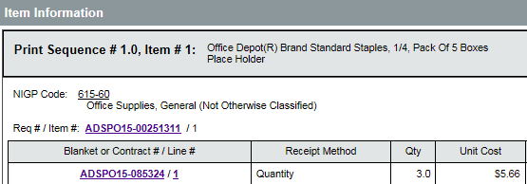
  - P-Card Enabled – If Yes is indicated, a P-Card must be used to pay for the goods or services on the PO
  - Primary Vendor Information and PO Terms – Displays the vendor that will be asked to fulfill the PO and the payment, shipping, and freight terms that will apply to the order

Master Blanket Purchase Orders
For Master Blanket Purchase Orders, the approval process should include a review of the Summary tab Header information, including the following fields:
  - Receipt Method – Indicates how the ordered Items will be received. A Receipt Method of Quantity is generally used for commodities, and a Receipt Method of Dollar is generally used for services
  - Primary Vendor Information and PO Terms – Includes the contractor, shipping, and freight terms that will apply to orders off the contract
  - Master Blanket Vendor Distributor List – Displays vendors that have been selected has distributors that can receive orders against the contract
  - Master Blanket Controls – Displays the Begin and End Dates of the active period for the contract, the organizations that can place orders against the contract, and any dollar limits imposed on those organizations
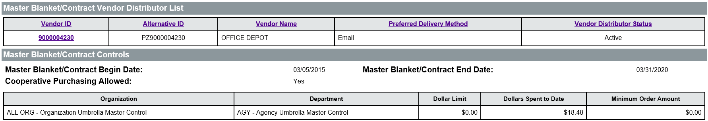

Review Change Orders
When reviewing Change Orders, there are two types of information displayed: overall and item level comments provided by the user who created the Change Order and system generated explanations of the changes made to the Purchase Order. For standard Purchase Orders, Change Orders may modify the accounting, item, or cost on the Purchase Order. For Master Blanket Purchase Orders, Change Orders represent contract amendments. Invoice Change Orders modify the accounting information.
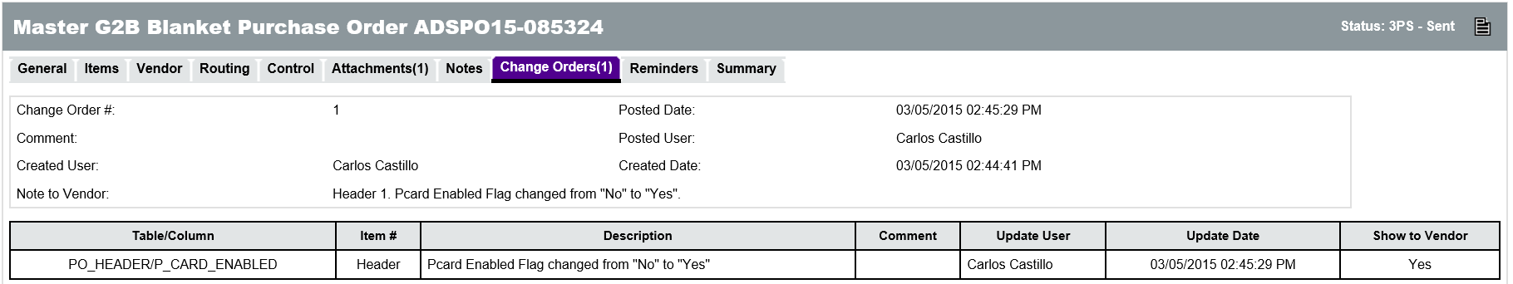

Review Receipts
When reviewing Receipts for Items received, each Item is listed in the Item Information section of the document. Approvers should review the information in the following fields:
- Received Quantity or Dollar – The total quantity or dollar amount that was received of the Item on the Receipt. The amount in parenthesis is the total quantity or dollar amount received to date
- Returned Quantity or Dollar – The total quantity or dollar amount that was returned of the Item on the Receipt. The amount in parenthesis is the total quantity or dollar amount returned to date
- Canceled Quantity or Dollar – The total quantity or dollar amount that was canceled of the Item on the Receipt. The amount in parenthesis is the total quantity or dollar amount returned to date
TIP: Cancellations will trigger an automatic Change Order to the Purchase Order that cancels the Items.
- Remaining Quantity or Dollar – The total quantity or dollar amount still to be received on the Purchase Order
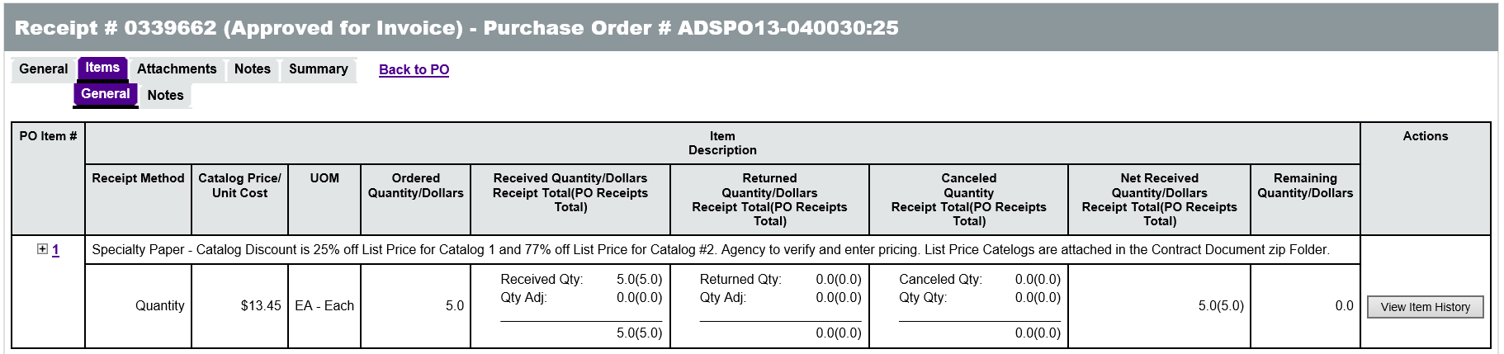

  - Approval
At the bottom of the Summary tab on each document being reviewed is the Approval Path section that displays all of the approvers that must review and approve the document in order for it to be processed forward and the order that each must approve it. The approval path will only be displayed once the document has been submitted for approval. All prior approvals applied to the document by other users will show the Date Approved/Disapproved for that level.

Add/Remove Approvers
Before submitting a document for approval, it is possible to add approvers to an approval path if they should be included in the process. Approvers can also manually add additional approvers to an approval path. In the last row of the Approver column is a drop down box that can be used to locate the name of a user who should be added to the approval list.
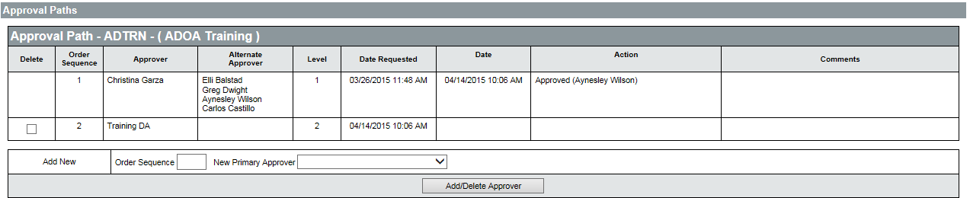
The additional approver is assigned an Order Sequence number which will place them at the end of the existing approval path. When finished, clicking the Add/Delete Approver button will add the new approver to the approval path for that document. Any approvers that have been added to the approval path can also be removed by clicking the check box for the user in the Delete column and then clicking the Add/Delete Approver button. Once the document has been submitted for approval, the submitter cannot add or delete approvers.

Approval Actions
Once the review is complete and the approval path has been updated, if necessary, the approver can apply an approval action to the document using the options located in the Approval Actions section at the bottom of the Summary tab.
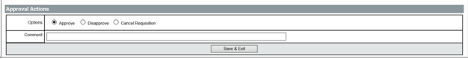
The three options are available, Approve, Disapprove, and Cancel. Choosing Approve will cause a notification to be sent to the next approver in the path if one exists or change the status of the document to allow for further processing. Choosing Disapprove will change the document to Returned status. Choosing Cancel will disallow any further edits to or processing of the document.
The Comment field is available for the approver to provide a message regarding the approval decision. The Comment field should always be used when disapproving or canceling a document to indicate the reason for the action. Once the correct option and comment have been entered, click the Save & Exit button to complete the action.

Lesson Summary
In this lesson you:
- Identified the actions, terms, and document types involved in the approval process
- Reviewed the navigation of the Approval Dashboard
- Identified the key parts of the document review process
- Learned how to approve, disapprove, and cancel a document

Check Your Progress
- Most canceled documents can still be cloned.
  - True
  - False
- What type of approver can be set up to approve documents for another user on any approval path?
  - Primary
  - Alternate
  - Proxy
  - None of the above
- When reviewing an RPA Requisition, what decision is being made?
  - Should the purchase request be authorized?
  - Should payment be authorized for an order already placed?
  - Should payment be authorized for items already received?
  - Should the document be published publicly to vendors?
- When reviewing a Contract Purchase Order Change Order, what decision is being made?
  - Should the purchase order be sent to the vendor?
  - Should the finalized contract be sent to the vendor?
  - Should the change order be applied to the Purchase Order?
  - Should the amendment be applied to the contract?

