13 Creating and Managing Bids

This page was intentionally left blank.

Contents
13. Creating and Managing Bids 1
Learning Objectives 1
Lesson Overview 1
13.1 Creating a Bid 2
Formal Bid (Solicitation) Creation 2
Bid Options in ProcureAZ 6
Complete a Bid Document 6
Adding and Removing Items 8
Adding and Removing Attachments 13
Adding, Editing, and Deleting Notes 16
Adding Vendors to the Bidders Tab 16
Adding Questions for the Bidders 19
Question and Answer process (Q &A) 20
Posting the Bid 21
Create a Bid Document 25
13.2 Bid Management 26
Finding your Posted Bid 26
Reviewing the Bid Holder List and Quote Activity 26
Managing Questions and the Q & A Response 29
Terms and Conditions 31
Creating a Bid Amendment (Addendum) 31
Apply Bid Amendment 34
Manage a Bid Document 36
13.3 End of Bid Process 37
Canceling a Bid 37
Reviewing the Quotes (Vendor Responses) 37
Opening the Bid 37
Requesting Revisions and Best and Final Offers 41
Evaluation Process 46
Award Process 47
Open and Award a Bid 51
Lesson Summary 52
Check Your Progress 53

- Creating and Managing Bids

Learning Objectives
In this lesson, you will:
- Create and post a Bid document
- Manage the vendor responses
- Examine the Quote review, evaluation, and award process

Lesson Overview
This lesson introduces the formal bid (solicitation) process in ProcureAZ. This process begins with the creation of a Bid document on which Item and Vendor information is entered. The process includes an open period of interaction with vendors and, finally, a quote review, evaluation, and award process.

- Creating a Bid
Bids are used to request pricing from vendors for comparison and selection. Once the Bid has been opened up to vendors, following a question and answer period, vendors submit their pricing for review.

Formal Bid (Solicitation) Creation
Users must have the Basic Purchasing role assigned to create a Bid. Bids can be created several ways, either by converting a Requisition, by cloning an existing document, or from scratch. They can also be formal bids or informal bids.

Reviewing and Converting Requisitions
One of the most common methods of creating a new Bid is to convert an approved Open Market Requisition. Converting a Requisition into a Bid brings all of the information on the Requisition into the Bid which reduces the amount of data entry that is required to complete the new Bid.
Open Market Requisitions are requests for goods or services that are not on an active contract. Once the Requisition has been approved, a Basic Purchasing user is notified that the Requisition is Ready for Purchasing. The Basic Purchaser determines if a solicitation is required for the desired items, or if the items can be ordered from a vendor without competition on the pricing.

Requisition Summary Tab
The Summary tab of the Requisition has buttons at the bottom that allow a Basic Purchaser to convert the Requisition into either a Bid or a Purchase Order. The Basic Purchaser can also disapprove the Requisition, which routes the document back to the Requisitioner for correction and resubmission or cancellation.

Clone Process
Another method of creating a new Bid is to clone a previous Bid or Requisition. The cloning process creates a new copy of the document, enabling users to re-use the information that was entered on the original while also allowing users to edit any information as necessary.

Use the Documents menu to locate an existing Bid or Requisition to clone. In the menu bar, click Documents. In the drop-down menu hover the mouse over Bids, then select New to display the Create a New Bid screen.
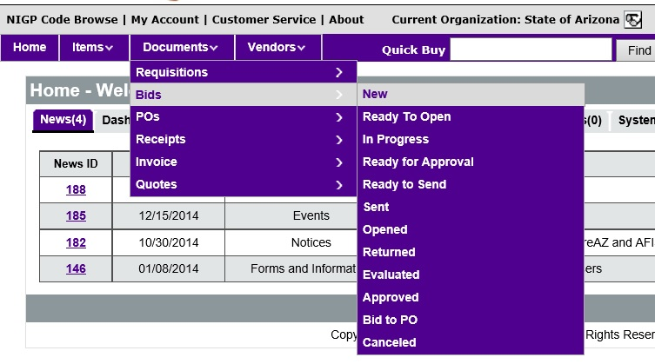

Select Clone a Bid from another document and click Continue to search for the Bid or Requisition to clone. Note that the Copy Contracts for Renewal option is not utilized by the State.

Any older Bid can also be cloned by first accessing it, then clicking the Clone Bid button at the bottom of the Summary tab.
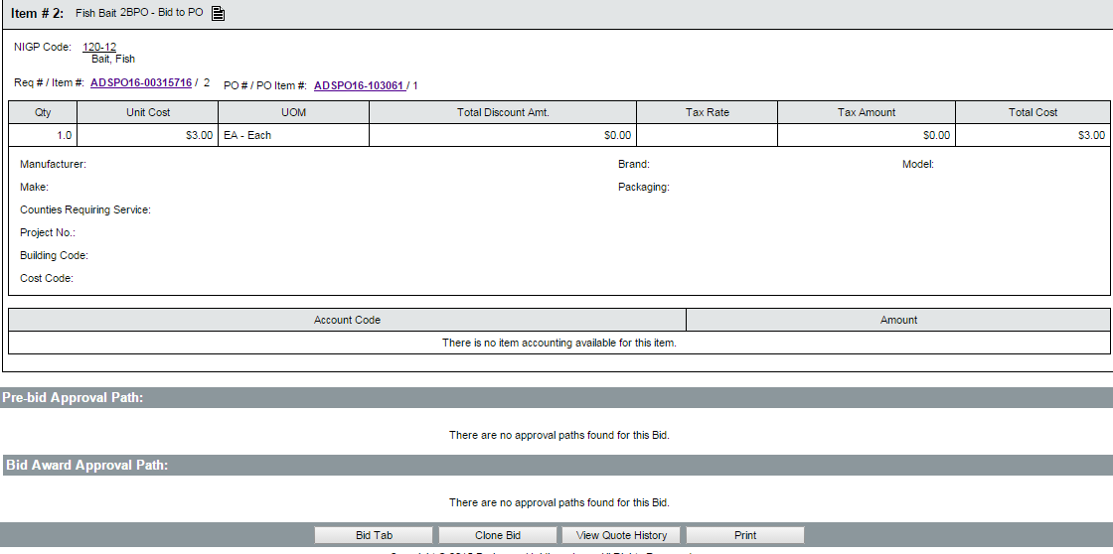
On the Search Documents to Clone to Bid screen, select either Requisitions or Bids in the Search For field. This determines the search fields that are displayed. This document search functions exactly like the Advanced Search feature. Enter any known criteria and click Find It. For more information on Advanced Search, refer to Lesson 12 Advanced Search in the ProcureAZ Training Guide.
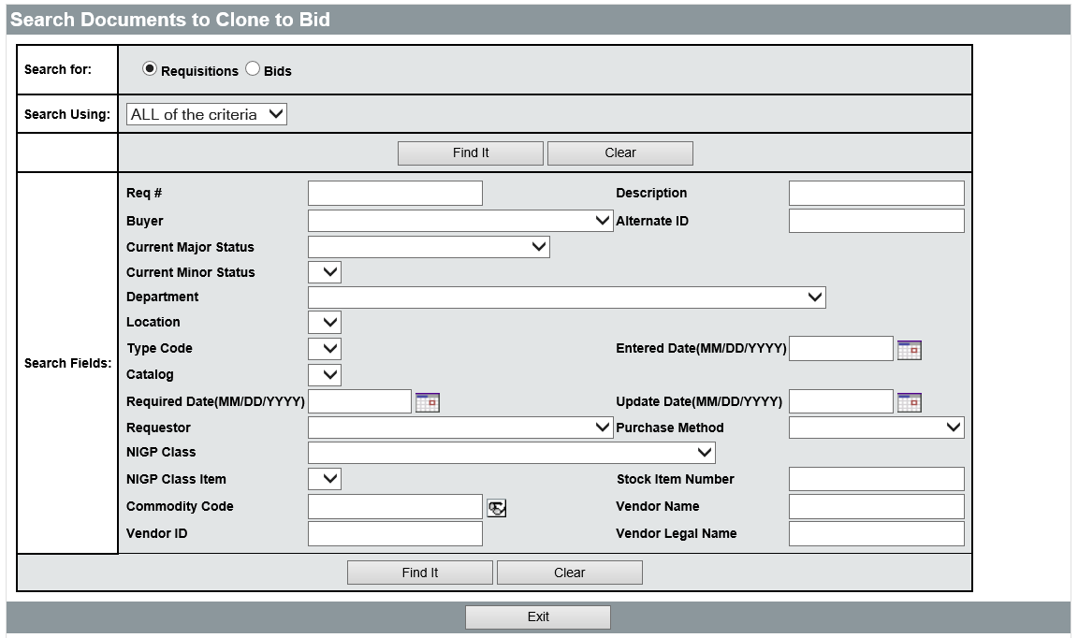
In the list of search results, click the button in the Select column next to the document to be cloned. You can also view the document by clicking the link in the Req # or Bid # column before creating the new clone document.
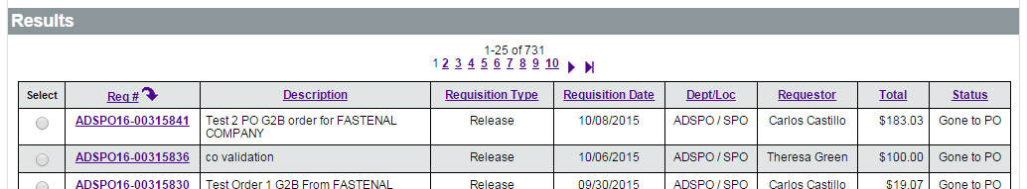
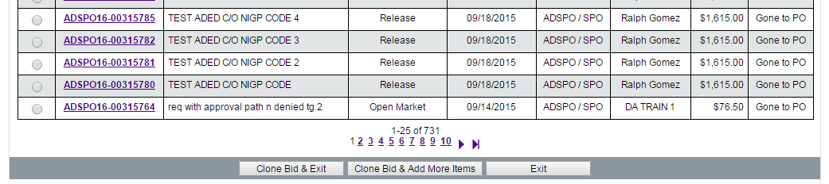

Click the Clone Bid & Exit button to display the General tab of the new Bid document. Click the Clone Bid & Add More Items button to create a new Bid that first displays a search screen used to find and add any item that has previously appeared on a ProcureAZ Requisition or Bid for your Organization. The process of finding and selecting items is the same as the process used to find the document for cloning. Once all desired items have been added to the Bid, the General tab of the new Bid document is displayed.
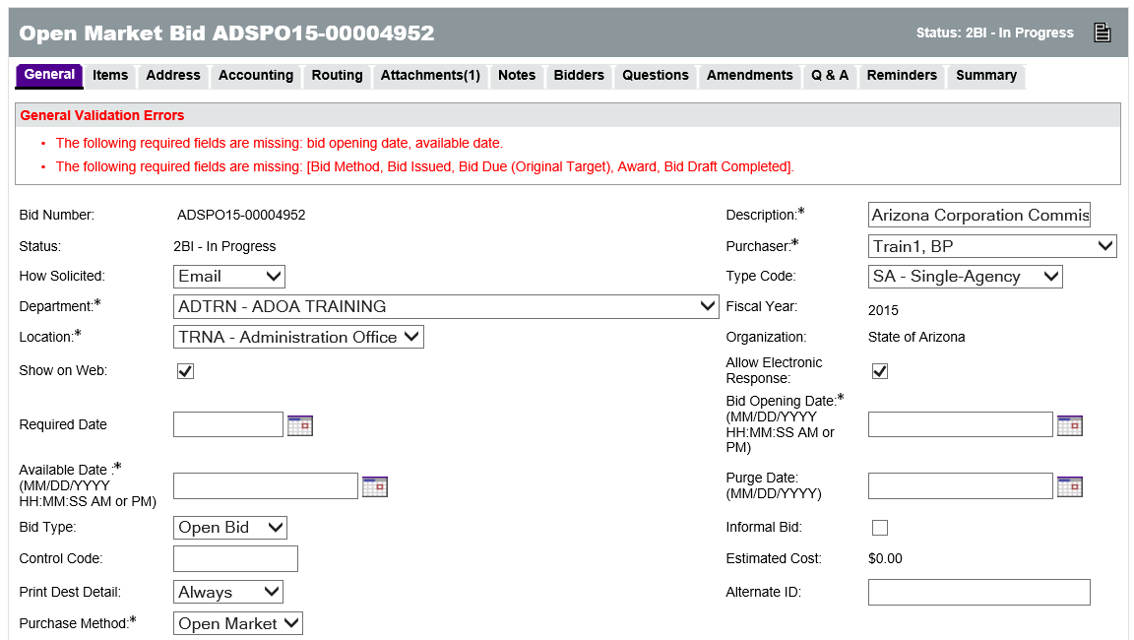

New Bid from Scratch
To create a new Bid from scratch, click the Documents drop-down menu in the Navigation bar, hover the mouse over Bids, and select New. On the Create a New Bid screen, select Create a Bid from Scratch and click Continue.
The General tab of the new Bid document will be displayed.
Unlike cloned documents, new documents are not assigned a number upon creation. In order for a number to be assigned, the required fields on the General tab must be completed and the document saved.

Bid Options in ProcureAZ
There are several key terms used when referring to Bids, they are as follows:
  - Open Bids – Allow any vendor registered in ProcureAZ to submit a response. They are also viewable to users without a ProcureAZ login by clicking the Open Bids link on the Login screen.
  - Closed Bids – Are only visible to those vendors that were originally notified of the Bid upon publication. They are the only vendors that can submit a response through the system.
  - Formal Bids – Do not allow Basic Purchasing users to view submitted responses until the Bid Opening Date/Time has been reached and the Bid has been opened. Bids are Formal by default. Formal Bids can be either Open or Closed.
  - Informal Bids – Allow Basic Purchasing users to view vendor responses prior to the close of the response period. An Informal Bid can be either Open or Closed.
The Bid document does not operate differently based on the Bid Type of solicitation being conducted. The type of response expected from bidders is made clear through the Items that are added, the external documents that are attached, and the other settings that are specified. ProcureAZ does allow users to configure certain behavior on a Bid by designating the Bid Type as Formal or Informal.

Complete a Bid Document
The process for completing any document in ProcureAZ is to work through the tabs along the top of the document from left to right, starting with the General tab, completing all required fields, then reviewing and submitting the document for approval via the Summary tab on the far right. Not all tabs are used on the Bid document.

General Tab
The fields on the General tab are used to determine vendor access and response schedules. There are several required Date fields on the General tab that must be completed in order to save and continue processing the document. The required fields are:
  - Description – Enter a short description of the Bid
  - Purchaser – Enter the BP user that owns the document
  - Department – Select the business unit that initiates the solicitation
  - Location – Select the location for the department
  - Bid Opening Date – Select the date and time that the solicitation will no longer accept electronic responses from vendors and the assigned Purchaser can Open the Bid to review the submitted responses
  - Available Date – Select the date and time that the solicitation will be published
  - Purchase Method – Select the purchase method of the resulting contract from either Open Market or Blanket. If the desired end result is a Master Blanket contract, select Blanket. If the desired result is a one-time Purchase Order, select Open Market. The Purchase Method is important as it dictates what type of document is created with the Bid and Award process is completed in ProcureAZ
  - Bid Method – Select the type of solicitation that is being conducted (i.e. RFP, IFB, RFQ)
TIP: An Open Market Bid will be converted to an Open Market Purchase order with a pre-encumbrance established in AFIS.
The following fields are intended to be based on the original solicitation schedule and are not required to be the actual date of the stated activity:
  - Bid Issued – Select the scheduled date that the solicitation will be published
  - Bid Due – Select the scheduled date that the response period closes
  - Award – Select the scheduled date that the solicitation will be awarded to a vendor
  - Bid Draft Completed – Select the scheduled date that the draft will be completed
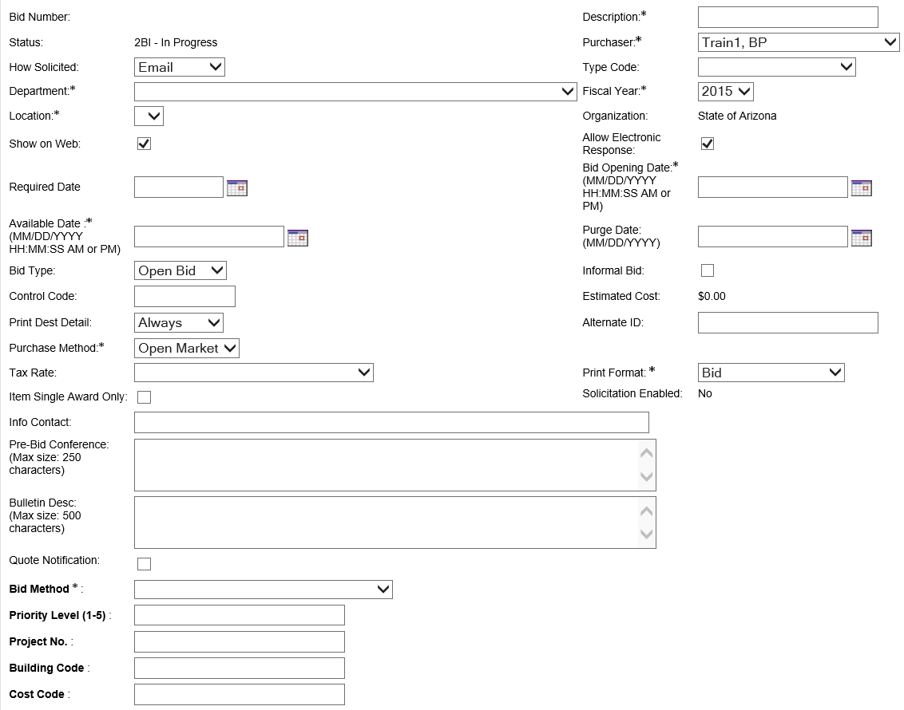
When all required fields have been completed, click Save & Continue to save the document and assign a document number if one has not been assigned already.

Adding and Removing Items
The Items tab displays the goods and services that vendors will provide quotes for in their responses. The process of defining the line items for the Bid will vary depending on the process used to create the new Bid document.
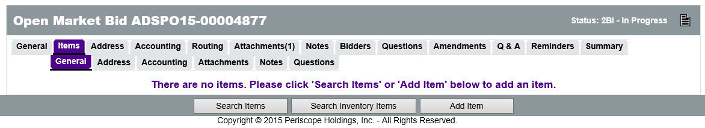
Every Bid must have at last one Normal item that will be bid on. If the Bid was created from scratch, items can be searched or added using the buttons on the Items tab. The Search Inventory Items button is not used. If the Bid was created by converting a Requisition or cloning another document, the Items tab will initially display the items from the source document. Items can be edited and deleted on the Items tab.

Create Items
Item entry begins on the Items > General tab. In order to create a new Normal Item, the following fields are available:
  - Print Sequence – The line sequence number determines the order in which the items will appear to vendors. This will default to the order in which Items are added to the Bid and does not need to be changed.
  - Item Type – This value can either be Normal or Narrative. Normal items can be ordered. Narrative items only allow a Description, Project, Building Code, Cost Code, and Property Number to be entered and only appear on the Bid document. Vendors will only see Normal items on the Items tab of their quote.
  - Description – Enter the definition of the good or service being requested. For Narrative items, this can be instructions or other information (Narrative items are not visible on the Items tab of a vendor’s quote – they are only viewable on the Bid).
  - Quantity – Enter the total number of the item being requested. Enter 1 if the quantity is unknown.
  - Unit Cost – Enter the estimated cost of one unit of the item. This is automatically hidden from vendors and can be left at 0 (leaving the unit cost in the item can make it easier to compare the old contract price with new vendor quotes).
  - Unit of Measure – Select the unit of measure for the item from the drop down menu. Enter EA for Each if the unit of measure is unknown.
  - NIGP Class –Search for the 3-digit NIGP Class code or the item can be entered directly in the field. The code can also be selected from the drop down menu or searched for using the eyeglass icon.
  - NIGP Class Item – Search for the 2-digit NIGP Class Item code or the item can be entered directly in the field. The code can also be selected from the drop down menu or searched for using the eyeglass icon next to the NIGP Class drop down.
TIP: Both the NIGP Class and NIGP Class Item are used to locate vendors that provide the commodity or service being requested on the Bid.

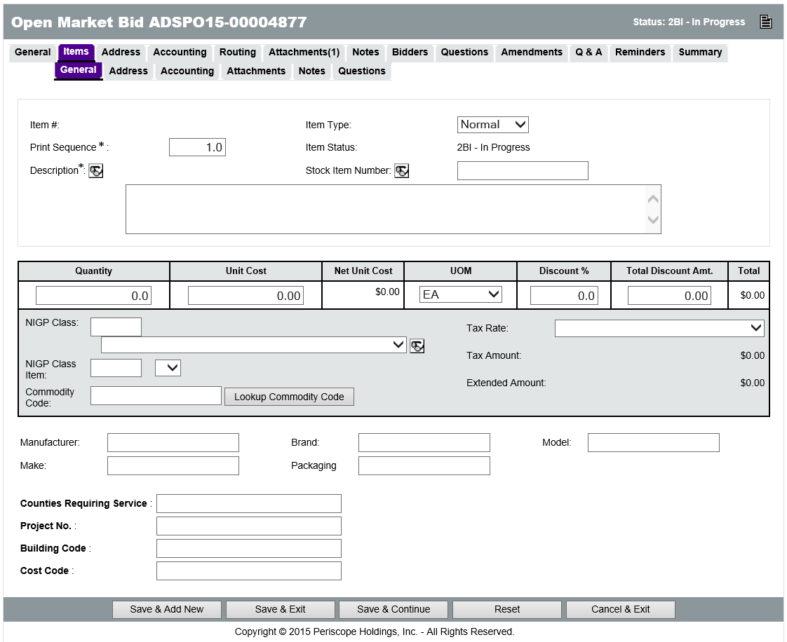
Other optional fields available when creating a Bid Item include: Discount %, Total Discount Amt., Tax Rate, Manufacturer, Brand, Model, Make, and Packaging.
The Manufacturer, Brand, Model, Make, and Packaging fields can be used to inform the vendor of the exact item that will meet the Purchaser’s needs.
The Tax Rate is based on where the order is coming from. Vendors will complete the Tax Rate and Discount fields, if appropriate, when submitting a quote.

Search Items
Click the Search Items button to search for any previously defined item. In the search fields, enter the desired criteria and click Find It to display the results. Users can search by Items or Documents using the Result Type menu at the bottom of the search page. For Normal items, enter the Quantity of the item being requested. When you are finished adding Items, click Save & Exit to return to the Items tab with the selected Items added to the Bid.
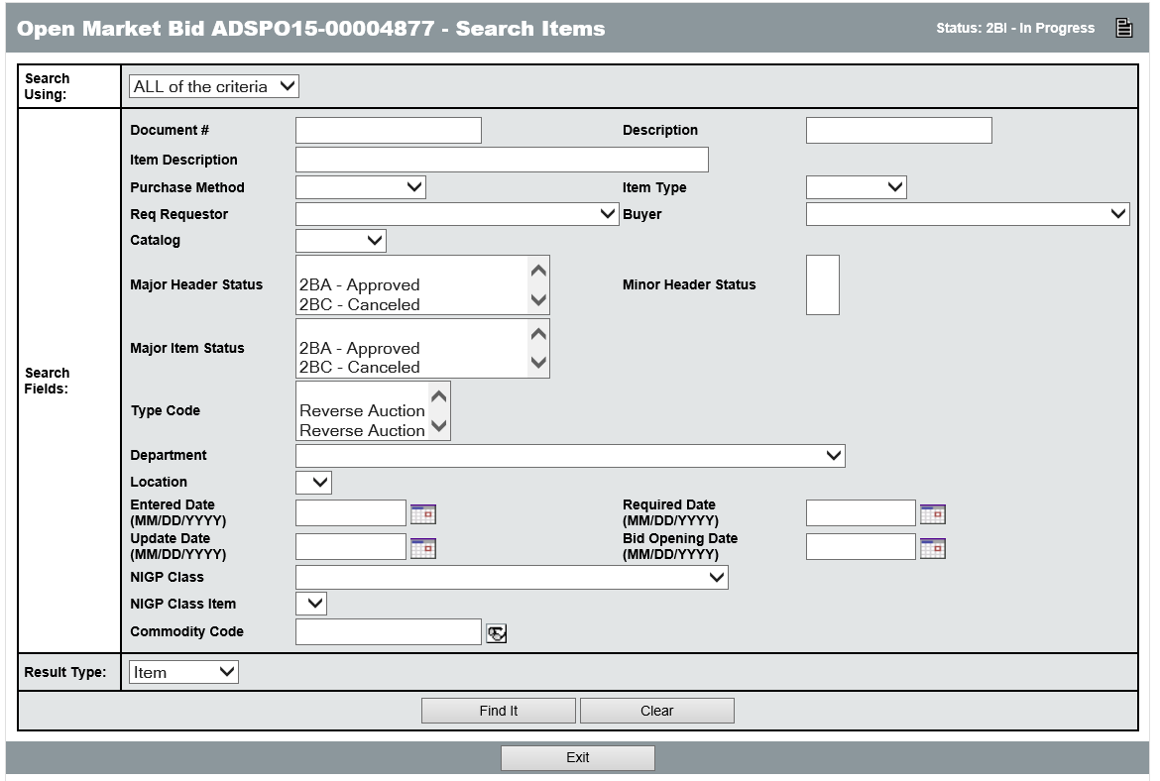

Edit Items
From the list of Items on the Bid, it is possible to edit the current items, continue adding items, delete existing items, modify the print sequence, or modify the quantity of existing items. To edit an existing line item description, click the Item Number link in the first column.
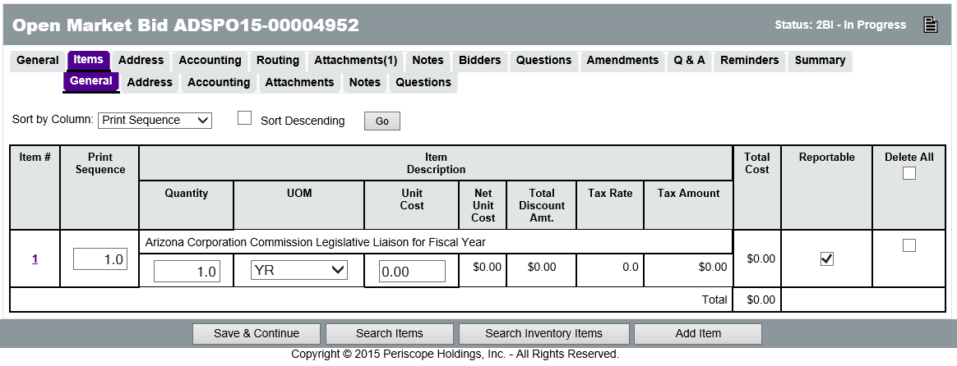
To add additional Items, click the Add Item button. To delete an item, check the Delete check box in the last column on the right and click the Save & Continue button. Checking the Delete All check box will mark all lines for deletion. To modify the print sequence or quantity, enter the new value in the corresponding field, and click the Save & Continue button.

Assigning NIGP Codes to Bid Items
The NIGP Class and Class Item fields allow searching for the appropriate class and item records to assign to the Item. This will open the NIGP Code Browse page in a pop-up window (browser pop-up blockers should be disabled when working with ProcureAZ). The NIGP Keyword search field allows users to search by keyword. Enter a keyword in the box and click the Search button.
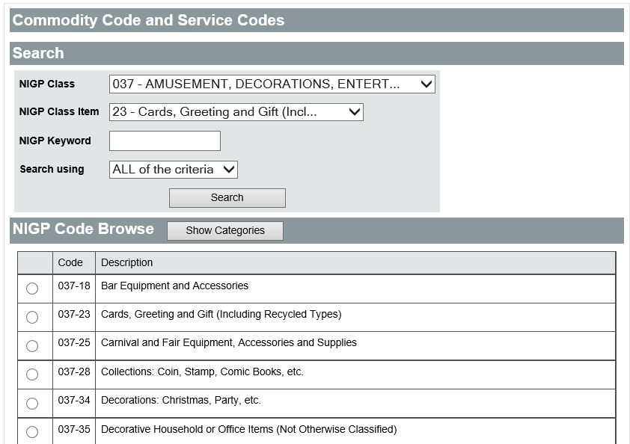
It may be necessary to try different keywords in order to find one that returns the desired results. It is recommended to begin the search with one word and refine the search if too many results are returned. The search results will include all instances where the keyword is contained anywhere in the name. For example, the results for the keyword “astro” will include Astronomical and Gastrointestinal. When the appropriate Class and Class Item have been found, select the radio button for the Class Item and click the Save & Exit button to populate the fields on the Bid. Service items (like professional temporary services, consulting and monthly janitorial or pest control services) should have NIGP codes in the 900 series. Goods (parts, batteries, pens, paper etc.) should have NIGP codes in the 005-800 series.
TIP: If you are still having difficulty in finding the appropriate Class and Class Item and know of a vendor who may respond to the Bid, search for the Vendor’s record to see what NIGP Codes are registered.

Add Freight Charges
If the agency will be required to pay freight charges for the requested items and the unit cost does not include freight and shipping charges, the freight cost must be entered by creating an additional line item on the Bid with the Freight commodity code of 962-86.
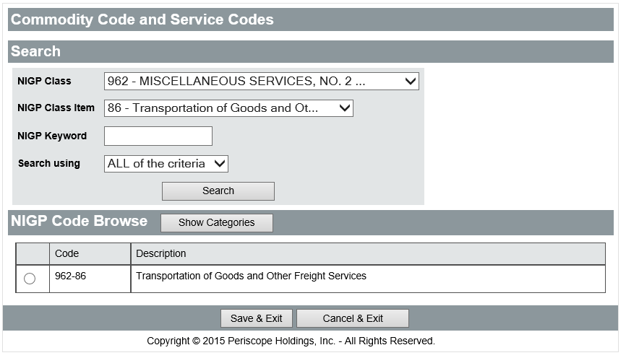

Adding and Removing Attachments
The official documentation related to the Bid, including Terms and Conditions, Instructions, Specifications, etc. need to be attached to the Bid document using the Attachments tab. Documents requiring vendor input require vendors to complete these documents outside of ProcureAZ and attach them to the Bid.
The Header > Attachments tab is used to view any existing attachments and add new attachments to the Bid. State Procurement Office administrators can add default attachments, such as Uniform Terms and Conditions or Uniform Instructions, to all new Bids so there may be attachments on the document that you did not add. The Attachments tab will display the number of attachments on the document in parenthesis. For example, Attachments(5) means that there are five attachments on the Bid.
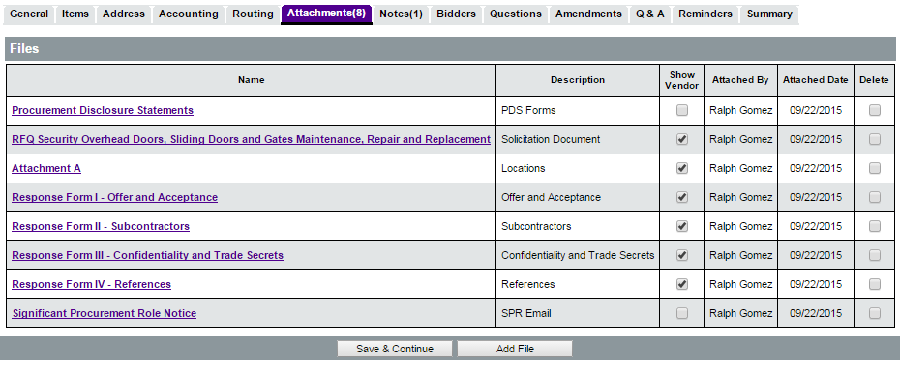
Any supporting documents for the Bid must be scanned and attached to the document as specified by policy. It is important that any attached document name accurately describes the document. If the document should not be viewable by vendors, the Show Vendor check box should be unchecked (it is checked by default).

Attaching a Document
On the Attachments tab, click the Add File button. On the Add File page, the Name field is the display name for the file that will appear wherever attachment repository files are displayed. The Name can be different than the name of the file and can contain alphanumeric characters, spaces, and special characters up to a maximum length of 200 characters. If no Name is entered, it will default to the file name.
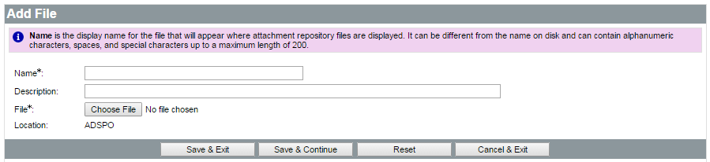
The Description field is optional but can be used to enter a longer description of the file, its purpose, or any notes/comments about the file. The description will be displayed on the

Terms and Conditions tab of the Vendor quote, but will not be displayed on the Summary tab of the Bid, which can be viewed on the Bid by the public and logged in vendors.
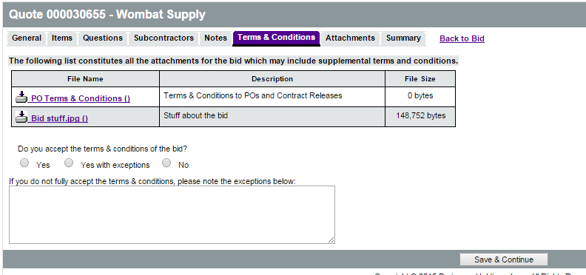
Clicking the Choose File button will display a File Explorer window that allows the user to navigate to the folder location on the local machine or shared drive to select the file to upload. When the appropriate file has been selected, click Open in the File Explorer window to add the file path to the Attachment screen.
When all fields have been completed and the file has been selected, click the Save & Exit button to upload the file to ProcureAZ and attach it to the Bid. If vendors should not be able to view an uploaded attachment uncheck the Show Vendor box (it is check by default). To attach more files, click Add File.

Attachment Modification
On the Attachments tab, the Show Vendor check box determines whether the vendor can view the attachment. The Delete check box will delete the attachment from the Bid. After changing either of these settings, click the Save & Continue button to apply the changes.
The Name of the file is a link to the Attachment File Detail screen. On the Attachment File Detail screen, only the Description can be modified. The file can also be downloaded by clicking the Download icon. If the Description has been changed, save the changes by clicking the Save & Exit button.

Adding, Editing, and Deleting Notes
The Header > Notes tab is used to add notes about the Bid document that are only visible to Organization users who access the document. Notes are entered in the Note field, which allows multiple lines of text to be entered. When one note is entered, clicking the Save & Continue button will save the note and add a new blank Note field for another note. Any notes that are saved to the document are stamped with the date they were added.
TIP: Notes are not considered part of the procurement file. If the note is required to be part of the procurement file, it should be added as an attachment on the Bid document.
Checking the Delete check box and clicking the Save & Continue button will remove the note from the document. The reset button will revert any changes made to the notes from the time the document was last saved. Like Attachments, the number of Notes added to the document will display in the tab name in the Header > Notes tab.
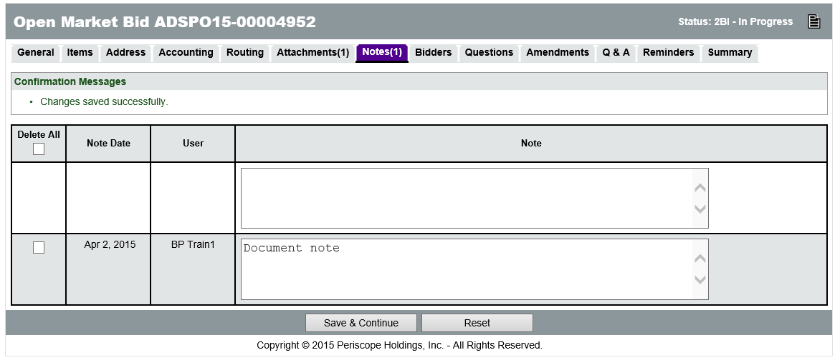

Item Notes
Notes can also be added to an individual Item on the Bid on the Items > Notes tab. Item level notes are only visible to Organization users who access the document. On this page, clicking the Item Number will display the same screen as the Header > Notes tab except that these Notes are added to a specific Item. Both header level and item level notes will follow on to the Purchase Order.

Adding Vendors to the Bidders Tab
The Bidders tab is used to select the vendors that will be notified about the solicitation. Vendor viewing privileges related to the Bid are also set on this tab. The vendor viewing configuration options on this screen include the Show Unit Prices to Vendors and Hide Bid Holder List on Vendor Side fields.
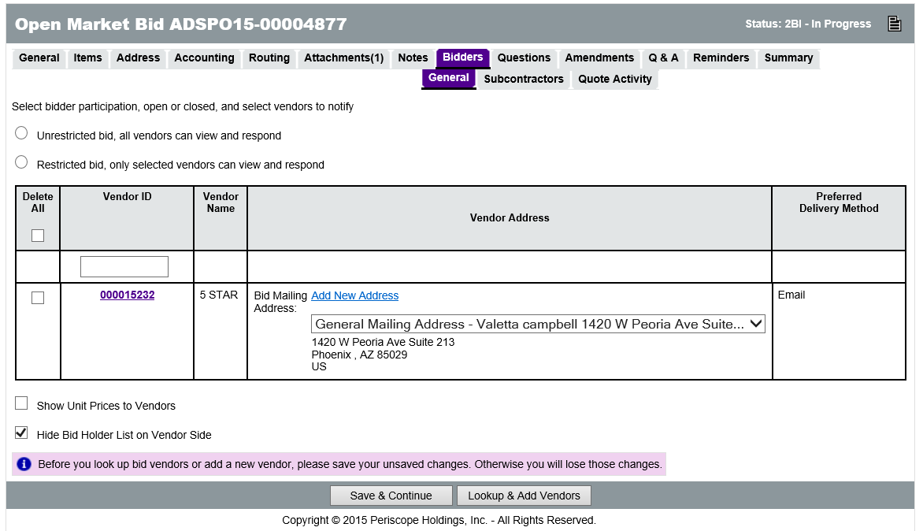
When the Show Unit Prices to Vendors field is checked, any price estimates entered on the Items tab are displayed to vendors. This option is unchecked by default so that vendors are not given an idea of how much is expected to be spent per item.
When the Hide Bid Holder List on Vendor Side field is checked, vendors cannot see the other vendors that may respond to the solicitation. This option is checked by default so that vendors do not know who their potential competitors are.
SPO policy requires that the Hide Bid Holder List option is checked. The exception to this policy is a construction project, where the Bid Holder List becomes the plan holder’s list and the Show Unit Price option can be enabled to reflect the architect’s estimate.
After making changes to either of those fields, click Save & Continue.

Search for Vendors
To add vendors to be notified, click Lookup & Add Vendors at the bottom of the screen. This will display a pop-up window that enables users to search for vendors by entering a variety of criteria, including Vendor Name, Tax ID, NIGP Commodity Code, and other specific categories vendors completed when they registered with ProcureAZ. After entering all desired criteria, click Find It to see the results, or simply click the Find Vendors for All Commodity Codes on the Bid button at the bottom of the screen to return all vendors that have registered with the commodity codes associated with the items on the Bid. It is common and encouraged that users search for and select vendors from multiple NIGP codes that may not necessarily be reflected on the item list.
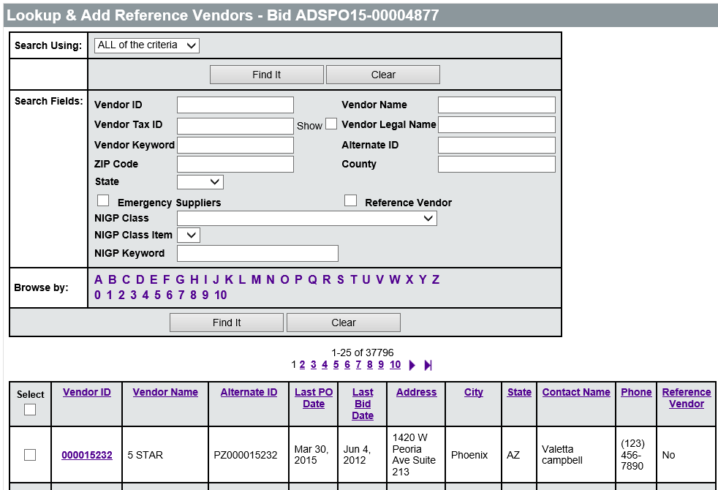
TIP: ProcureAZ does not track the search criteria that you use to develop your Bidders list. If this information is needed for historical reference, please document this using the Notes tab.
The vendor search results will appear below the search area. To select a vendor to add to the Bidders list, select the check box next to the vendor in the Select column. To select all of the vendors on that screen, select the check box in top row of the Select column. Once all selections have been made, click one of the Save options.
If the search returns more than 25 vendors, they will appear on multiple screens. Directly above and below the results list, the total number of results is displayed along with links to each page of results. Users can only add vendors to the Bidders list that appear on the screen currently displayed, so if vendors are needed from multiple pages, click the Save & Next Page button. This adds the vendor selections on the current screen to the Bidders list and displays the next page of vendors.
When all vendors have been added, click one of the Exit options to return to the Bidders tab. Vendors can be deleted by checking the Delete check box in the Delete column and clicking Save & Continue.

Subcontractors
The Bidders > Subcontractors tab is used to set the rules regarding subcontractor participation. If the use of subcontractors by bidders is expected or specific subcontractor participation is required, the options on the Subcontractors tab allow the designation of those requirements. This information should also be included in the formal documentation attached to the Bid.
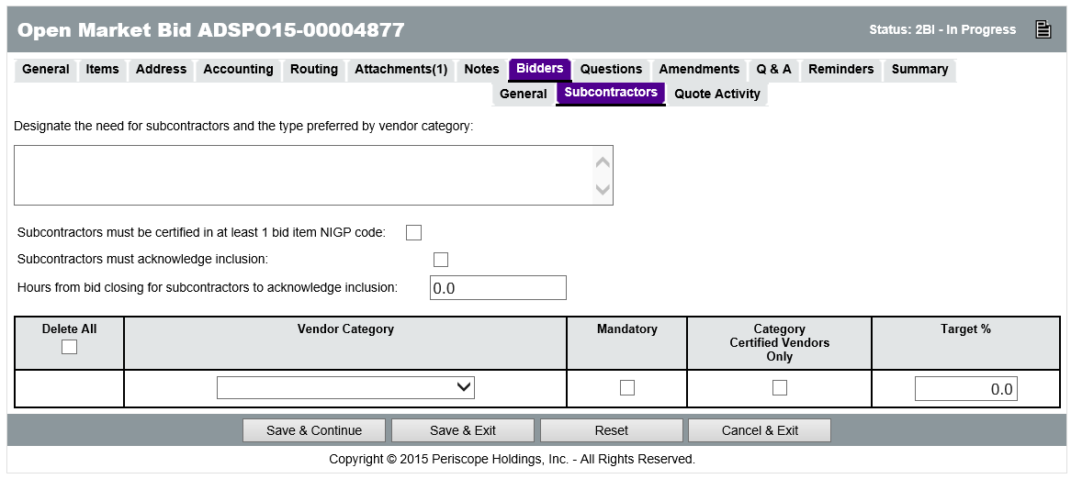
The other options on the Subcontractors tab allow the following:
  - Mandate that the vendors identified by the bidder as a subcontractor be registered with at least one of the commodity codes associated with the items on the Bid
  - Require that the subcontractors login to ProcureAZ to acknowledge their inclusion in the response
  - Require that the subcontractors acknowledge that inclusion within a certain period of time prior to the closing of the solicitation’s response period
TIP: Bidders will only be able to select vendors as subcontractors that are currently registered in ProcureAZ.

Adding Questions for the Bidders
The Questions tab is used to pose questions to vendors that they are asked to respond to within their Quote. Users are able to configure the type of response they are allowed to provide, as well as whether an answer to each Question is required before they can submit their Quote.
To add a Question, type the question into the Question field. If answering the Question is a requirement for vendors in order to submit their Quote, select the Required check box next to the Question.
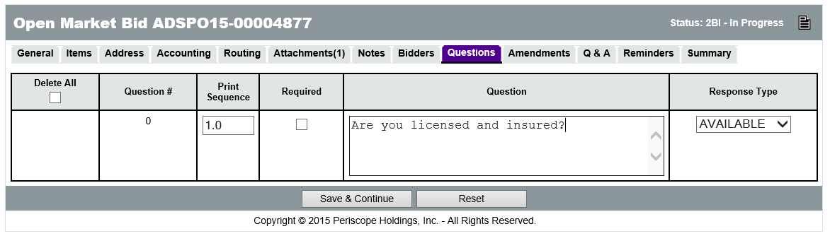
Lastly, select the type of response vendors are allowed to provide to the questions by choosing an option in the Response Type column. After adding a Question, click Save & Continue. Another row will appear enabling another Question to be entered.
TIP: Note that the questions and vendors’ responses do not become part of the resulting contract(s), therefore it is advised that questions related to the functions of fulfilling the contract be asked in attached documents, rather than via the Questions tab.
The Questions tab is best suited for questions regarding vendor’s capacity, experience, and qualifications, which can be compared when evaluating the responses. Any questions asked via the Questions tab should also be referred to within the Special Instructions attached to the Bid.

Item Questions
Questions for vendors that pertain only to a specific item or items can be entered on the Items > Questions tab. A list of the Normal items on the Bid will display above the field in the Question column. The process of adding questions is the same as the Header level Questions tab.
In order to view, edit, add, and delete questions for one specific item, click on the link in the Item # column next to that item on the Items > Questions tab. The tab will display a screen that looks identical to the Header level Questions tab, except that the Questions are applied only to the item selected.

Question and Answer process (Q &A)
Vendors may also ask questions regarding the solicitation. The Q & A tab on the Bid is used to document the questions and answers. Vendors and the public can access the Q & A while viewing the Bid document.
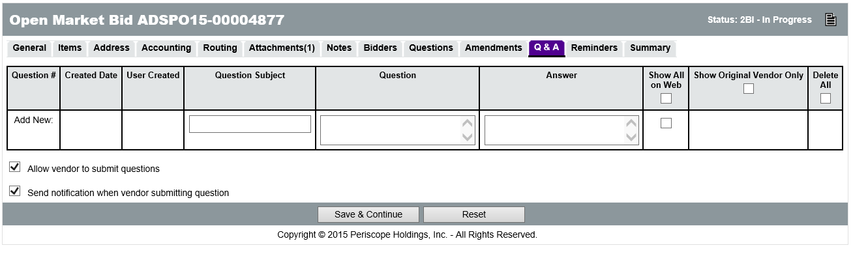
Prior to publishing the solicitation, select the option to enable vendors to submit questions through ProcureAZ. Select the Allow Vendor to Submit Questions check box to allow vendors accessing the bid to submit questions electronically. Users can also receive an email notification when a vendor submits a question by selecting the Send Notification when Vendor Submitting Question check box.
TIP: Without notifications, you must return to the Q & A tab to view submitted questions.

Posting the Bid
All of the information entered into the Bid can be reviewed on the Summary tab. Any validation warnings or errors will be displayed at the top of the page. Yellow warning messages do not require action, but red error messages will prevent submission of the Bid for approval until they are resolved.

Printing the Bid
Click the Print button to display a printable version of the document in a new window (pop-up blockers should be turned off for ProcureAZ). This makes a nice cover page if you are going to print the entire solicitation. Any documents that are attached to the Bid must be printed separately.

Submit for Approval
Click the Submit for Approval button at the bottom of the tab to submit the Bid and then click OK to confirm the submittal. If there is an approval path for the document it will be displayed. Click Continue to submit the document and route it to the first approver. Approvers can only approve/disapprove the Bid in the order that they are listed in the approval path.

If no approval path is configured for the document, approvers can be added manually by selecting the approver from the drop-down list and clicking Add Approver. If Automatic Approval is selected, the document is automatically pushed to Ready to Send status and may be published immediately. When finished, click Save & Continue.
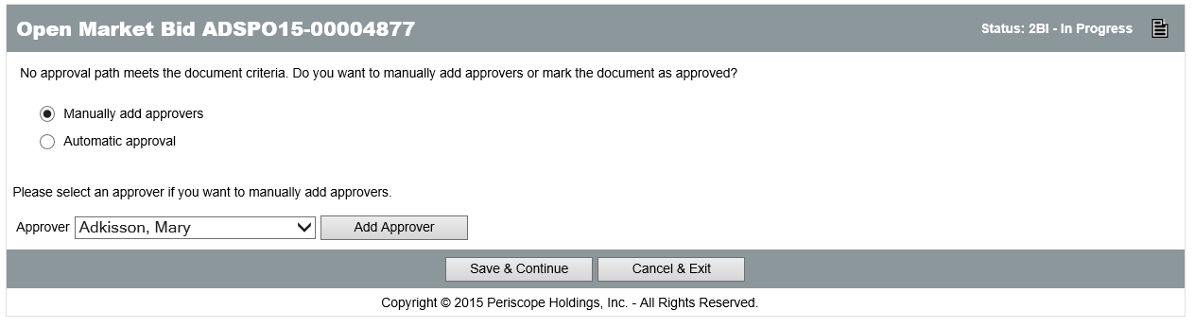
When the Save & Continue button is clicked, if document submission is successful, a message will be displayed at the top of the screen stating that the transaction was successful. Any warning or error messages generated by the submission will also be displayed.

Approval Process
During the approval process, the Bid document will be in Ready for Approval status. Only the Attachments, Bidders, and Reminders tabs can be edited during this stage. Approvers can add additional approvers as well. Users can view the status of the approval on the Routing tab, or along the bottom of the Summary tab.

Disapproval
If the document is disapproved, it will change to Returned status and the creator will be notified via an email that contains the approver’s comments. The document can be edited by clicking the Reopen button at the bottom of the Summary tab. This returns the document to In Progress status. Once editing is finished, the document must be resubmitted for approval.
When the Bid is reopened for editing, any approver’s comments are discarded. If the reason for disapproval needs to be retained it should be added as a note on the Bid. Any notes added will remain on the Bid after reopening.
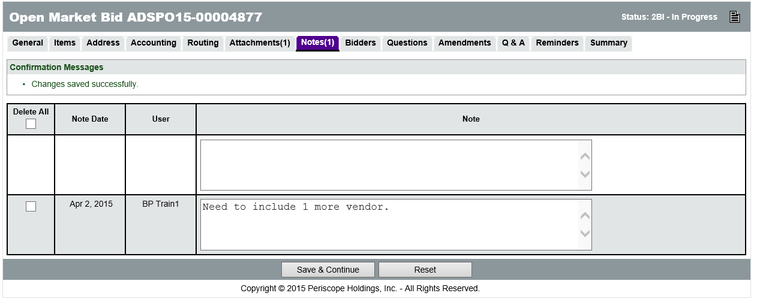

Approval
If the document is approved, it will change to Ready to Send status and the creator will be notified via email. The Bid is now ready to be published.

Vendor Notification
To publish the solicitation, navigate to the Summary tab of the Ready to Send Bid. On the bottom of the screen, there are two options in the Send Bid Actions section.
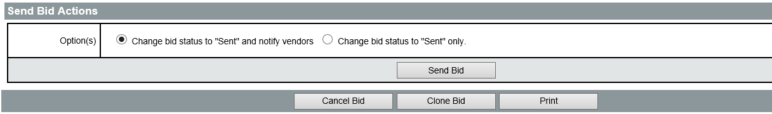
Users can select to Change bid status to Sent and Notify Vendors, which will publish the solicitation and send an email to all of the vendors added on the Bidders tab. The other option is to Change the bid status to Sent only, which will publish the solicitation, allowing vendors to access and respond, but will not send vendors an email to notify them.
If an email has been sent to vendors, users can choose to Include Attachments with Vendor Email Notifications, which will attach the Bid attachments to the email that is sent. This option should generally NOT be used due to the likelihood that this will slow down your email system. The notification email may also be rejected by the vendor’s email system. After deciding whether to notify vendors, click Send Bid. The Bid status changes to Sent.

After saving, if the notification option was selected, the Vendor Notification Result screen will display all of the vendors that were notified and the email address that the notification was sent to.
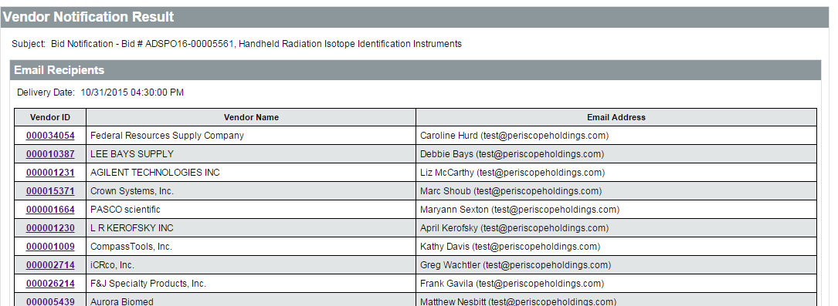
TIP: This screen is not accessible again after clicking OK, so if it is needed for your records, you may wish to print this screen using your web browser or copy and paste the resulting table into Microsoft Excel. An Excel spreadsheet is a searchable document.
Note that even after sending a Bid, it will not send notices to vendors, be viewable online, or allow a response until the Available Date identified on the General tab of the Bid has been reached.

Activity 13.1

Create a Bid Document

Scenario
You have received a request to create a Bid document.

Setup
- User is logged in to the ProcureAZ home page as a user with the Basic Purchasing role.

Steps
- Create a new Bid by converting a Requisition document.
- Add Items to the Bid document.
- Add an Attachment to the Bid document.
- Add Vendors to the Bidders tab of the Bid document.
- Add Questions for the Bidders.
- Submit and send the Bid to vendors

  - Bid Management
Managing Bids after they have been approved and notices have been sent to vendors involves locating Bids, reviewing quote activity, responding to vendor questions, and applying amendments to the Bid document.

Finding your Posted Bid
While the Bid is available to vendors for response, it remains in Sent status. To locate the Bid, click the Documents drop-down menu in the Navigation bar, hover the mouse over Bids, and select Sent. All Bids in Sent status will be displayed starting with the most recent at the top. Bids in Sent status allow only a few actions, which include the following:
  - View the vendors that have acknowledged receipt of the Bid and responded
  - Manage the Q & A on the Bid
  - Create and apply amendments to the Bid
  - Open the Bid to view the submitted responses after the Open Date

Reviewing the Bid Holder List and Quote Activity
In the Navigation bar, click Documents, hover the mouse over Bids, and select Sent. In the list of sent Bid documents, the Bid Holder column is displayed on the far right. Click the List link to display a list of vendors that have viewed and acknowledged the bid, meaning that they have elected to be informed of any amendments to the document.
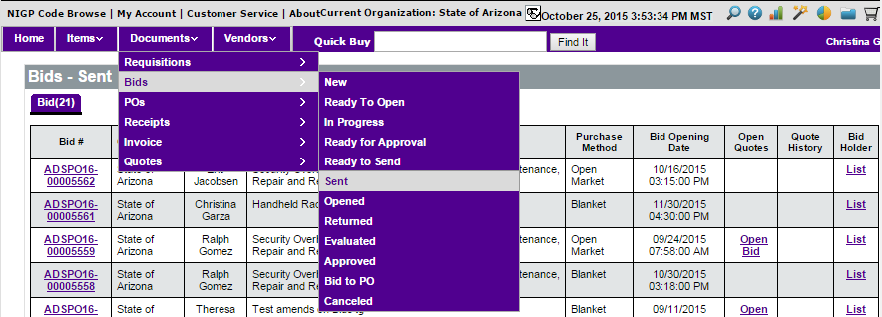
Click the List link in the Bid Holder column on the right for the appropriate Bid to see the list

of vendors that have officially acknowledged viewing the document.
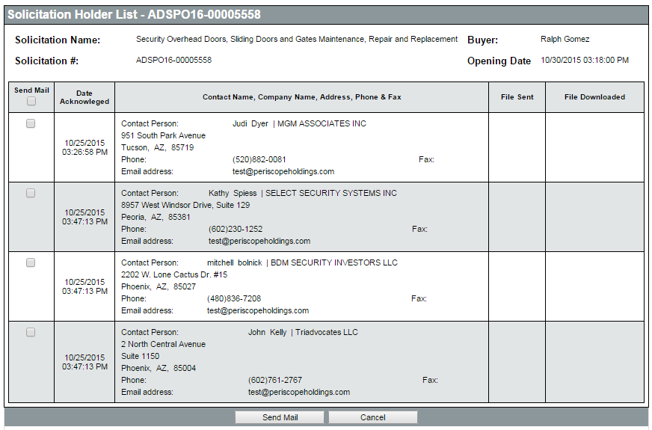

Emailing Vendors
If necessary, an email can be sent to selected vendors by checking the Send Mail check box and clicking Send Mail button at the bottom of the Bid Holder List screen. The email form allows users to build an email with fields for a Subject and Text. Any attachments on the Bid can also be attached to the email by selecting their check box. When the email has been composed, click Send to send out the email.
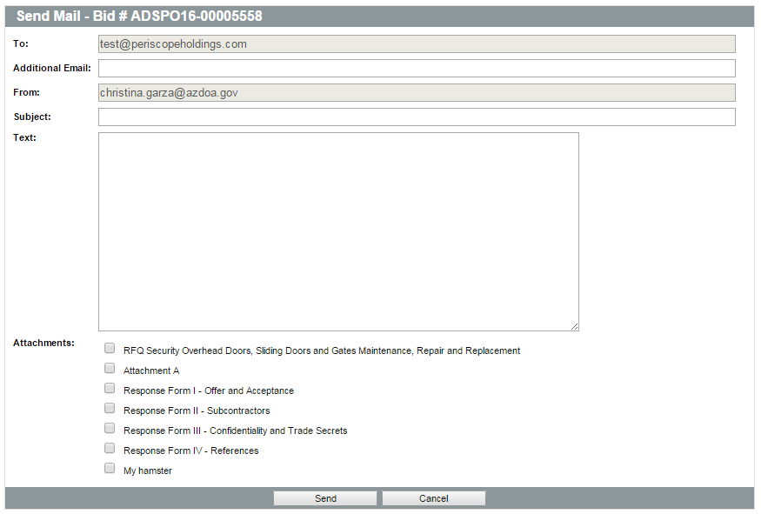

TIP: You will not have a copy of the email in your sent mail, so if you need a copy of the email, include your email address in the Additional Email field.

Managing Vendors
From the Bidders tab on the Bid document, users can add vendors to the Bid Holder List to enable email notification of amendments. New vendors can also be added and a manual notification email can be sent to them regarding the Bid.
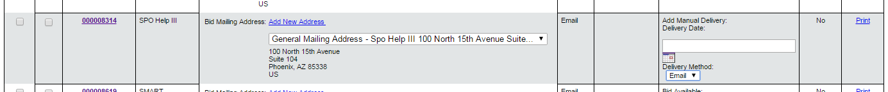
Disabling a vendor removes them from the list on the Bidders > General tab and on the Summary tab, but not from the Bidders > Quote Activity tab.
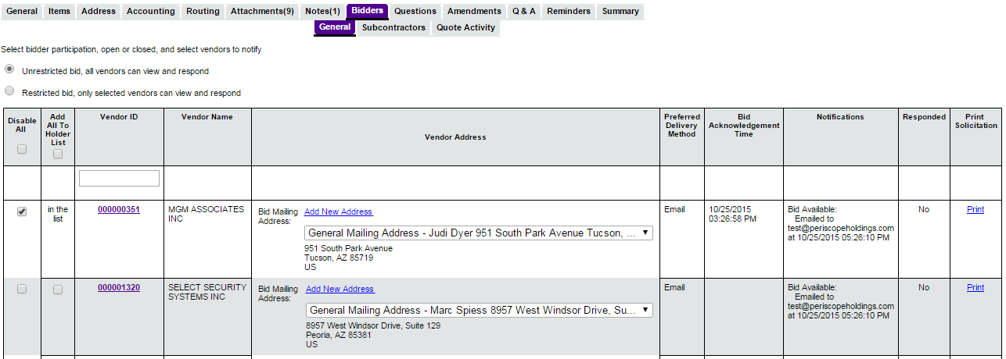
The Bid Holders List may be accessed from the Bids – Sent screen. Navigate to this screen using the Documents menu to select Bids > Sent.

Vendor Quote Activity
Vendors respond to Bids by creating and submitting a Quote document prior to the Bid Open Date that is defined on the Bid. In order to create and submit a Quote, a vendor must be registered in ProcureAZ and must log in using their Login ID and Password. Open Bids can also be viewed by vendors and the public without logging in to ProcureAZ by clicking the Open Bids link on the Login Screen.
After logging in, the vendor’s home page is displayed. On the Bids tab, vendors can view Bids by type: Request for Revision, Bid/Bid Amendments, Open Bids, and Closed Bids. Vendors can view Open Bids before creating a new Quote by clicking the link in the Bid # column. Vendors must first choose whether they want to receive future correspondence regarding the bid, or just view the bid. On the Acknowledge Receipt and View Solicitation screen, selecting Yes will place the vendor on the Bid Holder List and they will receive future notifications, while selecting No will just display the Bid.
In addition to the Bid Holder List, users can also view the list of vendors directly notified about the solicitation by accessing the Bid. This list can be viewed from either the Bidders > General tab, or the Summary tab in the Bidders field within the Header Information section. Next to each vendor it also displays when they were sent every notification, including amendments, and if they’ve submitted a response. The Bidders > Quote Activity tab allows Basic Purchasing users to see when a vendor has submitted a quote and when they may have withdrawn it.

Managing Questions and the Q & A Response
The Questions tab is where any questions that were setup on the Bid will appear. If any of the questions are required, a validation error will appear along the top of the screen on this tab of the Vendor’s quote until all required questions are answered. Vendors answer questions by choosing from the available options or entering data in any text fields if provided and clicking Save & Continue.
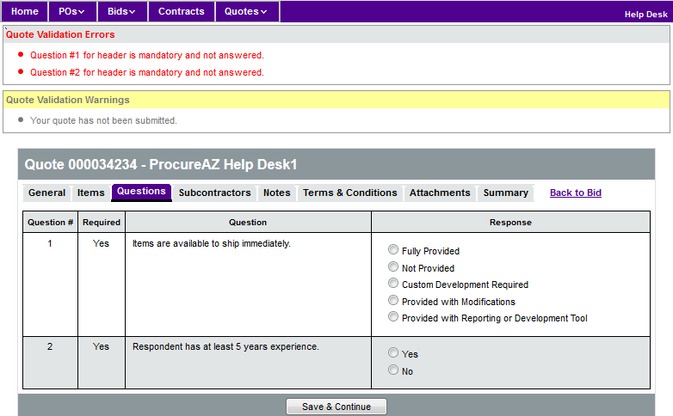
Following the publishing of a Bid, there may be questions from vendors regarding the solicitation. ProcureAZ enables users to provide answers to the questions via the Q & A tab on the Bid.

Vendors can then access this Q & A by viewing the Bid document.
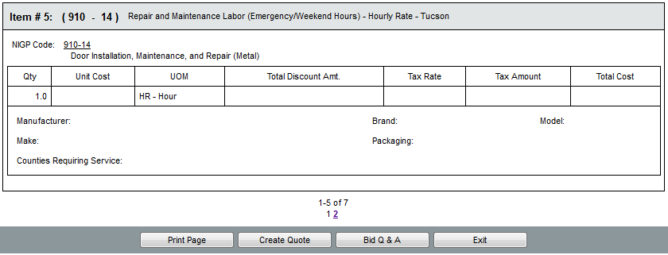

If the Allow vendor to submit questions check box is selected, vendors accessing the Bid may submit questions electronically. These questions will automatically appear on the Q & A tab. When composing an answer, Basic Purchasing users can select whether to show the question and answer on the web to every vendor by selecting the check box in the Show on Web column. Selecting the Show on Web and Show Original Vendor Only check boxes will display the question and answer only to the submitting vendor.
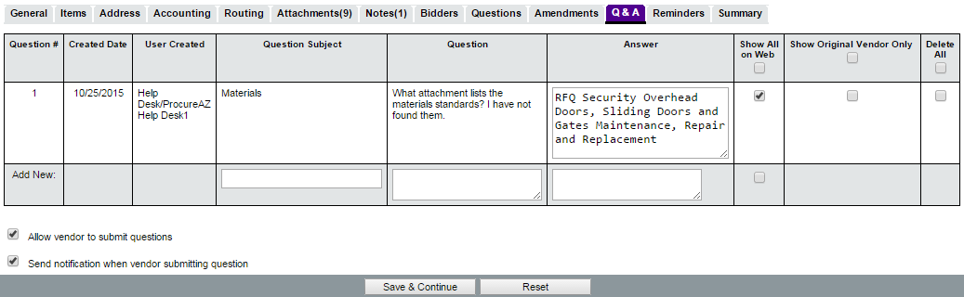

On the bottom of the Bid document, a Bid Q & A button is displayed that enables the vendor to view any questions that have been posted and responded to via the Q & A tab on the Bid. If vendors are allowed to submit questions, an Add new questions section will appear on the Q & A tab enabling the vendor to ask questions that will appear on the Bid’s Q & A tab to answer.
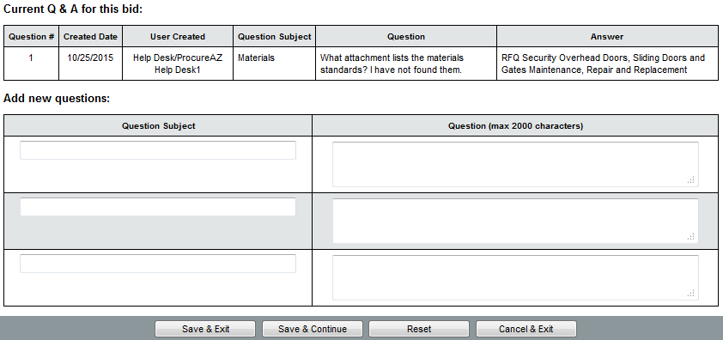

Terms and Conditions
The Terms & Conditions tab displays a list of all the files attached to the Bid, which can be downloaded and/or viewed by clicking the link in the File Name column. Before vendors are able to submit their Quote, they must select a button option indicating their acceptance of the Terms & Conditions of the Bid. Selecting either Yes with exceptions or No will require that the vendor enter text in the field below explaining their exceptions to the Terms & Conditions.

Creating a Bid Amendment (Addendum)
If an amendment to the Bid is necessary, select the Amendments tab on the Bid document. The Amendments tab allows users to view any previously completed amendment as well as create a new amendment by clicking the Create Bid Amendment button. Creating a new Bid Amendment will display a copy of the Bid, but with only four tabs available for editing: the General tab, Items tab, Attachments tab, and Summary tab.

General Tab
The General tab only allows users to edit the Show on Web, Allow Electronic Response, Bid Opening Date, Info Contact, and Pre-Bid Conference fields. If any changes are made on the General tab, click Save & Exit before continuing with the rest of the amendment.
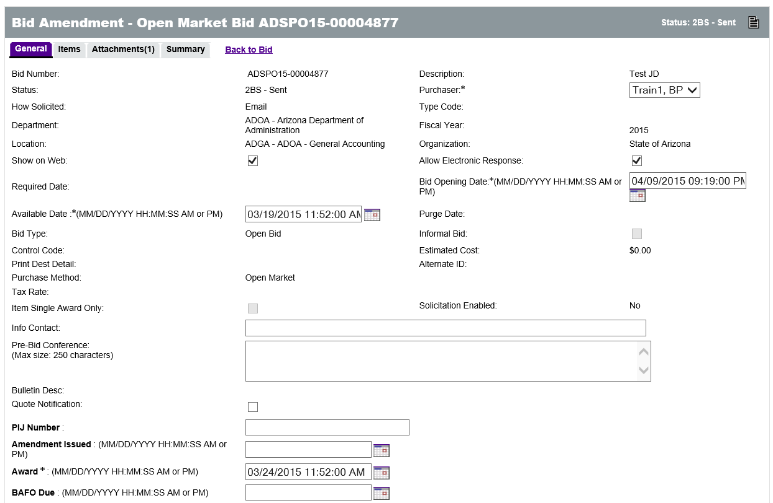

Items Tab
On the Items tab, all Item information can be edited using the same process as the Item setup process. Items can also be added and cancelled on the amendment.
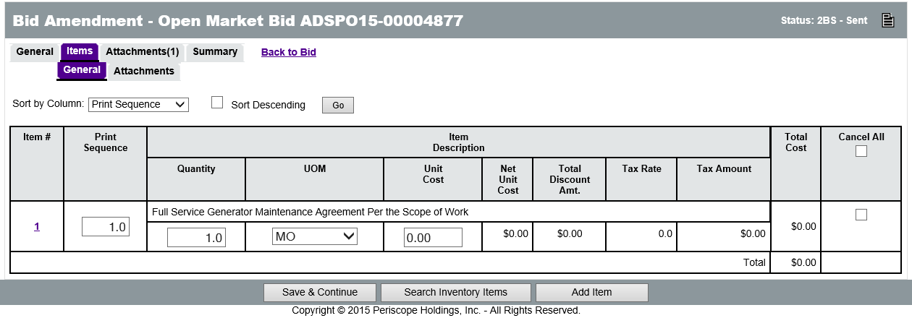

Attachments Tab
On the Attachments tab, attachments can be added or deleted. Users can also edit whether attachments should be shown to vendors.
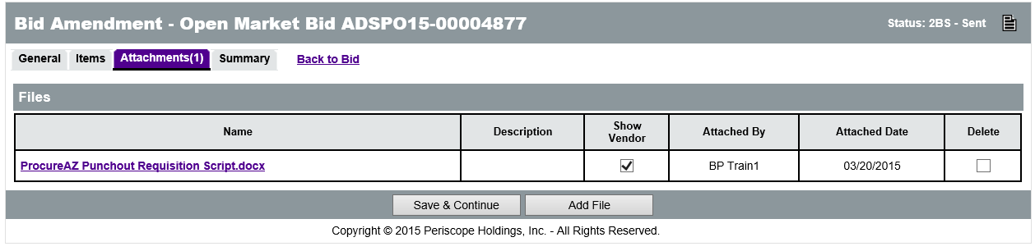

Summary Tab
On the Summary tab, a list of each change that was made on the previous tabs is displayed. The Description column has an explanation of each change. This explanation is editable if additional detail is needed. A Comment field also exists along the bottom of each listed change, enabling users to further explain any amendment. A global comment field is available along the top of the Summary tab so that users can provide information regarding the entire amendment, if necessary.
TIP: Putting a comment in the Comment for the whole bid amendment box at the top of the Summary tab will notify vendors of the amendment automatically, even if the Show to Vendor box is NOT checked next to the change.
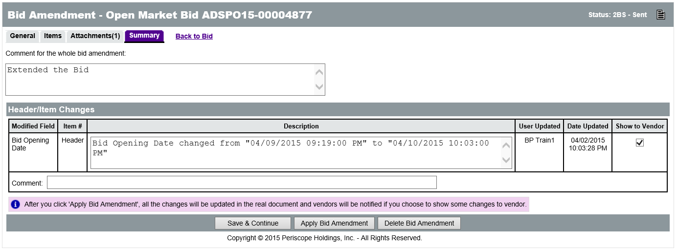
To the right of each change a Show to Vendor check box allows users to decide whether to inform vendors about the change. Amendments processed to fix typographical errors are an example of changes that may not need to be sent to vendors. By default, vendors will be informed of all changes. If any changes are made on this screen, ensure that you click Save & Continue before applying the Amendment.
TIP: You can select Delete Bid Amendment to discard the amendment and create no changes to the Bid.

Apply Bid Amendment
Click the Apply Bid Amendment button on the bottom of the Summary tab to apply the changes to the Bid and inform the vendors that were originally informed about the Bid along with those on the Bid Holder List.
Upon applying the amendment, the changes will automatically be applied to the Bid document and the Vendor Notification Result screen will be displayed, listing the vendors that were emailed regarding the amendment, what time they were emailed, and what email address was used.
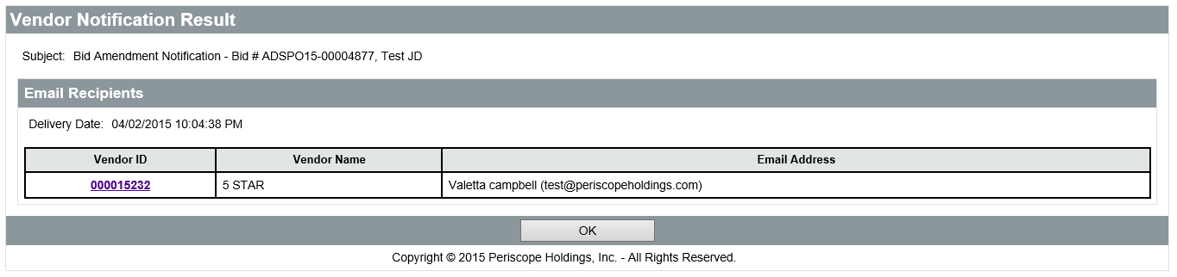
After a Bid Amendment has been applied, vendors can acknowledge the Amendment by accessing the Bid and selecting the Acknowledge Amendment(s) button at the bottom of the document. An Amendments field will appear in the Header Information section listing each Amendment that has been applied to the Bid. Clicking the Acknowledge Amendment(s) button will display a pop-up window informing the vendor that they have acknowledged all Amendments and reminding them to review any Quotes they have previously started or submitted.
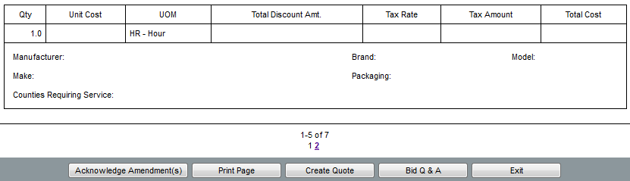
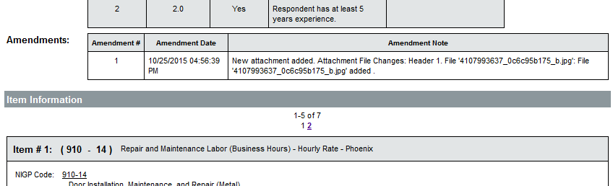

Vendors are able to acknowledge amendments after the Bid has reached its opening date. After the Bid has been opened, vendors will receive an error message when trying to acknowledge amendments, but their quotes will reflect acknowledgement on the date and time a revised quote was submitted or the bid was awarded.

Activity 13.2

Manage a Bid Document

Scenario
You have received a request to review and amend a Bid document.

Setup
- User is logged in to the ProcureAZ home page as a user with the Basic Purchaser role.

Steps
- Locate the Bid document.
- Review the Bid Holder List.
- Review the Quote Activity.
- Create a Bid Amendment.

  - End of Bid Process
At the end of the Bid process, the Bid is opened and vendor responses are reviewed and compared. Additional information may be needed before a decision can be reached. Once the decision has been made, the award may be made to the selected vendor.

Canceling a Bid
Once a Bid has been published, if it needs to be terminated by canceling the Bid, a notification will be sent to all vendors chosen as bidders, along with any additional vendors that have been added to the Bid Holders List.
Click the Cancel Bid button at the bottom of the Summary tab to terminate the Bid. The vendor notification screen will display a list of the vendors that have been notified regarding the Bid cancellation. Once a bid is canceled it is no longer available for vendors or the public to view. Vendors who submitted quotes prior to cancellation will not be able to view them.

Reviewing the Quotes (Vendor Responses)
Access the Bids Ready To Open screen by clicking on the Documents menu and selecting Bids > Ready to Open. If responses have been received, an Open Bid link will appear in the Open Quotes column next to the Bid. If no responses have been received a Create Quote link will appear in this column, allowing users to enter Quotes that may have been received offline. If no responses have been received, an amendment may need to be created that extends the response period by pushing back the Bid Opening Date. Otherwise, users may want to cancel the Bid.
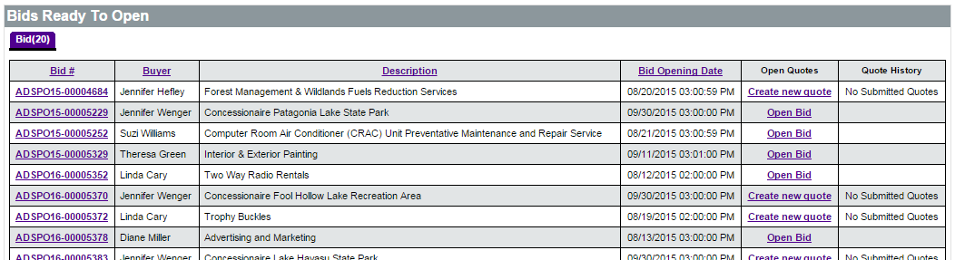

Opening the Bid
Once the Bid Opening Date and Time has been reached, the Bid will once again be accessible via the Bids tab on the Homepage on the Ready to Open sub-tab. It can also be accessed from the Documents drop-down menu in the Navigation bar by clicking Bids > Ready to Open. Prior to opening a Bid, verify that responses have been received from vendors for review, evaluation, and award.
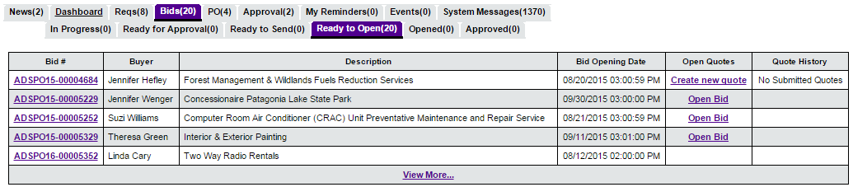
TIP: You can change the Bid Opening Date and Time with an Amendment even after the opening date and time have passed, as long as the Bid has not been opened.
On the Bid, the Bidders > Quote Activity will show which vendors submitted quotes.
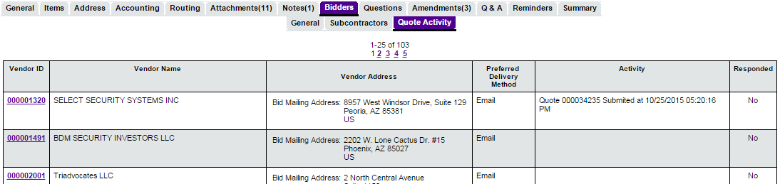
When the Bid is ready to be opened, click the Open Bid link to display the Summary tab of the now Open Bid. The Bid can also be opened from the Summary tab by clicking the Open Bid button at the bottom of the screen.
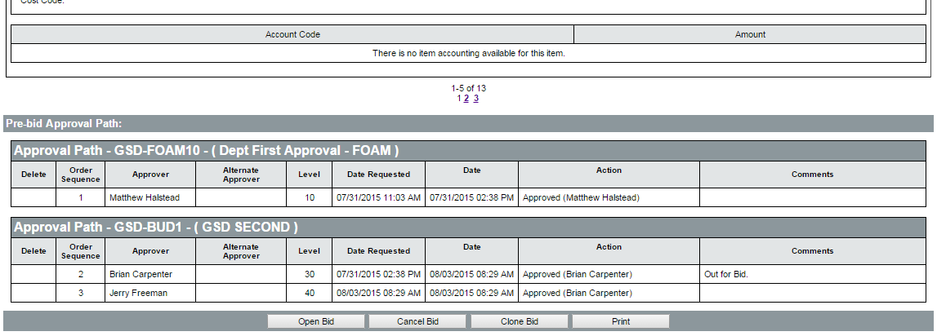
Users can access the Bid Tabulation (Bid Tab) document and the Quote History for the Bid once it has been opened. From the Bid Tab, users can view the submitted Quotes and begin the evaluation and award process.
The Quote History screen displays only the submitted Quotes. Users can view the submitted Quote by clicking the link in the Quote # column. The price quotes for each item on the Quote can be viewed by clicking the Expand icon next to the link in the Quote # column.
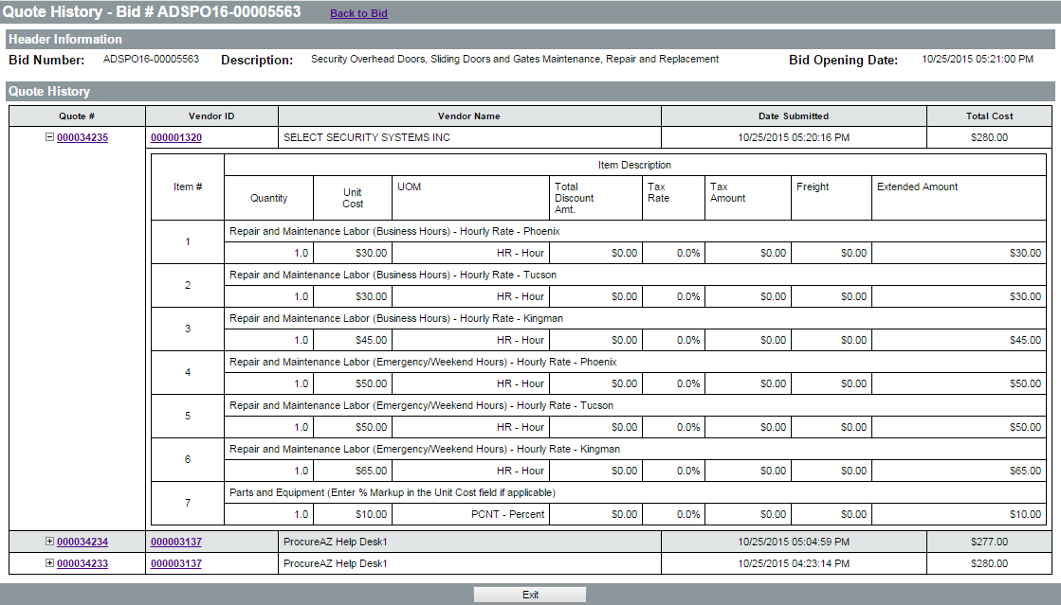

Bid Tabulation
The Bid Tabulation, like all documents in ProcureAZ, is completed by working through a series of tabs, then reviewing all of the information on the Summary tab before submitting the document.
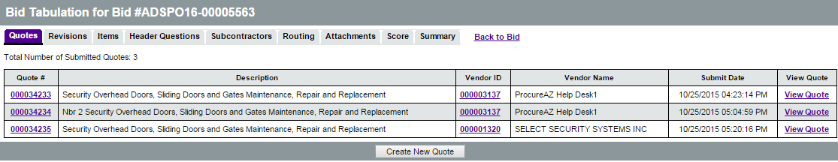
The tabs on the Bid Tab enable users to compare Quotes, both in their entirety and for specific elements, request revisions to Quotes, conduct an evaluation, attach files, and recommend an award.

Quotes Tab
The first tab on the Bid Tab is the Quotes tab, which displays all of the Quotes that were received in response to the Bid. If a revision to a Quote is requested, and one is submitted, the revised Quote will take the place of the original in this list. Click on the link in the Quote # column to open a pop-up window displaying that specific Quote. Selecting the View Quote link on the far right will open the Quote in the same screen, rather than as a pop-up. All of the tabs available to the vendor when completing the Quote are visible, except the Notes tab.
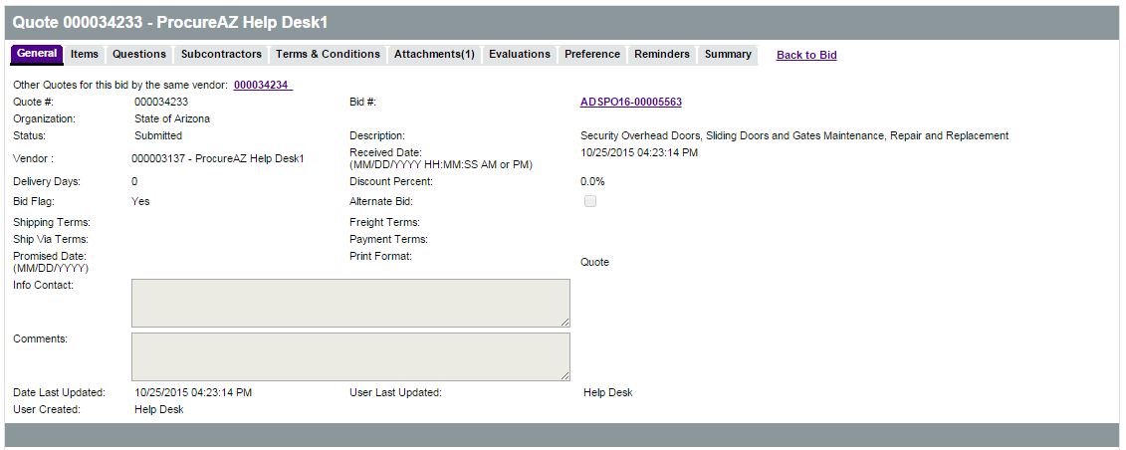
The Bid Tab allows users to view and compare every vendor’s quoted pricing by item, as well as their answers to the questions asked on the Bid. A vendor’s attachments and Terms & Conditions response can only be viewed by looking at the Quote document.
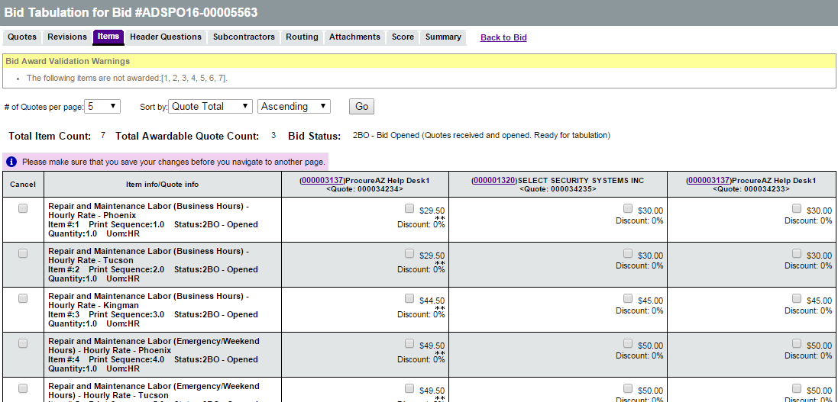
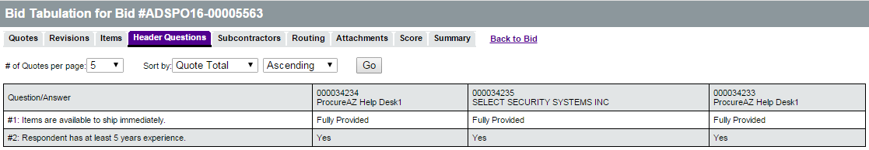
The Quote document also lets users know if the vendor acknowledged viewing every amendment applied to the Bid. On the Summary tab of the Quote, the Bid Acknowledgements field displays when the vendor acknowledged each amendment. A yellow validation warning will appear on the top of the Summary tab if the vendor did not acknowledge all amendments.
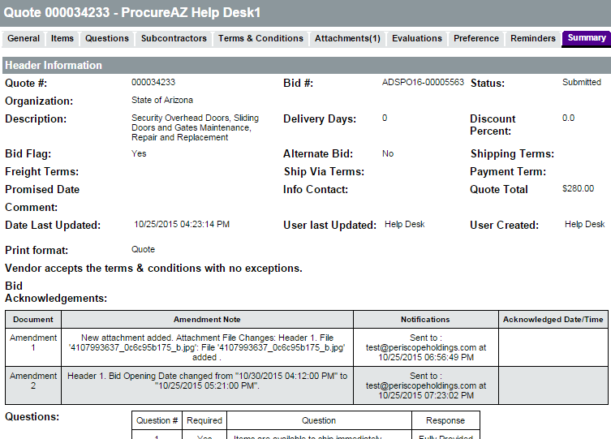
TIP: This warning does not drive any system functions and is intended solely to provide you with information regarding the Quote.

Requesting Revisions and Best and Final Offers
Once the Opening Date/Time has been reached for a formal Bid and the response period has closed, vendors can no longer submit new Quotes or edit the Quotes they have already submitted. However, once a Bid has been opened, users can request revisions and Best and Final Offers (BAFOs) via the proposal revision feature on the Revisions tab of the Bid Tab. Since a clarification

is not a revision of a Quote, any clarifications that are needed should be conducted outside of ProcureAZ either by phone or email.
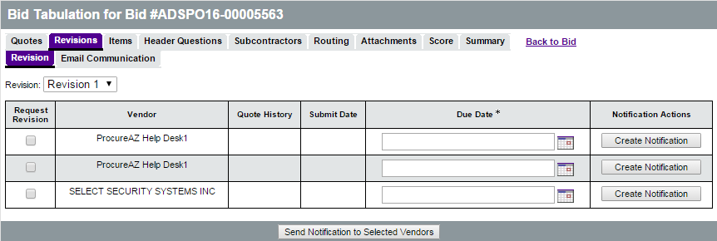
Requesting a proposal revision is done by choosing a particular Quote and sending a system email to the vendor that created it. A copy is then made of that Quote that has the same number with
-RX appended to the end, where “X” is the number of revisions that have been requested for that Quote. This new copy of the Quote is editable by the vendor until the revision process is closed.
While the revision process remains open, users are prohibited from recommending an award and the vendor can submit and withdraw their Quote as needed. They are also able to acknowledge any amendments that have been applied to the Bid.

Revision and Best and Final Process
The revision process is used to solicit Best and Final Offers. Only one Best and Final Offer is allowed unless approval from the State Procurement Administrator is granted to conduct a second Best and Final Offer. Multiple Revisions, however, are allowed. Most Revisions are yes/no questions. To request a revision, the first step is to choose which vendors to request a revision from and to determine if multiple vendors should receive the same revision request email, or if individual vendors should receive separate emails.
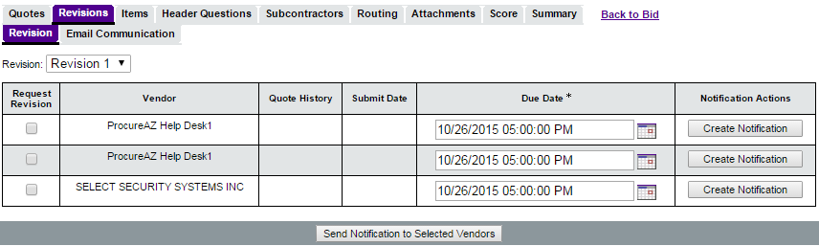
To send the same email request to multiple vendors, pick a Due Date for each revision by clicking the calendar icon and selecting the check box in the Request Revision column for each vendor to receive the request email. Click the Send Notification to Selected Vendors button at the bottom of the screen.
To send a revision request to one vendor, pick the Due Date for that vendor’s revision, then click the Create Notification button in the Notification Actions column.
TIP: The date selected in the Due Date column does not effect when you are able to cutoff the revision process and view a vendor’s submitted revision. At any point you can close the revision process and either start again or continue with the evaluation and award process.
Next, the Send Quote Revision Email screen enables users to develop the email message that will be sent requesting the proposal revision(s), including adding Additional Email Recipients, a Subject, Text (body), and Attachments. Once complete, click the Send Revision Request button at the bottom of the screen. A pop-up message is displayed confirming the intent to make vendors’ Quotes editable and to send the email (the look of the message will vary based on the web browser being used).
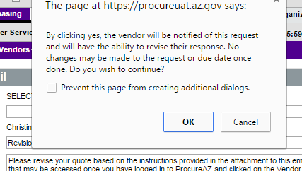
The Text field does not support standard formatting, so it is recommended to limit the text in this field and include any instructions in attached documents. This email will not appear in your email Sent folder, so if you need a copy for your records, include your own email in the Additional Email Recipients field.
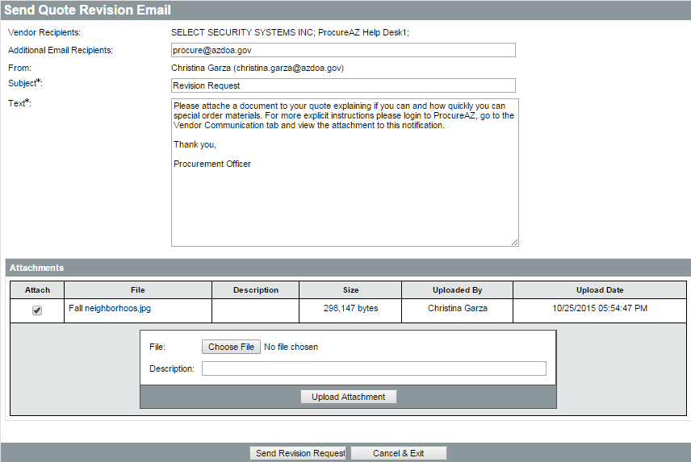
Vendors can access their editable Quote from the Request for Revision section on the Bids tab of their Homepage. The editable Quotes that display in this section are sorted from newest to oldest. Clicking the link in the Quote # field will open all fields for editing, allowing the vendor to change all aspects of their Quote, including the item price quotes, question answers, Terms & Conditions response and exceptions, and attachments. After completing the editing process, the vendor can submit their revision by clicking Submit Quote on the Summary tab. Revisions can be submitted and withdrawn as desired by the vendor until the revision round is closed.
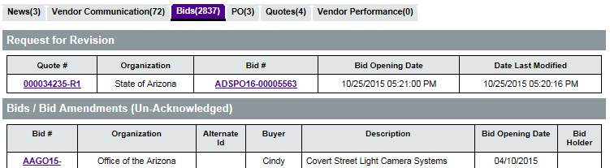
Note that if a revision round has been closed without the vendor submitting a response, the copy of their Quote that was created to allow editing will continue to appear on their Homepage under the Request for Revisions section. However, upon selecting the Quote, a pop-up message is displayed alerting the vendor that the revision process for that Quote has ended. At that point, the Quote will disappear from their Homepage.
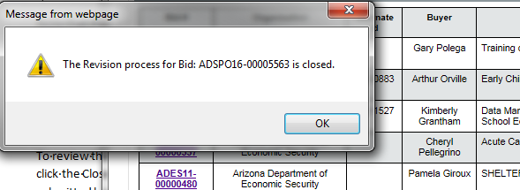
To review the revised Quotes, navigate to the Revision tab on the Bid Tab of your Bid and click the Close Revision Process button at the bottom of the screen. If a revision was submitted by a vendor, the revised Quote will replace their original on the Bid Tab. The

evaluation and award process can begin or another round of revisions can be conducted, if approved, by selecting the next round in the Revision drop-down.
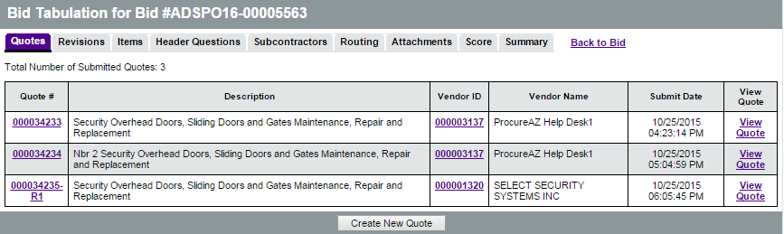
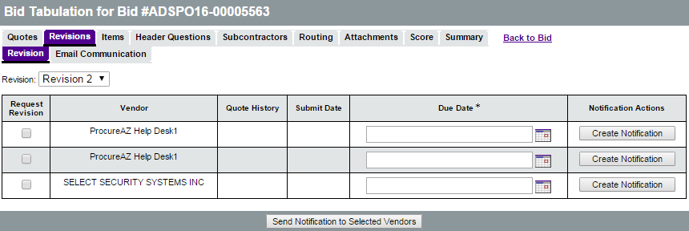

Evaluation Process
When all quotes have been received and no revisions are necessary, navigate to the Items tab to compare the Quotes. Each item on the Bid is listed with the price by vendor. Users can sort and organize the list to enable different comparisons as needed.
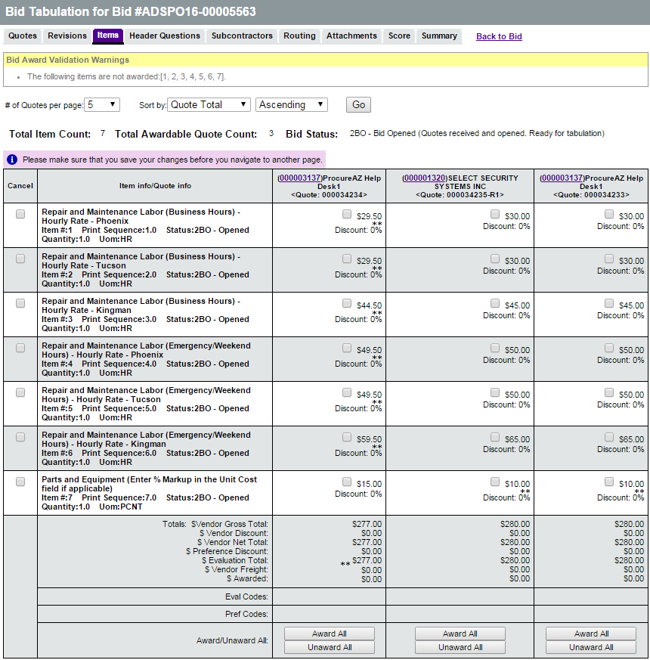

The Header > Questions tab displays a list of all the header-level questions entered on the Bid and allows users to perform a side-by-side comparison of the responding vendors’ answers.
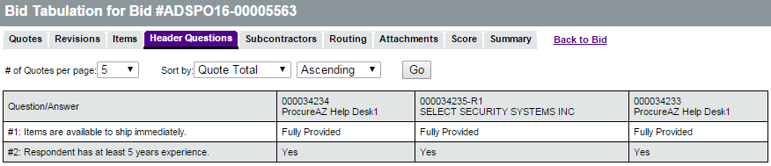

Scoring Tool
The scoring tool is not used within ProcureAZ. Evaluations can be conducted offline, but the documentation related to this process should be attached to the Bid Tab. The Attachments tab on the Bid Tab works identically to the Attachments tab on the Bid. Click Add Attachments to find the files to attach to the Bid Tab.

Award Process
Solicitation awards in ProcureAZ are completed from the Bid Tab document for the corresponding Bid. Award(s) can be recommended and submitted for approval at any time once the Bid has been opened. Evaluation and Award documents should be attached prior to award so they may be automatically transferred to the resulting Master Blanket Contract(s).
Each item can be awarded to a single vendor, to multiple vendors, or items can be canceled and awarded to no one. A partial award can also be performed by not awarding an item or items to any vendor, which allows users to return to the Bid Tab later to create another award.
The Bid document will remain in Opened status until all items on the Bid have been either awarded or canceled. This means that the Bid document, and all its associated documents, including the Bid Tab, Quotes, and their attachments will not be visible to the public.

Award Recommendation
To award an item, click the check box next to the item within the column of the vendor to be awarded. To award all items to a vendor, click the Award All button within that vendor’s column. Click the Unaward All button to uncheck all items that were previously marked as

awarded to a vendor. Directly below the list of items, each vendor’s quote totals, including any quoted discounts and freight charges is displayed. When finished awarding items, click Save & Continue.
TIP: If there is a long list of items to be awarded, with most but not all awarded to a single vendor, it is quicker to select Award All, and then deselect the individual items that are not to be awarded.
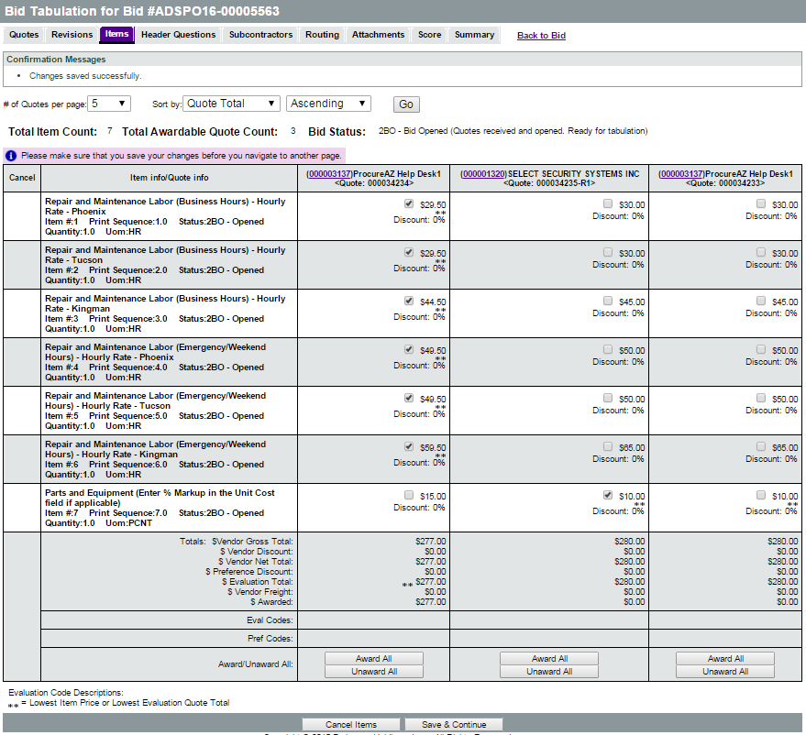

Approval Process
The next step in the solicitation award process is to submit the award recommendation(s) for approval. On the Summary tab of the Bid Tab, review the award recommendations before clicking Submit for Approval. The approval process for award recommendations is the same as when the Bid was submitted for approval to be published.
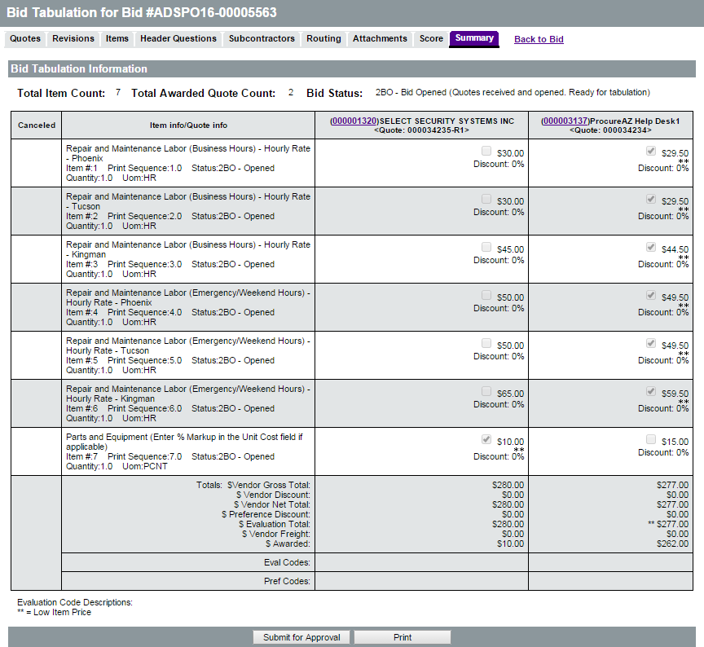
Once award of the solicitation has been approved, the document creator and all the vendors that submitted Quotes will be notified via an email that lists the awarded vendors. Both the Bid and Bid Tab are now available for viewing by the public.

Create the Master Blanket Purchase Order(s) or One-Time Buy Purchase Order(s)
After the award recommendation has been approved, the Summary tab of the Bid Tab has a Create PO button that is used to create the resulting PO(s), both Master Blanket Contracts and one-time buy Purchase Orders. Creation and management of the resulting Master Blanket Purchase Order(s) is addressed in Lesson 14, Creating and Managing Master Blanket Contracts.
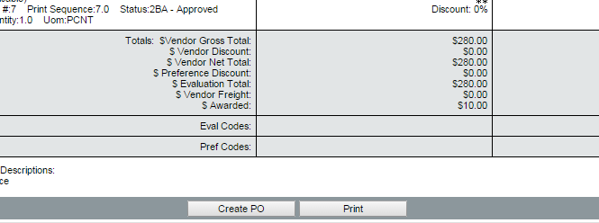
TIP: All Bid items must be either awarded or canceled in order for the Bid Tabulation to become public. If outstanding items remain, you can return to the Bid Tab at any time to either award or cancel them.

Activity 13.3

Open and Award a Bid

Scenario
You have received a request to open and award a Bid.

Setup
- User is logged in to the ProcureAZ home page as a user with the Basic Purchaser role.

Steps
- Open the Bid.
- Review the vendor responses.
- Review the Bid Tabulation.
- Award the contract to a vendor.

Lesson Summary
In this lesson you:
- Created and posted a Bid document
- Managed the vendor responses
- Examined the Quote review, evaluation, and award process

Check Your Progress
- All of the following are methods of creating a new Bid document except ____________.
  - Clone an existing Bid document
  - Create a Bid from scratch
  - Create a Bid by opening an existing contract
  - Create a Bid from an approved Requisition
- The Bid Opening Date is the date that the bid is made available to vendors to provide quotes.
  - True
  - False
- Only the vendors may ask questions on the Bid.
  - True
  - False
- Once a Bid has been sent to vendors, users can no longer ____________.
  - Change the Bid Opening Date
  - Answer vendor questions
  - View vendor acknowledgement
  - None of the above
- Bids can be canceled after they have been published.
  - True
  - False
- Items can be awarded to ___________.
  - A single vendor
  - Multiple vendors
  - No vendors
  - All of the above

