14 Creating and Managing Master Blanket Contracts

This page was intentionally left blank.
Contents
14. Creating and Managing Master Blanket Contracts 1
Learning Objectives 1
Lesson Overview 1
14.1 Creating a Master Blanket Purchase Order 2
Beginning a New Blanket Purchase Order 2
Complete a Master Blanket Purchase Order 5
Adding, Editing, and Deleting Line Items to Master Blanket 7
Updating and Reviewing Vendor Shipping and Payment Terms 13
Adding Controls to the Master Blanket PO 14
Adding and Removing Attachments on the Master Blanket Purchase Order 17
Adding, Editing, and Deleting Notes on the Master Blanket Purchase Order 18
Submitting the Master Blanket Purchase Order for Approval 19
Create a Master Blanket Purchase Order 22
14.2 Managing a Master Blanket Contract 23
Locating the Master Blanket Purchase Order 23
Amending the Master Blanket Purchase Order (Change Orders) 24
Manage a Master Blanket Purchase Order 28
Lesson Summary 29
Check Your Progress 30

14. Creating and Managing Master Blanket Contracts

Learning Objectives
In this lesson, you will:
- Create a Master Blanket contract
- Manage the communication of the contract with the vendor
- Examine the Master Blanket completion and amendment processes

Lesson Overview
This lesson introduces the Master Blanket contract process in ProcureAZ. This process begins with the creation of a Master Blanket Purchase Order on which Item, Vendor, and Control information is entered. The process continues with document approval and vendor notification as well as the possibility of Master Blanket amendments and reassignment.

14.1 Creating a Master Blanket Purchase Order
Purchase Order (PO) documents are used to communicate an agreement with a vendor for the provision of goods and/or services. The agreement established by a Purchase Order may be for a one-time purchase, a term contract, or an order against an existing term contract. Master Blanket Purchase Orders are used to establish and manage term contracts between vendors and the State of Arizona. Master Blanket Purchase Orders do not require Shipping, Billing, or Accounting information since they are not orders for goods or services and do not encumber funds.

Beginning a New Blanket Purchase Order
Users must have the Basic Purchasing role assigned to create a new Blanket PO. Blanket POs can be created several ways, either from an approved Open Market Requisition, from cloning an existing PO or Requisition, from an approved bid award recommendation, or from scratch. The most common method for creating a Blanket PO is to convert an awarded bid to a PO with the PO Type, Blanket.

Converting Requisitions
One method of creating a PO is to convert an approved Open Market Requisition into a PO and change the PO Type to Blanket. Converting a Requisition into a PO brings all of the information from the Requisition over to the PO, which reduces the amount of data entry that is required to complete the new PO.
Open Market Requisitions are requests for goods or services that are not on an active contract. Once the Requisition has been approved, a Basic Purchasing user is notified that the Requisition is Ready for Purchasing. The Basic Purchaser determines if a solicitation is required for the desired items, or if the items can be ordered from a vendor without competition on the pricing.

Requisition Summary Tab
The Summary tab of the Requisition includes buttons at the bottom that allow a Basic Purchaser to convert the Requisition into either a Bid or a Purchase Order. The Basic Purchaser can also disapprove the Requisition, which routes the document back to the Requisitioner for correction and resubmission.
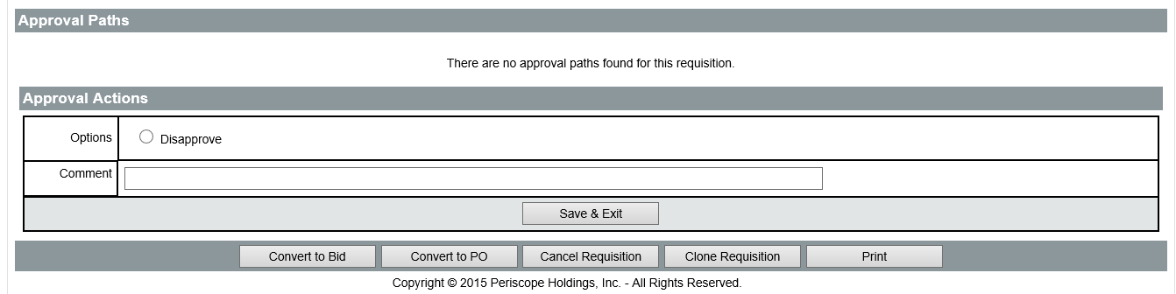
TIP: Unless the creator of the Requisition conducted an Informal Request for Quotes (RFQ), you will most likely need to conduct a formal solicitation before awarding a term contract by creating a Master Blanket PO.

Clone Process
Another method of creating a new PO is to clone a previous PO or Requisition. The cloning process creates a new copy of the document, enabling users to re-use the information that was entered on the original while also allowing users to edit any information as necessary.
Use the Documents menu to locate an existing PO or Requisition to clone. In the drop-down menu, hover the mouse over POs, then select New to display the Create a New Purchase Order screen.
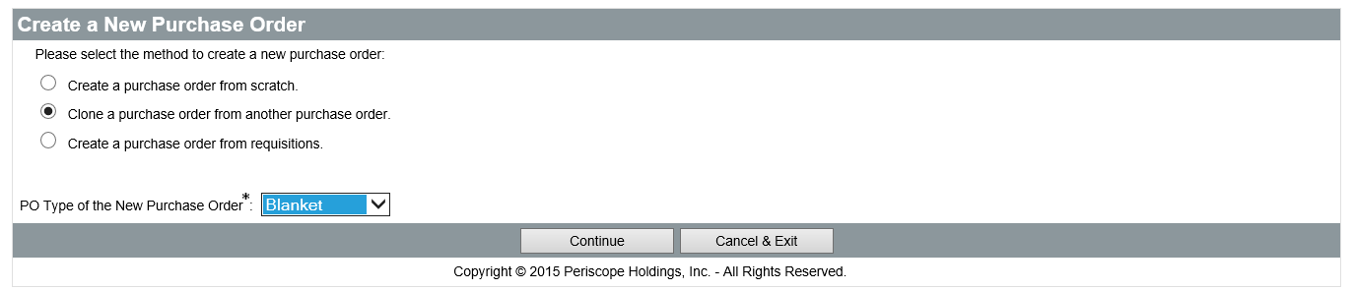
Select either Clone a purchase order from another purchase order or Create a Purchase Order from requisitions, then select Blanket from the PO Type for the new Purchase Order drop-down menu and click Continue to search for the PO or Requisition to clone. Any older PO can be cloned by accessing it and clicking the Clone PO button at the bottom of the Summary tab.
On the Search Documents to Clone screen, enter any known search criteria and click the Find It button to return all matching results. In the list of search results click the radio button in the Select column next to the document to be cloned. You can also view the document by clicking the link in the Purchase Order # column before creating the new clone document.
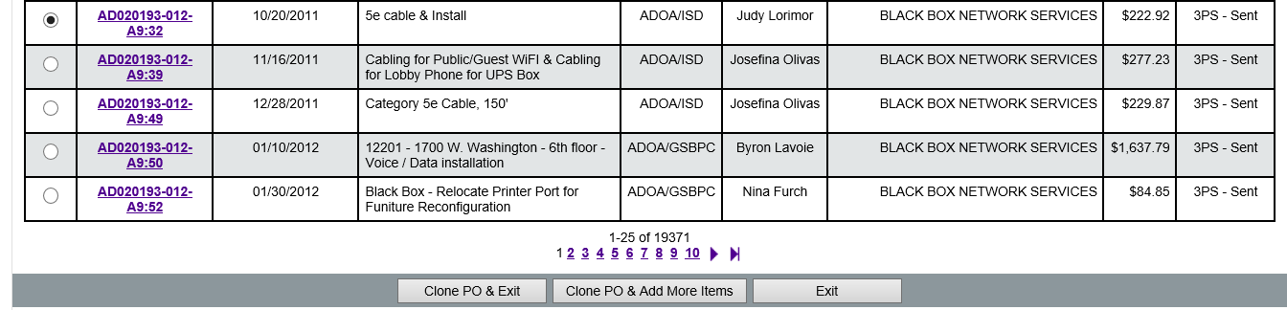
Click the Clone PO & Exit button to display the General tab of the new Blanket PO. Click the Clone PO & Add More Items button to create a new Blanket PO that first displays a search screen used to find and add any item that has previously appeared on a ProcureAZ PO for your Organization. The process of finding and selecting items is the same as the process used to find the document for cloning. Once all desired items have been added to the PO, the General tab of the new PO document is displayed.
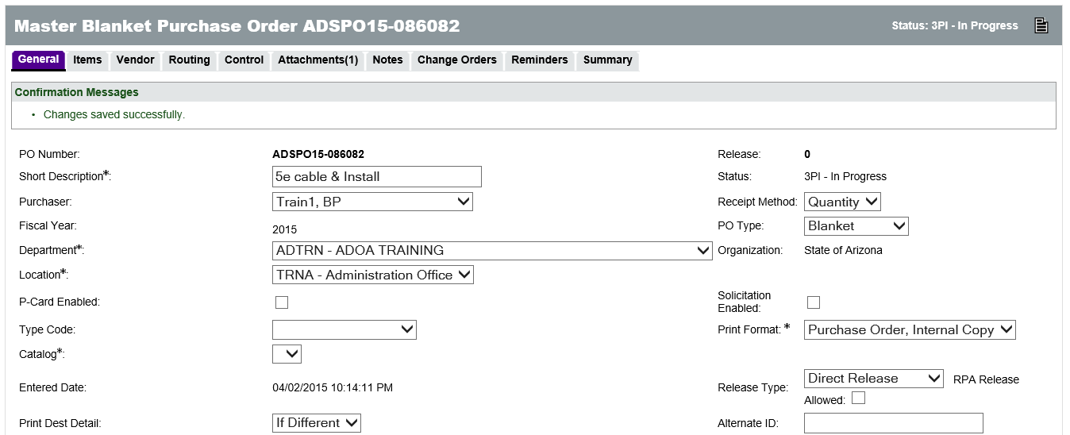

New PO from Scratch
To create a new Blanket PO from scratch, click the Documents drop-down menu in the Navigation bar, hover the mouse over POs, and select New. On the Create a New Purchase Order screen, select Create a Purchase Order from Scratch, select Blanket from the PO Type for the new Purchase Order drop-down menu, and click Continue. The General tab of the new PO document will be displayed.
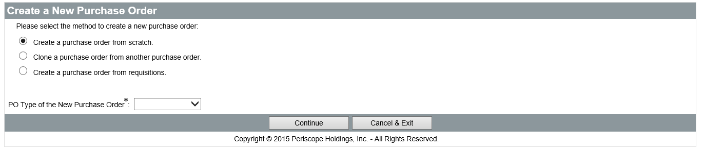
Unlike cloned documents, new documents are not assigned a number upon creation. In order for a number to be assigned, the required fields on the General tab must be completed and the document saved.

Converting a Completed Bid to a Master Blanket PO
Once an award recommendation has been approved on a Bid Tabulation Summary tab, click the Create PO button to create a new PO; the Purchase Order Creation Preview screen is displayed.

Purchase Order Creation
On the Purchase Order Creation Preview screen, a list of awarded vendor Quotes is displayed. A separate PO is created for each different vendor that was awarded at least one Bid Item. The Purchase Order Creation Options are listed below the vendor list and are used to bring information from either the Bid or the vendor Quotes to the PO. All of the options are checked by default and any information brought over can be deleted after creation of the PO. The options include:
  - Include Narrative Items
  - Include Bid Attachments
  - Include Bid Tab Attachments
  - Include Bid Notes
Click the Continue button to create the PO. All POs created will be displayed on the screen. Click the link in the PO # field to view that PO. The OK button at the bottom of the page will return the user to the Homepage.

Complete a Master Blanket Purchase Order
The process for completing any document in ProcureAZ is to work through the tabs in the document from left to right, starting with the General tab, completing all required fields, then reviewing and submitting the document for approval via the Summary tab. On a Master Blanket PO, information must be completed on the General, Items, Vendor, Control, and Attachments tabs.

General Tab
The fields on the General tab are used to describe the PO and define the type of contract it signifies, either a one-time Open Market purchase (may also be referred to as a Blanket) or a term Master Blanket contract (multiple purchases made using Releases). If the PO was created from scratch, all required fields (indicated with an asterisk) must be completed before clicking Save & Continue. If the PO was created by cloning another document or from a bid award, the information on the General tab will be automatically completed but can be edited if necessary.
The required fields on the General tab are:
  - Short Description – Enter a short description of the PO document
  - Department – Select the business unit that owns the contract
  - Location – Select the location for the department
The other standard fields on the General tab are:
  - Receipt Method – Select either Quantity or Dollar as the method that users will be able to received ordered contract items. Commodities must be received by quantity based on the integration with the State’s financial system, AFIS. Dollar is the preferred for service contracts, but if the services are ordered and billed at an hourly rate, the receipt method should be set to quantity. Receipt method may also be set at the line item level in the case of Master Blanket Contracts that have both commodity and service line items
  - PO Type – Set this to Blanket if not already specified at the time of creation
  - P-Card Enabled – Select this check box to enable users that order off this contract to pay with a P-Card
  - Type Code – Select whether the contract is for a Single-agency, Multi-agency, or Statewide
  - Release Type – Select either Standard or Direct Release Type to set whether orders against the contract must route through a Basic Purchaser before being sent to the vendor
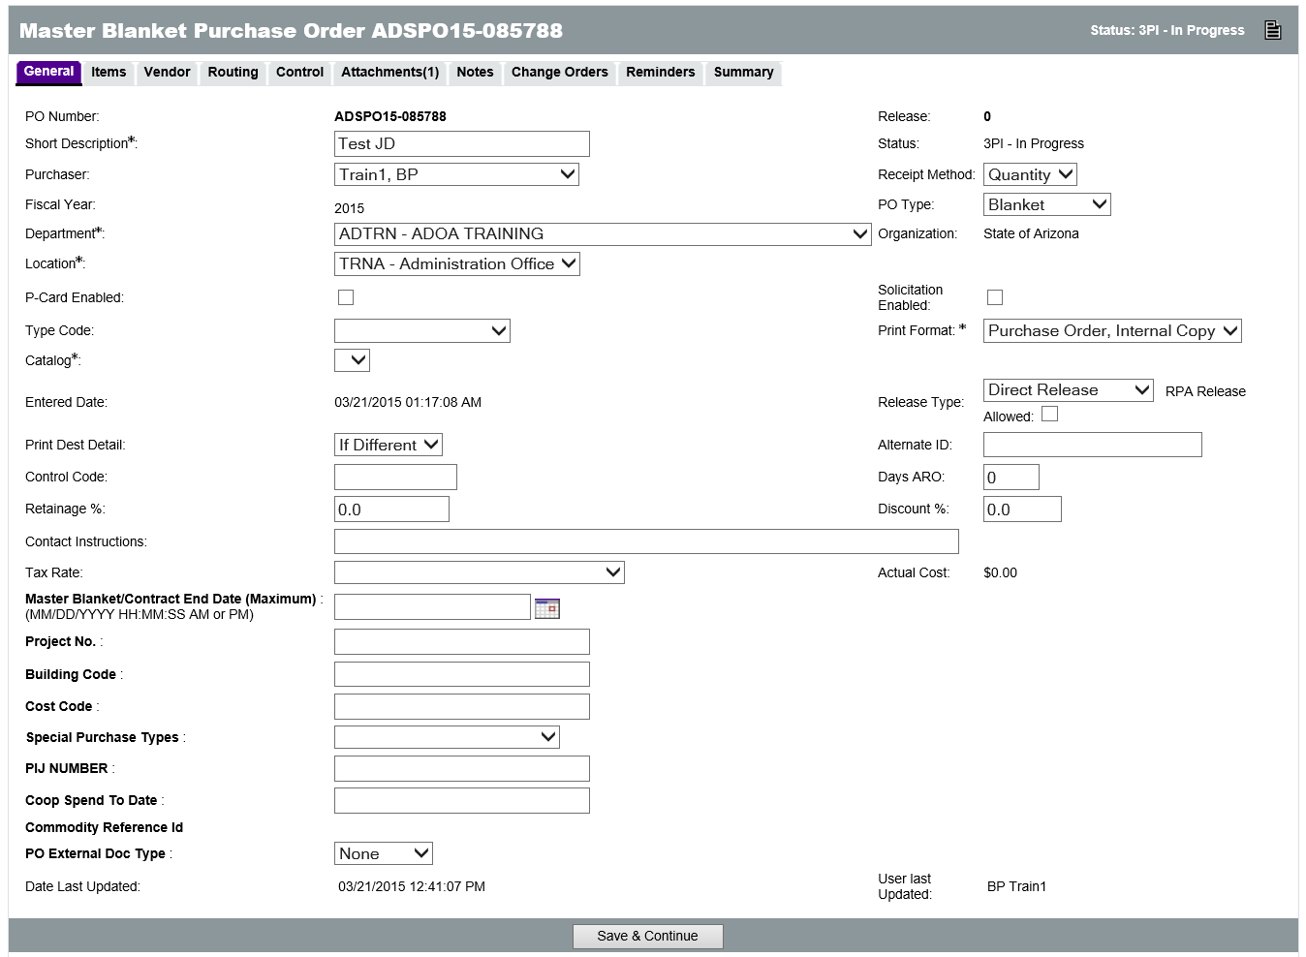
When all required fields and other desired fields have been completed, click Save & Continue to save the document and assign a document number if one has not been assigned already.

Adding, Editing, and Deleting Line Items to Master Blanket
The Items tab displays the goods and/or services that vendors will provide. The process of defining the line items for the PO will vary depending on the process used to create the new PO document.
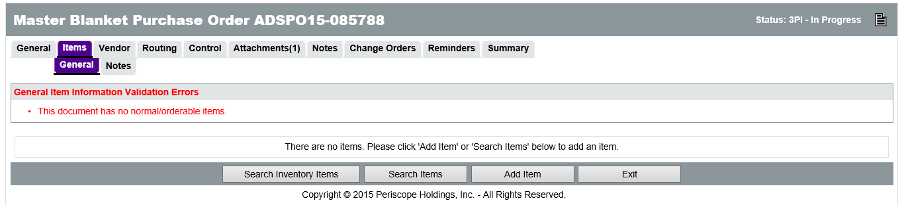
Every PO must have at last one Normal item that can be ordered. If the PO was created from scratch, Items can be searched or added using the buttons on the Items tab. The Search Inventory Items button is not used. If the PO was created by converting a Requisition or a Bid or cloning another document, the Items tab will initially display the items from the source document. Items can be edited and/or deleted on the Items tab.

Create Items
Item entry begins on the Items > General tab. In order to create a new Normal Item, the following fields are available:
  - Print Sequence – The line sequence number determines the order in which the items will appear to vendors. This will default to the order in which Items are added to the Bid and does not need to be changed.
  - Item Type – This value can either be Normal or Narrative. Normal items can be ordered. Narrative items only allow a Description, Project, Building Code, Cost Code, and Property Number to be entered.
  - Minimum Order Quantity – Enter the minimum quantity that must be ordered on any one Requisition, for no minimum, leave it as the default of 0.
  - Description – Enter the definition of the good or service being requested. For Narrative items, this can be instructions or other information.
  - Quantity – Enter the total number of the item being requested.
  - Unit Cost – Enter the estimated cost of one unit of the item. This is automatically hidden from vendors.
TIP: It is recommended that either the Unit Cost or the Quantity field should be zero, depending on what has been locked in on the term contract.
  - Unit of Measure – Select the unit of measure for the item from the drop down menu. Enter EA for Each if the unit of measure is unknown.
  - NIGP Class – If known, the 3-digit NIGP Class code for the item can be entered directly in the field. The code can also be selected from the drop down menu or searched for using the eyeglass icon.
  - NIGP Class Item – If known, the 2-digit NIGP Class Item code for the item can be entered directly in the field. The code can also be selected from the drop down menu or searched for using the eyeglass icon next to the NIGP Class drop down.
  - Property Number – Used to record an Asset Tag number and pass this information to the Purchase Order. This free-text field can accept individual numbers or a range of numbers, for example 75800 – 75810.

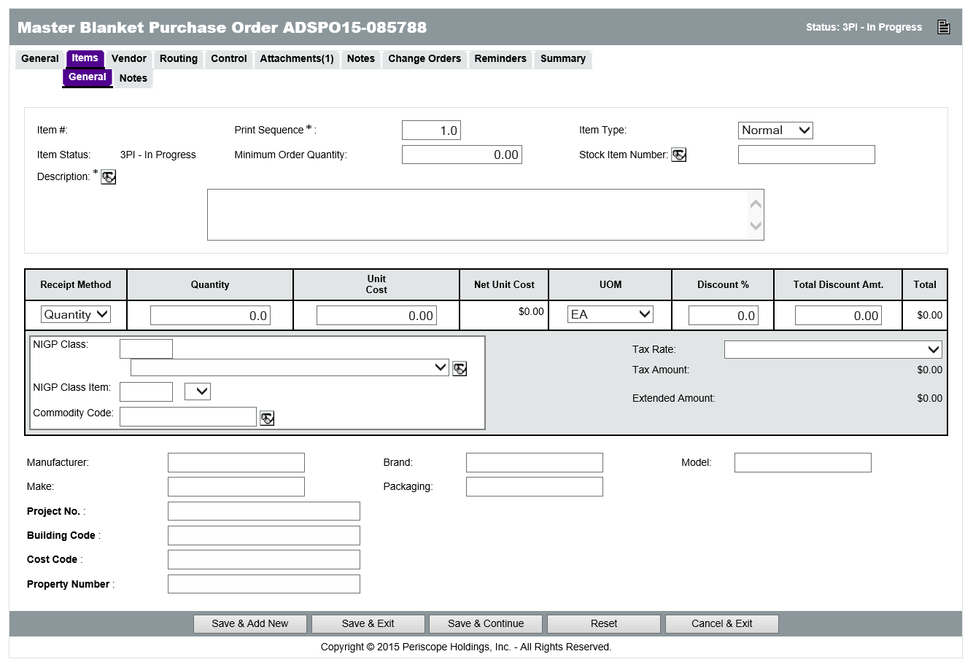
Other optional fields available when creating a Blanket PO Item include: Discount %, Total Discount Amt., Tax Rate, Manufacturer, Brand, Model, Make, Packaging, Project No., Building Code, and Cost Code. The specification fields (Manufacturer, Brand, Model, Make, Packaging and Property Number) may only contain information for Commodity line items. If information is entered into those fields for service line items, resulting POs will generate errors when trying to integrate with AFIS at the time the PO is sent to the vendor.
The Tax Rate is based on where the order is coming from. For example, if the vendor is in Flagstaff, then that is the Tax Rate that should be used. The Tax Rate should always be entered when the vendor is known. If the vendor is out of State, then the AZ State Tax rate should be chosen (use tax) to encumber the use tax.

Search Items
Click the Search Items button to search for any previously defined item. In the search fields, enter the desired criteria and click Find It to display the results. Users can search by Items or Documents using the Result Type menu at the bottom of the search page. For Normal items, enter the Quantity of the item being ordered. When you are finished adding Items, click Save & Exit to return to the Items tab.
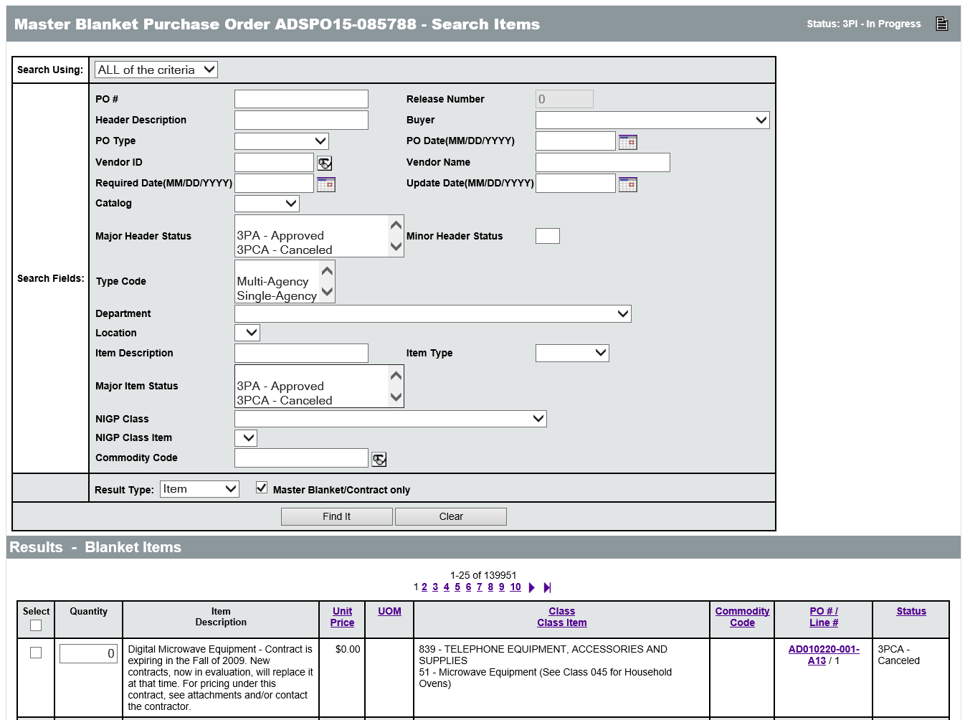

Edit Items
From the list of Items on the PO, it is possible to edit the current items, continue adding items, delete existing items, modify the print sequence, or modify the quantity of existing items. To edit an existing line item description, click the Item Number link in the first column. The resulting screen is the Item Detail screen (shown on page 8) and allows for the entry and editing of specific line item information.
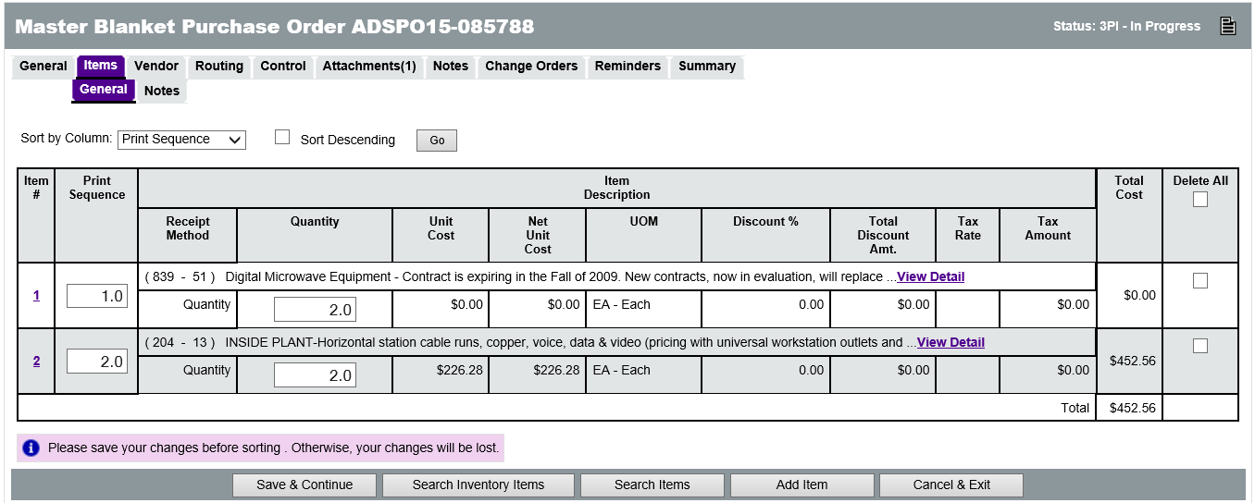
To add additional Items, click the Add Item button. To delete an item, check the Delete check box in the last column on the right and click the Save & Continue button. Checking the Delete All check box will mark all lines for deletion. To modify the print sequence or quantity, enter the new value in the corresponding field, and click the Save & Continue button.

Assigning NIGP Codes to Master Blanket Items
The NIGP Class and Class Item fields allow searching for the appropriate class and item records to assign to the Item. This will open the NIGP Code Browse page in a pop-up window (Pop-up blocker should be disabled when working with ProcureAZ). The NIGP Keyword search field allows users to search by keyword. Enter a keyword in the box and click the Search button.
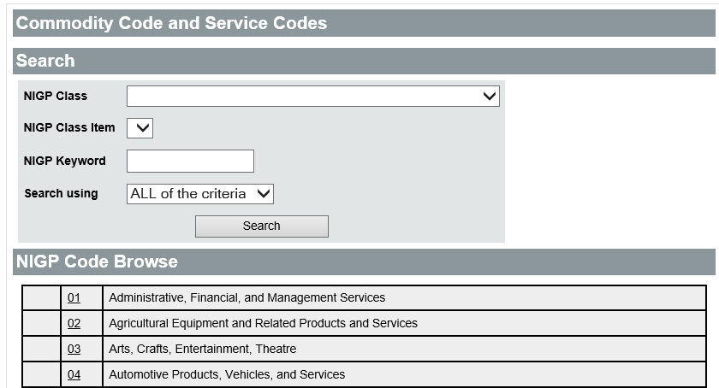
It may be necessary to try different keywords in order to find one that returns the desired results. When the appropriate Class and Class Item have been found, select the radio button for the Class Item and click the Save & Exit button to populate the fields on the PO.
In order for Accounts Payable staff to be able to pay for items and services ordered from Master Blanket Contracts in ProcureAZ, the items must have the correct type of NIGP code. Service items (like professional temporary services, consulting and monthly janitorial or pest control services) should have NIGP codes in the 900 series. This makes these items easier to pay through the integrated invoice process and assures that Fixed Asset Shells will not be created in error in AFIS. Goods (parts, batteries, pens, paper etc.) must have NIGP codes in the 005-800 series in order for the automated Fixed Asset Shell process to function properly in AFIS.

Add Freight Charges
If the agency will be required to pay freight charges for the ordered items and the freight charge has not been included in the price of the Item, the freight cost must be entered by creating an additional line item on the PO with the Freight commodity code of 962-86.
In order to encumber freight cost when multiple items have been purchased and partial shipments are expected, it is recommended to spread the freight across all of the Items by entering the same quantity for freight and dividing the total cost by the number of units.
TIP: It is recommended that an equal quantity for freight and items is entered to enable receipt of items and freight in the same quantity.
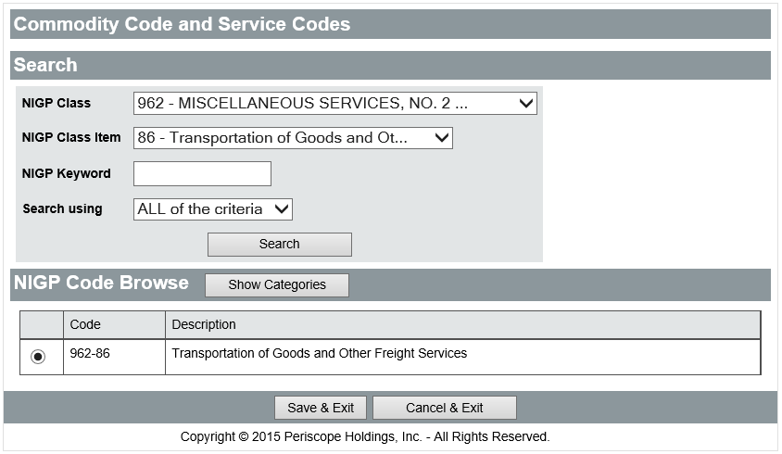

Special Items
For some contracts, a spreadsheet is attached that lists the items and prices available. When creating a requisition, Generic Line Items can be added to describe the different general categories of items available. These items are placeholders with no specified unit price. Users should refer to the attached spreadsheet that contains the items and pricing information. When a generic line item is selected, the customer must provide the price, quantity, and unit of measure for the specific item and add to the item description in order to specify exactly what is being purchased.
If the contract needs to enable the processing of blanket encumbrances against it, Blanket Encumbrance Items are used to describe the general categories of services the agency would like to encumber funds for. If funds should be encumbered upfront for all services on the entire contract, then only one Blanket Encumbrance Item is necessary. When a Blanket Encumbrance Item is selected, the customer must provide the total dollar amount to be encumbered and can add to the item description in order to specify exactly what is being purchased with the funds.

Updating and Reviewing Vendor Shipping and Payment Terms
The Vendor > General tab displays the prime contractor for the contract along with the relevant Payment, Shipping, and Freight terms. If the Blanket PO was created by cloning another document, the terms on the Vendor > General tab will be populated with whatever was contained on the source document.
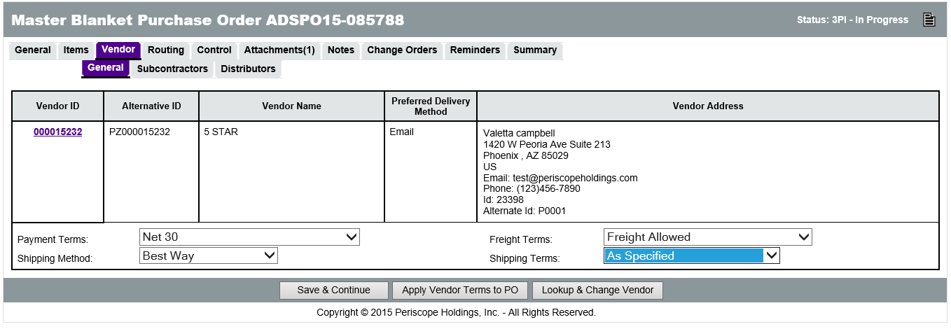
If the PO was created from awarding a Bid, the vendor will be the one that was awarded Bid Items and the terms will be the terms that the vendor provided in their response. The terms on this tab can be changed, if necessary, by selecting the desired option from the drop-down menus for each field.
Clicking the Apply Vendor Terms to PO button will populate the Payment, Shipping, and Freight terms with the information provided by the vendor when they registered in ProcureAZ.
TIP: Be sure to check the Vendor Terms applied to the PO against the terms negotiated as part of the contract.
The Lookup & Change Vendor button is used to change the vendor, however, this is not recommended if the contract is the result of a Bid award. Clicking the Lookup & Change Vendor button will display the ProcureAZ search screen that allows users to search for and select a different vendor for the contract.

Distributors
The Vendor > Distributors sub-tab displays the list of vendors that are authorized to deliver the goods and services outlined in the contract. When a user orders off of the contract, they are able to choose a vendor from the Distributors tab to deliver the purchased items. The vendor selected on the Vendor > General tab will be automatically added as a Distributor, however to enable this you must check the Include Primary Vendor check box in the Vendor Distributor List.
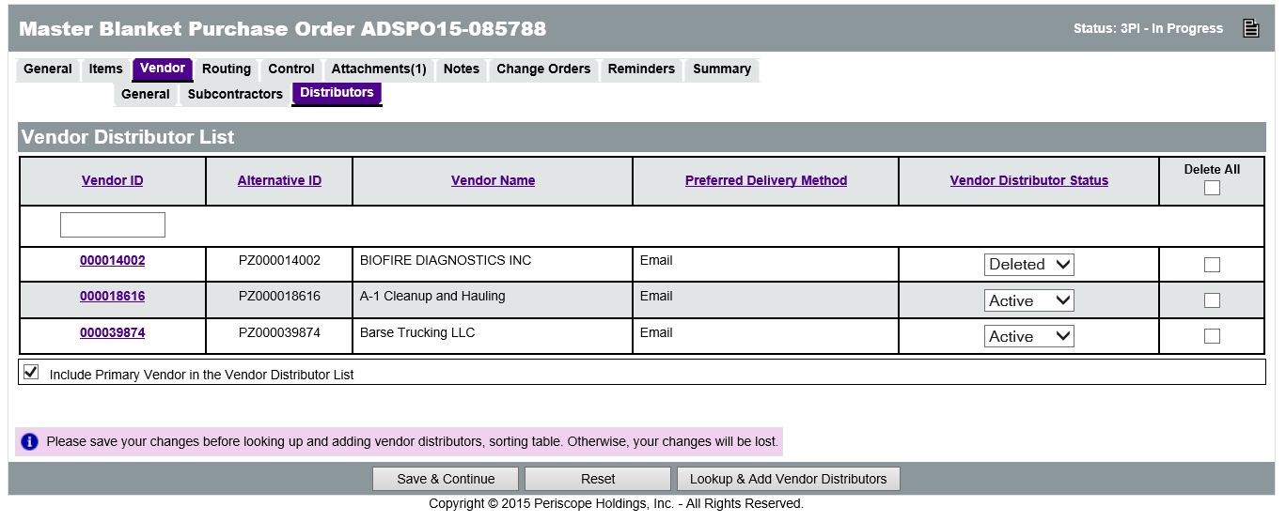
Additional vendors can be added as Distributors by clicking the Lookup & Add Vendor Distributors button. When returning to the Vendor > Distributor tab, if the Primary Vendor should remain on the Distributor list, be sure to re-check the Include Primary Vendor check box before clicking Save & Continue.
Uncheck the Include Primary Vendor in the Vendor Distributor List check box and click Save & Continue to remove the Primary vendor from the list.
TIP: There must always be at least one vendor with a Vendor Distributor Status of Active on the Distributors tab.

Adding Controls to the Master Blanket PO
The Control tab is used to select the Agency(s), COOPs, and Departments that can order from the contract, the minimum and maximum amounts that can be spent, and the Begin and End Dates for the contract. At least one control, with at least one Organization and Department, is required for Master Blanket contracts.
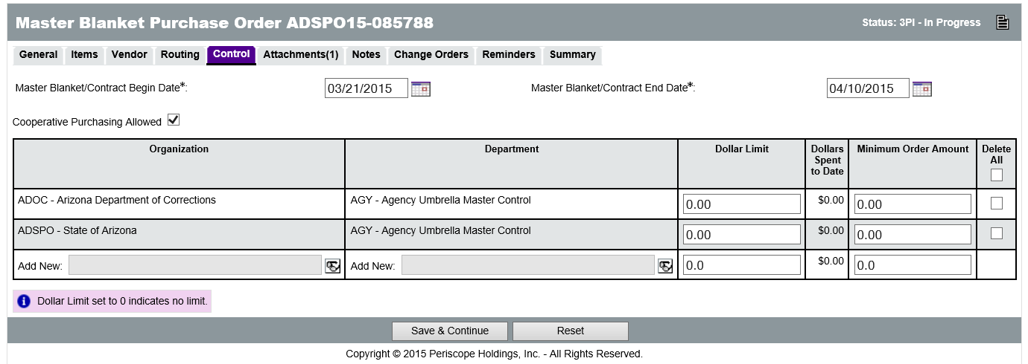

Begin and End Dates
The Begin and End Date fields are used to establish the active period of the contract. The contract is active at midnight on the date selected as the Master Blanket/Contract Begin Date. The contract becomes inactive at midnight on the day following the date selected as the Master Blanket/Contract End Date and will no longer allow users to place orders against the contract in ProcureAZ or process Change Orders for existing POs. While the contract is active, it is visible to the public via the ProcureAZ login screen (Contract & Bid Search link). When a contract is extended, the Master Blanket/Contract End Date field needs to be changed to the new contract end date.
TIP: Alert end users when the expiration date of the Master Blanket is approaching so they are not caught off-guard when they can no longer create change orders on their POs.

Single-Agency
After setting the active period for the contract, the spending limits need to be configured (if appropriate). If the contract is for one agency only, select that agency from the Organization lookup page. Depending on the user profile, the Organization may be populated with the default choice. The Department lookup page is used to select specific departments with the agency. If all departments in the agency can order off the contract with the same ordering controls, select the Agency Umbrella Master Control from the Department lookup page (accessed via the Glasses Icon search function). If different departments will have differing ordering controls, select the individual department from the lookup. For each department, set the Dollar Limit (maximum per order) and the Minimum Order Amount. Setting the amounts to 0 indicates that there is no limit.
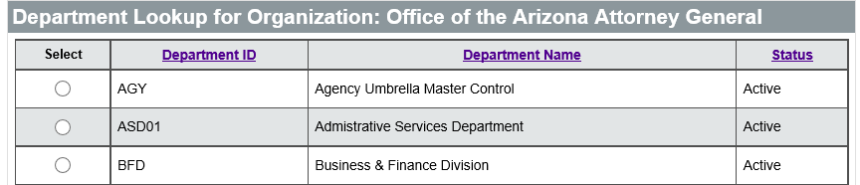

Multi-Agency or Statewide
If the contract is for multiple agencies or statewide, check the Cooperative Purchasing Allowed check box to allow the selection of multiple Organizations. For statewide contracts, select the Organization Umbrella Master Control from the Organization lookup page.
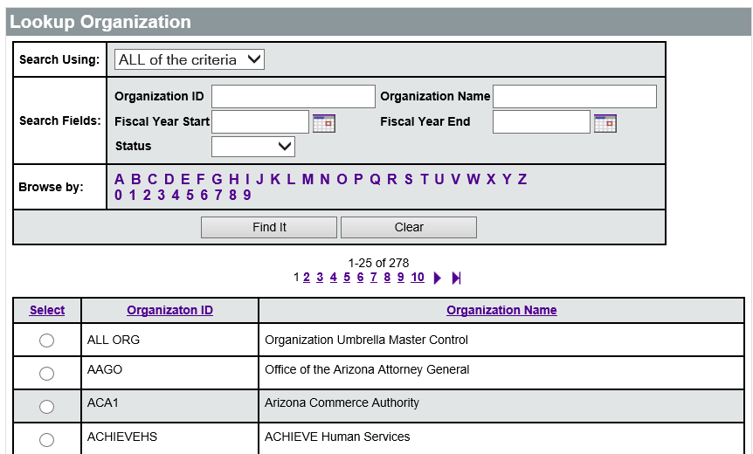
The Agency Umbrella Master Control will load automatically. Then set the ordering Dollar Limit and/or Minimum Order Amount for the State, if necessary, and click the Save & Continue button.
For multiple agencies, select the first agency in the Organization field, select the Agency Umbrella Master Control in the Department field, set the ordering Dollar Limit and/or Minimum Order Amount for the agency, and click Save & Continue to save that control line and get a new control line.

Adding and Removing Attachments on the Master Blanket Purchase Order
The official documentation related to the contract, including Terms and Conditions, Instructions, Specifications, etc. need to be attached to the PO document using the Attachments tab. Users need to complete these documents outside of ProcureAZ and attach them to the PO.
The Header > Attachments tab is used to view any existing attachments and add new attachments to the PO. State Procurement Office administrators can add default attachments, such as -Uniform Terms and Conditions or Uniform Instructions, to all new POs so there may be attachments on the document that you did not add. If the contract was created from a Bid award, the attachments from the Bid will also appear on the Blanket PO if you opted to bring these over when clicking on Create PO from the Bid Tab. The Attachments tab will display the number of attachments on the document in parenthesis. For example, Attachments(2) means that there are two attachments on the document.
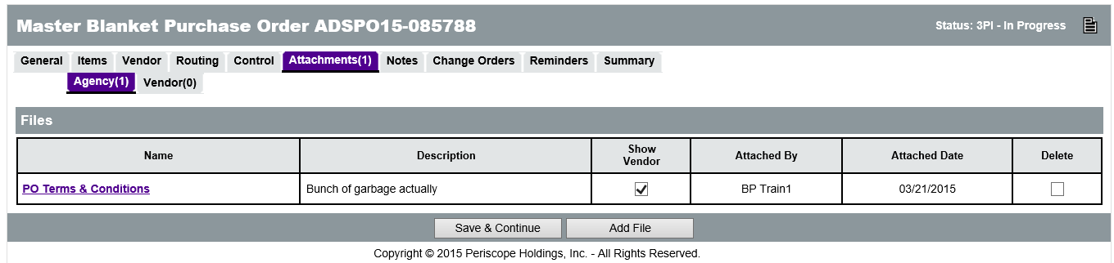
Any supporting documents for the PO must be scanned and attached to the document as specified by policy. It is important that any attached document name accurately describes the document. If the attached document should not be viewable by the vendor, the Show Vendor check box should be unchecked (it is checked by default).

Attaching a Document
On the Attachments tab, click the Add File button. On the Add File page, the Name field is the display name for the file that will appear wherever the attachments are displayed. The Name can be different than the name of the file and can contain alphanumeric characters, spaces, and special characters up to a maximum length of 200 characters. If no Name is entered, it will default to the file name. The Description field is optional but can be used to enter a longer description of the file, its purpose, or any notes/comments about the file.
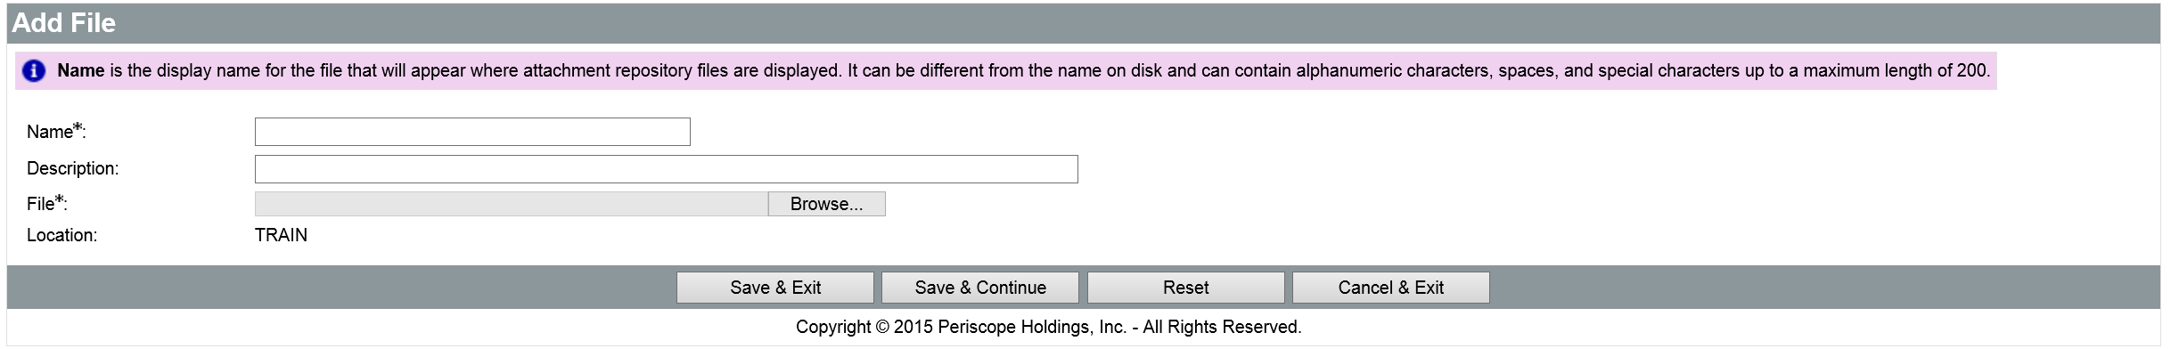
Clicking the Browse button will display a File Explorer window that allows the user to navigate to the folder location on the local machine or shared drive and select the file to upload. When the appropriate file has been selected, click Open in the File Explorer window to add the file path to the Add File screen.
When all fields have been completed and the file has been selected, click the Save & Exit button to upload the file to ProcureAZ, attach it to the PO, and return to the Attachments Tab. To attach more files, click Add File.

Attachment Modification
On the Attachments tab, the Show Vendor check box determines whether the vendor can view the attachment and the Delete check box will delete the attachment from the PO. After changing either of these settings, click the Save & Continue button to apply the changes.
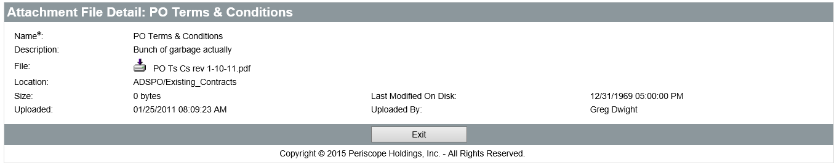
The Name of the file is a link to the Attachment File Detail screen. On the Attachment File Detail screen, only the Description can be modified. The file can also be downloaded by clicking the Download icon. If the Description has been changed, save the changes by clicking the Save & Exit button.

Adding, Editing, and Deleting Notes on the Master Blanket Purchase Order
The Header > Notes tab is used to add notes about the PO document that are only visible to Organization users who access the document. Notes are entered in the Note field, which allows multiple lines of text to be entered. When one note is entered, clicking the Save & Continue button will save the note and add a new blank Note field for another note. Any notes that are saved to the document are stamped with the date they were added.
TIP: Notes are not considered part of the procurement file. If the note is required to be part of the procurement file, it should be added as an attachment on the PO document.
Checking the Delete check box and clicking the Save & Continue button will remove the note from the document. The reset button will revert any changes made to the notes from the time the document was last saved. Like Attachments, the number of Notes added to the document will display in the tab name in the Header > Notes tab.
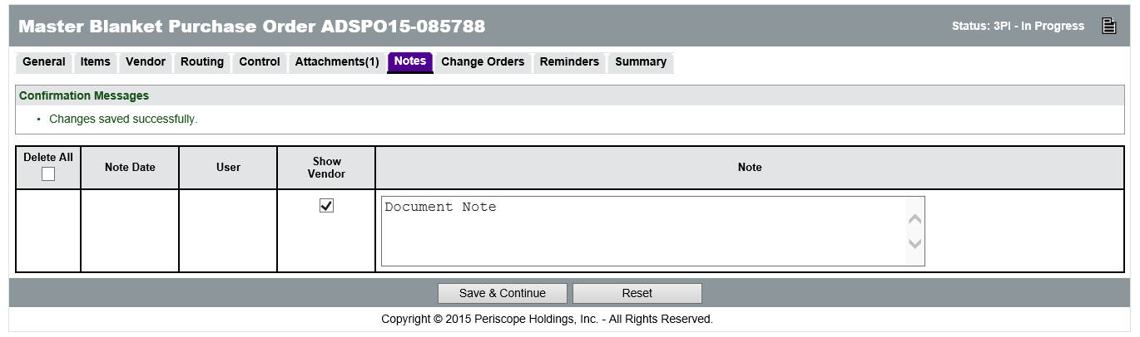

Item Notes
Notes can also be added to an individual Item on the PO on the Items > Notes tab. Item level notes are only visible to Organization users who access the document. On this page, clicking the Item Number will display the same screen as the Header > Notes tab except that these Notes are added to a specific Item.

Submitting the Master Blanket Purchase Order for Approval
All of the information entered into the Blanket PO can be reviewed on the Summary tab. Any validation warnings or errors will be displayed at the top of the page. Yellow warning messages do not require action, but red error messages will prevent submission of the document for approval until they are resolved.

Printing the PO
Click the Print button to display a printable version of the document in a new window (pop-up blockers should be turned off for ProcureAZ). The Print button displays a version of the document that includes all of the information on the PO. The Print Vendor Copy button displays the publicly-available version of the document.

Submit for Approval
Click the Submit for Approval button at the bottom of the Summary tab to submit the Blanket PO. The approval path for the document will be displayed. Click Continue to submit the document and route it to the first approver. Approvers can only approve/disapprove the PO in the order that they are listed in the approval path.
If no approval path is configured for the document, approvers can be added manually. Select the Manually add approvers radio button, then select the approver from the drop-down list and click the Add Approver button. Otherwise, select the Automatic approval radio button, which automatically approves the document and allows immediate sending and publishing. When finished, click Save & Continue.
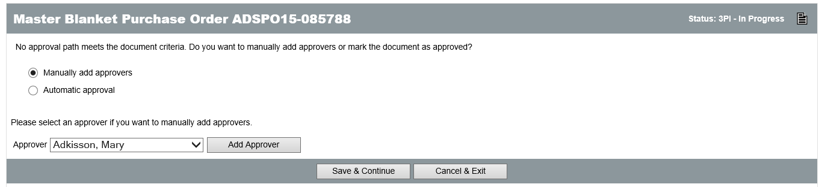
When the Save & Continue button is clicked, if document submission is successful, a message will be displayed at the top of the screen stating that the transaction was successful. Any warning or error messages generated by the submission will also be displayed.

Approval Process
During the approval process, the Blanket PO document will be in Ready for Approval status. Only the Commodity information can be edited during this stage and only by the current approver. Approvers can add additional approvers as well. Users can view the status of the approval on the Routing tab, or along the bottom of the Summary tab.

Disapproval
If the document is disapproved, it will change to Returned status and the creator will be notified via an email that contains the approver’s comments. The document can be edited by clicking the Reopen PO button at the bottom of the Summary tab. This returns the document to In Progress status. Once editing is finished, the document must be resubmitted for approval.
When the PO is reopened for editing, any approver’s comments are discarded. The recommended best practice is to include “See Note” in the approver’s comment box, then add a Note to the document that explains what changes need to be made or why it was disapproved.

Approval
If the document is approved, it will change to Ready to Send status and the creator will be notified via email. The Blanket PO is now ready to be sent to the vendor and published for public viewing on the Login screen of ProcureAZ.

Vendor Notification
To send the finalized Blanket PO to the vendor, navigate to the Summary tab of the Ready to Send PO. On the bottom of the screen, there are two options in the Vendor Notification Actions section.
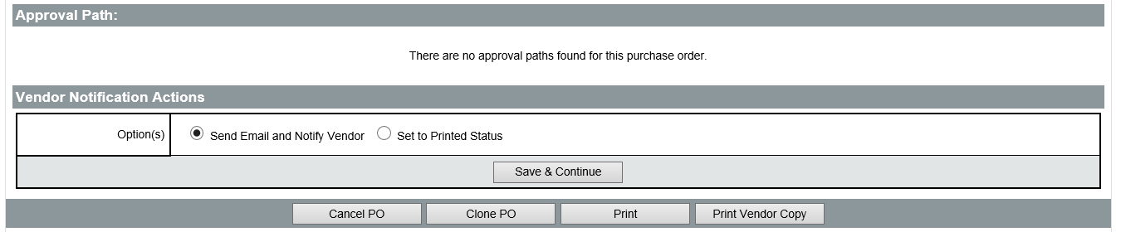
Users can select to Send Email and Notify Vendor, which will publish the contract as of the selected Begin Date and send an email to the primary vendor on the contract notifying them that the contract has been finalized and the orders may be placed against it. The other option is to Set to Printed Status, which will publish the contract as of the selected Begin Date, but will not send the primary vendor an email to notify them that the contract has been finalized. After selecting either option and clicking Save & Continue, the PO status changes to Sent.
After saving, if the notification option was selected, the Vendor and email address that was notified will display on the Notification Result screen.

Activity 14.1

Create a Master Blanket Purchase Order

Scenario
You have received a request to create a Master Blanket Purchase Order for a new purchasing contract.

Setup
- User is logged in to the ProcureAZ home page as a user with the Basic Purchaser role.

Steps
- Create a Blanket Purchase Order from a Bid award.
- Complete the General tab of the PO.
- Add an Item to the PO.
- Verify the vendor terms on the Vendor tab of the PO.
- Add controls on the Control tab of the PO.
- Submit the PO for approval.
- Send the PO to the vendor.

14.2 Managing a Master Blanket Contract
Management of Blanket POs that have been Sent involves viewing the ordering activity against the contract, creating and applying amendments (Change Orders), and reassigning the contract.

Locating the Master Blanket Purchase Order
While the PO is active, it remains in Sent status. To locate the PO, click the Documents drop-down menu in the Navigation bar, hover the mouse over POs, and select Sent. All POs in Sent status will be displayed separated on tabs by PO Type and starting with the most recent at the top. Click the Master Blanket tab to view the Blanket POs.
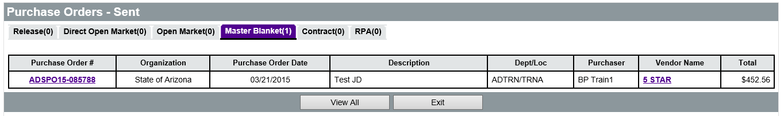
TIP: Expired Master Blanket POs remain in Sent status.

View Ordering Activity
On the Control tab of the Blanket PO, the Dollars Spent to Date is displayed next to each Organization and Department line.
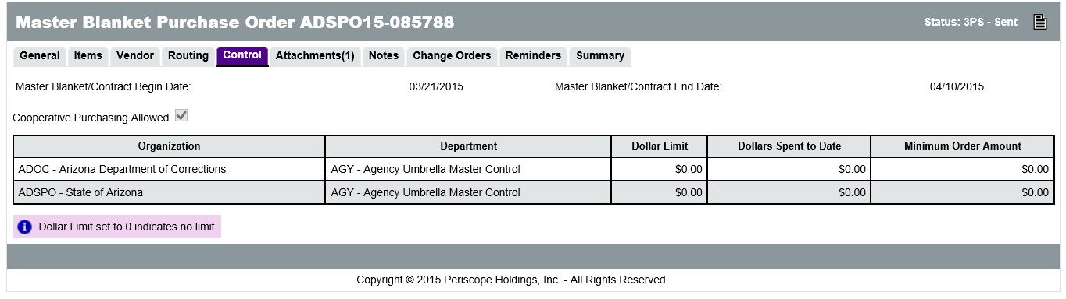
The Advanced Search feature can be used to view each of the orders placed against the Blanket PO. Click the Advanced Search magnifying glass icon in the Navigation bar. On the Advanced Search page, in the Document Type drop-down menu, select Purchase Orders. In the PO # field, enter the complete PO # for the Master Blanket PO and click Find It.
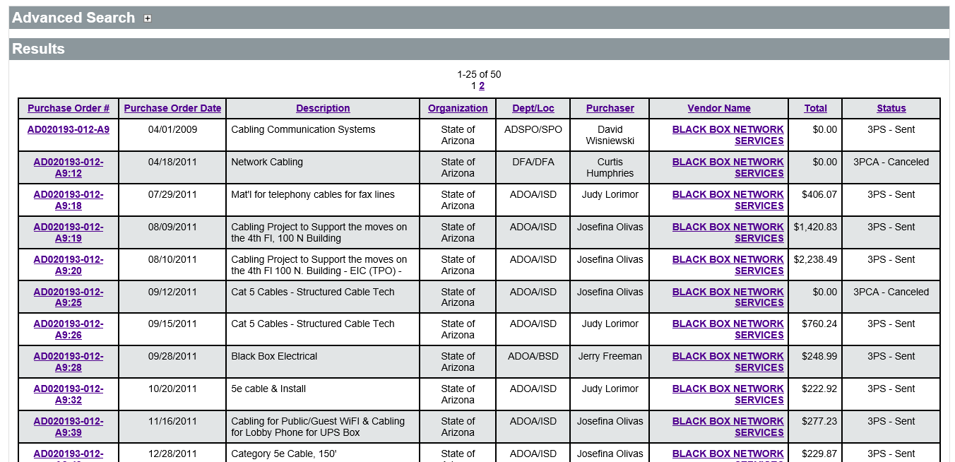
The results will display the Blanket PO followed by each of the Releases (Orders) that have been created against the Blanket PO within the Organization. To view only completed orders, on the Advanced Search page, in the Header Major Status field, select the Sent status and click Find It.

Amending the Master Blanket Purchase Order (Change Orders)
Change Order documents are used to modify Blanket POs that have been sent to a vendor/contractor. The changes that are possible on a Change Order include: quantities, pricing, terms and conditions, attachments, and extensions.

Create a Change Order
To create a new Change Order, locate and open the Blanket PO, then click the Change Orders tab. On the Change Orders tab, click the Create Change Order button. A copy of the Blanket PO is displayed with tabs available for editing, starting with the General tab where most fields can be modified.
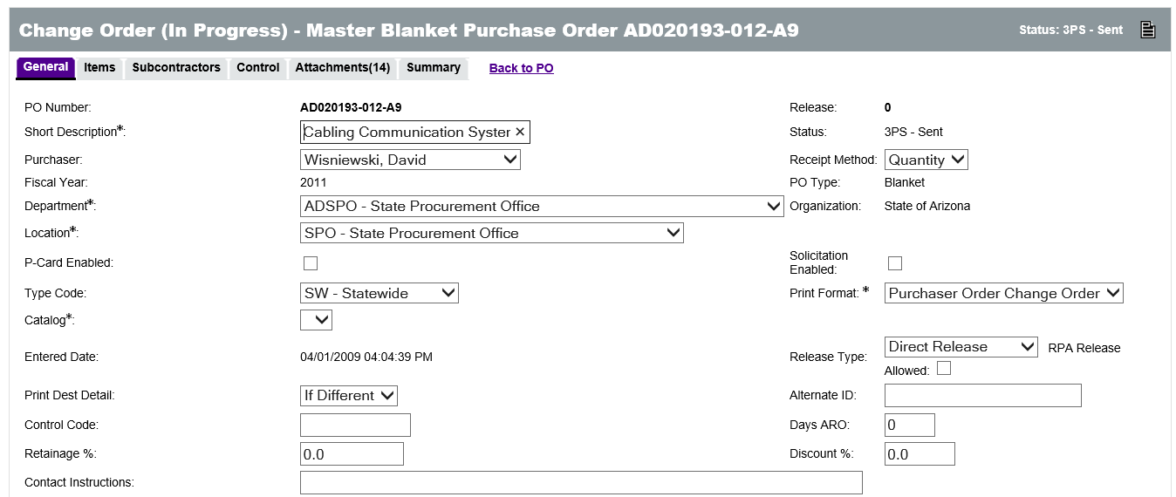
On the Items tab of the Change Order, all information for each item can be edited using the same process as the Item setup. Additional items can be added to the PO and existing items can be canceled.
TIP: Alert end users prior to making changes to Master Blanket items as changing line items when there are active POs and invoices can prevent payments to vendors and encumbrance liquidations in AFIS.

On the Attachments tab, attachments can be added or deleted. The option to show attachments to vendors can also be changed.
On the Control tab, any of the ordering controls on the contract can be edited, including which Organizations and Departments can order off the contract.
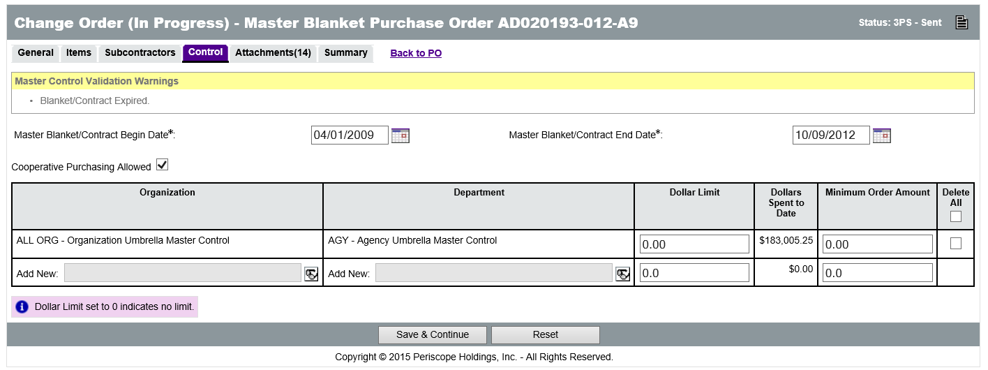

Contract Extension
The Control tab on the Change Order is where the contract can be extended by editing the Master Blanket/Contract End Date field. Although the system allows users to change the Master Blanket/Contract End Date after the document has expired, refer to the procurement code for additional procedures to extend and expired contract.
TIP: Do NOT change the Master Blanket/Contract Begin Date.

Review and Submit
When the information on the Change Order is complete, click the Summary tab to review all of the information. A list of each change that was made is displayed along with an explanation of each change in the Description column. The Description provided is editable in order to provide more detail. Comments can also be written for both the Change Order as a whole and for individual tabs.
The Show to Vendor check box is used to inform the vendor of the change. By default, vendors will be informed of all changes.
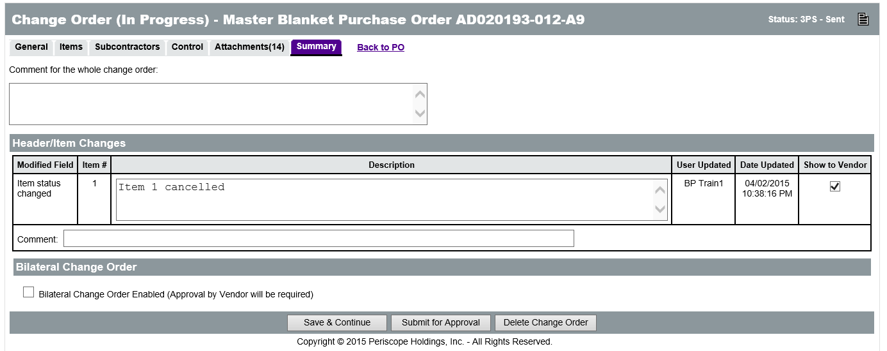
The Bilateral Change Order Enabled check box is used to require vendor approval of the amendment. The vendor will automatically be asked to approve the amendment after all internal approvals have been applied. Bilateral change orders are not required if the vendor physically signed and returned an amendment form.
If any changes have been made on the Summary tab, click the Save & Continue button. Click the Submit for Approval button at the bottom to submit the Change Order. Click the Delete Change Order button to discard the amendment which will not modify the contract.
TIP: Putting a comment in the Comment for the whole bid amendment box at the top of the Summary tab will notify vendors of the amendment automatically, even if the Show to Vendor box is NOT checked next to the change.

Apply Change Order
Once the Change Order has been approved, an email notification will be sent. Return to the Change Order and click the Apply Change Order button to apply the change to the Blanket PO. The Vendor Notification Result screen will display the vendor email that was notified regarding the amendment.

Vendor Acknowledgement
When the vendor accesses the Blanket PO, they have to acknowledge receipt of the Change Order. The Download Acknowledgement screen displays two options. The first option, I am acknowledging receipt of this Purchase Order and/or its Change Order(s), must be selected by the vendor in order to view the PO. The second option, Notify requestor of receipt of this Purchase Order and/or its Change Order(s), is optional and will send the original requestor an email notification of the acknowledgement.

Activity 14.2

Manage a Master Blanket Purchase Order

Scenario
You have received a request to review and amend a Master Blanket Purchase Order for an existing purchasing contract.

Setup
- User is logged in to the ProcureAZ home page as a user with the Basic Purchaser role.

Steps
- Locate a Master Blanket PO.
- Look at orders that have been placed against a contract.
- Create a Purchase Order Change Order to amend the contract.
- Submit and apply the Change Order to the contract.

Lesson Summary
In this lesson you:
- Created a Master Blanket contract
- Managed the communication of the contract with the vendor
- Examined the Master Blanket completion and amendment processes

Check Your Progress
- Master Blanket Purchase Orders can be created __________.
  - By cloning an existing document
  - From a Bid award
  - From scratch
  - All of the above
- Freight is always included automatically in the pricing of commodities on a contract.
  - True
  - False
- Multiple vendors can be added as distributors for the Blanket contract.
  - True
  - False
- What types of controls need to be setup on a Blanket contract?
  - Active period
  - Departments that can order
  - Spending limits
  - All of the above
- What page is used to view all of the ordering activity against a Blanket PO?
  - Documents > POs > Sent
  - Quick Find
  - Advanced Search
  - None of the above
- The following can all be changed on a Blanket PO Change Order except ___________.
  - Vendor information
  - Item information
  - Contract end date
  - Spending limits

