11 Invoices

Contents
11. Invoices 1
Learning Objectives 1
Lesson Overview 1
11.1. Locate a Purchase Order 2
Advanced Search 2
Documents Menu 4
11.2. Create an Invoice 6
General Tab 6
Invoice Number 7
Invoice Description 7
Dates 7
Payment Terms 8
Use Tax 8
Payment Options 9
Miscellaneous and Freight 10
Purchase Order Information 10
Vendor Information 11
Save and Continue 11
Items Tab 11
Payment for Items 12
Collect Invoice Data for AFIS Interface 12
Service Dates 14
Credits Tab 15
Add Credit Memo 15
Delete Applied Credit Memo 16
Accounts Tab 16
Distribution Information 16
Miscellaneous/Freight Information 16
Credit Memo Information 17
Attachments Tab 17
Add File 17
Attachment Management 17
Reminder Tab 18
Create a Reminder to Complete a Receipt 18
Change Order Tab 18
Request a Change to PO Accounting 18
Review and Submit Invoice 19
Invoice Integration Results in AFIS 20
Invoice Cancellation after AFIS Integration 21
Disbursements 22
Activity 11.2 23
Create an Invoice 23
11.3. Invoice Search 25
Invoice Search Page 25
Search Results 25
Activity 11.3 27
Search for an Invoice 27
11.4. Credit Memos 28
Create Credit Memo 28
General Tab 28
Purchase Order Number 29
Items Tab 30
Purchase Order Number Selected 30
No Purchase Order Number Selected 31
Vendor Tab 32
Address Tab 32
Accounting Tab 32
Object Code Inference 33
Add Accounting to Header 33
Add Accounting to Line Items 34
Attachments Tab 34
Add File 34
Attachment Management 35
Reminders Tab 35
Review and Submit Credit Memo 35
Activity 11.4 37
Create a Credit Memo 37
Lesson Summary 39
Check Your Progress 40

- Invoices

Learning Objectives
In this lesson, you will:
- Review how to locate a Purchase Order for payment
- Create an Invoice to request a payment
- Review how to locate Invoices in ProcureAZ
- Create a Credit Memo

Lesson Overview
Payments for goods and services received are recorded by Accounts Payable users in ProcureAZ using an Invoice document. After an Invoice has been created, submitted, and approved, the payment request is processed through a near real-time interface with AFIS to create a Payment Request document. Once the payment has been made, the AFIS document ID of that process is then interfaced back to ProcureAZ in order to record the payment in the alternate ID field. This lesson details the steps and new features involved in the creation, submission, and processing of an Invoice as well as the Invoice search methods and Credit Memo application process.

  - Locate a Purchase Order
Invoices can be created by users with the Accounts Payable role to request payment for goods or services on a Purchase Order. Invoices can only be submitted for Purchase Orders that contain Items that have been partially or completely received and where the Permit to Pay amount is greater than or equal to the amount to be entered on the Invoice. The Invoice creation process can begin several ways, which include the following commonly used methods:
- The Advanced Search feature can be used to locate Purchase Orders that have a status of Partial Receipt or Complete Receipt.
- The Documents menu can be used to create a new Invoice by selecting Invoice > New. This will display a search page that can be used to locate and select a Purchase Order for payment.

Advanced Search
Click the Advanced Search magnifying glass icon from the Header Bar to open the Advanced Search page. In the Document Type drop down list, select Purchase Order to display the relevant search fields. Users can enter search criteria into one or more fields and use a combination of those criteria or any of those criteria to locate documents in the system. If the PO number has been provided, enter it into the PO # field. The Department or Location fields can also be used to narrow down the search results if the PO # is not known.
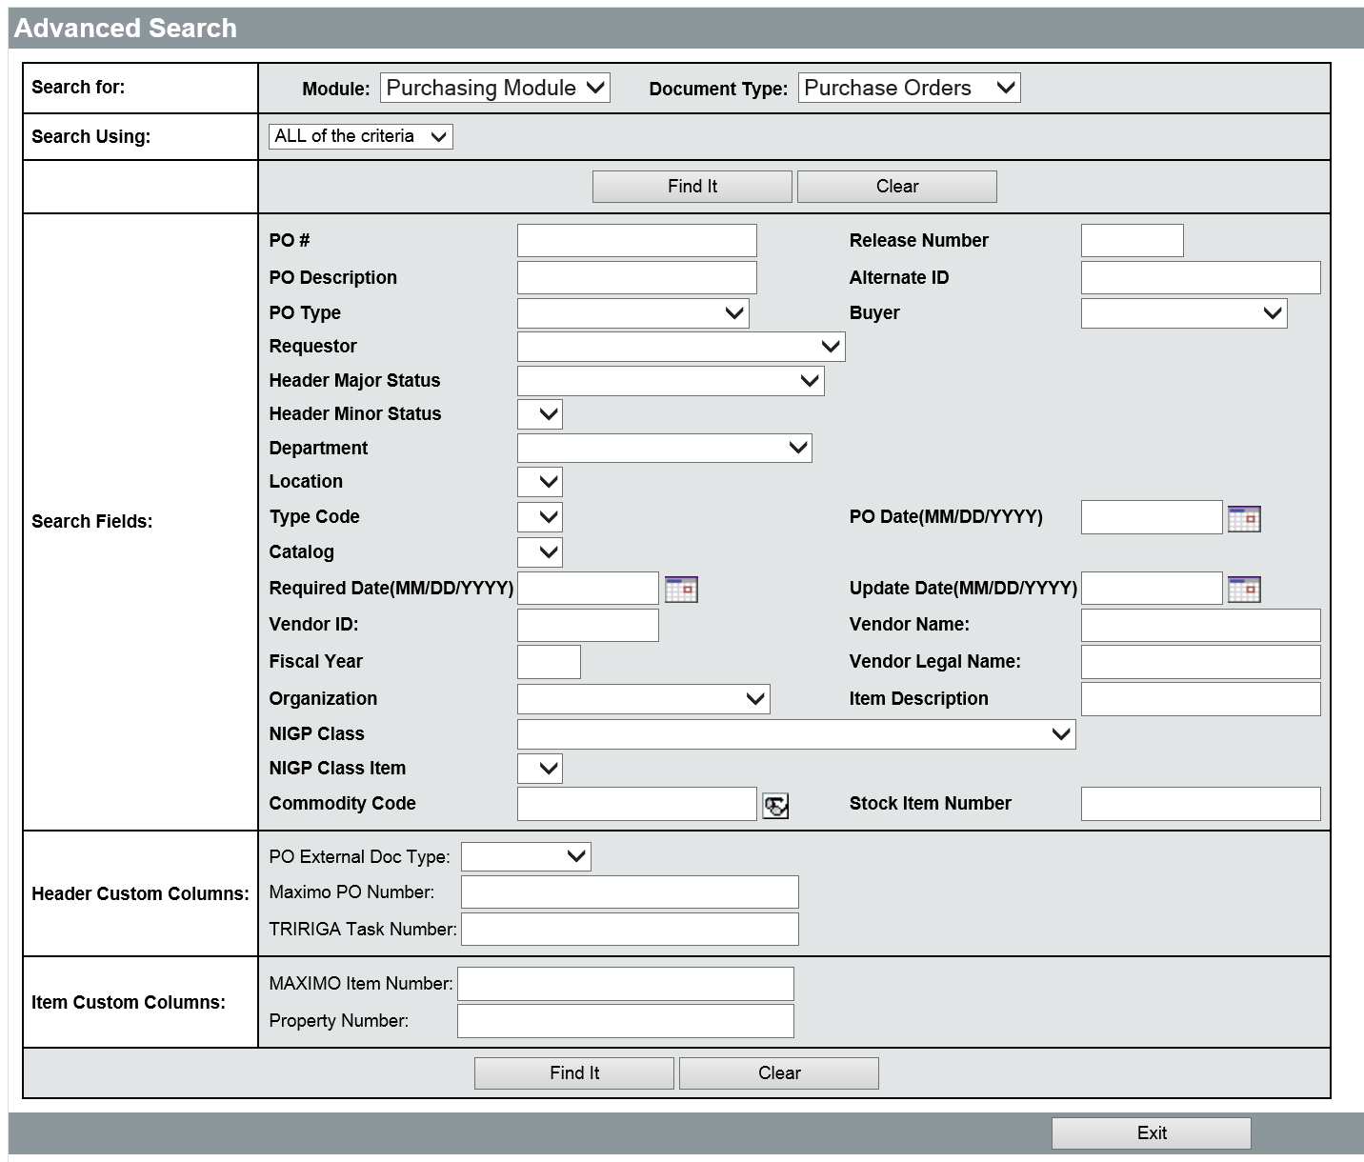
Any of the available fields can be used to search for existing Purchase Orders in the system. Once all of the desired search criteria have been entered, click the Find It button to display the results. The right-most column of the results set will display the Permit to pay amount. If there is a dollar amount in the Permit to pay column for a Purchase Order, some receipt of items has been recorded in the system and the amount has been authorized for payment. An Invoice can be created and submitted up to the permit to pay amount for the Purchase Order.
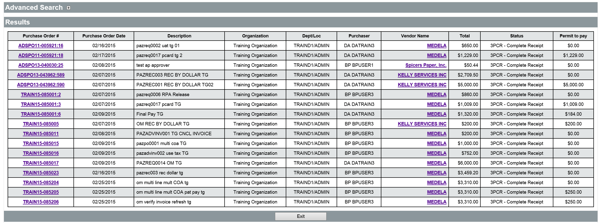
Once the Purchase Order has been located in the search results, click the Purchase Order # in the left column to open the document to the Summary tab. Review the information on the Summary tab to ensure that it is the correct PO. On the Summary tab, the Receipt Information section displays any Receipts that have been previously entered against the PO along with their current status. The Invoice Information section displays any Invoices that have been previously entered along with their current status. Click the Create Invoice button to begin the Invoice process.
For more information on the Advanced Search feature, refer to Lesson 12 Advanced Search.

Documents Menu
The New Invoice – Search PO screen opens when users select Documents > Invoice > New from the Header Bar. This screen has the same search fields as the Advanced Search screen for Purchase Orders. The criteria entered into the search fields are used to narrow down the results returned. If the PO number has been provided, enter it into the PO # field. If you do not have the PO number, you may try to locate a Purchase Order with a status of Partial Receipt or Complete Receipt by selecting the status in the Header Major Status drop down list. Enter any other relevant information for the Purchase Order and click the Find It button to perform the search.
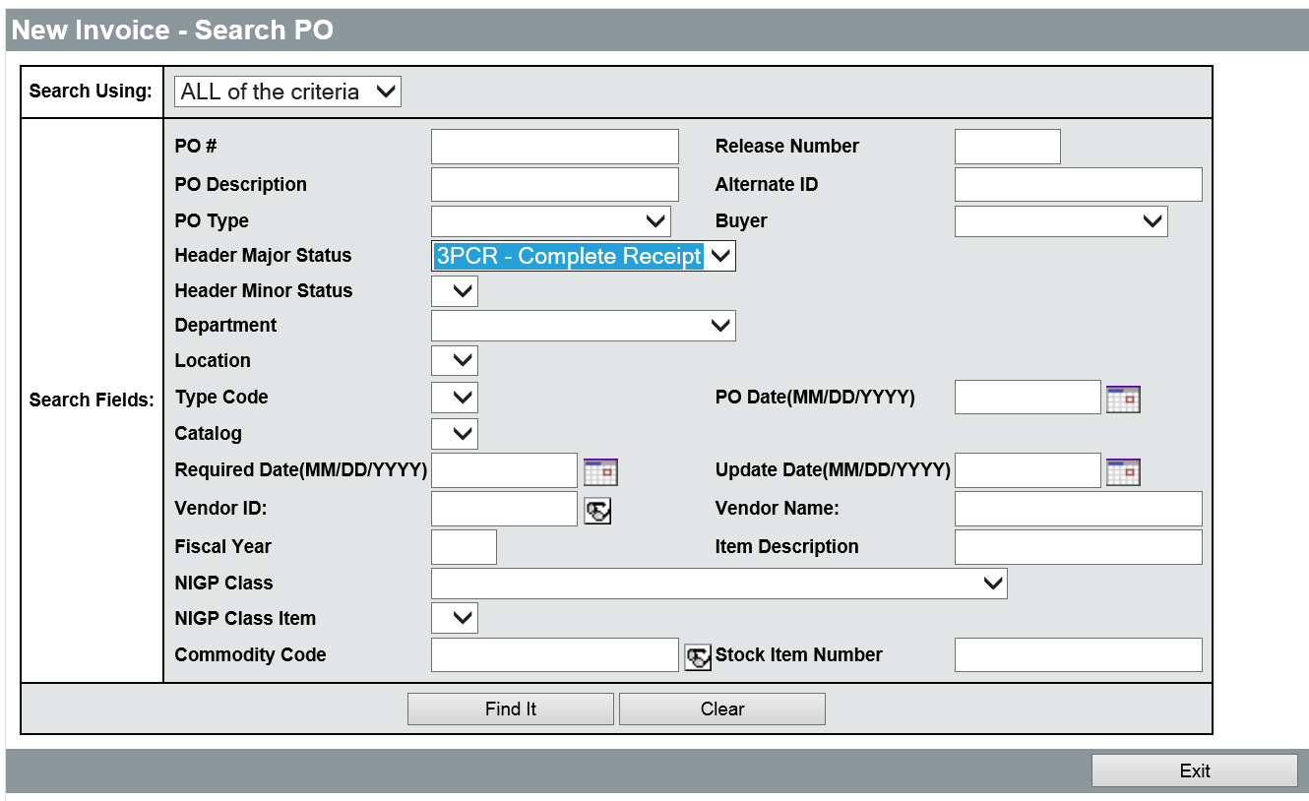
Once the Purchase Order has been located in the search results, click the radio button for the Purchase order in the left column, then click the Select button at the bottom of the page. This will open a new Invoice document with the Purchase Order reference information already entered.
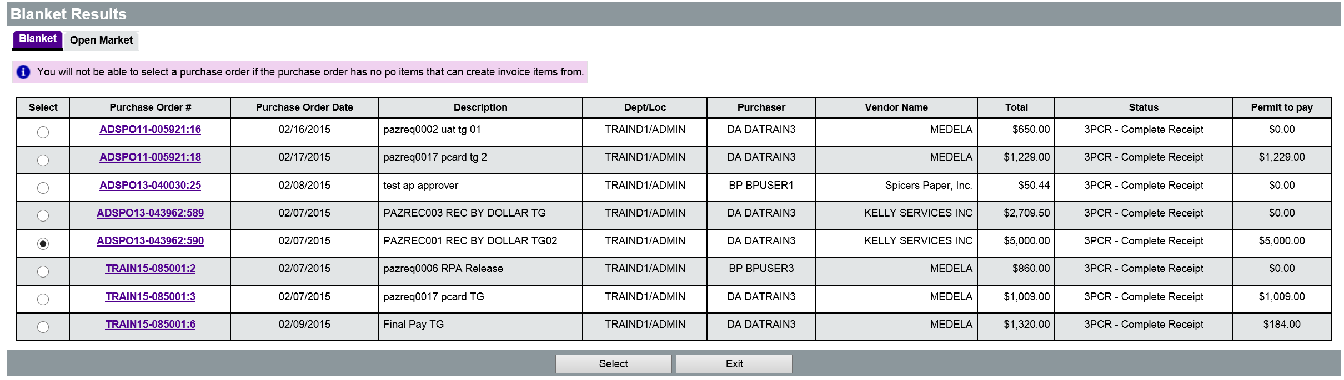

  - Create an Invoice
After completing the steps in the Locate Purchase order section, the Invoice will be open on the General tab. As with other ProcureAZ documents, completion of an Invoice should proceed through the tabs on the header of the document from left to right. The subcontractors tab will not be used and can be ignored.
If an Accounts Payable Change Order needs to be done (to change chart of accounts for example), then the General Tab must be filled out first and then the Change Order Tab second. Then you can move from left to right for the remaining tabs. If you were to fill out the Items Tab before the Change Order Tab, the information on the items tab will be erased.
TIP: If an in progress Invoice exists for the PO with an Invoice Change Order, users cannot create another Invoice until the Invoice with the Change Order is approved or canceled.

General Tab
On the General tab there are several required fields that must be completed before the rest of the document can be accessed. The Invoice number and description must be entered. The Invoice Date and Payment Date fields will be interfaced to AFIS so those fields must also be entered. Accounts Payable users can enter Miscellaneous and Freight amounts if they are nominal and have not been accounted for within the item costs. There are also several new features for Invoices that should be noted.
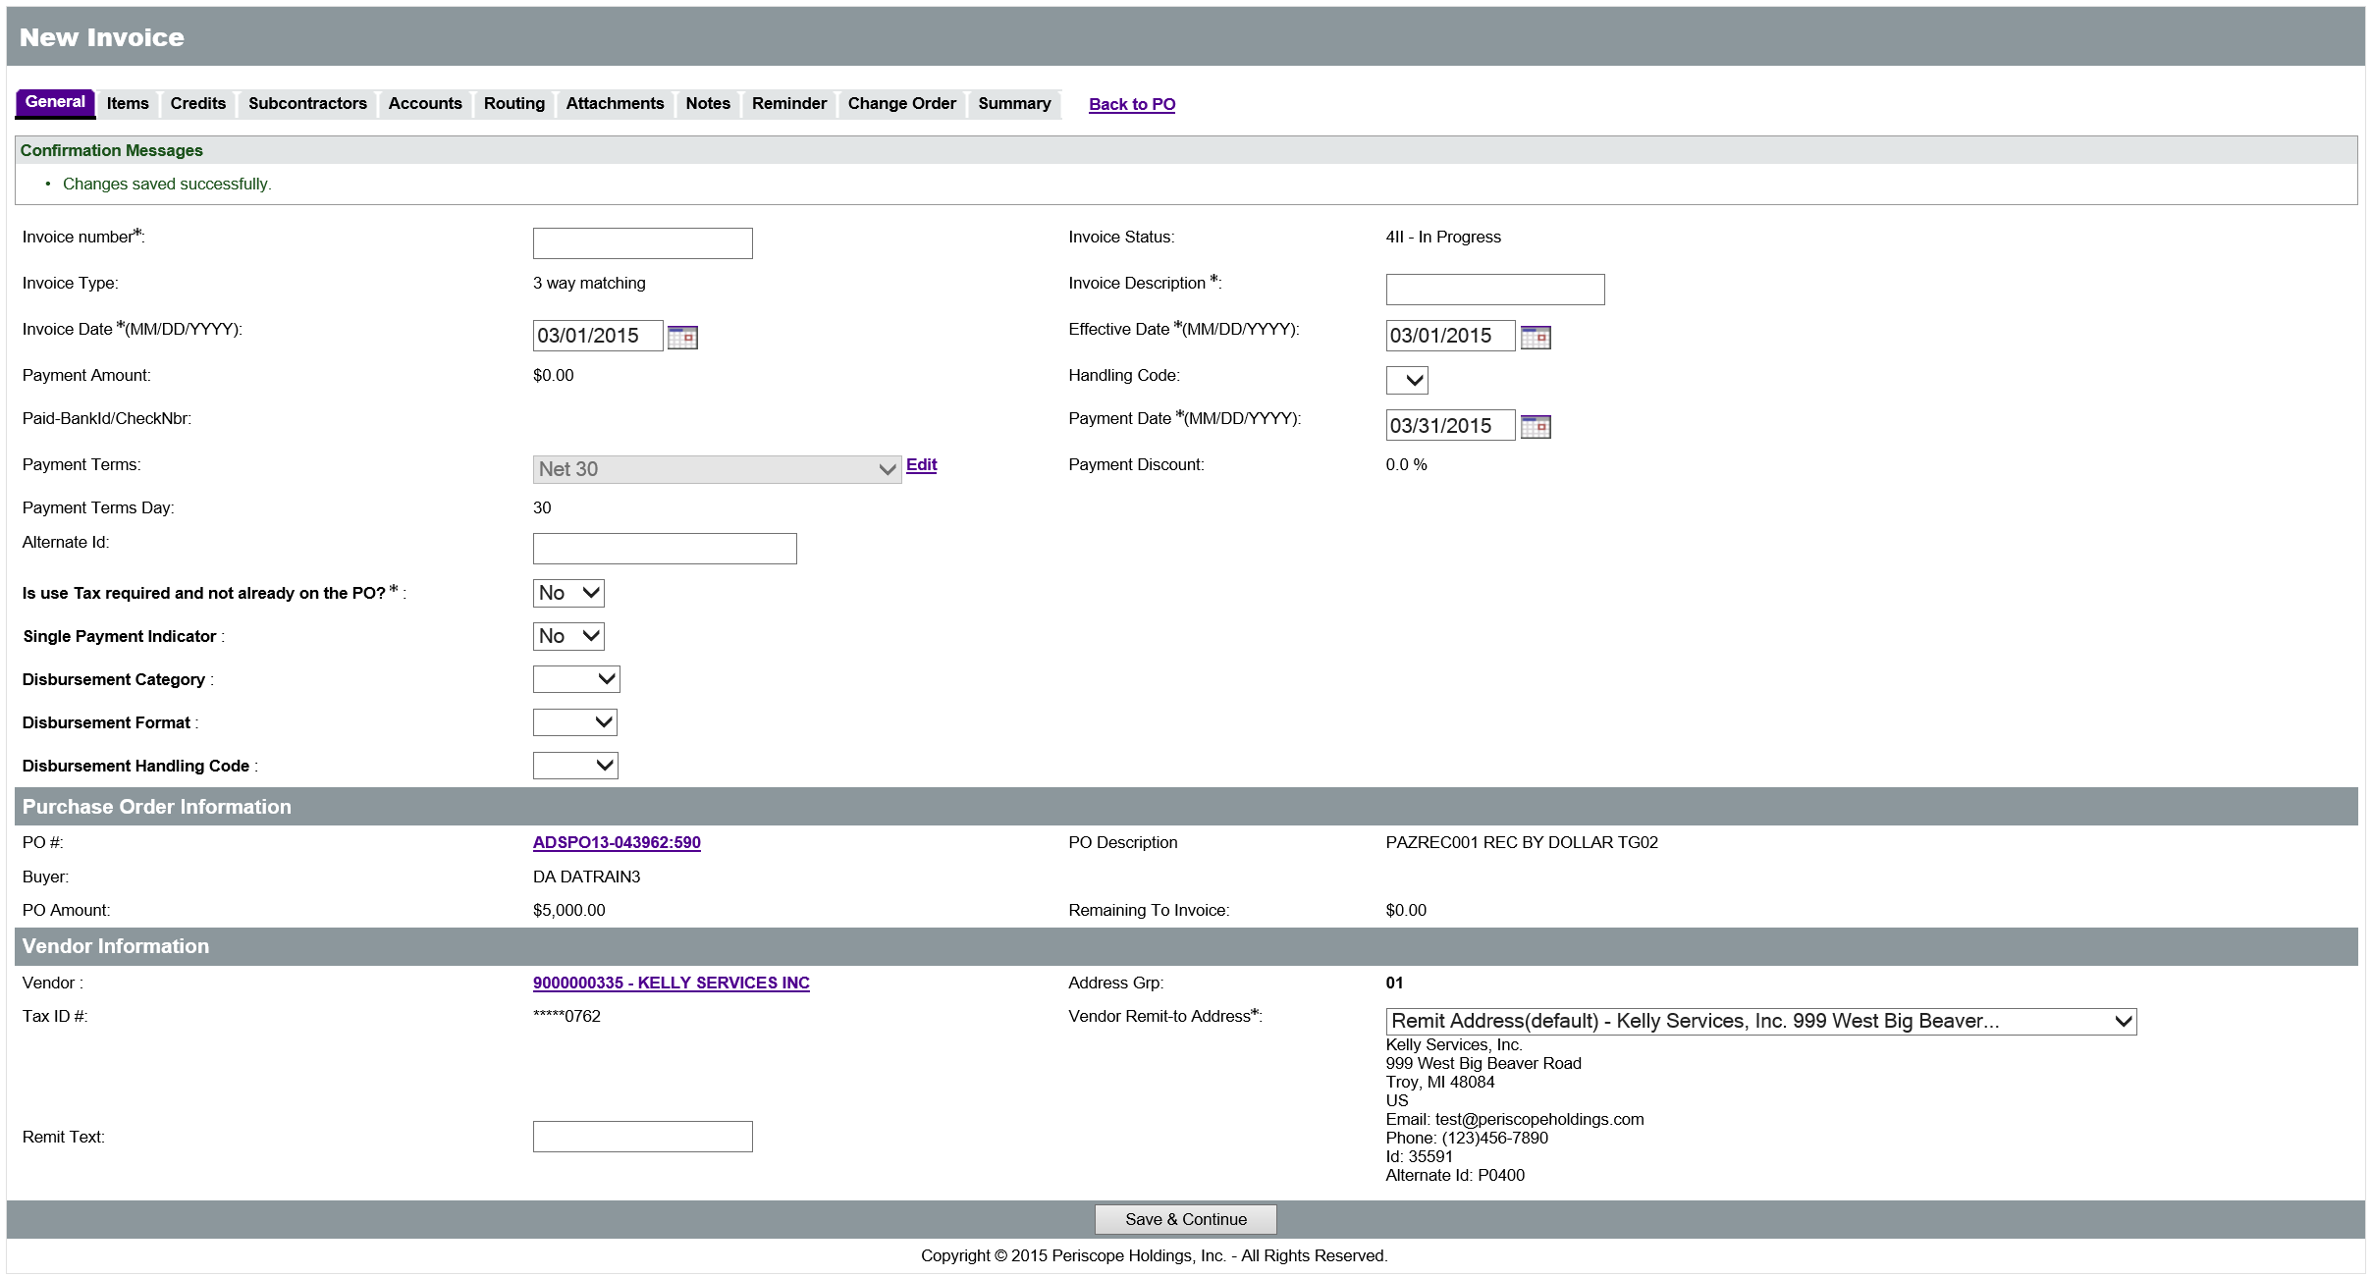

Invoice Number
New
Feature
Enter the vendor Invoice number In the Invoice number field. This field is required. If an Invoice payment is split or the vendor uses the same Invoice number more than once, an indicator such as A or B can be added to the end of the number to make it unique.
Duplicate Invoice numbers for the same vendor are not permitted in ProcureAZ. The only exception to this rule, and a new feature, is when the previous Invoice with the same Invoice number has been canceled. This allows the agency to provide a corrected Invoice. For more information on Invoice cancellation, refer to Invoice Cancellation on Page 21.

Invoice Description
In the Invoice Description field, enter a brief description of the goods or services being paid for. This field is required and will be part of the Line Description field in the payment request document in AFIS. The Line Description will ultimately print on the warrant remittance.

Dates
The Invoice Date field will default to the current system date. GAO recommends that agencies modify the invoice date to match the date the vendor Invoice was received by the agency if it is different.
The Payment Date field will default based on the payment terms on the Purchase Order. The default for Purchase Orders with no payment terms is 30 days from the Invoice Date. If the Invoice Date field is changed, a pop up dialog box will be displayed to inform users that the Payment Date field will be recalculated to correspond to the new Invoice Date. Both the Invoice Date and the Payment Date will be interfaced to AFIS during processing. The payment date determines when the warrant or EFT/ACH will be issued.
TIP: To generate a same-day payment, enter the current date in the Payment Date field.
The Effective Date field is the date of the Invoice and will default to the current system date. This date does not need to be changed. Follow your agency guidelines when specifying the Effective Date. This date is not interfaced to AFIS.
TIP: An Accounts Payable best practice is to ensure that payments are made during the vendor discount period to take advantage of any applicable discounts.

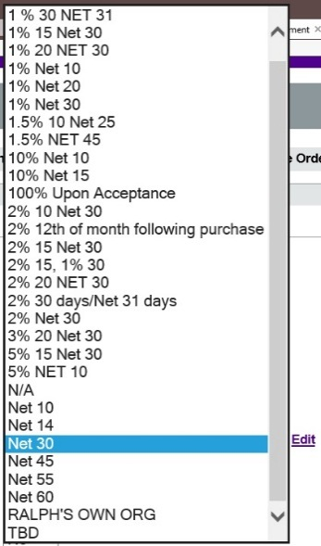
Payment Terms
The payment terms provided by the vendor’s contract/on the Purchase Order (Open Market) will be entered by default in the Payment Terms field. ProcureAZ allows Accounts Payable users to edit the Payment Terms on individual Invoices. AP Users can modify the payment terms by clicking the Edit link next to the field and selecting the new terms from the drop down list. The payment date will change to take advantage of the payment terms. For instance if the terms are 10% net 10, the invoice date is 03/04 the payment date will be 03/14. The payment date can be changed after the terms have been saved. If the specified terms are not listed in the drop down menu, users must contact the SPO Helpdesk to request the addition of the terms to the menu. Only ProcureAZ Internal Administrators can add selections to the Payment Terms drop down menu.
New
Feature

Saving the Invoice will update the Payment Discount percentage and the Payment Terms Day fields on the Invoice if they have been edited. The terms selected are forwarded to AFIS and will only reduce the warrant/payment amount if the Payment Date falls within the specified term period.

Use Tax
If the use tax has not already been entered on the items, ProcureAZ allows Accounts Payable users to enter Use Tax during Invoice creation. This allows the specified amount to be identified as Use Tax, rather than as a Miscellaneous amount on the Invoice. Selecting Yes for “Is Use Tax required and not already on the PO?” provides the ability to enter the Use Tax amount on the accounting lines for each Item on the Invoice.
New
Feature
The Use Tax must be calculated by the Accounts Payable user that is entering the Invoice and then entered in the Use Tax Amount field in the Distribution section of the Accounting tab. If there are multiple accounting lines for an Item, the Use Tax can be split across all lines or applied to one line. The use tax amount(s) will post to a Use Tax Balance Sheet Account Use Tax 1616 in AFIS. The Use Tax will be held in this balance sheet account until transferred to the Department of Revenue. Additional information is provided in the Accounts tab section of this chapter on page 16.

Payment Options
New
Feature
There are several payment options available in AFIS that are also included on the General tab of an Invoice in ProcureAZ. When selected, these options will be interfaced to AFIS when the Invoice is successfully submitted. The following payment option fields are included:

  - Single Payment Indicator – This field defaults to No which means that this payment can be grouped with other payments to the same vendor by the same agency. When Yes is selected, the vendor will receive one warrant/electronic fund transfer (EFT) for only this payment document.
  - Disbursement Category – This field is blank by default which means that GAO will distribute the warrant to the vendor after it is generated. The PULL option should only be selected from the drop down list if the agency will pick up and distribute the warrant to the vendor. The PULL option should not be selected for all payments unless there is a justifiable reason. The GAO will contact the agency if the PULL option is used frequently.
  - Disbursement Format – This field is blank by default which means that AFIS will use the default payment method for the vendor. If the vendor normally receives an EFT/ACH payment but has requested a payment method of warrant, select the WAR option from the drop down list. If a vendor is setup to receive EFT/ACH it does not matter what address ID is selected, EFT/ACH will always be the distribution default unless WAR is selected in this field.
  - Disbursement Handling Code – This field is blank by default and will not be used at this time.
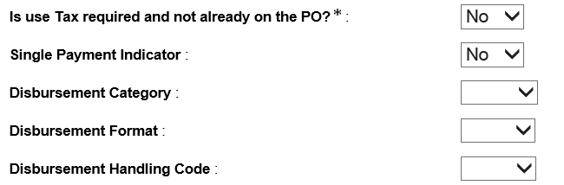

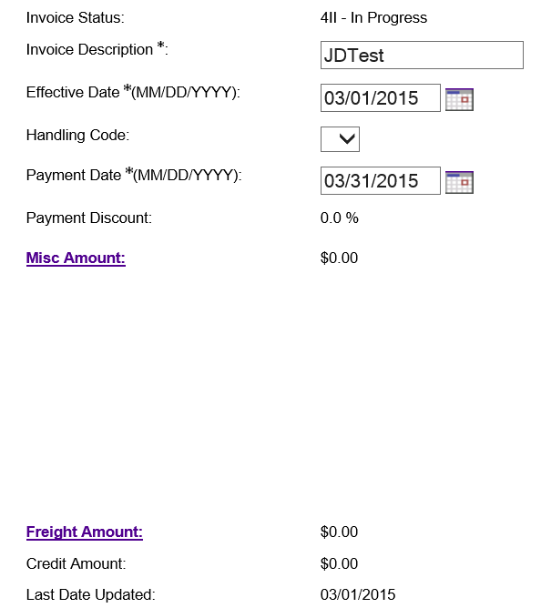
Miscellaneous and Freight
On the General tab, there are two links that can be used to add Miscellaneous and Freight amounts to the Invoice. The links are only displayed after the document has been saved by clicking the Save & Continue button. Both links display the same data entry page, but with the corresponding Event Type pre-selected.
Freight should only be added to an Invoice when it has not been encumbered as a line Item on the Requisition/Purchase Order. On the Invoice Freight and Misc. Charges page, enter the Chart of Accounts information and the dollar amount for the charges for the Misc or Freight charge. If more than one Chart of Accounts is required to pay for the charge, click Save and Continue to display a new line.
TIP: The Freight and Misc fields should not be used as a substitute for a Change Order. GAO expects amounts entered into Misc and Freight on the invoice header to be nominal.
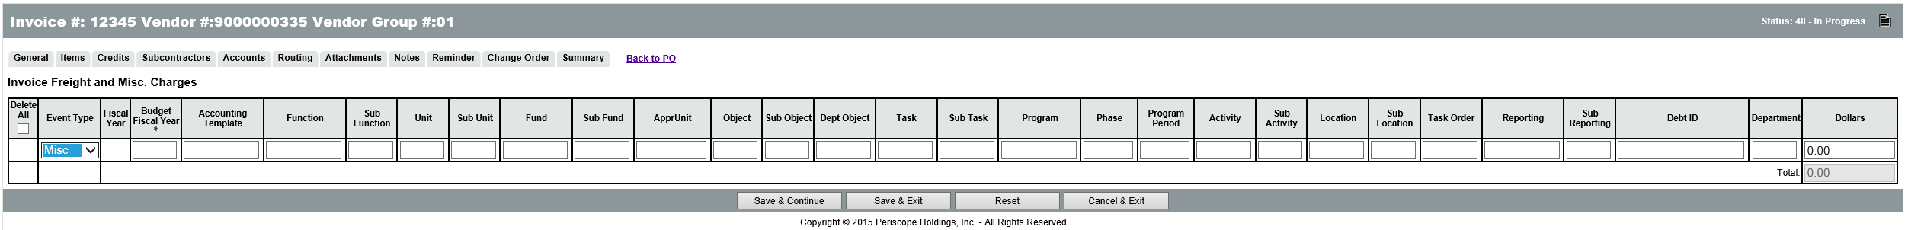
When finished, click the Save & Exit button to return to the General tab of the Invoice. The amount entered for Miscellaneous or Freight will be displayed in the Misc. Amount or Freight Amount fields respectively.
TIP: ProcureAZ allows the setup of approval paths based on misc/freight amounts entered on an invoice header. Agencies should implement this type of approval path to require the review of miscellaneous and freight charges on an Invoice when they exceed pre-defined agency thresholds.

Purchase Order Information
The Purchase Order Information section on the General tab includes a link to the Purchase Order document, the Buyer who submitted the Purchase Order, the PO Amount and Description, and the amount that remains to be invoiced on the PO.

Vendor Information
The Vendor Information section on the General tab includes a link to the vendor and a drop down list for the Vendor Remit-to Address. A default Remit-to Address will already be selected based on the address used on the Purchase Order but can be changed by selecting a different address from the list.
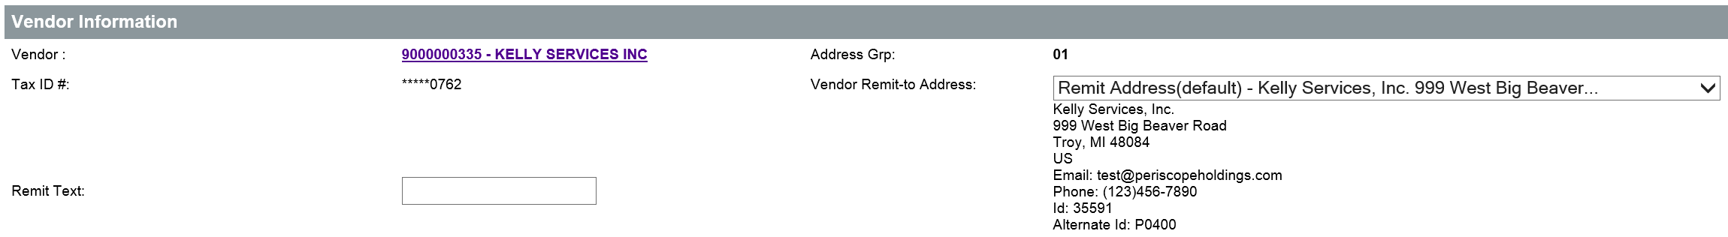

Save and Continue
When the General tab has been completed with the required information and any optional information and settings, click the Save & Continue button to create the In Progress Invoice document and allow the rest of the document tabs to be completed. Once saved, the Invoice can be completed at a later time. It can be located by using the Advanced Search feature or the Documents > Invoice > In Progress drop down option from the Header Bar.

Items Tab
The Items tab displays all of the Items on the Purchase Order, along with columns for their PO Item Status, PO Item Amount, Previous Invoice Amount, Permit to Pay amount, and the Discount percentage.
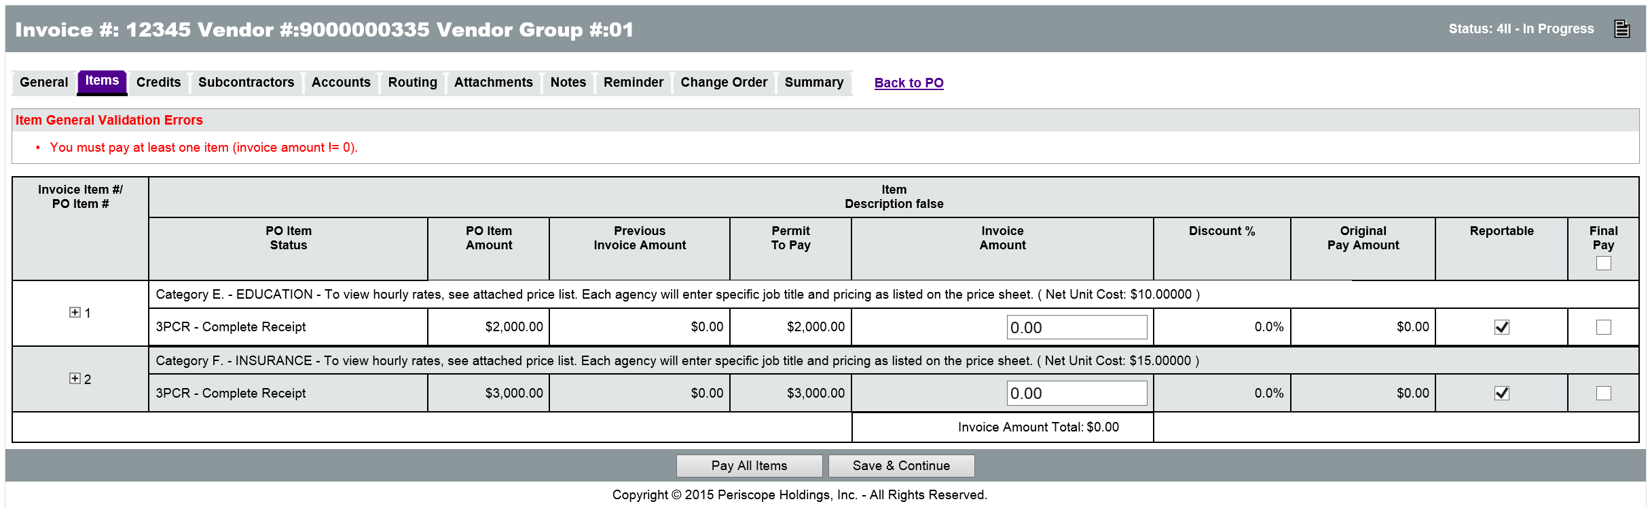
TIP: The Invoice displays the PO Item amount net of any item discounts. It does not display the PO item discount %. The field "Discount %" displayed on the Invoice serves no purpose and will always be blank.

The Invoice Amount field on the Items tab is where payment amounts are entered. The Invoice Amount entered cannot be greater than the Permit to Pay amount but may be less if the Invoice does not include all of the Items that have already been received. Items can be paid for partially or completely. If the Invoice is the final payment for the invoiced Items, the Final Pay check box should be checked for each Item, or all Items in the right column. Each Item can also be expanded by clicking the expand icon in the left column. This will display some additional fields for the individual Item. There are situations (described below) that require completion of the additional fields. When all fields on the Items tab have been completed, click the Save & Continue button to save the changes and continue completing the Invoice.

Payment for Items
To pay for individual Items, enter the Invoice Amount in the field for the Item. To pay for all of the Items on the PO at once, click the Pay All Items button at the bottom of the page. If the payment is the final payment for an Item, click the check box in the Final Pay column for the item.
TIP: Clicking Final Pay on the item will close out the item. In addition, if the total paid is less than the encumbrance, Final Pay will automatically generate a change order that will cancel the encumbrance and return the amount to the agency budget in AFIS. A change order will also be created that will reduce the quantity on the Purchase Order.

To select Final Pay for all Items at once, check the box at the top of the Final Pay column. If a payment will completely pay for an Item, but the Final Pay check box is not checked, a warning message box will appear when saving the Invoice. The message is to notify the user the Item will be fully paid, but the Final Pay box is not checked and that the Item will not be closed upon Invoice approval.
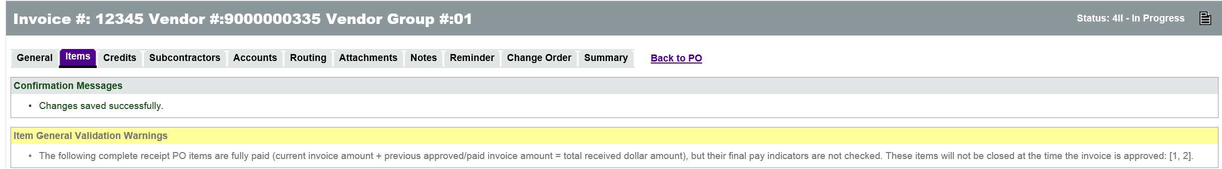

Collect Invoice Data for AFIS Interface
All ProcureAZ Invoices are interfaced to AFIS as a Payment Request (PRCPZ1) document which is used to issue a payment to the vendor. The PRCPZ1 document requires information that is not automatically entered on the ProcureAZ Invoice when the Invoice is paying for goods rather than services. For this reason, there are additional fields on the Items tab that must be completed when the payment is for goods received. This information will then be transmitted to AFIS through the interface process.
New
Feature
The Item line on the Invoice must be expanded in the left column to view the additional fields. The first field is the Receive by Quantity field that must be set to Yes for non-service Items.
TIP: AFIS considers any NIGP codes that are not 900 series to be non-service Items.
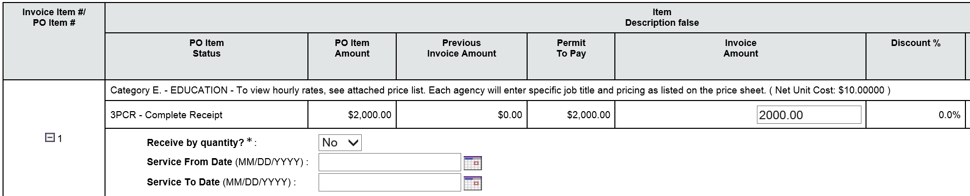
Selecting Yes in the Receive by Quantity field will cause the following additional fields to be displayed:
  - Invoice Quantity – Enter the quantity of the Item on the Invoice.
  - Unit Price – Enter the ‘Net Unit Price’ of the Item on the Invoice.
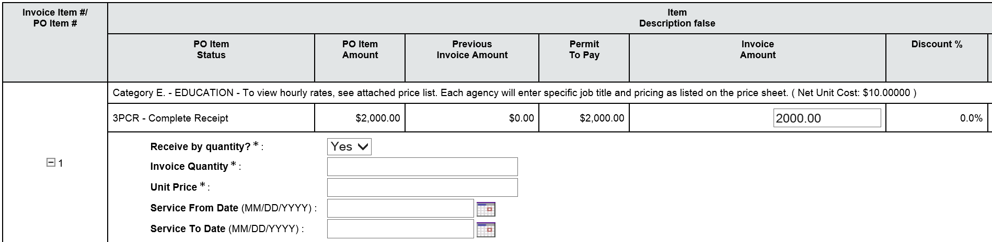
In order for a non-service Item Invoice to successfully interface with AFIS, the product of the Invoice Quantity multiplied by the Unit Price must exactly equal the Invoice Amount entered for the Item, if the item does not include any taxes. The method of determining the values that belong in the Quantity and Unit Price can be affected by the Receipt method associated with the item. It is expected that all goods will have a Receipt Method of Quantity. When the Receipt Method is Dollars, the Receipt will state the dollar amount received which can be used to calculate the Invoice Quantity by dividing the Invoice Amount by the Net Unit Cost. The Receipt Method can be verified by opening the Purchase Order in a new browser window (right click the PO link) and then clicking the PO Receipts Summary button to view the Receipt information.

TIP: More detailed information on the completion of the Invoice Quantity and Unit price fields can be found in Appendix B - Enhancements Overview within the ‘Collect Invoice Data Required to interface Goods to the New AFIS PRCPZ1 Document topic.

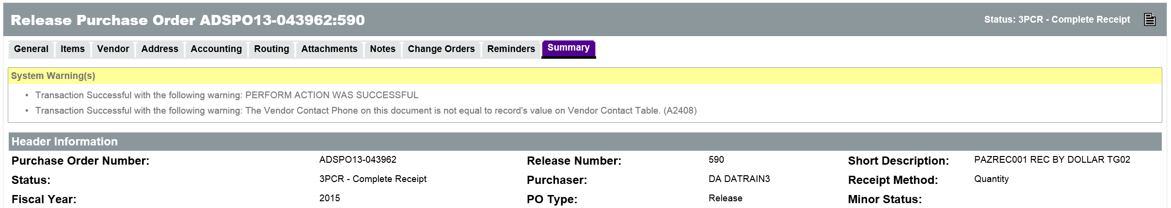

Service Dates
New
Feature
The Service From Date and Service To Date fields appear on Receipt and Invoice documents and are displayed on the Invoice Item tab when the Invoice Item is expanded. These fields may be used by agencies to record the actual service dates for purchases made using grant dollars. This will allow the appropriate grant funds to be used for the purchase.
If an agency is relying on the Service Dates to determine the appropriate funds for a purchase, the Service From and To Date fields must be completed on the Invoice Item tab. The Service Dates entered on the Receipt should be reviewed to determine what dates to enter on the Invoice. The Service Dates can be verified by opening the Purchase Order in a new browser window (right click the PO Link) and then clicking the Receipt number on the Summary tab of the PO. If the user who creates the receipt inputs the Service From/To Dates, the Summary tab of the Receipt will display the Service From/To dates in the Item Information section for each Item.
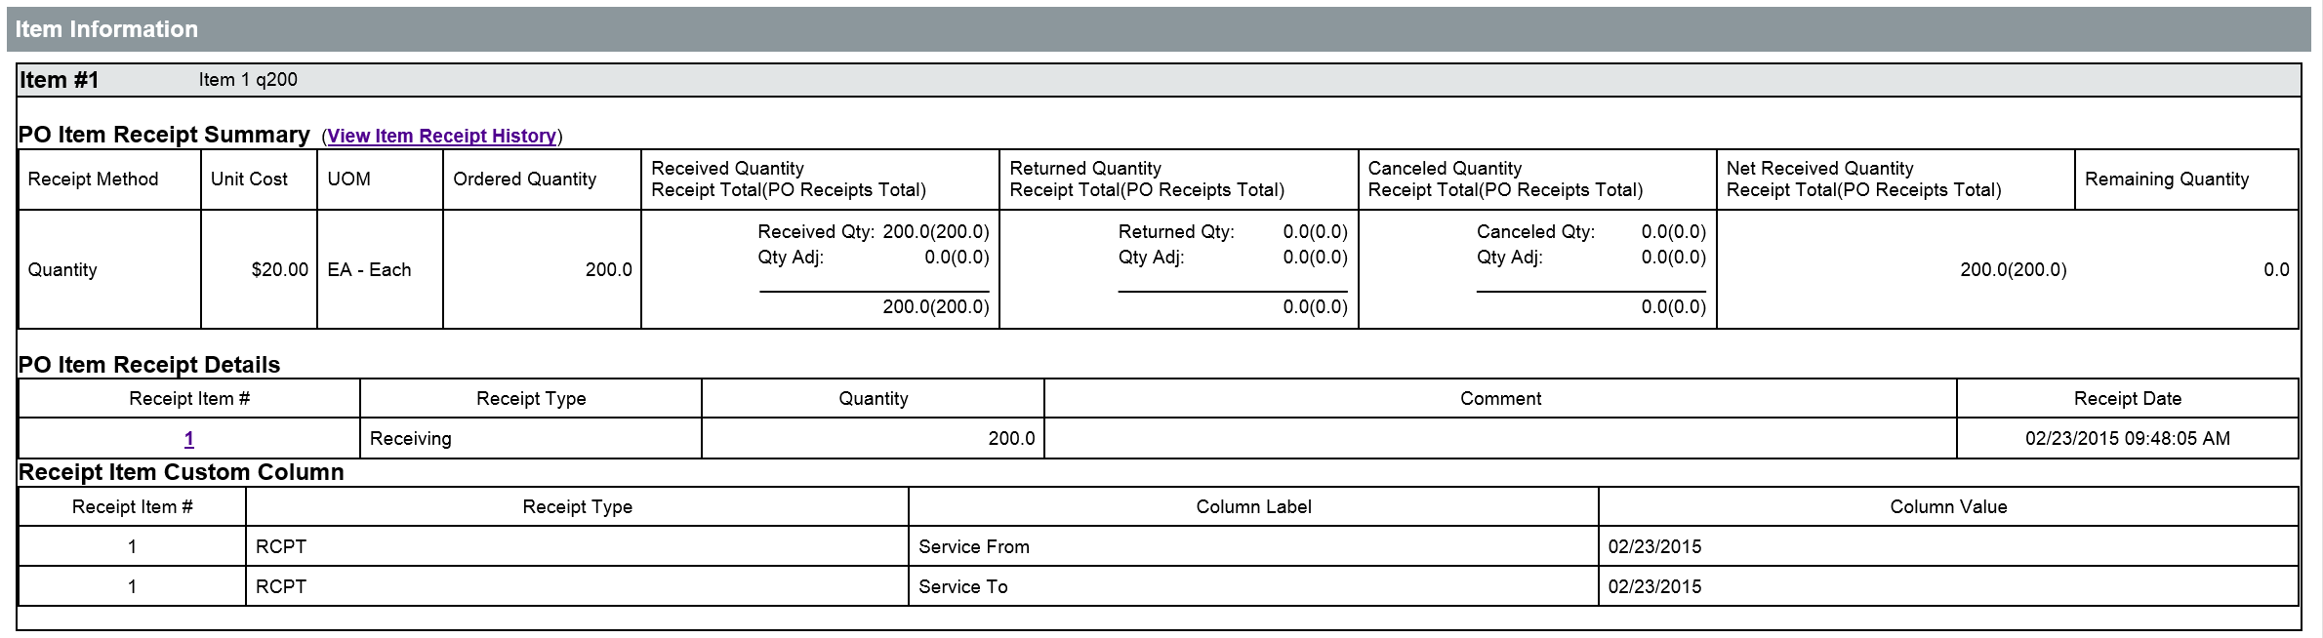

TIP: More detailed information on the completion of the Service From/To Date fields can be found in Appendix B - Enhancements Overview within the ‘Allow Entry of Service From / To Dates’ topic.

Once the dates have been identified on the Receipt, they can be entered on the Invoice in the appropriate field. The Service From Date and Service To Date fields will be recorded on the Received Service From Date and Received Service To Date fields respectively on the PRCPZ1 document in AFIS when the Invoice is successfully interfaced.
TIP: If Service From/To Dates are not provided on invoice items, the AFIS fields will default to the current system date.

Credits Tab
The Credits tab displays any approved Credit Memos for the Organization/Department/Location of the Invoice that may be applied to the Invoice to offset the amount of the Invoice. Credit Memos must be created before they can be applied to an Invoice. Refer to topic 11.4, Credit Memos, of this guide for more information on creating a Credit Memo.
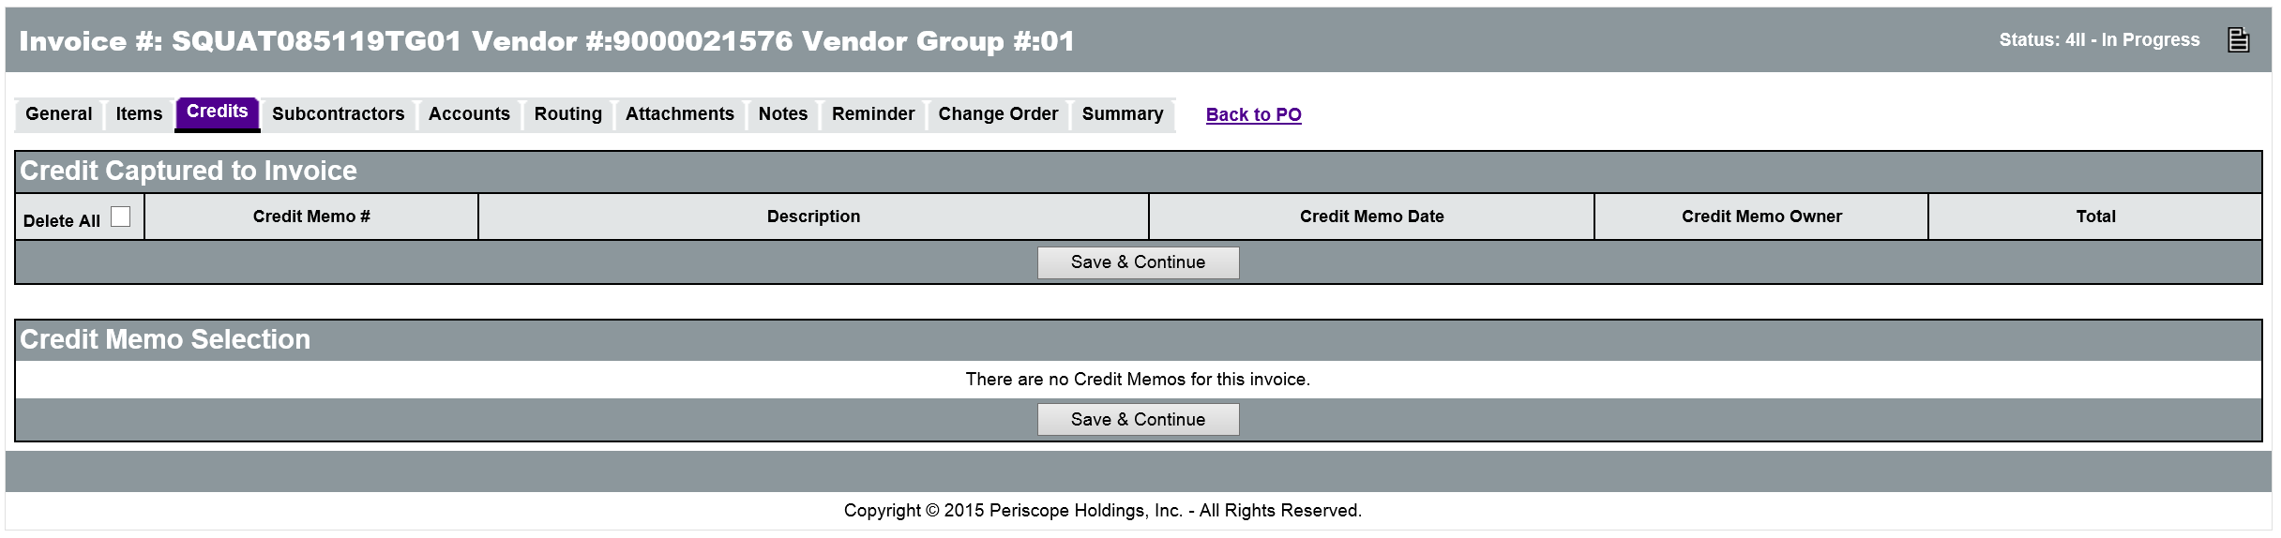

Add Credit Memo
To apply a Credit Memo to the Invoice, expand the Credit Memo Selection by clicking the expand icon in the left column and select a Credit Memo. Enter the Amount to Take and then click the Save & Continue button. The selected Credit Memo will be displayed in the Credit Captured to Invoice section.
TIP: The Credit Memo amount applied to an Invoice must be less than the Payment Amount on the Invoice. AFIS cannot issue a $0 or negative amount payment.
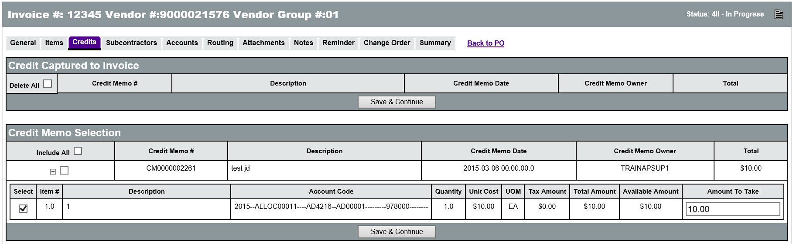

Delete Applied Credit Memo
To remove a Credit Memo amount that has been applied to the Invoice, check the Delete check box for the Credit Memo and then click the Save & Continue button. The selected Credit Memo will be removed from the Credit Captured to Invoice section.

Accounts Tab
The Accounts tab will display the PO Accounting Information that was entered on the Purchase Order. The account codes cannot be modified on the Accounts tab. If the accounting information needs to be changed, a Change Order must be created that will update the PO. Refer to Lesson 8 Change Orders for more information on creating Change Orders.
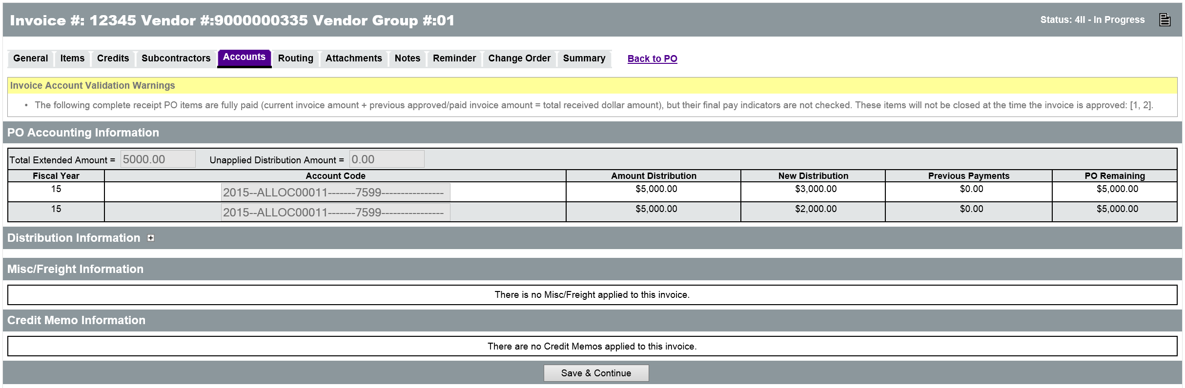
The Accounts tab also includes sections for Disbursement Information, Miscellaneous/Freight charges and any Credit Memos applied to the Invoice.

Distribution Information
The Disbursement Information section is where the Use Tax Amount needs to be entered if Yes is selected for “Is Use Tax required and not already on the PO?” on the General tab of the Invoice. Click the + to expand the Distribution Information section. Each item will be listed along with the account coding identified for the item. Enter the amount of the Use Tax under the appropriate accounting for each Item that requires a Use Tax payment on the Invoice. When finished, click the Save & Continue button.

Miscellaneous/Freight Information
The Misc/Freight Information section displays any Miscellaneous or Freight charges that have been added to the Invoice on the General tab. This section allows users to add any Use Tax, if necessary, to the line Items for Misc. and Freight. When finished, click the Save & Continue button.

Credit Memo Information
The Credit Memo Information section displays the details of any Credit Memos that have been applied to the Invoice on the Credits tab. No data entry is expected in this section.

Attachments Tab
The Attachments tab is used to upload and attach files from a local hard drive to the ProcureAZ Invoice. The paper Invoice document must be scanned and saved to the local machine or a shared network drive.

Add File
On the Attachments tab, click the Add File button to display the Add File page. On the Add File page, click the Browse button (Browser dependent) to bring up a File Explorer window and browse to the scanned file. Select the file and click Open. The Name field will default to the name of the file but can be changed if necessary. The Description field is optional but can be used to enter a brief description of the file.
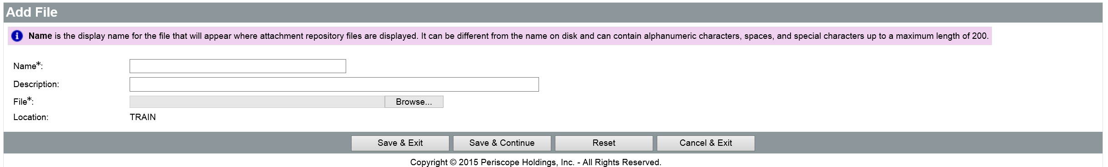
When the fields are complete, click the Save & Exit button to upload the file to the Invoice. Click the Save & Exit button once more to return to the Invoice Attachments tab. The attachment will be displayed in the Files section.

Attachment Management
The Confidential check box can be checked to ensure that the document is only seen by relevant personnel and will not be displayed publicly. Any added attachments can be removed from the Invoice by checking the Delete check box for the file and clicking the Save & Continue button.
To download an attached file from the Invoice, click the name of the file to display the File Detail page, and then click the Download File icon. To return to the Attachments tab, click the Cancel & Exit button.

Reminder Tab
It may be necessary to create reminders on the Invoice that will notify other users on a specified date that an action is required on their part. For example, if the Invoice cannot be completed because there is not yet a complete Receipt and an approved amount for payment, a reminder can be sent to the appropriate Department reminding them to complete the Receipt. More than one reminder can be added to an Invoice. Any reminders currently assigned to a user will be displayed on the My Reminders tab on the user’s Home Page.

Create a Reminder to Complete a Receipt
On the Reminder tab, in the Due Date field, enter the date that the Receipt needs to be completed by. In the Comment field, enter any instructions for the reminder. In the Remind Whom drop down list, select the user who should receive the reminder and complete the Receipt. In the Days Prior to Remind field, enter the number of days prior to the Due Date that the reminder will be sent. Check the Send Email check box to ensure that the user received the reminder in their email. When the reminder fields are complete, click the Save & Continue button.
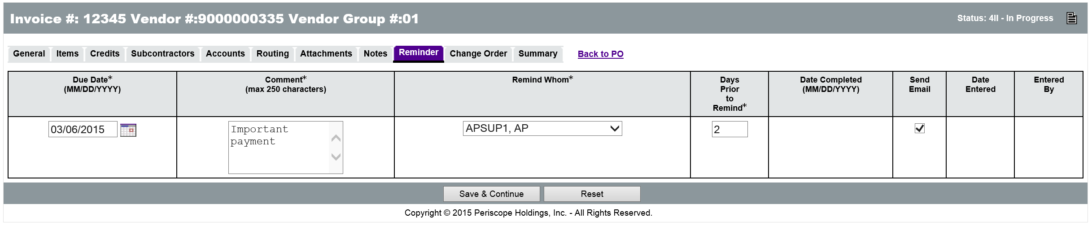

Change Order Tab
If the accounting information on the Purchase Order needs to be changed to make this payment, an Invoice Change Order can be created on the Change Order tab of the Invoice. Invoice Change Orders can only modify the account codes and distribution for the Items on the Purchase Order. Changes cannot be made to Invoices that have already been paid or that are in Approved for Payment status.
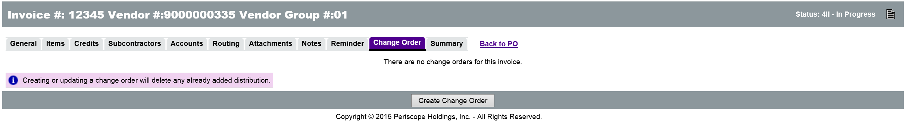

Request a Change to PO Accounting
To create a request to change the accounting on the Purchase Order, click the Create Change Order button on the Change Order tab. On the Items > Accounting tab, click the Item number (not the +) in the left column to open the Accounting page for the Item. The existing account codes can be edited in the necessary fields. Account codes can be added and/or redistributed. The distribution can be based on Percentages or Dollars. The Accounting can also be changed at the Header level.
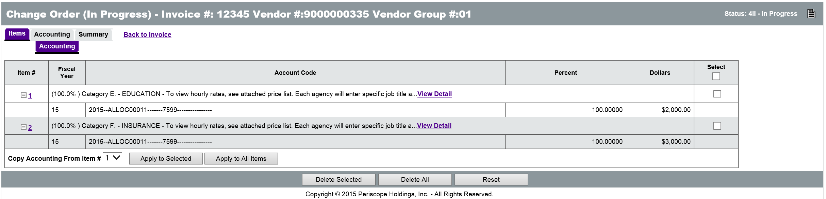
When working at the Item level, users can determine what page is displayed next by selecting the option in the Go to after Save drop down list. When the account codes and distribution have been corrected, click either the Save Based on Percentages or Save Based on Dollars button. When working at the Header level, once all changes have been made and saved, click the Rebuild for All Items button to push the Accounting information to the line Items.
Click the Summary tab to review the information on the Change Order.
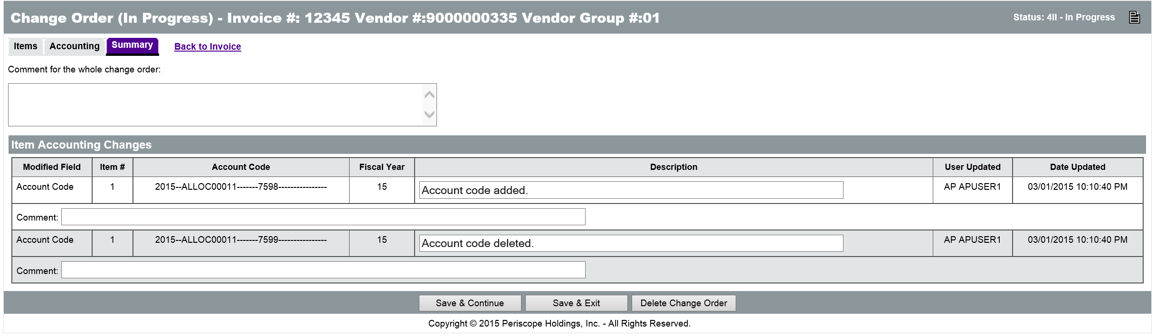
When finished, click the Save & Exit button to save the Change Order and return to the Invoice. Submitting the Invoice will route the Change Order for approval. Once the Change Order has been approved, the Invoice can be processed.

Review and Submit Invoice
On the Invoice Summary tab, users can thoroughly review all of the information on the Invoice for accuracy. Any changes that need to be made to the document can be made on the corresponding tab.
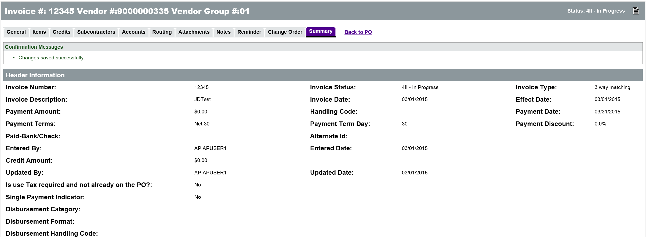
The Summary tab will display any warning messages in yellow and any error messages in red. Warning messages will not prevent the document from being submitted but red error messages must be addressed before the Invoice can be submitted for approval.
TIP: If there are available Credit Memos that could be applied to the Invoice, a general validation warning message will be displayed at the top of the Summary tab.
If everything on the document is correct, the Invoice can be submitted by clicking the Submit for Approval button. Once the Invoice has been approved by the designated approvers, it will be interfaced to AFIS for payment processing and, if successful, the status of the Invoice will change to Approved for Payment.
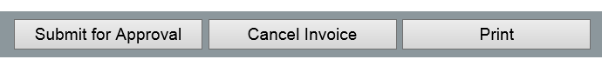

Invoice Integration Results in AFIS
The interfaced Invoice document from ProcureAZ is used to create the Payment Request (PRCPZ1) document in AFIS that generates the payment request. Invoices that have been approved for payment in ProcureAZ are interfaced to AFIS after the final approval. If the Invoice interface is unsuccessful, AFIS will provide a message to ProcureAZ.
i
When the interface has successfully created the PRCPQ1 document in AFIS, the Alternate ID on the ProcureAZ Invoice will be updated with the PRCPZ1 document ID that was created as a result of the integration.
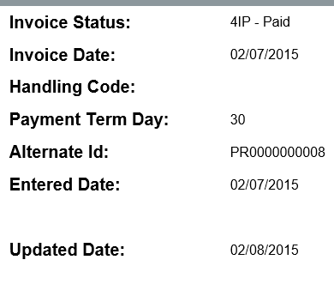
Individuals with access to AFIS can search for that Document ID to review the Payment Request that was created in AFIS.
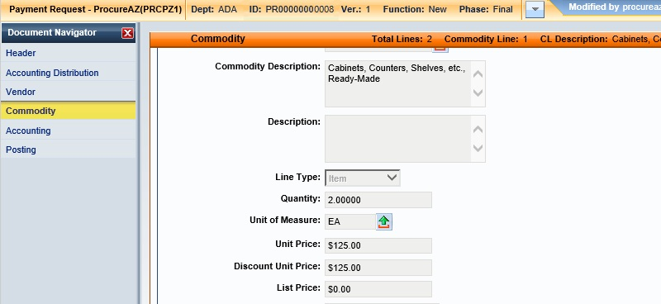

Invoice Cancellation after AFIS Integration
If an Invoice has been interfaced to AFIS but not yet disbursed as a warrant/EFT, it can be canceled in ProcureAZ by a user with the Accounts Payable Supervisor role. Invoices can also be canceled if a warrant cancellation is received from AFIS through the warrant update file.
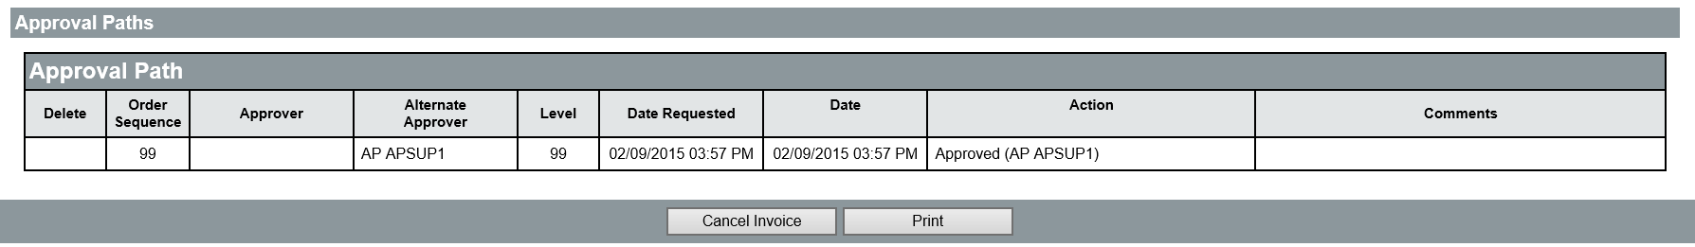

Disbursements
The disbursement process is part of the batch job cycle that runs automatically every night in AFIS. The payment date on the invoice determines which night’s disbursement job generates the vendor payment.
As a result of the nightly batch job, the payment to the vendor is generated and the outcome of the process is interfaced back to ProcureAZ. The warrant or EFT numbers will be interfaced back to ProcureAZ and the view more hyperlink can be opened. The information provided will enable the ProcureAZ user to identify the total payment amount vs. any discounts that were taken when making the payment. The status of the Invoice also changes to Paid.
i
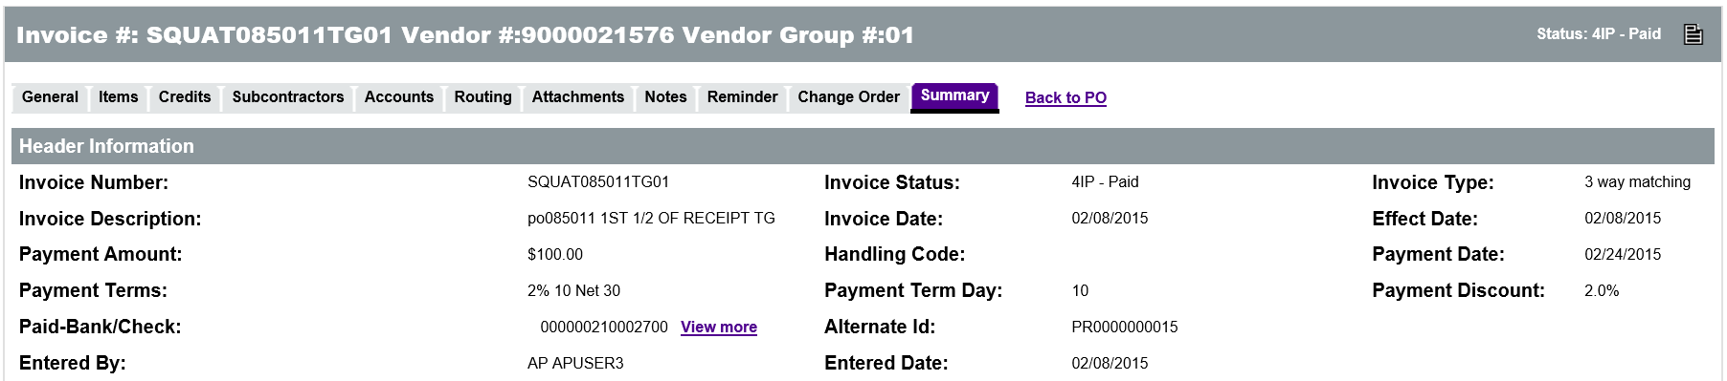

Activity 11.2

Create an Invoice
Scenario
You have received notification that a Receipt has been approved for a Purchase Order and need to create an Invoice to request a payment to the vendor. You will locate the Purchase Order and then create the Invoice for the received Items.
Setup
- This exercise assumes that you/someone has completed the Lesson 5 Open Market Activities 5.1 – 5.3 and the Lesson 10 – Receiving Activity 10.1
- Log in to ProcureAZ with the Accounts Payable (AP) role from your Training Data Card
Steps
- Locate the Purchase Order.
  - In the Header Bar, click Documents > Invoice > New.
  - On the New Invoice – Search PO page, in the Header Major Status field, select 3PPR - Partial Receipt.
  - In the Description field, enter Oar.
  - In the Vendor field enter Maurer.
  - Click the Find It button.
- Create the new Invoice.
  - In the search results, select the radio button for the Purchase Order that you created.
  - Scroll to the bottom of the page.
  - Click the Select button.
- Complete the General tab on the Invoice.
  - In the Invoice Number field, enter the Invoice Number on your Training Card.
  - In the Invoice Description field, enter Training Invoice ## where ## is your student number.
  - Next to the Payment Terms field, click the Edit link.
  - In the Payment Terms drop down list, select 2% 10 Net 30.
  - Click the Save & Continue button.
- Complete the Items tab on the Invoice.
  - Click the Items tab.
  - Click the Plus Sign to expand Invoice Item 2 (Oars).
  - In the Receive by quantity field, click the drop down and select Yes. The Invoice Quantity and Unit Price fields are displayed.
  - In the Invoice Quantity field, enter 1.
  - In the Unit Price field, enter the Net Unit Cost from the Item Description.
  - In the Invoice Amount field for Invoice Item 1, enter the same amount as the Unit Price.
  - Click the Save & Continue button.
- Review the Accounts tab.
  - Click the Accounts tab.
  - Review the PO Accounting Information section.
- Review the Summary tab.
  - Click the Summary tab.
  - Review all of the information on the Summary tab of the Invoice.
- Submit the Invoice for approval.
  - Click the Submit for Approval button.
  - In the pop up message window, click OK.
  - On the approval page, select Automatic approval.
  - Click the Save & Continue button.
  - In the pop up message window, click OK.
  - When the page refreshes, observe that the status of the Invoice is Ready for Approval.
    - The AP Supervisor will now need to review/approve the invoice for it to be submitted to AFIS for payment.
  - When you are finished, click Home to return to the Home Page.

  - Invoice Search
There are several ways to search for Invoices in ProcureAZ. The Advanced Search feature is accessible by clicking the magnifying glass icon from the Header Bar at the top of the screen. Users can search for documents by type and narrow down the search by entering document specific information into the search fields. For more information on the Advanced Search feature, refer to Lesson 12 Advanced Search.

Invoice Search Page
Accounts Payable users can also access the Invoice Search feature by navigating to Document > Invoice > Search from the Header Bar. On the Invoice Search page, users can search by Invoice number, Invoice Status, PO number, PO Description, PO Status, PO Type, Department, Location, Vendor ID, Vendor Name, and/or Invoice Amount.
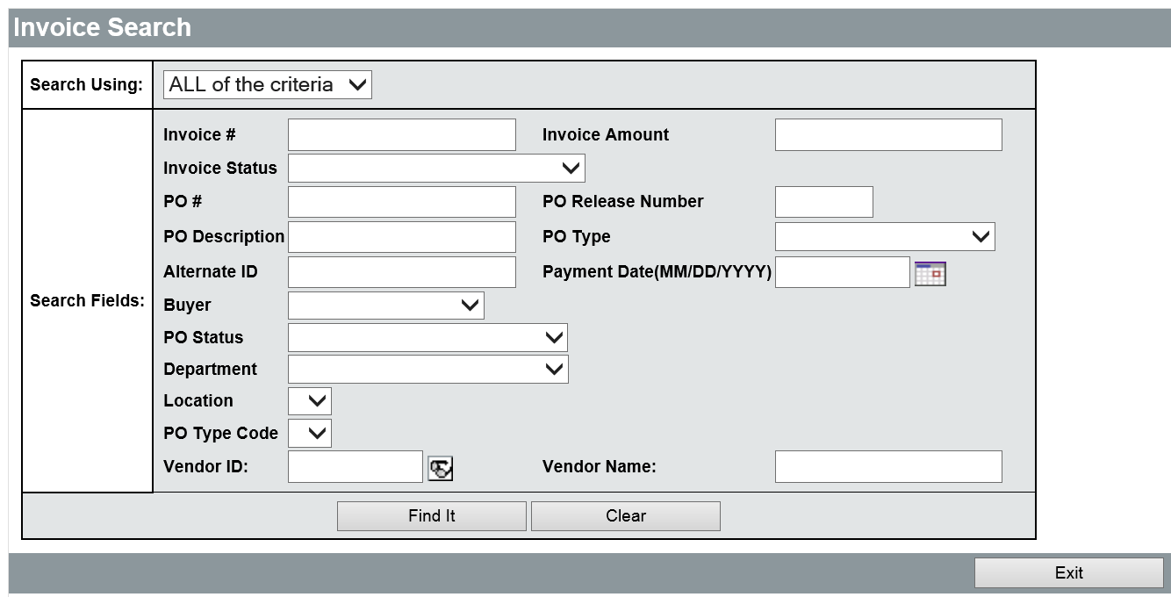
Searches can be configured to return the results that match ALL or ANY of the search criteria entered into the search fields. When the criteria has been entered, click the Find It button at the bottom of the page to display the results.

Search Results
In the Invoice Search results, key Invoice information is displayed. Users can click the available links for Invoice number, Vendor number/name, or PO number to open the respective page. The Invoice Description, Invoice Date, Payment Date, Invoice Amount, Invoice Status, and PO Status are also displayed.
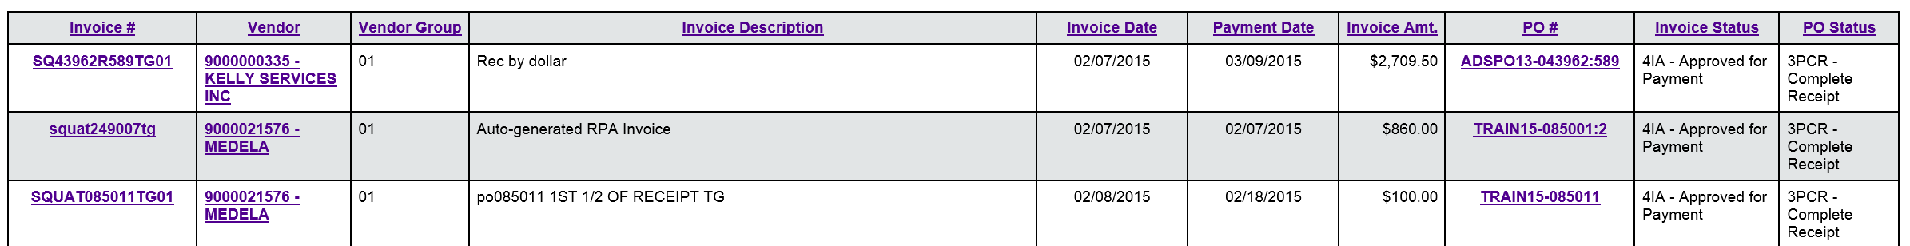
If there are more than 25 results in the search, the additional page links appear above and below the results. To leave the search page, click the Exit button.

Activity 11.3

Search for an Invoice
Scenario
You need to locate and review the status of the Invoice you created in the previous activity. You will use the Invoice Search feature to search for the document.
Setup
- User is logged in to the ProcureAZ home page as a user with the Accounts Payable role.
Steps
- Use the Invoice Search page to locate an Invoice.
  - In the Header Bar, click Documents > Invoice > Search.
  - On the Invoice Search page, in the Invoice number field, enter the Invoice number you created in Activity 11.2.
  - Click the Find It button.
- Review the Invoice information.
  - In the search results, observe the Invoice information.
  - Observe the Invoice Status.
  - Click the Invoice number link to open the Invoice document.
  - Review the information on the Summary tab of the Invoice.
  - When you are finished, click Home to return to the Home Page.

  - Credit Memos
Credit Memo documents are used to record a credit that has been offered by a vendor for use on a future Invoice. For example, if a payment has been sent to a vendor and the PO has been closed, the PO cannot be reopened in order to return Items or cancel an Invoice. In this case, the vendor may provide a Credit Memo that can be applied against future Invoices.

Create Credit Memo
Credit Memos are created in ProcureAZ by users with the Accounts Payable role. To create a new Credit Memo, click the Documents > Credit Memos > New option from the Header Bar. This will display the General tab of the new Credit Memo document. The Credit Memo tabs should be completed from left to right.

General Tab
The General tab contains fields that define the entire Credit Memo. On the General tab, the following fields are available:
  - Vendor Credit Memo Number – Enter the number from the vendor Credit Memo. This must be a unique number by vendor. This is a new field. This is the number that will interface into AFIS and be displayed on the warrant remittance.
New
Feature
  - Description – Enter a brief description of the Credit Memo.
  - Vendor – Select the vendor by clicking the Vendor Search eyeglass icon. On the Lookup & Add Vendor page, enter the search criteria into the search fields and click Find It. In the Results, select the radio button for the desired vendor and click the Add Vendor button. If you select a Purchase Order number, the vendor will be automatically selected.
  - Department – Select the Department from the drop down list.
  - Location – This field will default based on the Department selected, but can be changed if there are more locations available.
  - Credit Memo Date – Enter the date that the Credit Memo was issued.
  - Print Format – This field is populated by default but will not be used.
  - Purchase Order Number – This is an optional field that allows users to select a Purchase Order in the system, before or after a vendor is selected. When selecting a PO first, the Vendor will be set by default. If a PO number is selected, the Items tab will provide the option to add Items from the PO, instead of creating them manually.
When the information on the General tab is complete, click the Save & Continue button to save the document and proceed to the other tabs.
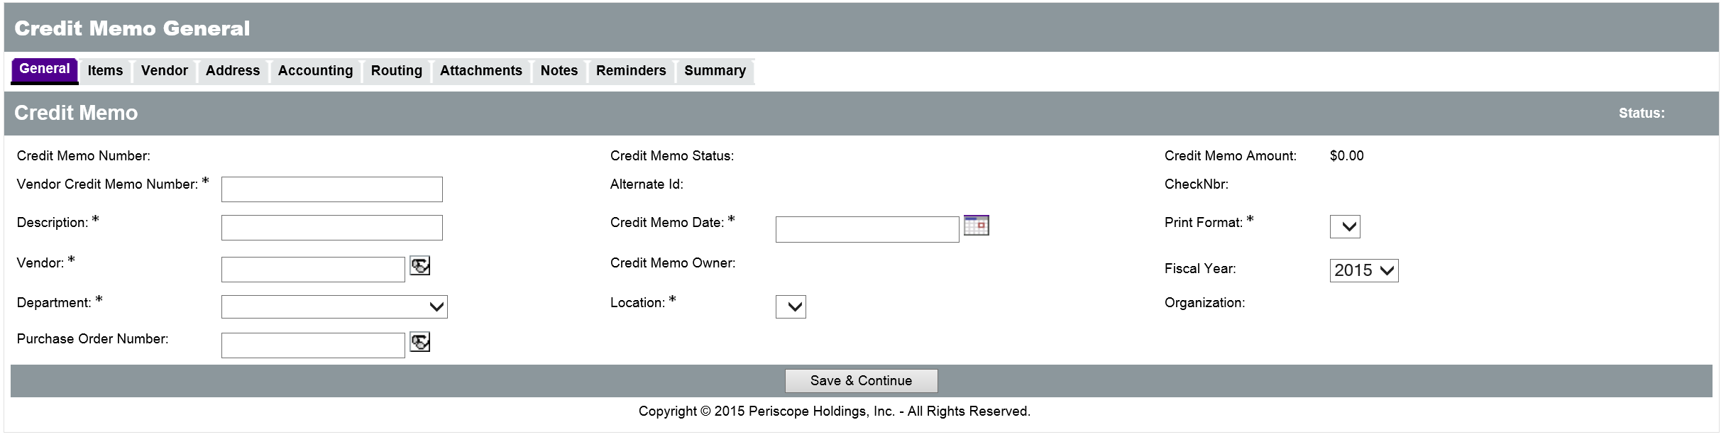

Purchase Order Number
Rather than add Items manually to a Credit Memo, Items can be selected from a Purchase Order. Click the eyeglass icon next to the field to display the Lookup PO window.
New
Feature

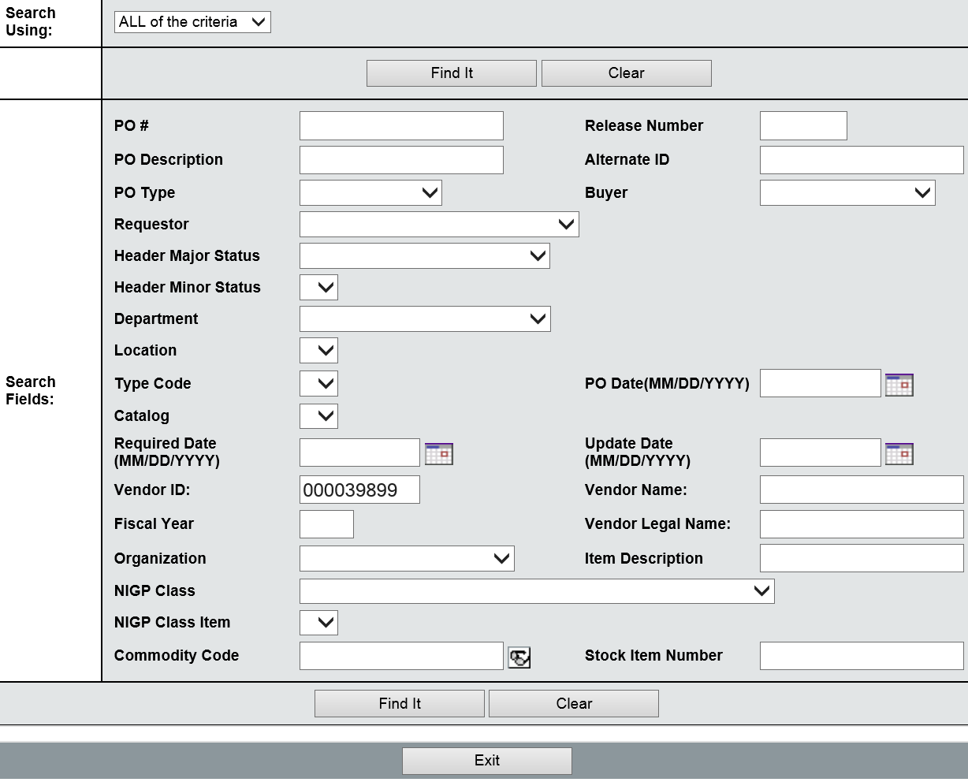
In the Lookup PO window, the Vendor ID field will default to the vendor selected (if any) on the General tab of the Credit Memo. Use the search criteria fields to narrow down the results of the search and locate a specific Purchase Order for the vendor. Once the search criteria has been entered, click the Find It button to display the results.
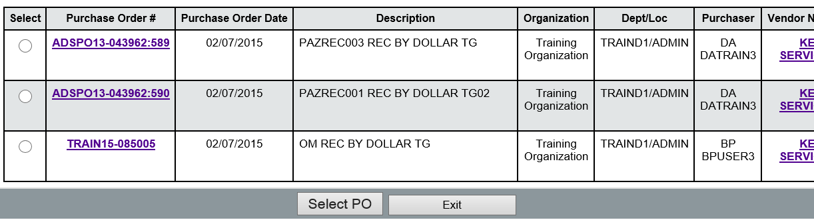
After locating the Purchase Order with the Items that have been returned or credited, click the radio button in the left column to select it and then click the Select PO button at the bottom of the page. This will complete the Purchase Order number field, and also the Vendor field it if was not already completed. Click Save and Continue before leaving this tab.
If the PO Number is ever changed after being selected, a pop up message will appear to let users know that changing the PO number on the Credit Memo will remove any Items from the Credit Memo and reset the PO and vendor information on the Credit Memo. Click OK in the dialog box to continue.

Items Tab
On the Items tab, users can add the individual Items and amounts on the Credit Memo. Credit Memos are flexible in that they do not need to reference a particular Item on a Purchase Order. If a Purchase Order number was selected on the General tab, the options will be slightly different.
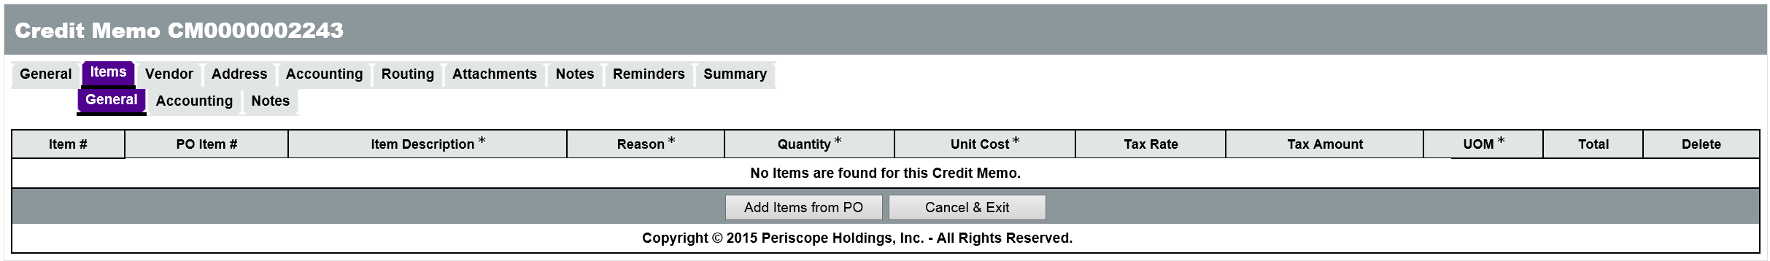

Purchase Order Number Selected
If a PO Number is selected on the General tab, the Items > General tab will not display fields for user entry by default. Click the Add Items from PO button to select Items from the PO.
New
Feature
A new window will be displayed where users can select the Item to reference on the Credit Memo. The Item Description, Quantity, and Cost are shown on the PO Items page. Once the Items have been selected, click the Save & Exit button to return to the Items tab of the Credit Memo.
The Item Description field on the Items tab will populate with the information from the PO Item. The following fields can be completed with the necessary information:
  - Reason – Select a reason for the Credit Memo from the drop down list.
  - Quantity – Enter the number of Items returned.
  - Unit Cost – This field is populated based on the PO selected. If changes are required, enter the cost of the good or service for which the credit is being created.
  - Unit of Measure – This field is populated based on the PO selected. If changes are required, select the Unit of Measure for the good or service from the drop down list.
  - Tax Rate – This optional field is populated based on the PO selected. If changes are required, select the Tax Rate from the drop down list.
When finished adding Items to the Credit Memo, click the Save & Continue button.
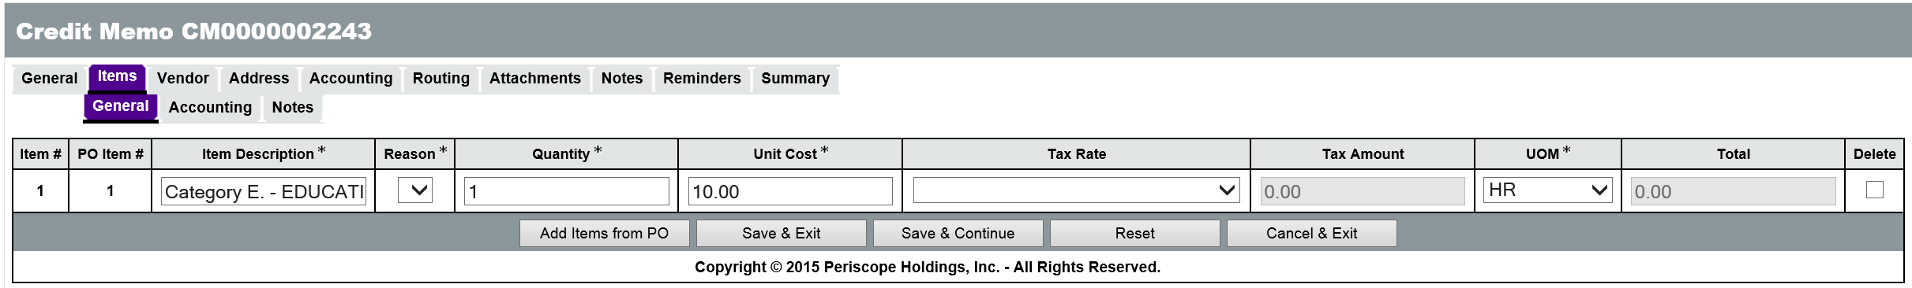

No Purchase Order Number Selected
If no PO Number is selected on the General tab, the Items > General tab will display fields for user entry. The following fields on the Items > General tab require user input:
  - Item Description – Enter a brief text description of the Item.
  - Reason – Select a reason for the Credit Memo from the drop down list.
  - Quantity – Enter the number of Items returned.
  - Unit Cost – Enter the cost of the good or service for which the credit is being created.
  - Unit of Measure – Select the Unit of Measure for the good or service from the drop down list.
The Tax Rate field contains a drop down list of tax rates which can be selected by the user; however, the Tax Rate is optional. When finished adding Items to the Credit Memo, click the Save & Continue button.
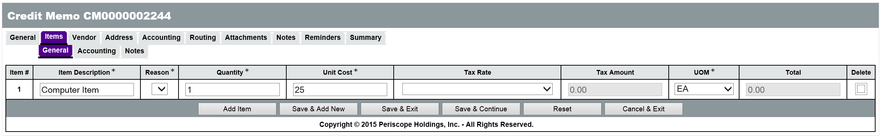

Vendor Tab
The information on the Vendor tab is populated based on the vendor selection made on the General tab. No user input is required on the Vendor tab.

Address Tab
The information on the Address tab is populated based on the address information for Department and Location selected on the General tab. No user input is required on the Address tab.

Accounting Tab
The Accounting tab is used to record the appropriate accounting distribution for the Items on the Credit Memo. If the Items were selected from a Purchase Order, the Items > Accounting tab will be populated with the accounting information from the PO. If that accounting is correct, no other action is required related to accounting.
If the Items have been added manually, the accounting information can be added at the Header level for all Items or at the Item level for individual Items.
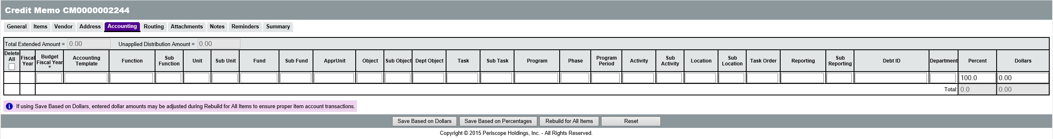
Users will need to know the specific Account Codes for their Department, or enter the Budget Fiscal Year along with an Accounting Template or Function code that will infer the appropriate Account codes.
The elements/segments that must be entered depends upon the accounting methodology selected by the agency. If the agency has adopted use of Accounting Template or Function codes, the user must enter,
  - Budget Fiscal Year
  - Either Accounting Template or Function
If neither Accounting Template nor Function code are entered, the user must enter
  - Budget Fiscal Year
  - Unit
  - Fund
  - Appr Unit
  - Task.
TIP These are the minimum requirements enforced by ProcureAZ. However, the fields required by AFIS vary dependent upon the Agency’s accounting methodology.

Object Code Inference
ProcureAZ requires that each Item being purchased can be identified using a five-digit NIGP code. Because of this established relationship, when users complete the Accounting tab on a Credit Memo, the Object code for each Item can be inferred based on the combination of NIGP code and dollar amount. If the user enters an Object code, ProcureAZ will not overwrite the code with an inferred Object code. The Object code will only be inferred if the field is left blank. During the inference process, if a matching Object code is found, it will be written to the Object field, but if no matching Object code is found, the field will be left blank and require input from the user before submitting the document to AFIS.
New
Feature
TIP: Users should refer to their agency’s policy regarding Object code usage. Users should enter an Object code if their agency has special expectations or usage for it.

Add Accounting to Header
On the Header > Accounting tab, the Accounting codes can be entered into their respective fields. At the far right of the page (scrolling is necessary) there are fields for entering the Percent or Dollar distribution for the Accounting line. If multiple Accounts are responsible for payment of the request, their responsibility amount can be entered as either a percentage of the total or a dollar amount. Only the Percent field or the Dollars field can be used but not both.
Entering a value into one field will automatically calculate the other when the changes are saved. If the Percent field is used, the Save Based on Percentages button will update the Dollars. If the Dollars field is used, the Save Based on Dollars button will update the Percent. The sum of the percentages must equal 100 and the sum of the dollars must equal the total amount of the cost of the Items on the request. The Unapplied Distribution Amount must always be 0. For documents with one line Item, it is recommended to use the Save Based on Percentages with 100 entered for the Percent.
Once all Accounting information has been entered and the Unapplied Distribution Amount is 0, clicking the Rebuild for All Items button will apply the Accounting information to all of the Credit Memo Items.
At this point the document will be locked by ProcureAZ to perform several tasks and a system warning message will inform the user that the document is locked for editing. After locking the document, the Object code is inferred based on the Item’s NIGP code and a validation check is performed to ensure that all required information has been entered. Once the process is complete, a message box is displayed that informs the user that the page will be refreshed.
TIP: The Object code is only inferred if left blank. If an Object code has been entered, ProcureAZ will not overwrite the Object based on the NIGP code.

Add Accounting to Line Items
When Accounting codes must be different for each line item on the Credit Memo, the Items > Accounting tab must be completed. On this screen, each Item on the Credit Memo is displayed. Clicking the Item Number for an Item will display the same screen used on the Header, except that it applies only to the individual Item. The same Accounting information is required on this page and the Percent or Dollars fields can be used to distribute the credit for an Item across multiple accounts.
After entering the last Accounting line for an Item, but before saving, you can tell the system what to display after clicking one of the save buttons. The available options are: Current Page, Next Item, Previous Item, and Exit. Upon saving any changes, the system will lock the document for editing and perform the Object inference (if left blank) as well as the required field validation. A message box will be displayed when the document is ready to be refreshed.

Attachments Tab
The Attachments tab is used to upload and attach files from a local hard drive to the ProcureAZ Credit Memo. The attachment can be a file that has been saved to the local machine or a shared network drive.

Add File
On the Attachments tab, click the Add File button to display the Add File page. On the Add File page, click the Browse button (browser dependent) to bring up a File Explorer window and browse to the scanned file. Select the file and click Open. The Name field will default to the name of the file but can be changed if necessary. The Description field is optional but can be used to enter a brief description of the file.
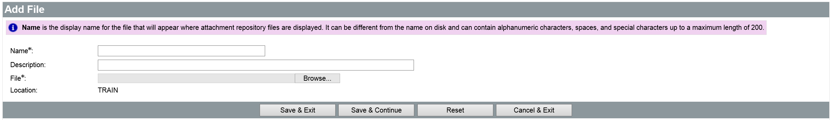
When the fields are complete, click the Save & Exit button to upload the file to the Credit Memo. Click the Save & Exit button once more to return to the Credit Memo Attachments tab. The attachment will be displayed in the Files section.

Attachment Management
The Show Vendor check box can be checked to allow the vendor to view the file. Any added attachments can be removed from the Credit Memo by checking the Delete check box for the file and clicking the Save & Continue button.
To download an attached file from the Credit Memo, click the name of the file to display the File Detail page, and then click the Download File icon. To return to the Attachments tab, click the Cancel & Exit button.

Reminders Tab
It may be necessary to create reminders on the Credit Memo that will notify other users on a specified date that an action is required on their part. For example, if the credit should be applied to an Invoice before a given date, a reminder could be set up to remind users that the Credit Memo is available. Any reminders currently assigned to a user will be displayed on the My Reminders tab on the user’s Home Page.
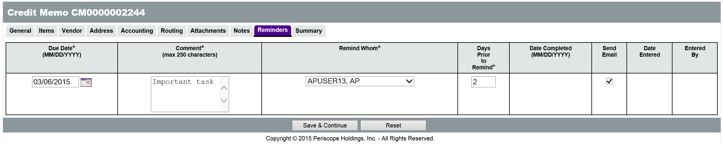

Review and Submit Credit Memo
On the Credit Memo Summary tab, users can thoroughly review all of the information on the Credit Memo for accuracy. Any changes that need to be made to the document can be made on the corresponding tab.
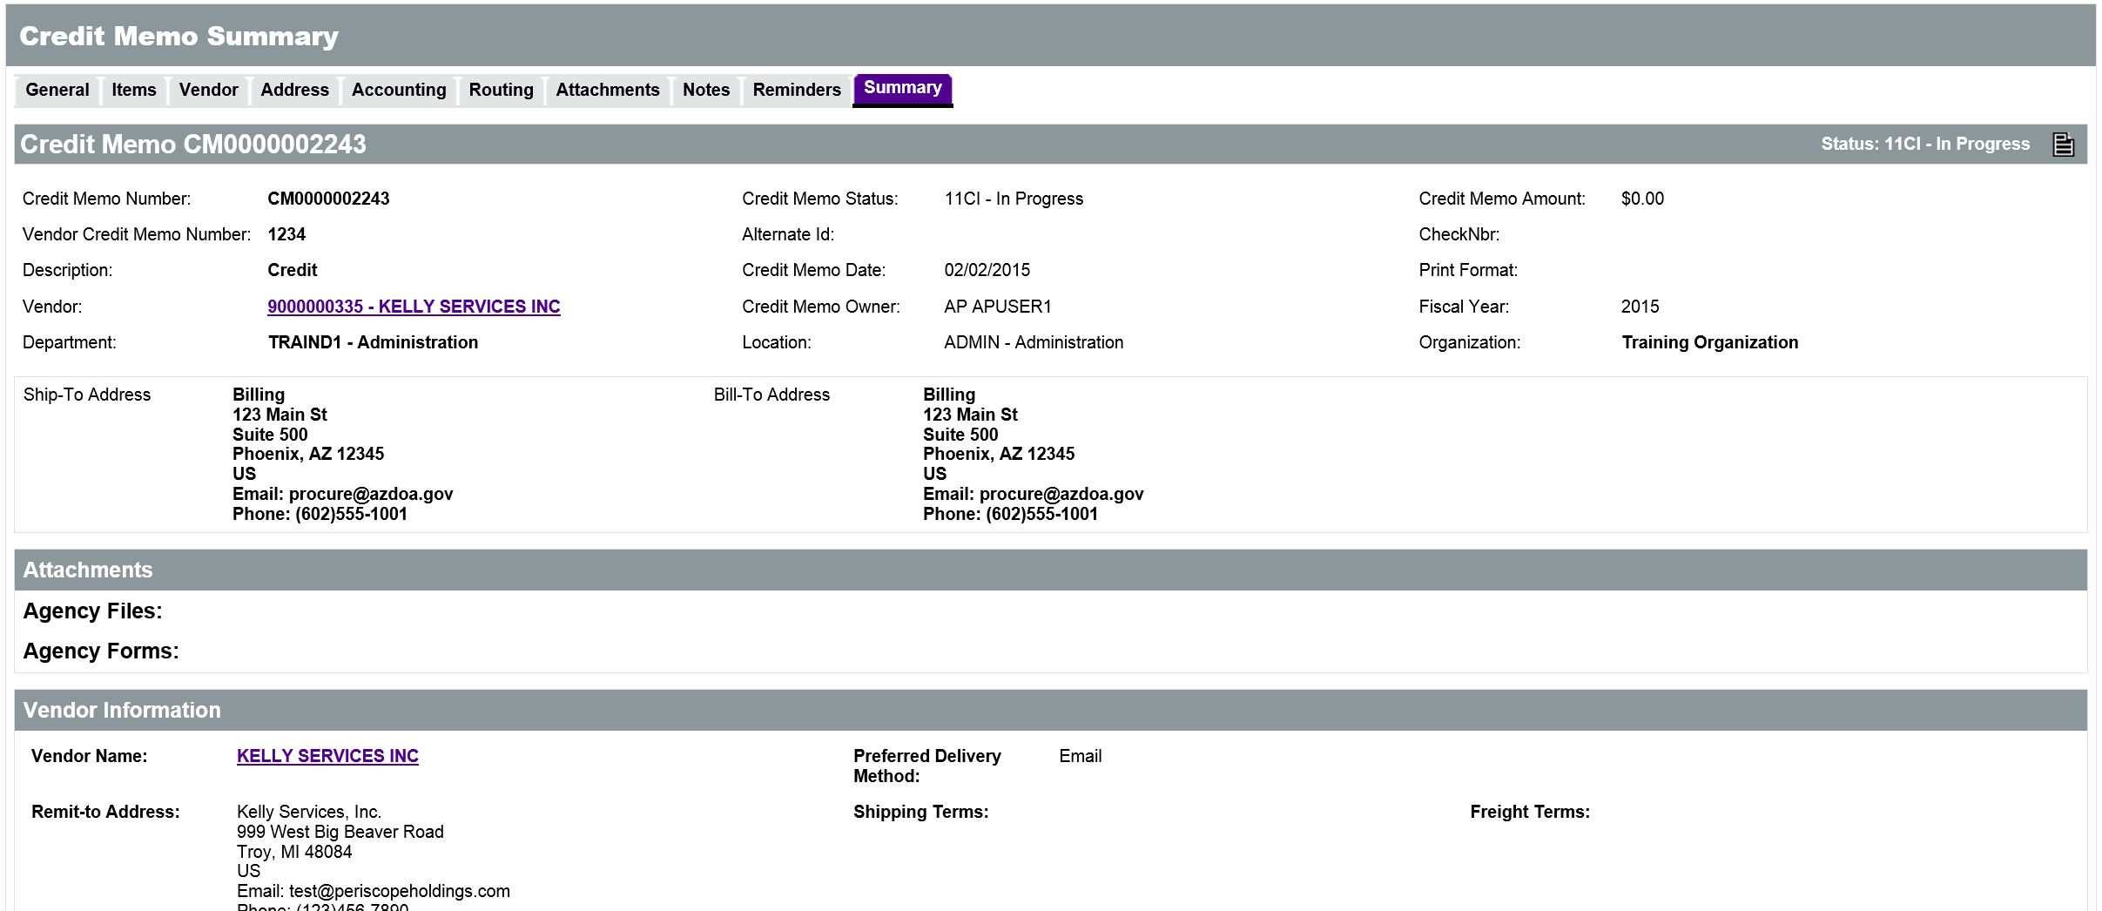
The Summary tab will display any warning messages in yellow and any error messages in red. Warning messages will not prevent the document from being submitted but red error messages must be addressed before the Credit Memo can be submitted for approval.
If everything on the document is correct, the Credit Memo can be submitted by clicking the Submit for Approval button. Once the Credit Memo has been approved by the designated approvers, it will be made available for application to any appropriate Invoices from the designated vendor.
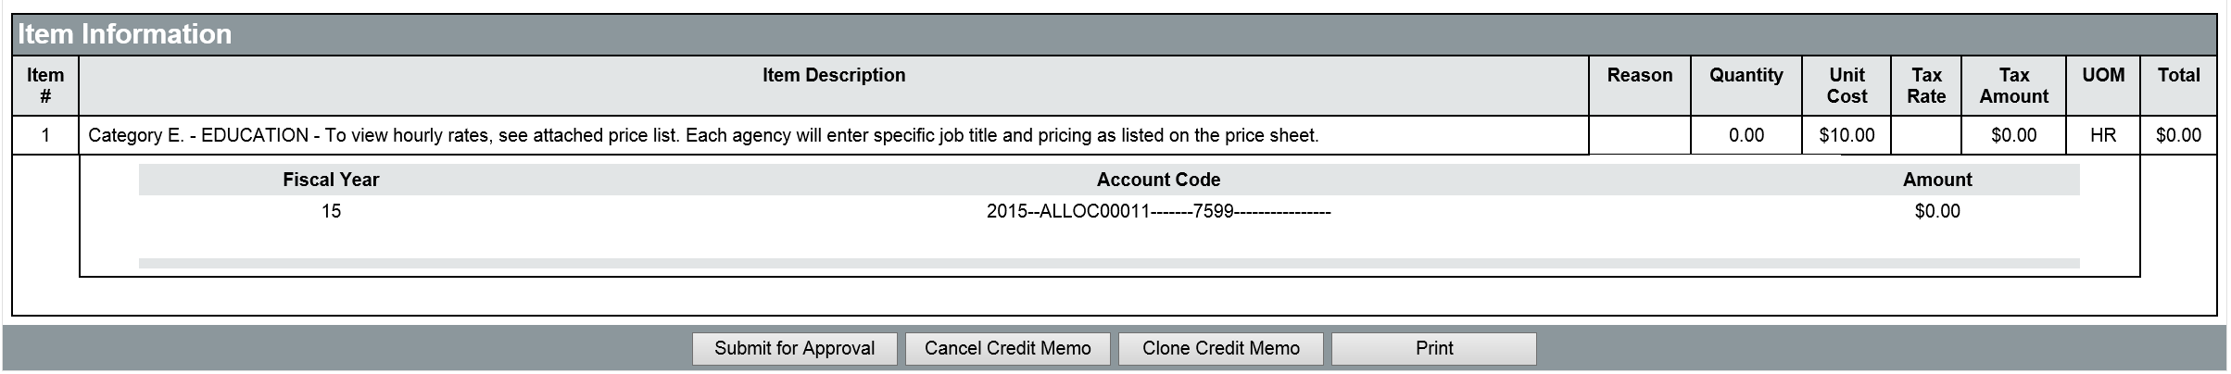

Activity 11.4

Create a Credit Memo
Scenario
You have received a request to create a Credit Memo for Items that were returned to the Vendor after payment was sent. The vendor has sent you a document that shows the Items and amount of the credit.
Setup
- User is logged in to the ProcureAZ home page as a user with the Accounts Payable role.
Steps
- Create a new Credit Memo.
  - In the Header Bar, click Documents > Credit Memos > New.
  - In the Vendor Credit Memo Number field, enter the Credit Memo Number from your Training Card.
  - In the Description field, enter Credit Memo APTrain## where ## is your student number.
- Add a vendor to the Credit Memo.
  - In the Vendor field, click the eyeglass icon to open the Lookup Vendors page.
  - In the Vendor Name field, enter Maurer.
  - Click the Find It button.
  - In the search results, select the radio button for MAURER MARINE INC.
  - Scroll to the bottom of the page.
  - Click the Add Vendor button.
- Add a Purchase Order Number to the Credit Memo.
  - In the Department drop down list, select ADTRN
  - In the Location drop down list, select TRNF.
  - In the Purchase Order Number field, click the eyeglass icon to open the Lookup PO page.
  - On the Lookup PO page, in the PO Description field, enter oar.
  - Select today’s date (or the date you completed Activity 5.1) for the PO Date field
  - Click the Find It button.
  - In the search results, select the radio button for the PO you created in Activity 5.1 in the left column.
  - Click the Select PO button at the bottom of the page.
- Complete the rest of the fields on the General tab.
  - In the Credit Memo Date field, enter the current date.
  - Click the Save & Continue button.
- Complete the Items tab.
  - Click the Items tab.
  - Click the Add Items from PO button.
  - On the PO Items page, check the Select check box for Item 2 (Oars).
  - Click the Save & Exit button.
  - Observe that the Item Description, Unit Cost, and Unit of Measure fields have been populated with information from the PO.
  - On the Items > General tab, in the Reason field, select Other from the drop down list.
  - In the Quantity field, enter 1.
  - Click the Save & Continue button.
- Review the Items > Accounting tab
  - Click the Items > Accounting tab
  - Click the number 1 (not the plus) to open the Accounting line
  - Notice that the accounting for the item has been automatically entered because the item was selected from the PO
  - You do NOT need to make any changes to this information.
- Review and submit the Credit Memo.
  - Click the Summary tab.
  - Review the information on the Summary tab.
  - Click the Submit for Approval button.
  - Click OK when the dialog box displays
  - Select the radio button for Automatic Approval.
  - Click Save & Continue
  - Click OK when the dialog box displays.
  - When the document refreshes, review any messages that are displayed on the Summary tab.
  - Notice that the Credit Memo Status (top left corner) is now Approved for Invoice.
  - When the document refreshes, review any messages that are displayed on the Summary tab.
  - When you are finished, click Home to return to the Home Page.

Lesson Summary
In this lesson you:
- Reviewed how to locate a Purchase Order for payment
- Created an Invoice to request a payment
- Reviewed how to locate Invoices in ProcureAZ
- Created a Credit Memo

Check Your Progress
- Invoices can be created for Purchase Orders with what current status?
  - Partial Receipt
  - Complete Receipt
  - Closed
  - Both a and b
- In order to create an Invoice, a Purchase Order must have an amount that has been approved for payment.
  - True
  - False
- What is used to modify the accounting information on an Invoice?
  - New Purchase Order
  - New Invoice
  - New Change Order
  - New Item
- When are payments scheduled to be processed by AFIS?
  - Weekly
  - Monthly
  - Nightly
  - Yearly
- When creating a Credit Memo, what field can be used to allow the selection of existing Items?
  - Vendor Credit Memo number
  - Description
  - Department
  - Purchase Order Number

